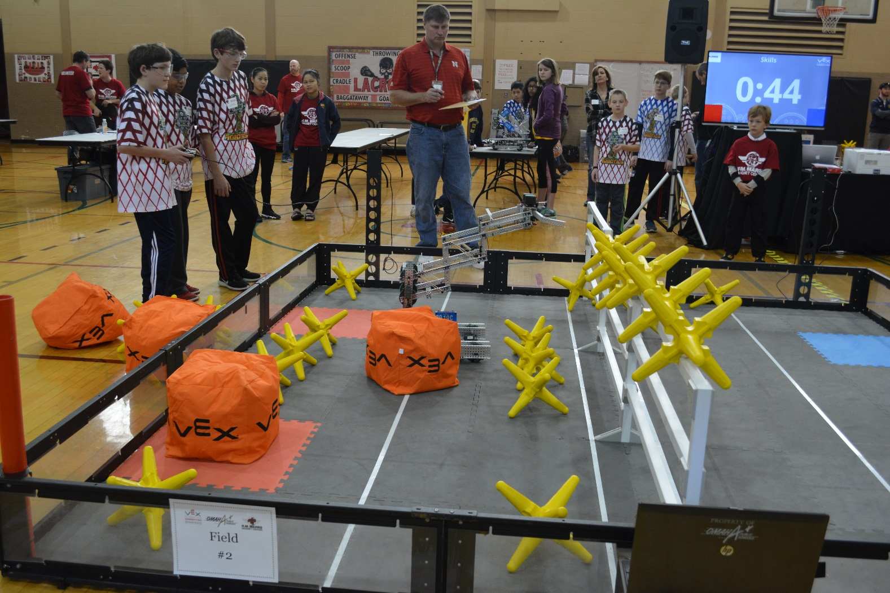

Team 3919C practicing before they start the robotics competition at RM Marrs Magnet Center, Omaha, Nebraska. They came here to win, and that’s why they are doing this.

