Evolving Girl Power

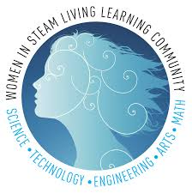
GIRL POWER MEANS…

- Girl Power means that we take the initiative to get things done. We don’t sit around and be lazy we take the initiative to work out our challenges and get our robot and the rest of the key components, for example: notebook, competition-ready. Our team never back down from an obstacle. We always work through the challenges that arise we never just throw it out because it’s hard. We never give up even if we keep losing at a competition we still give it our 110% we just learn from that experience and use the knowledge to help us prepare for a better future. We take time to do things right the first time. We don’t rush through our robot just to get to something else we take our time perfecting it. We empower everyone to be the best that they can be. We motivate ourselves and our teammates, by giving each other words of encouragement. We make sure that everyone on our team learns all of the skills so they are able to do it by themselves but when they need help they are able to ask anyone on our team.

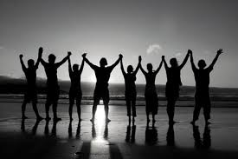
OUR TEAM APPROACH..

- Our team approach is we include everyone. Nobody is left out we all work together. We don’t back down from a challenge just because it’s hard. We do not give up. We work together to overcome any challenge that crosses our path. We don’t rush through our robot just to get to something else we take our time perfecting it. We empower everyone to be the best we can be. We motivate ourselves and our teammates, by giving each other words of encouragement. We don’t put each other down for an idea, instead we talk out our ideas, make models, and write down pros and cons.

TAKING INITIATIVE

- From Oct. 26th to Dec. 21st we have been volunteering in the UMOJA ACT-SO Enrichment Program getting middle schoolers involved in S.T.E.M. through teaching them how to build and program a robot. This year they used their teamwork skills to market the robot on two different teams.
- Fun Fact: UMOJA is the Swahili word for Unity

WHAT WE HAVE LEARNED FROM TRYING DIFFERENT ROLES

- When we tried different roles on the team we realized how interconnected many of the roles are and that we were bound to find something we liked. We have different strengths and weaknesses so when deciding on what we wanted our role to be on the team we gravitated to different aspects. As we said before, everything seems to be interconnected which meant that we still communicated to help better ourselves and our performances. One other thing we have learned is that you never know if you will like something until you try it..

EFFECTS OF DIVERSITY
- In Piratech there is a very diverse group of students. This allows us to have a wider range of ideas and a wider encompassed culture. Everyone comes from a different background which gives everyone different strengths and weaknesses. Having a more diverse group also means that everyone has a different skill set and mindset of how to get things done. One challenge of having a diverse group would be having different points of view and having to get them on the same wavelength.

STEM ROLE MODEL

- My STEM role model is Mrs. Coleman. She is a science teacher at Stone Magnet Middle School and she has inspired me to be apart of STEM. Without her I probably would have gone a different route in my life and not found my love for robotics.
- My STEM role model is Mr. Allen. He is the robotics teacher as well as our coach at Palm Bay Magnet High School and he has continued to inspire us and push us to be the best that we can be. Without him I would not have the opportunity to find my true passion in the field of engineering and robotics.

CREDITS

- Evolving Girl Power
- Entrants

  - Alexis Buhrman
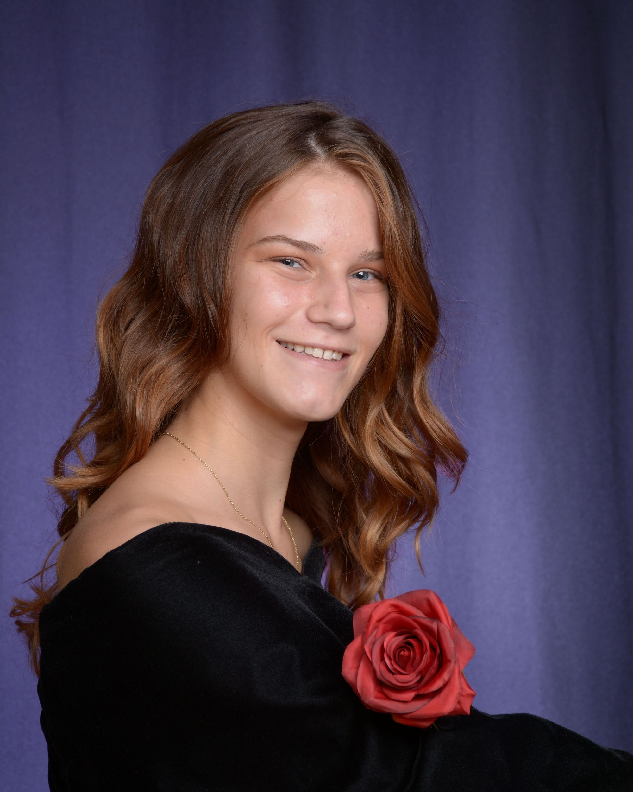

  - Jessica San Roman
- Piratech’s 508B

