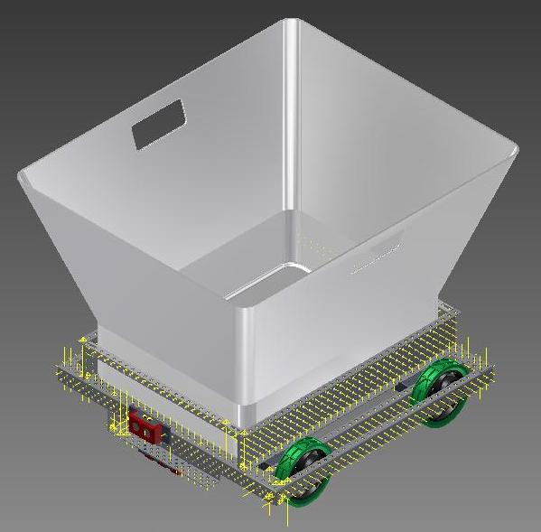Project Description: “Bin Bot”

Introduction
Given the choice of basing our design on Industry, Science, Exploration, Medical or law enforcement, we chose Industry; we made this choice by assessing the possibilities for each topic then comparing the various attributes for each.

Initial ideas included an autonomous hospital bed, a snow proof robot, a lock opening robot and a moving Bunsen burner however we ultimately settled on the idea of a Moving Secure Document Bin for the workplace – we call it “Bin Bot”.

Objectives
The key objectives of this robot are as follows
- To consolidate confidential documents in a timely and secure fashion from office workstations to a secure storage or destruction point within the office.
- Generate a return on the investment by helping highly paid staff become more productive.

Specifications
- Autonomous navigation to each desk with short pauses at each workstation
- Self propelled
- Obstacle sensing
- Suited to flat floor offices (one Bin Bot per level)
- Capable of carrying 5kg of paper
- Speed to be no more than 1.5m/s

Construction
The chassis is square and has independently operable wheel/motor assemblies at each corner to provide movement in all directions as well as providing stability & reasonable ground clearance due to the wheels being 4” in diameter. The micro controller is located within the chassis at the bottom together with a battery. There are sensors to allow the Bin Bot to follow a predetermined track including where to stop and start. The track consists of a contrasting stripe laid in/on the floor with wider areas defining the stopping points. An ultrasonic sensor is fitted at the front so as not to bump in to anyone or anything. A charging socket is provided so the battery does not have to be removed. The bin is injection moulded from 3mm plastic. It has a load capability in excess of the specifications.

Operation
This device will be used to automatically circulate around the office at predetermined times, stopping at specific desks for say one minute intervals thus allowing time for the person to put their secure documents inside and then it will continue to the next stop point until it returns to the area where the documents will be processed.

Further Considerations
For additional security of contents the following could be implemented:
- RFID attached to each bin with sensors at doorways to ensure no unauthorised removal of bins and contents.
- Bins can be made with a lid c/w lock comprising of a padlock, sequential numbered tag or zip tie. The bin lid would have a slot just large enough to allow paper to be inserted.
- Business processes can be implemented around the retrieval of documents from the bin/storage area prior to destruction.

