Quadriplegic Gantry
Team 341 Iron Eagles

Brief Description: A 5-motor gantry (figure 1) constructed of VEX parts that can be operated by a quadriplegic through head motions only.

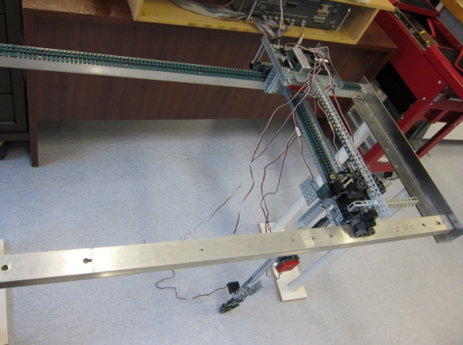
Mechanical System: The gantry structure is 50 inches long by 25.75 inches wide by 35 inches high. A 2-VEX motor carriage (figure 2) carries the gantry gripper (figure 3) on perpendicular tracks the length (x-axis) and width (y-axis) of the gantry structure. A third VEX motor raises and lowers (z-axis) the gripper. A VEX servo opens and closes the gripper, while a fourth VEX motor rotates the gripper in the horizontal plane.

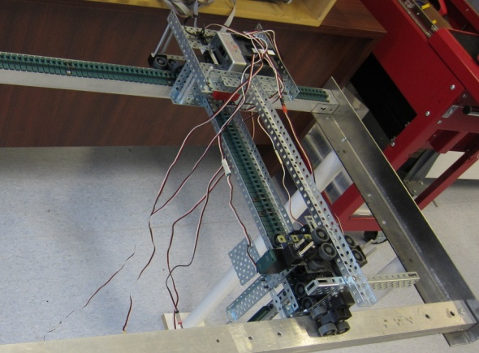
Electrical System: Two VEX yaw rate sensors are mounted on a hard hat that is worn by the operator (figure 4). The sensors are mounted in orthogonal planes: a yaw sensor on the top of the hat senses motions in the horizontal plane and a pitch sensor mounted on the side of the hat senses motions in the vertical plane. A VEX limit switch operated by a sideways (roll) motion of the operator’s head, selects one of 3 possible gantry operating modes. Three VEX quadrature encoders, one for each of the principal gantry motors, measure the distances traversed in the $x-y-z$ plane. Three VEX limit switches located at the starting positions of the 3 principal motors provide a ‘hard home’ starting point for the gantry carriage and gripper.

Operating System: The operating system is written in EasyC v4 for Cortex (v4.0.2.8). At startup, the 3 principal gantry motors autonomously move the carriage and gripper to their hard home starting location using the limit switches to sense the stops. The operating system starts in mode 1 which allows the operator to move the carriage along the gantry x axis, using a yaw motion of the head, and along the y axis with a pitch motion of the head. The output of the 2 VEX yaw rate sensors is calibrated such that motor speeds are proportional to head displacement in degrees. A 45º rotation of the head drives the motors at top speed. The limit switch mounted on the hard hat implements modes 2 and 3 by successive tilts of the operator’s head. Mode 2 allows the operator to raise or lower the gripper (pitch motion of the head) and to open or close the gripper (yaw motion of the head). Mode 3 allows the operator to rotate the gripper in the horizontal plane (yaw motion of the head). The 3 quad encoders prevent the motors from overdriving the tracks in any direction. An LED in the field of view of the operator indicates the operating mode: a single repeated blink for mode 1, double blinks for mode 2, and triple blinks for mode 3.

