How to build a simple X-Drive Chassis – Team 2918A (GC*EC)
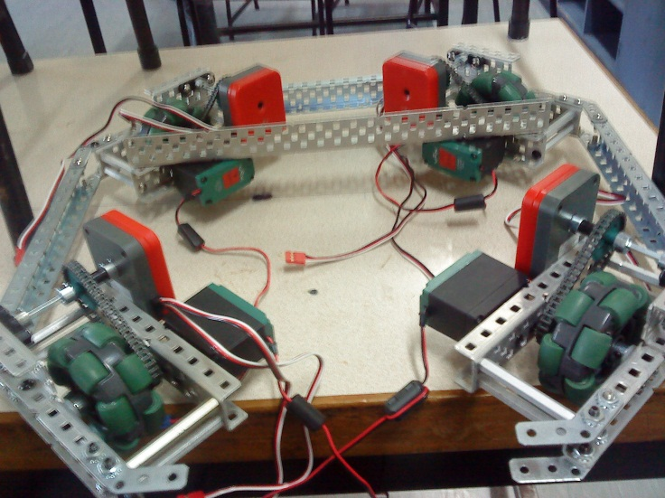
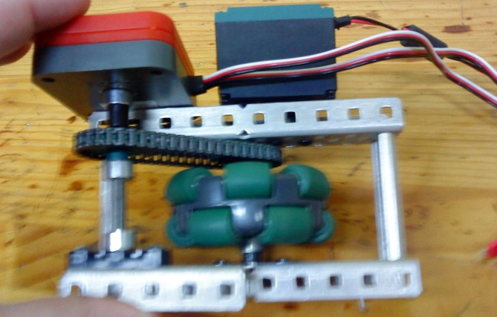
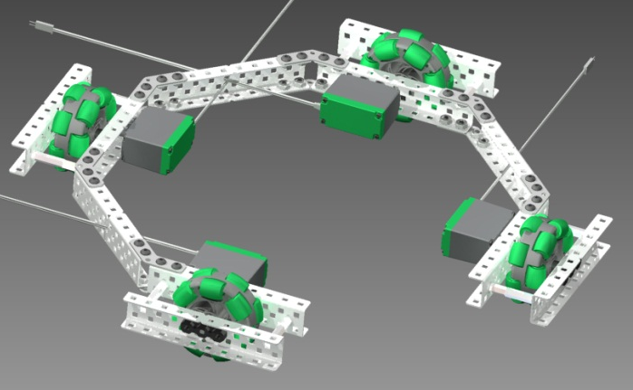
X-Drive has become a common feature of GCEC Robots lately, and we have discovered some tips and tricks for making them simple and reliable along the way.
The most reliable way we have found of building an X Chassis is to build four separate wheel modules. These fit together with 45 degree gussets to make a strong structure and a sturdy shape, and make it very simple to replace or tighten motors.
The line in red, in the above CAD diagram, is the smallest distance in the open front of the chassis. This is the widest your intake can be, if you want it to sit further back in the robot.
You can maximise this distance by mounting your motors as far back as possible, as shown in the CAD diagram, as mounting further forward would produce a narrower gap between the two motors.
The photo to the right is one of the most basic forms of wheel module we build.
On the top you can see a shaft encoder and a motor, both attached onto a 10-hole C Channel.
This X-Drive is built with 2.75” Omni Wheels, which produce a more compact base than 4” Omni Wheels
Low strength chain works well in this task, as there is not enough load on the chain to snap it during a match.
These modules require a maximum of 4 screws undone to tighten a motor. This has saved us many times in qualification matches when our motor screws started to come loose.
You can also attach the modules from the outside frame, as shown on the left. This does narrow the gap in the front, but if you use an intake which is predominantly extended over the front of the chassis, this doesn’t cause a huge problem.
The bar mounted across the back in this photo provides bracing on the wheel modules and also provides us with a place to mount our cortex, power expander and batteries.
X-Drives provide us with an extra direction of motion over a tank drive, and are great for Sack Attack as they rarely get sacks stuck in the wheels – a problem we found frequently with H-Drives.

