Christian R. Gideon
January 13, 2014
Team 83- Chaminade College Prep Middle School

Thanks, Dad
I am lucky to be surrounded by people who love what they do. My father was a successful college football player at U.C.L.A. and found his passion in coaching and teaching kids. My mother, who always loved children, found her passion working with children and teaching elementary school. I come from passionate people.
One day when I was in fourth grade, my dad came home from work and sat me down to talk. He said, “Christian, I see how hard you work at building marble mazes in your room and working on your idea for designing a new Pokemon Theme Park. I think I have something to show you that you might like.”
A few weeks later, my dad took me to my first VEX Robotics Tournament. The little details of that day were forgotten in my nine-year-old brain, but the most important thing I remember is being amazed. I remember sitting on the floor leaning up against a playing field and being amazed. I remember the robots going through the challenges, the teammates working together, the gears turning, the lights flashing. I knew this was what I wanted to do.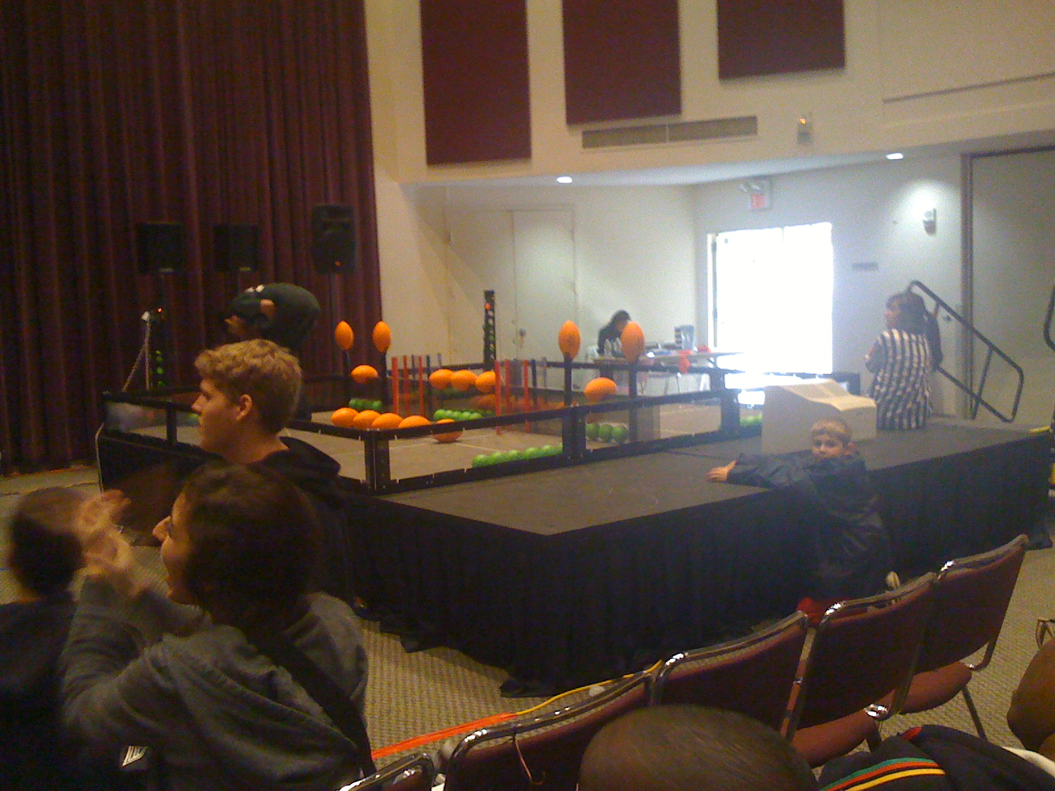 Me as a fourth grader watching my first VEX
Robotics Tournament in 2010.
So I got involved in VEX when I was in sixth grade in middle school. The older kids were really helpful in teaching me about VEX. They boosted my confidence when they put me in charge of programming the autonomous program and letting me drive the robot. I learned how to work with teammates, how to give presentations, how to teach others through Outreach, and how to shine. I learned about C-channels, programming with Easy-C, and scissorlifts. I learned that engineering is my passion. And I can’t wait to learn some more.
So thanks, Dad. Thanks for seeing me for who I am and helping me find my passion.

