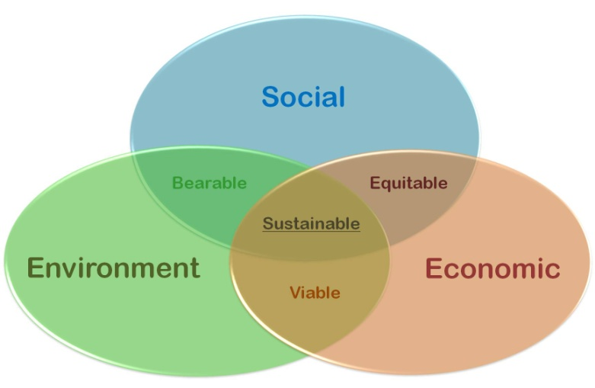
Introduction
Due to the depletion of resources, humanity must know that technology and ecology must be mutually increasing, development should allow both the welfare of society and the environment, and this is called sustainable development
Three years ago started in our school an ecological project based on recycling, all students got engaged to bring a bottle filled with recycled material, today all these bottles were used to make chairs and furniture and the idea is to continue with this project until build a complete ecological house as outlined here

Our project is a prototype of a house which seeks genuine sustainable development; its main objectives are the efficient use of energy, water conservation, recycling and land use.

These are the components that make our home sustainable

Energy:

- The main source of energy are solar panels, the robot controls the amount of energy using the voltage sensor , if suboptimal connects the house to the local electricity network until it stabilizes in order to prevent damage to electronic devices, this creates a great energy saving in the house safely.

- Corridors have a system of sensors (light and ultrasonic range finder) that turn on the lights only if the following conditions are true, there are little light and there are people passing right thought.

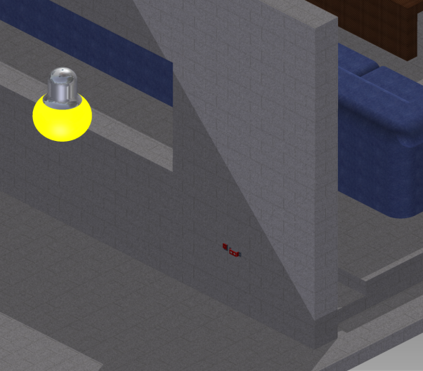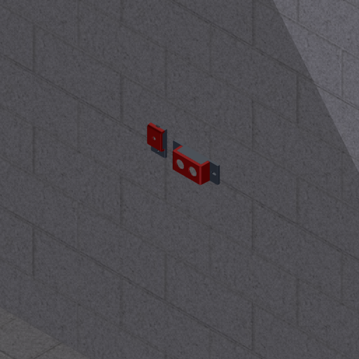
- The house has large windows for maximum use of sunlight avoiding the use of artificial lights that consume energy.

- Clothes dried using the sun and wind outside to avoid using electric dryer.

- Robot also uses solar panels for energy.

Water:

- The roof of the house helps to collect rainwater which is stored and used to wash the house and by the robot for watering plants.

- The robot uses the rainwater to water the plants in its night tour verifying whit the humidity sensor the approximate amount of water needed to avoid waste.

Recycling:

- All the walls are made from ECO-bricks then are covered with cement and painted as shown in pictures, that is PET plastic bottles stuffed whit recycled components as plastic bags, aluminum foil, or laminated paper, the material must be completely clean and dry and must not contain organic or toxic waste, into the bottle components must be tightly compacted to yield a solid rigid brick long-lasting.
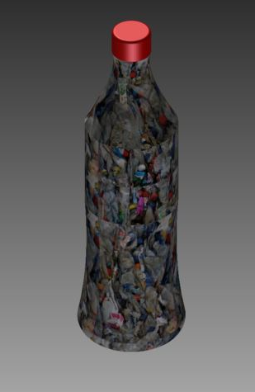
To learn more about ECO-bricks go to
http://ecoladrillo-lafabulosa.blogspot.com/p/prueba.html

- The robot is equipped with a component that helps compacting the recyclable items into the bottles in this way contributes to the construction of more ecological houses.

Land use

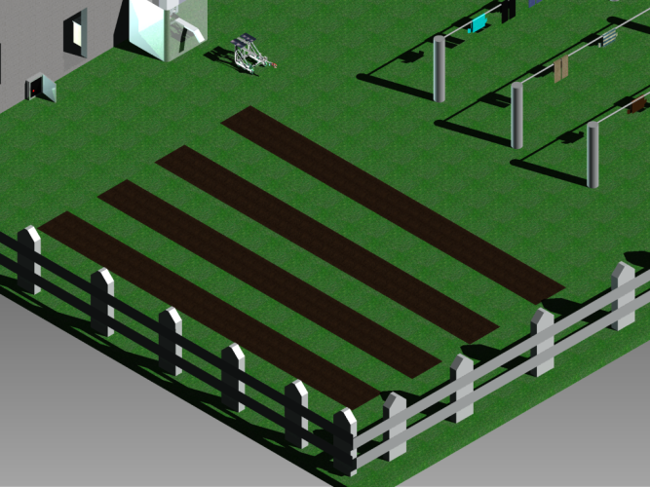
- Part of the garden is ready for planting organic vegetables for home consumption that lowers the environmental spending in the process of packaging and transportation, the robot takes care of proper irrigation in this area by measuring the amount of water needed

The robot

As part of the development process is sought automation to facilitate the work of man, the house is not only an ecological house is one sample of sustainable development in which both the environment and humans are benefited.

The robot has several functions in the house that make man work easier and help to conserve water and energy

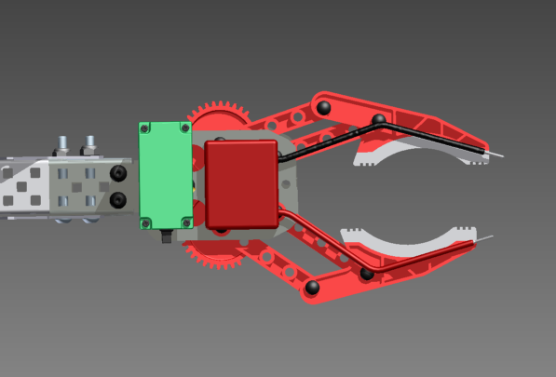
- The robot monitors the voltage generated in the home solar panels using the voltage sensor and verifies that it is suitable for the proper functioning of electronic devices if is suboptimal connects the house to the local electricity network until it stabilizes in this way greater use of solar energy is obtained without causing any damage to the electrical equipment

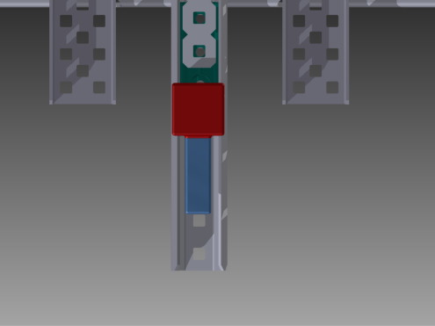
- Watering plants at night to prevent water evaporation by the sun also uses the humidity sensor to measure the approximate amount of water needed by plants which can vary due to rainfall and other climatic factors

- Disconnect electronic devices that are not in use at night to prevent further consuming of energy and connect again in the morning

- Is equipped with a mechanism that helps to compaction of recyclable components inside the bottle in this way contributes to the construction of new eco-houses.

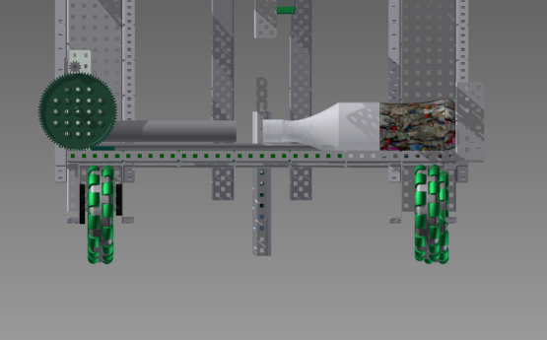

- Uses the energy of the sun to its own operation and is equipped with solar panels on top

Credits

Team number: 4502G

Created by: Juan Diego Villamizar with Nestor Eduardo Ribero

Software used: Autodesk inventor professional 2014

