Soil and water are vital to life on Earth. As such, it is necessary for us to maintain the soil and water so that we continue to have clean water to drink and nutrient rich soil to grow crops and sustain Earth's plant life.
This is where the ecocopter comes in. The ecocopter can autonomously retrieve soil and water samples so that they can be tested to ensure that the water is safe and healthy and that the soil contains the right balance of nutrients to sustain crops or other plant life.
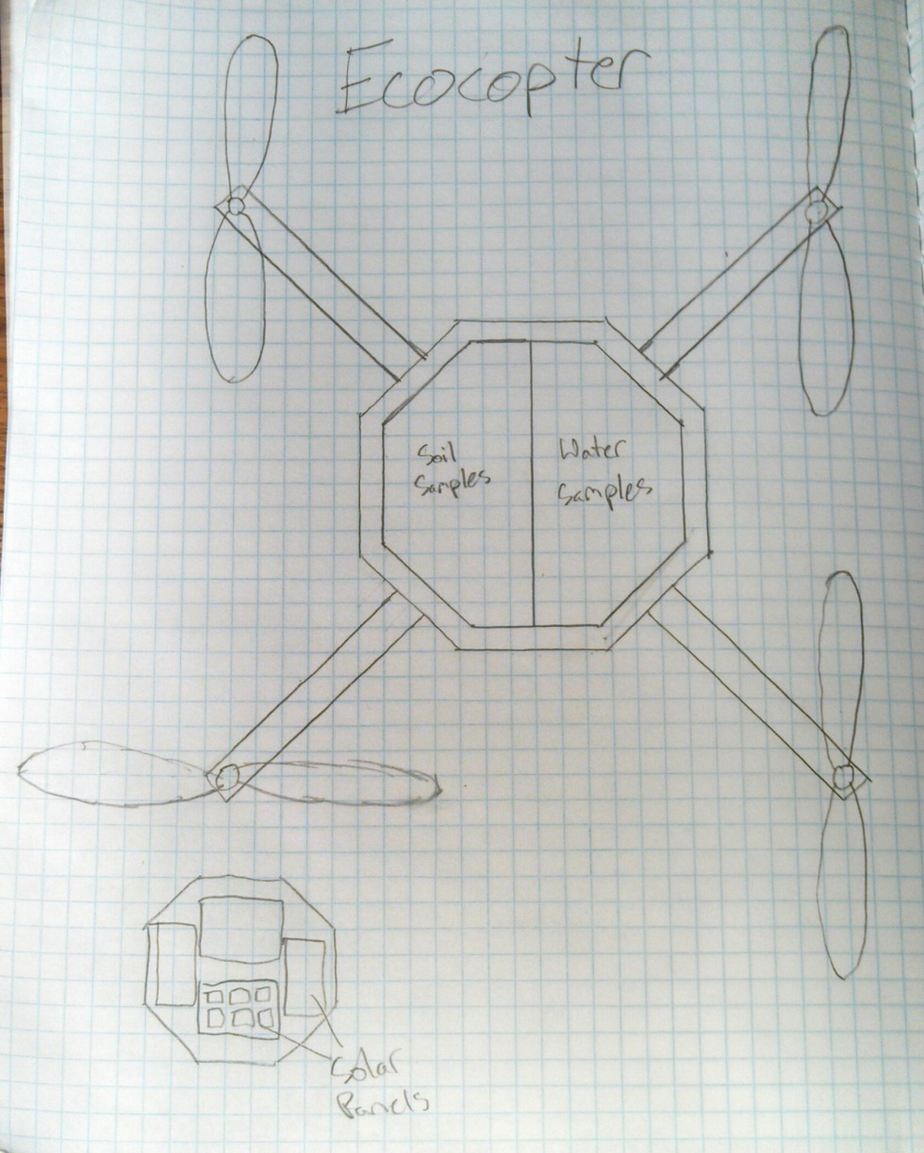
First we created a sketch of what we wanted the robot to look like and determined what features it should have.
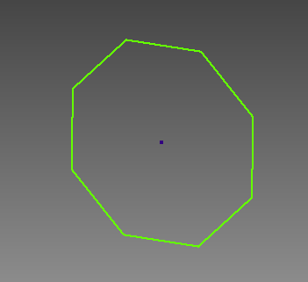
Then, we began creating all of the parts in Autodesk inventor.

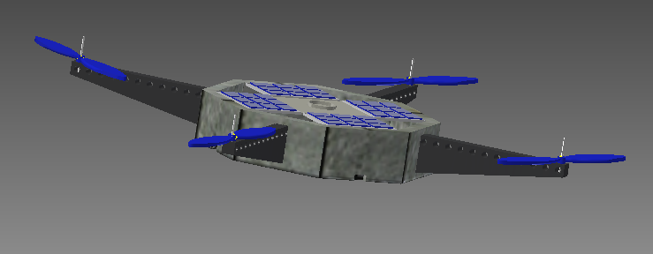
Finally, we put all of the parts together into one assembly file.
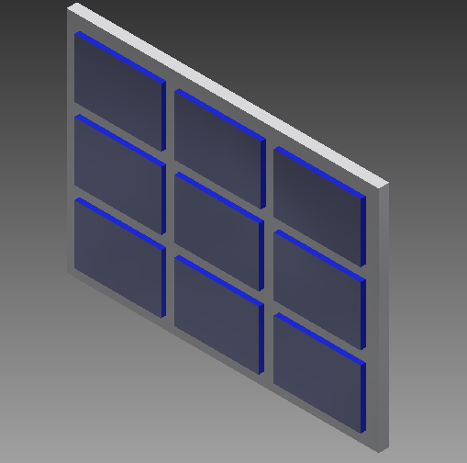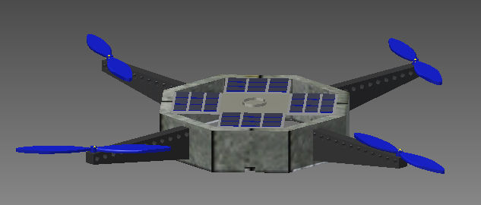The ecocopter incorporates solar panels to increase the longevity of its battery life. In addition, because it flies, the ecocopter has a very low impact on the environment. In order to increase efficiency, the ecocopter's frame is made up of lightweight aluminum and carbon fiber.

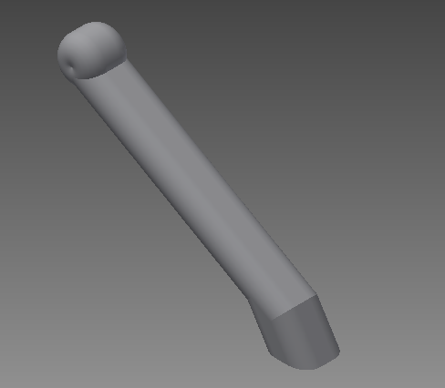
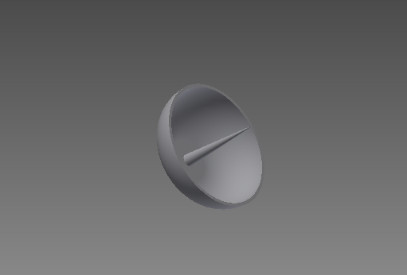
Radar
Landing Gear
Detachable Parts

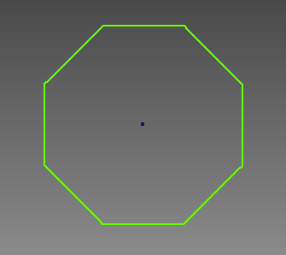
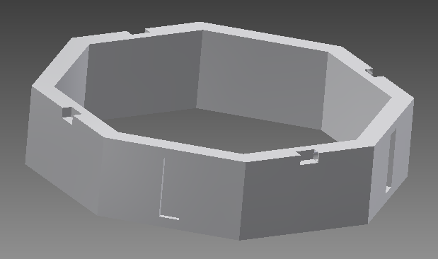
Final Result
Step 2
Step 1
Part Progression

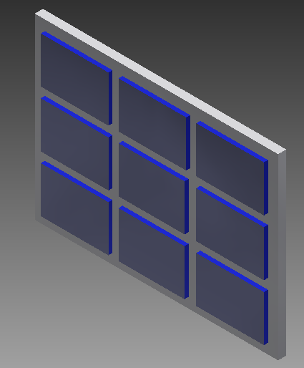
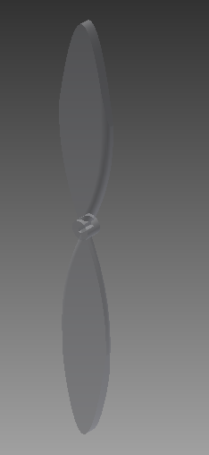
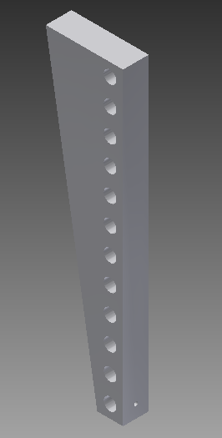
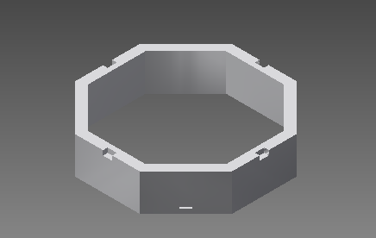
Sub-assemblies
Solar Panels
Propellers
Arm
Base
Front View
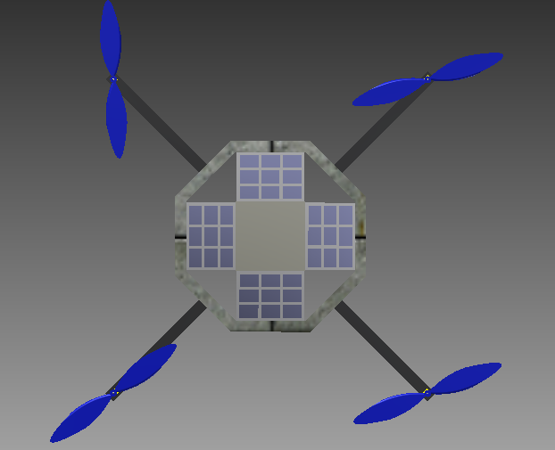
Completed Design
Back View
Side View
Top View

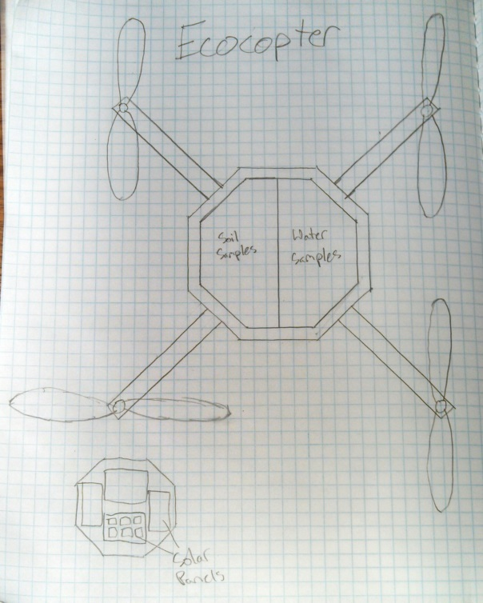

Next, we created the base to attach the rest of the parts to.

Then, we began sketching the parts in Autodesk Inventor.

Finally, we assembled all of the CAD parts to create the finished ecocopter.

We began by sketching out our idea for the ecocopter.

