I have redesigned the current VEX EDR part library to support the new high strength shafts. With the current VEX EDR parts, there is a large incompatibility with the newly released high-strength shafts due to the small holes on the metal, in the motors, in the bearing blocks, and all cogs.
The parts that I have designed are not meant to replace the current parts - they are meant to be an addition to the current VEX EDR part library.

The parts I have designed are as follows:
- 1×2×15, 1×2×25, 1×2×35, 1×5×25 C-channels for High Strength (HS) shafts
- 5×15, 5×25 Plates for HS shafts
- 2x2x25, 2x2x35, 3x3x35 Angles for HS shafts
- 15-tooth, 24-tooth, 40-tooth, 48-tooth Low Strength (LS) Sprockets for HS shafts
- 6-tooth, 12-tooth, 18-tooth, 24-tooth, HS sprockets for HS shafts
- HS 392 Motor
- Tread drive wheel for HS shafts
- LS to HS shaft joiner
- Low profile Bearing block
- HS shaft lock

These new VEX EDR parts would be used with the new HS shafts which would give them more functionality, because with these new parts you can fit the HS shafts through most components without using additional parts to secure the shaft. A main feature of my parts list is that the HS Shaft Inserts that already exist are compatible with everything I have designed. All metal is compatible with original parts, as they still have 1/8’’ holes in places that can easily join pieces of metal together.

The CAD software I used was Autodesk Inventor Professional 2015. I used the measurement tool to check the measurements of the original parts and new HS shafts to ensure compatibility. I used the rectangular pattern tool to repeat steps where the pattern could apply. I used basic assemblies to check that the HS shaft would fit through the redesigned parts. During the design process I changed the shape of the redesigned holes from a uniform square to one with rounded corners - I noticed that the uniform square holes did not provide enough metal between holes diagonally across, therefore degrading the structural strength of the metal. The new rounded squares provide more metal between the holes diagonally, eliminating this problem.

Due to the number of parts designed, only two will be documented.

Here is my design process for the 15x5 plate. Note: I have used the same design for all plates.
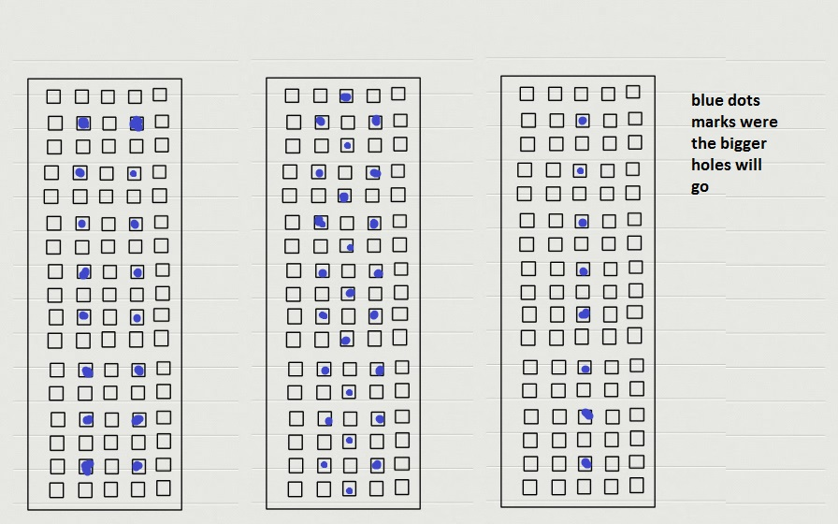

I mapped out possible positions for the larger holes. I used the middle design for reasons stated above.

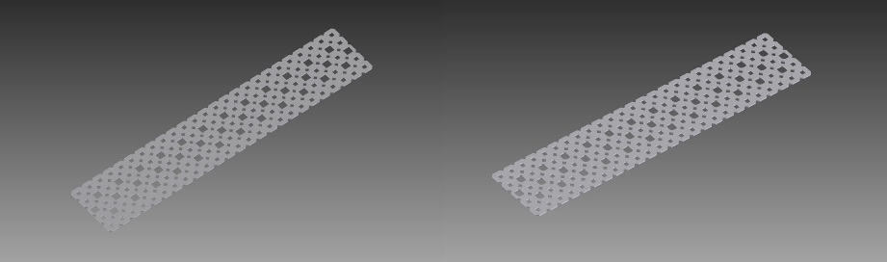

Shown: original plate designed with larger holes (left) and rounded holes (right).

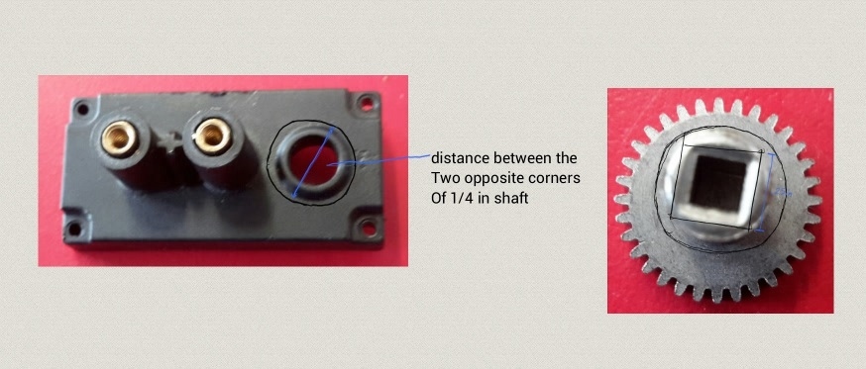
Here is my design process for the 392 motor.

I determined the width needed for the HS shaft to fit into the drive gear in the motor.

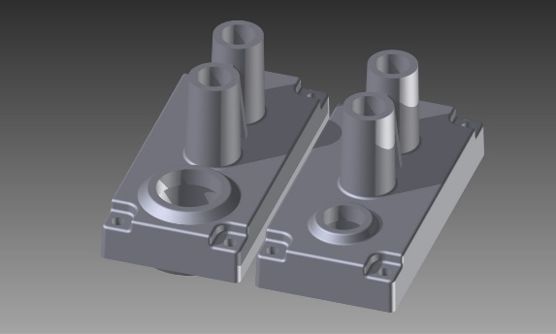
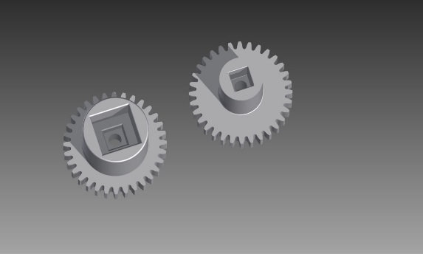
Shown: redesigned face-plate for the motor alongside original (right), and the redesigned drive gear alongside original (left)
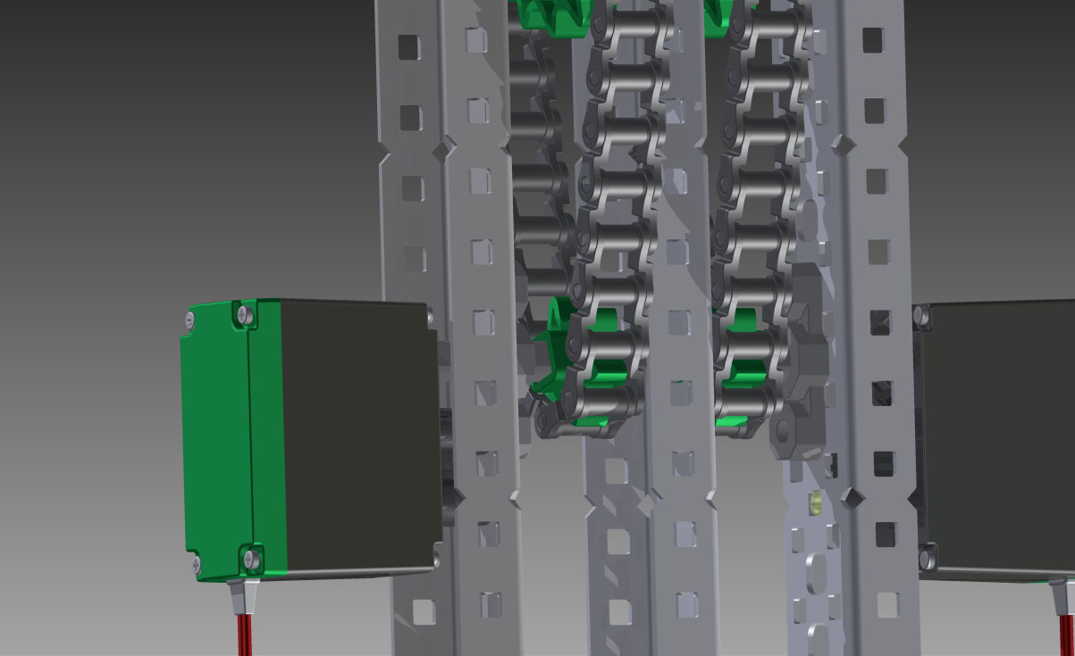

Shown in this rendered image is the redesigned C-Channel, 392 motor, low profile Bearing blocks, and HS 6-tooth sprocket – all of which accommodate the HS shafts.

