Team Livewire1069F
12-30-14
Design Process for High Strength Shaft Output Conversion
As a team we wanted to make something that would be useful, easy to use and integrated with current VEX parts. We had a couple ideas, which are listed below:
- Double output shaft motor
- High strength shaft output motor
- Spacers for the high strength shaft with a round inside
- Snap in battery holders for the 7.2v batteries (Similar to the 9v holder)
- Battery monitor for 7.2v
After we brainstormed these ideas we went through and made a decision matrix. This was based on the three goals stated above along with the secondary goal of how it might score in the online challenge.
Idea: | Useful: | Ease of use: | VEX integration: | Online Challenge:
-Double output shaft motor | In some situations (7/10) | Just like a normal motor (9/10) | Easy, mounts on both side may be hard (8/10) | Very different (9/10)
-High strength shaft output motor | In some situations (7/10) | Just like a normal motor (9/10) | Easy (10/10) | Most need piece in our mind (9/10)
-Spacers for the high strength shaft with a round inside | Useful, but not needed (5/10) | No way to mess these up (10/10) | Easy (10/10) | Super simple, not very original (4/10)
-Snap in battery holders for the 7.2v batteries (Similar to the 9v holder) | Useful, but not needed. Speeds up build time (6/10) | Should be easy to use, but may be hard to find space at first (7/10) | Easy (10/10) | Not a super impressive idea (7/10)
-Battery monitor for 7.2v | Useful only to teams that need to be very precise (6/10) | Would have a small learning curve (6/10) | Software may need to be changed (6/10) | Already available if you know how (7/10)
As you can see, based on our decision matrix, we decided to build the high strength shaft output conversion, because it fit our criteria the best. We used calipers to get the dimensions of the high strength shaft and used that to make the new output gear in Autodesk Inventor Pro:
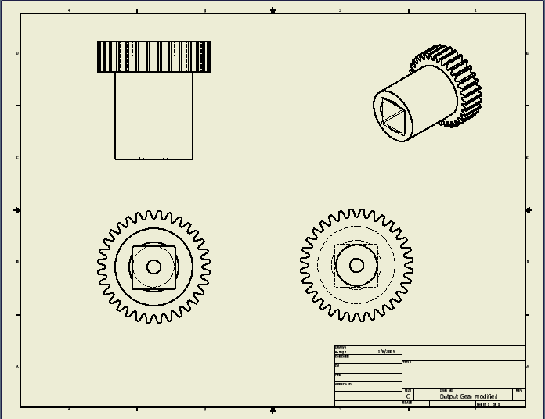
We made sure the dimensions were correct and then made the plastic pieces that holds the gears in:
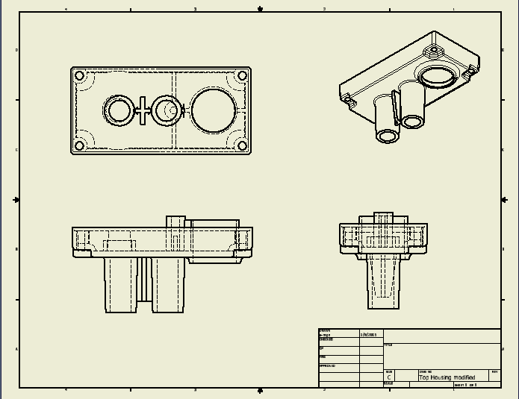
After it was all completed we made drawing of the internals of the motor:
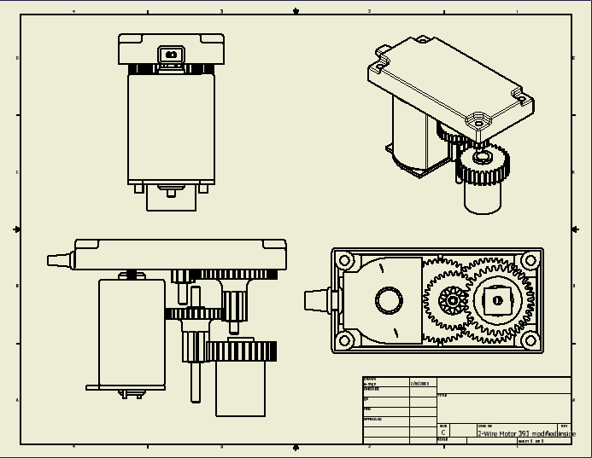
This new conversion kit uses the current VEX 393 motor and converts it to use with the new high strength shafts, which have used on multiple parts of our robot this year.

