Bradley Bunz
December 1st 2015
Make it Real CAD Engineering Challenge
Final Report
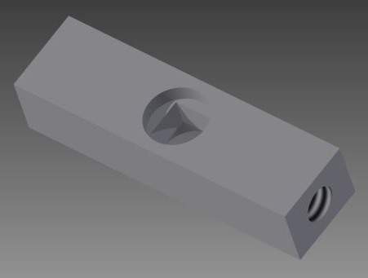
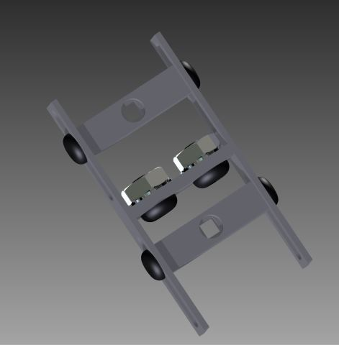
The shaft tensioner I created is the answer to an issue my fellow competitors and I have encountered with gear slippage on drivetrains and manipulators. To successfully transfer power when driving a manipulator/drivetrain mechanism with two or more gears the gears obviously need to be in contact. Custom manipulators, especially when 3D printed, commonly have issues with gears slipping and power not being efficaciously transferred which adversely affects competition performance. Previously, to solve this problem I used dozens of rubber bands to apply tension to the shafts and keep them closer together, but this always resulted in underwhelming results and an exhausting process of removing and reapplying countless rubber bands when the manipulator had to be modified. My shaft tensioner solves this dilemma.
Fig. 1 – Full Apparatus of Shaft Restraints and Brackets
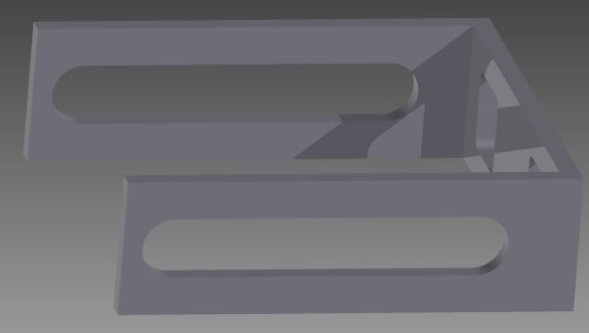
The shaft tensioner would be used to solve the aforementioned issue by forcing two shafts connected to gears together; eliminating slippage. The entire apparatus to be used would be two shaft restraints (Fig. 2) and two brackets (Fig. 3). A shaft would be pushed through the square hole in the shaft restraint. The shaft restraint is secured to the bracket with 6 – 32 ¼ inch screws that screw into the side of the shaft restraint through the long holes on the side of the bracket; the shaft restraint fits perfectly between the forks of the bracket, so this is possible. Another bracket with shaft restraint is secured to the first bracket to complete the apparatus. The screws on the side of the brackets can be loosened to adjust the position of the shaft restraint to tighten the shafts together and therefore the gears. A rendering of a possible set up is shown in Fig. 4 with all necessary components.
Fig. 2 – Shaft Restraint
Fig. 3 - Bracket
Creating this part, I used Autodesk Inventor 2015. The Inventor program has enabled me to experiment and develop my ideas without having to create physical models for each iteration. This saves lots of time and money
for product development. I was able to use assemblies to create mock-ups of situation in which my part would be used to verify that my part is a viable utility. Without Inventor I would not have been able to complete this project in the time that I did and with the quality that I did.
Fig. 4 – Full Apparatus with shafts, gears, and shaft collars
In creating this part I have learned a great deal about the design process of building a custom part. The ability to explore different options and refine an idea so easily in a 3D modeling program is a major reason I will return to use Autodesk Inventor in the future. I can use Inventor for creating 3D models and drawings of components of a pinball machine I am restoring to have them built or to print more VEX parts to improve my robot designs with parts that don’t exist. I have used Inventor before to create 3D printed parts that help me overcome the challenges posed by the VEX robotics competitions I have been involved in. Autodesk programs can also help competitive robotics teams by creating 3D models of robot designs that can be changed to experiment with brainstormed ideas much quicker and easier than to physically modify an existing robot design. 3D design software education will surely aid me in my career path because I will attend college to become an Electrical Engineer and 3D design software can help me create things like electrical infrastructure setups. Software like Autodesk Inventor will be a great boon to me personally and the world in the future.

