Texas Instruments Electronics Online Challenge
9364C

As time and technology progress, robots are sure to be integrated more and more into our daily lives. Commercially produced robots are becoming more common. One example of this is the automated robotic vacuum Roomba produced by iRobot. We of team 9364C chose this device to deconstruct because of the potential implications in our lives the vacuum itself and the industry holds. And it’s cool.
The Roomba ended up being much more complex than we had originally thought. For the sake of brevity, we will mainly look at what was found on and around the circuit board.
In total 5 clearly marked TI chips were found on the motherboard while most of the rest appeared to be manufactured by ST.
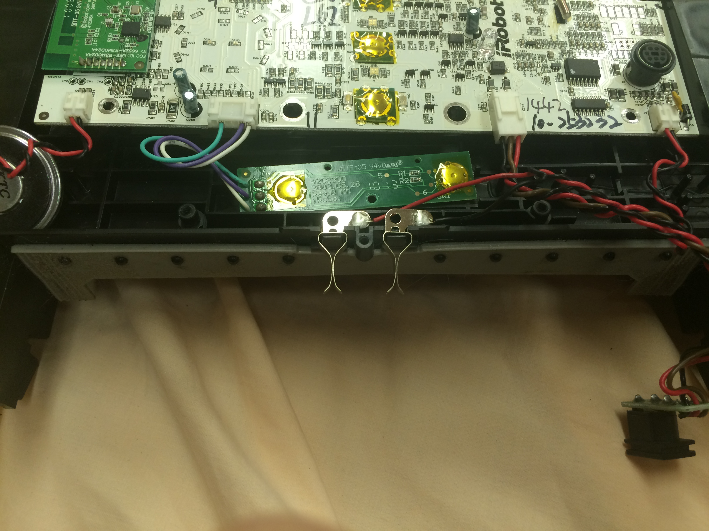
The wires connected to the main circuit board on the very left are a speaker. This is used to make annoying and loud beeps whenever the robot does anything. Next is the second, smaller circuit board. This appears to provide an input for the two buttons on the bottom of the control panel. To the right of that is the input for charging the robot with a wire as opposed to the wireless dock. On the very right is the input for two sensors that ensure the vacuum bin is in place. It also provides power to the fan in the vacuum bin.

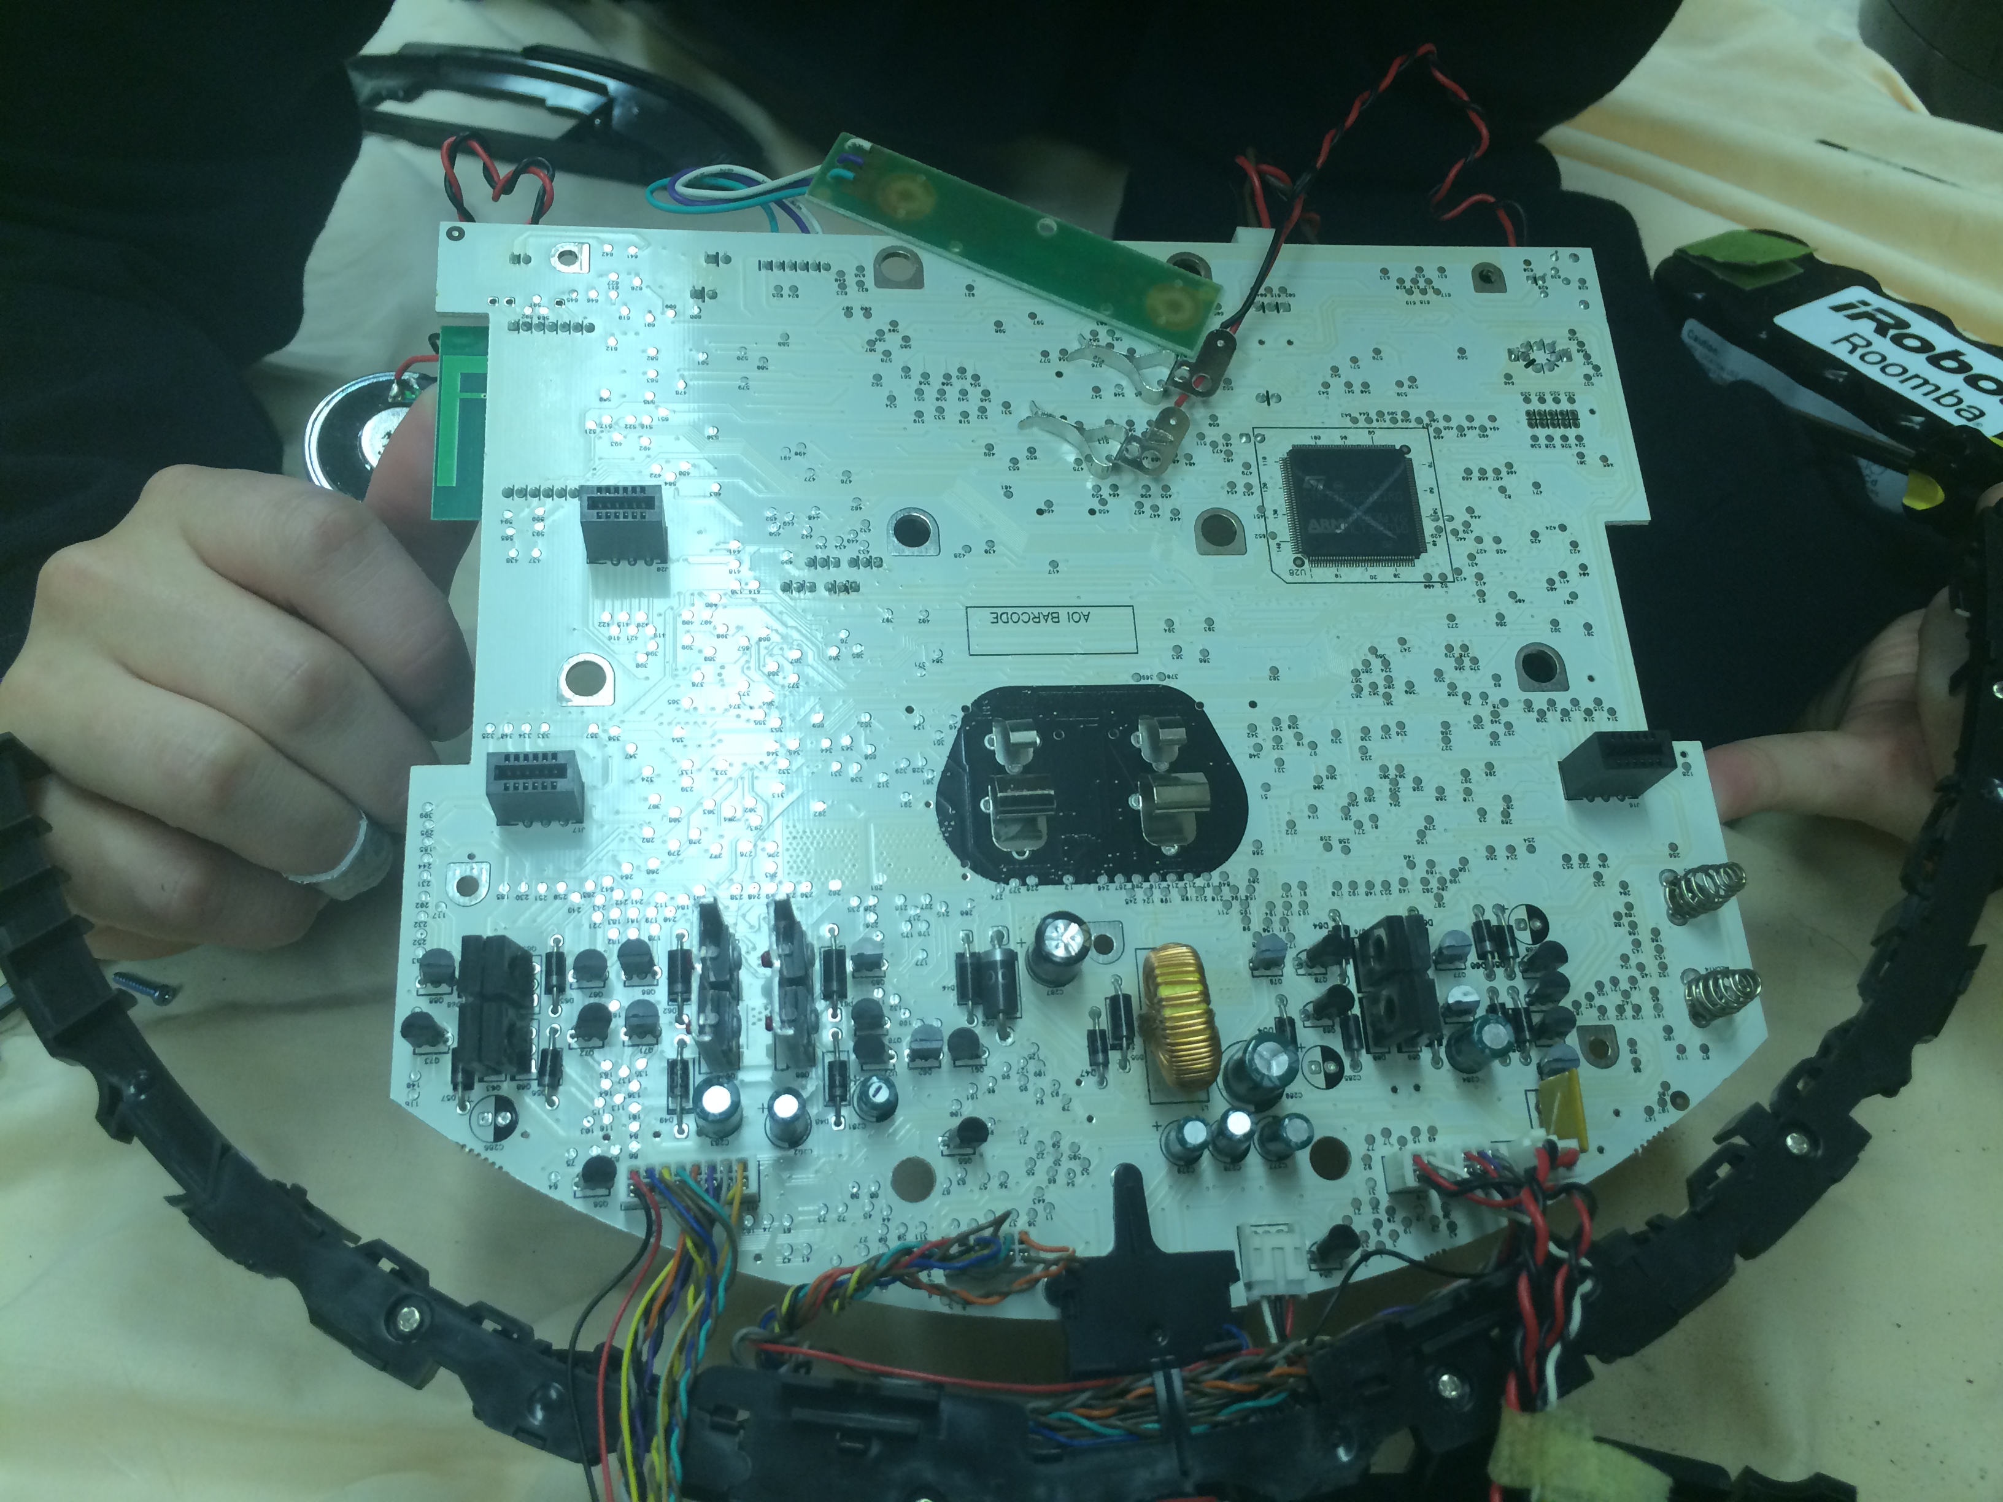
This is the underside view of the circuit board. The large black area in the middle is where the battery connects. Also the connectors (two on the left and one on the right) that meet the underside brushes and the two wheels can be found. One of the more important elements, the main processor, can be found in the upper right corner.
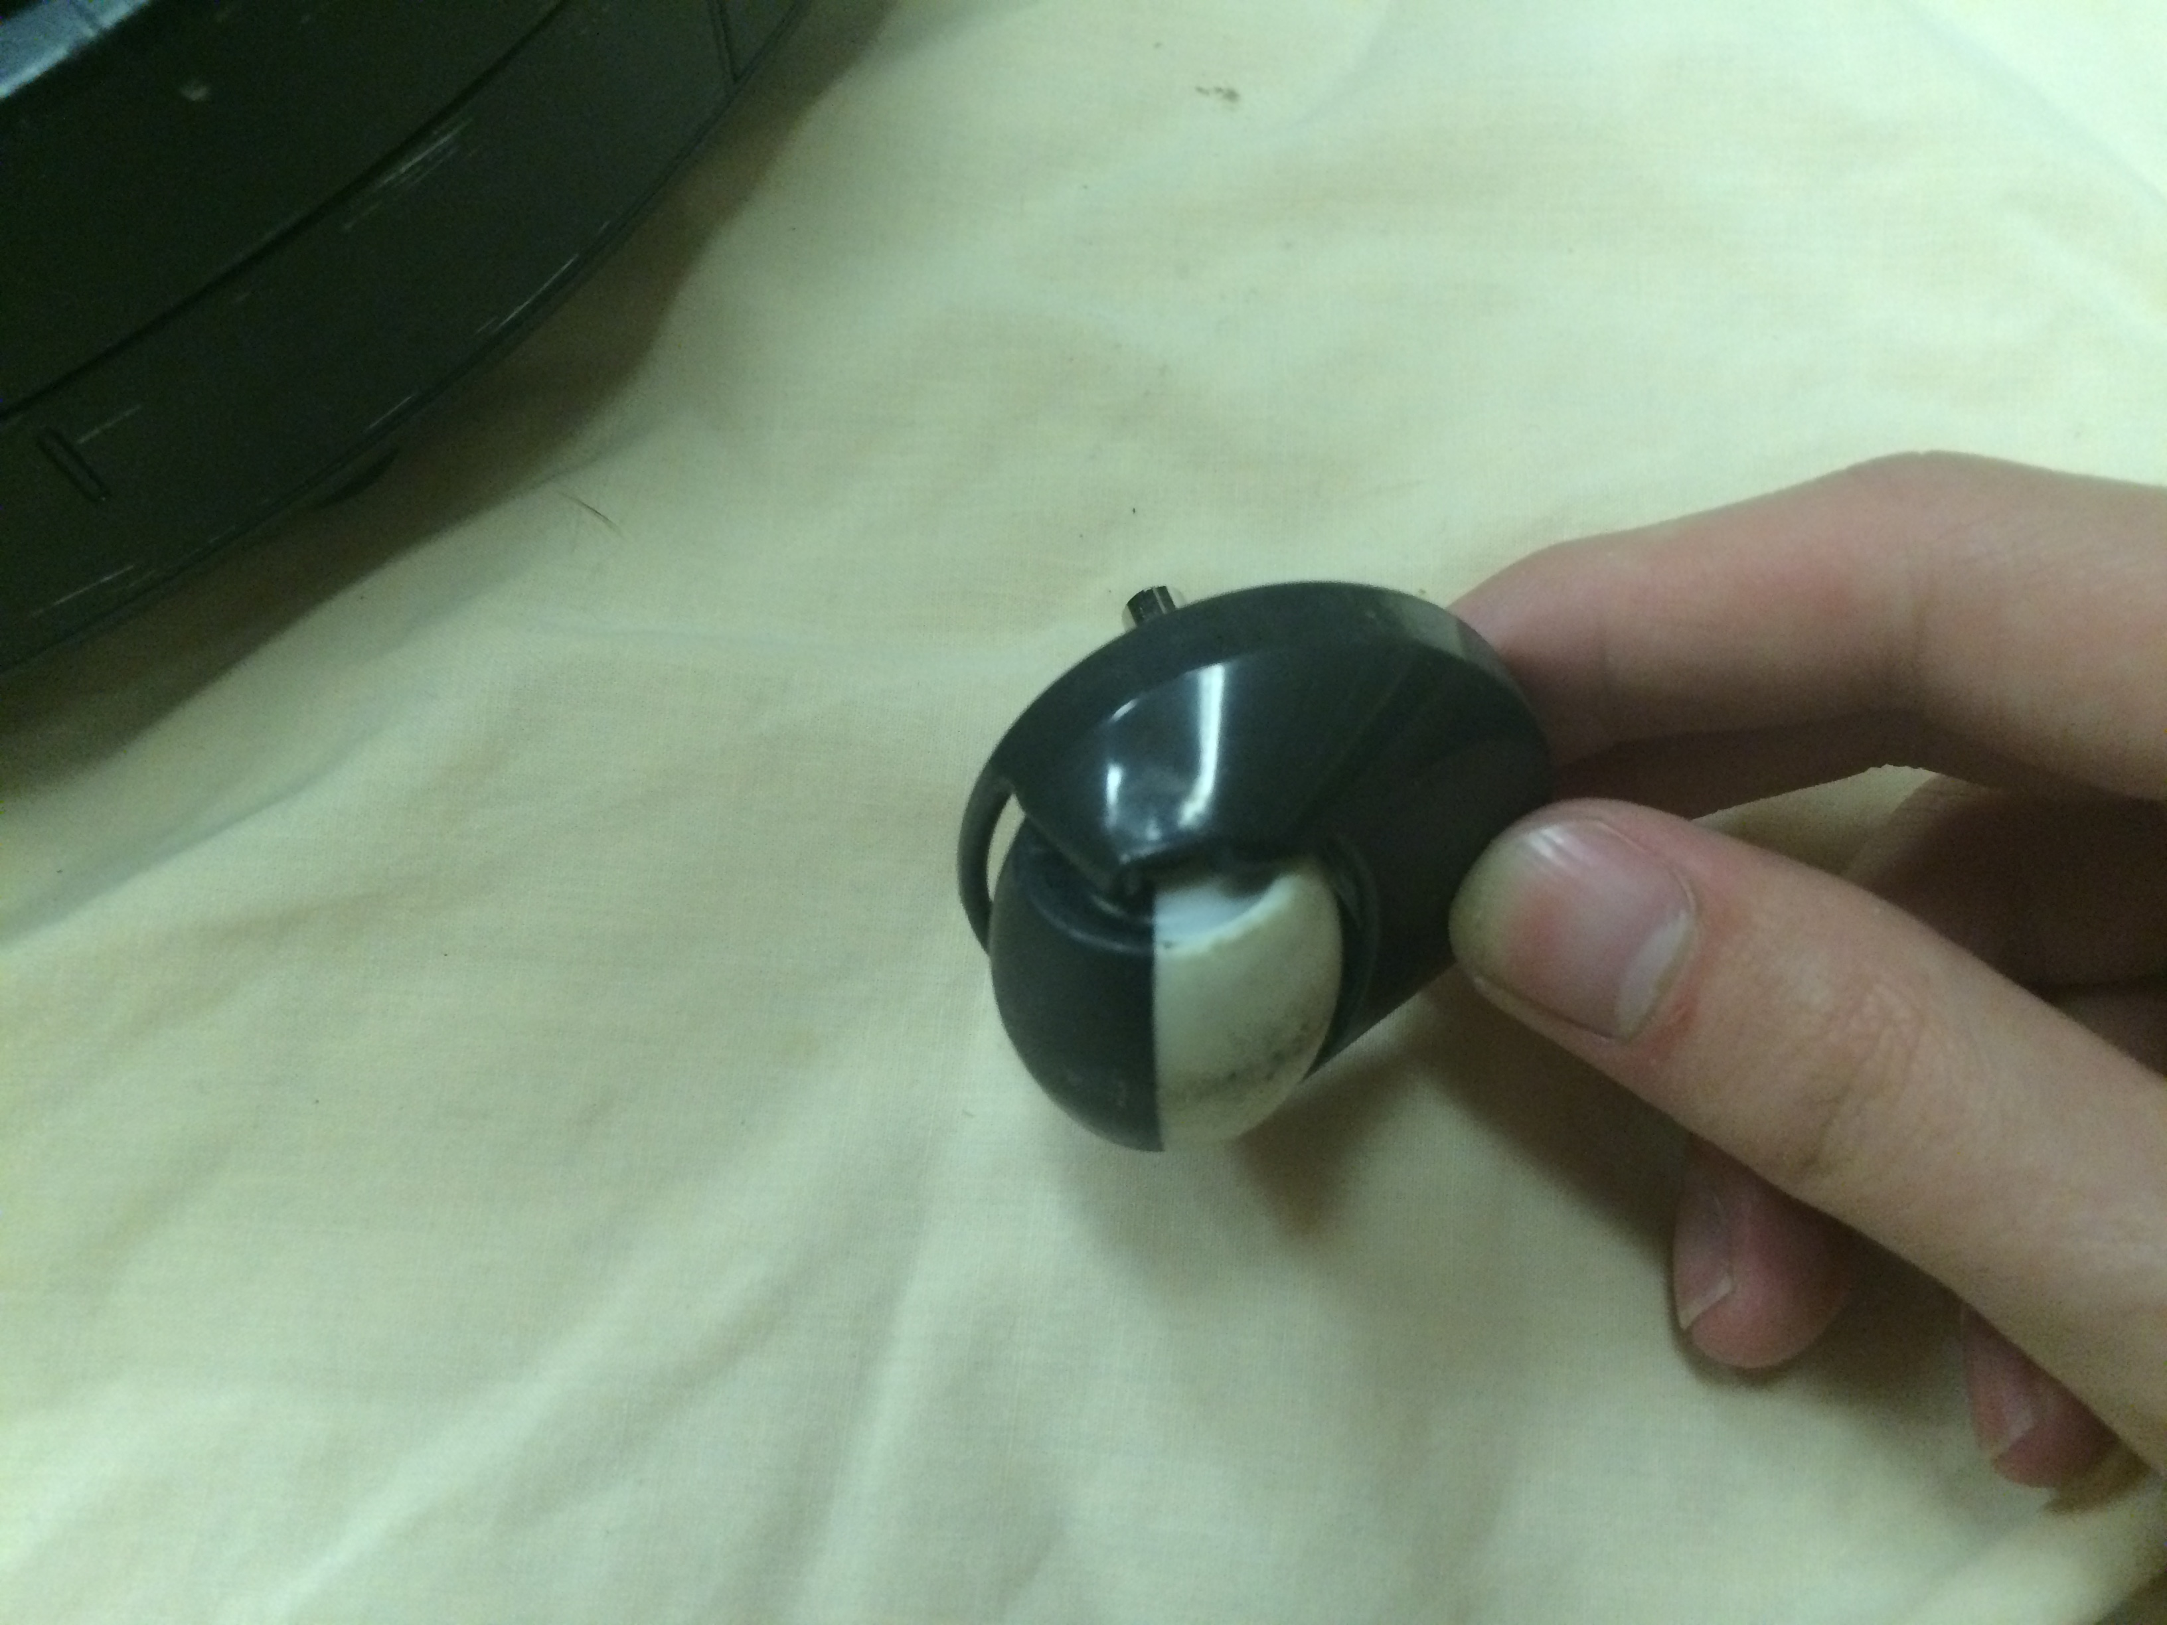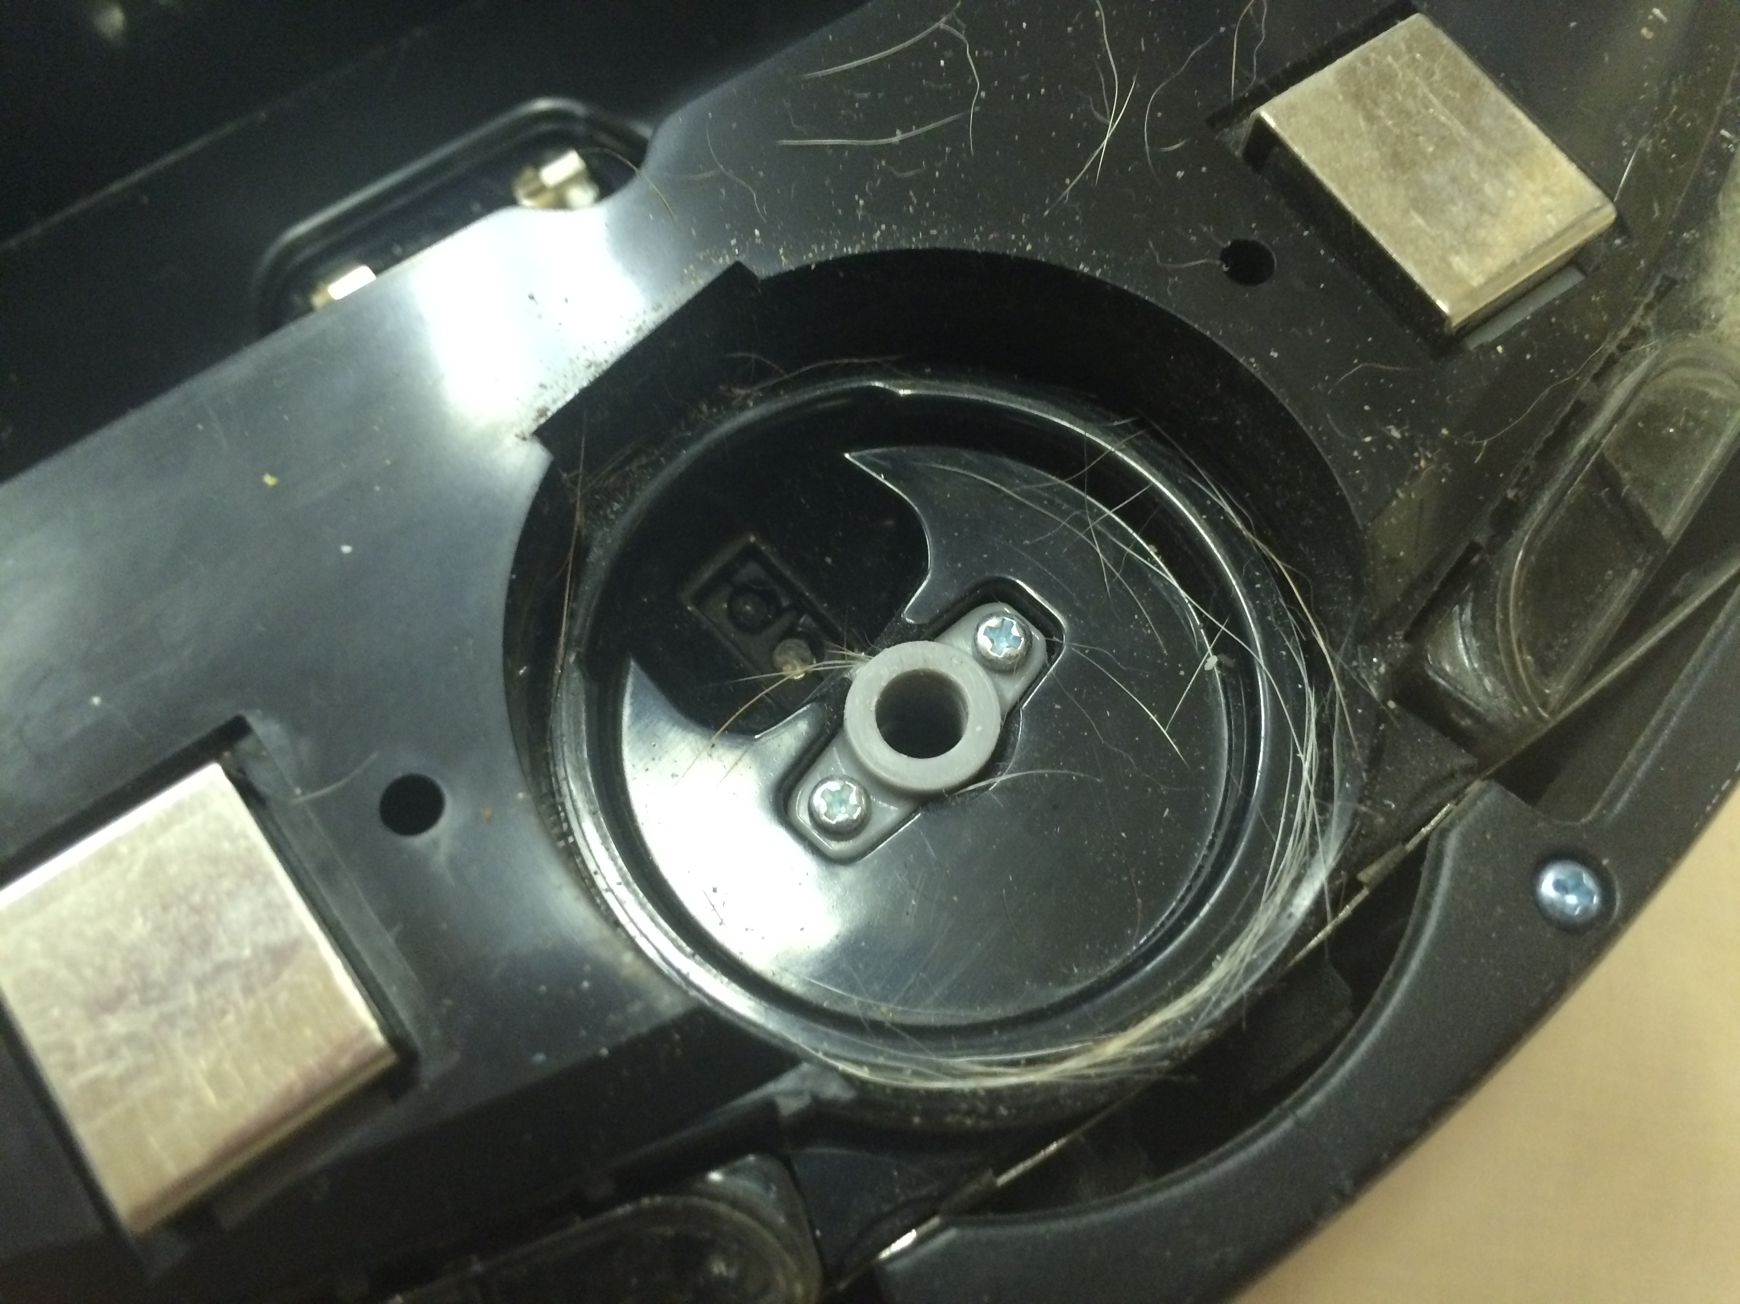
What we find to be the most interesting component of the Roomba was the wheel located at the front. On the right (pardon the dog hair) appears to be an emitter and a receiver that detects whether the wheel (left) is moving. We also presume it is used to determine how quickly and how straight the robot is moving, and the robot would be programmed to adjust. This component of the robot especially hit home with us due to its similarity to the integrated motor encoders used in our own robot.
Overall deconstructing the Roomba was a rather eye-opening experience. To see just how much work goes into each of these machines made us realize how the Vex challenges just don’t compare (Just kidding. Those are still hard). Not only did we find a component similar to ones we use in our own robot, but we discovered the global teamwork it takes to manufacture such a feat of engineering.

Two of the several Ti chips.

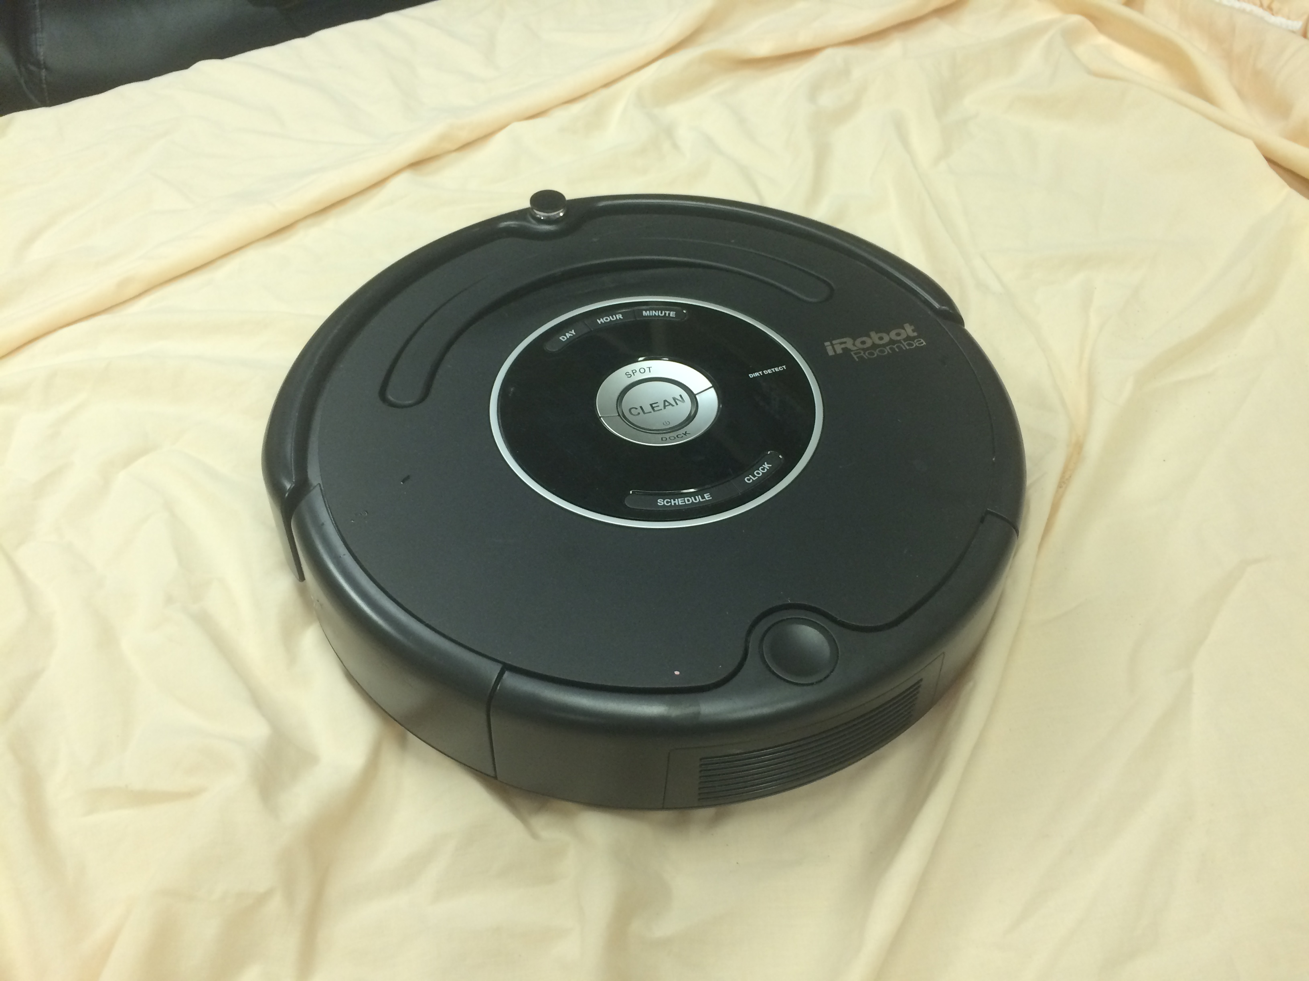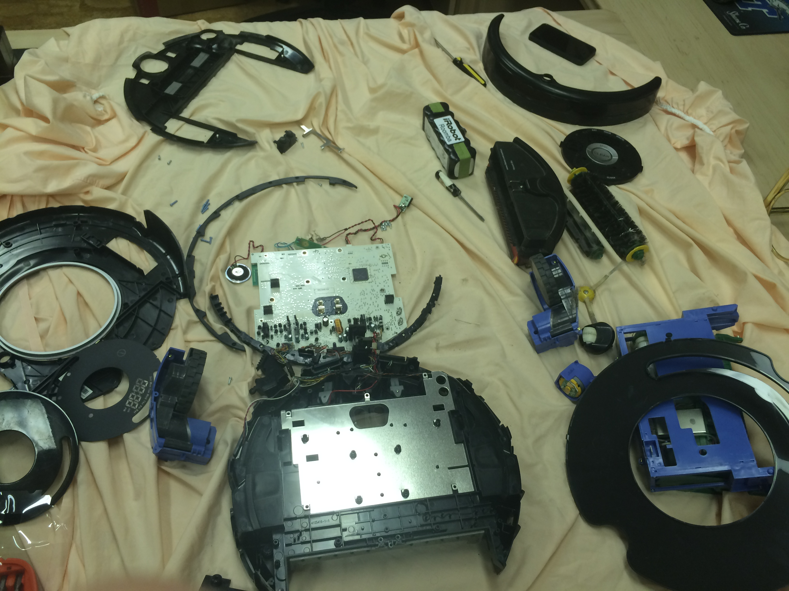
Before and after

One last thing this taught us is to label and categorize screws. We’re still not sure where these are all supposed to go.

