Make it real CAD Challenge Report
By: Matt Downs
Introduction
If you look into all the pieces VEX has created, you’ll notice a simple trend. Not many of them are cylindrical. So, what happens if you want to create something that can rotate on an axle but cannot attach to an axle? You have to create a complicated mechanism, made of multiple parts, and that may not even work as desired. This part solves the situation. I received the inspiration for the idea at our very first VEX competition, when I saw that a team had a mechanism similar to our part that hit balls into their conveyor belt. It looked complicated and makeshift, which is when I realized that there was no easy way to accomplish the task with available VEX pieces; there was no one simple part to do just that.
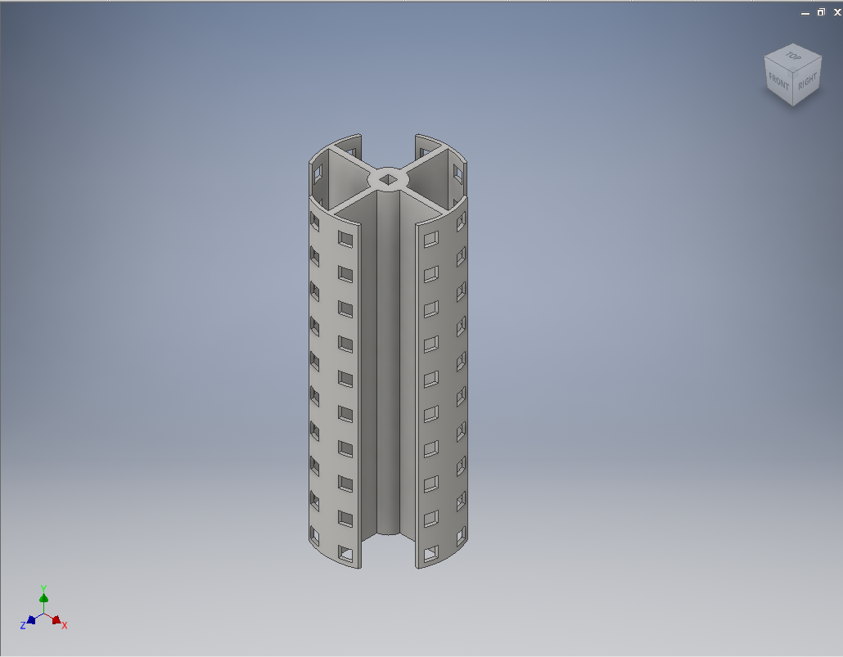
Figure 1: The Completed Model

Purpose
The specific situation that I had in mind for this part was to tilt it horizontally and attach it to a motor. As it spins, one can feed balls into it which are then hit into your conveyor belt or whatever system you use to feed balls into your launcher. However, this piece could be used for multiple scenarios, especially outside of this year’s VEX game. These include pushing things along a tract, or creating something like a revolving door mechanism. This piece offers plenty of uses. Imagine you need a way to simply let things through an area in separate intervals (such as in a marble sorter.) Attach this to a servo motor and it can act as a gate for the marbles, only letting them through when the servo activates.
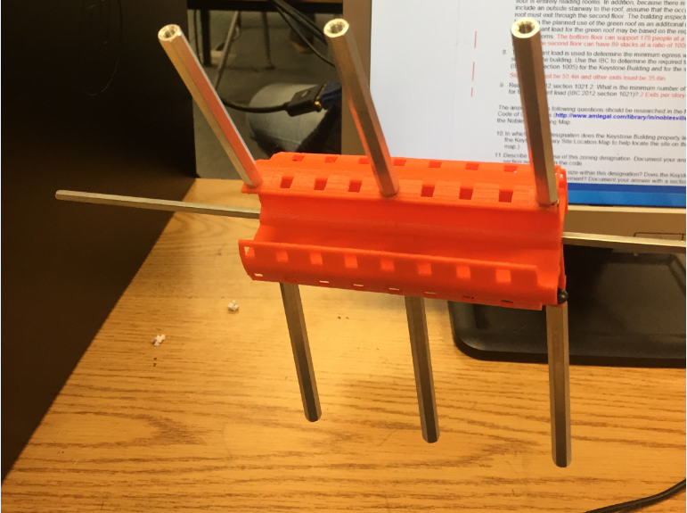
Figure 2: Example of Part.

Creation
To create this part, I used Autodesk Inventor as opposed to Fusion, seeing that I was taught Inventor in school and was more familiar with the program. My original idea was a full cylinder, as opposed to the retracted current model. However, it quickly became apparent after the first print that it was impossible to fit fingers into the middle of the cylinder, which rendered most of the holes inaccessible. To fix this, I got rid of pieces of the outside circle which allow you to access it from more than just the top and bottom of the piece. As for the actual modeling of the part, I first started by creating the inner cylinder which is designed to hold the cross shaped supports attaching the outer sides. I then extruded all of it by 5 inches, which I decided by the limits on our 3D printer. Now it was time for the holes, these were difficult because they had to be standardized along with the rest of the VEX pieces to insure that all screws and axles could fit into them and that they would align with other pieces. I accomplished this by measuring other VEX pieces that were available for download on the VEX website and measuring their holes. However, I did have to account for the tolerance of the printer which was ± 1mm. I then created a hole in the very top center of the inner cylinder and extruded it backwards in order to create the hole for the axle to fit through. To create the holes on the outer side of the part, I created a 2D sketch base off of the inner axle hole that was extruded through the part. I aligned all the squares in the 2D sketch and then extruded them in both directions. This cut holes into the outer side of the part but also into the inner side which I then had to fix by separately extruding them back to what they were.
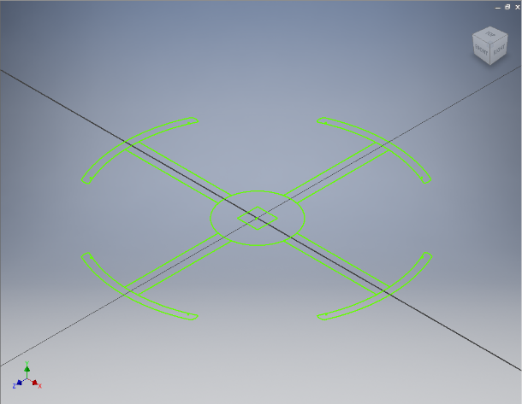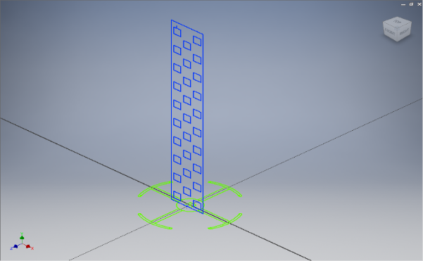
Step 1: Create the base sketch Step 2: Create sketch for the holes
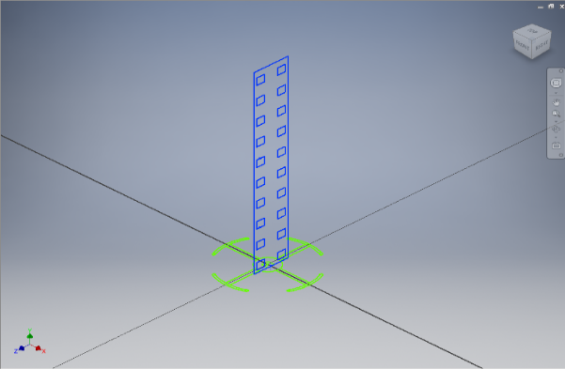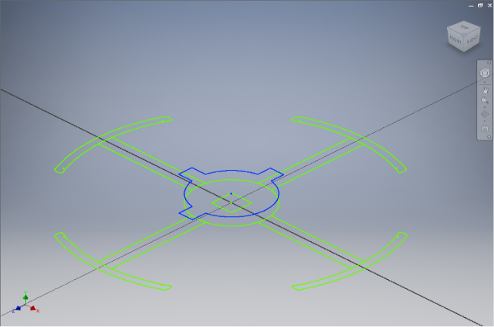
Step 3: Create sketch for other holes Step 4: Fix the areas cut out by the holes

Conclusion
I learned quite a lot from this project as I used to dislike inventor when I was initially taught it in my 8th grade year because I was told what to make and given step by step instructions on how to make it. But actually creating a part from scratch in order to solve a practical problem that I experienced and watching it come to life with a 3d printer was amazing. Actually seeing all your hard work and many broken models finally work was something I hadn’t experienced prior to this project. This could potentially help us because we could create parts for our robot that would help it and give us an advantage over other teams. Honestly I am now considering a job in the modeling field because of how much fun it was to solve a problem and watch how what you created actually fixed that problem, after all that is all engineering is, fixing problems.

