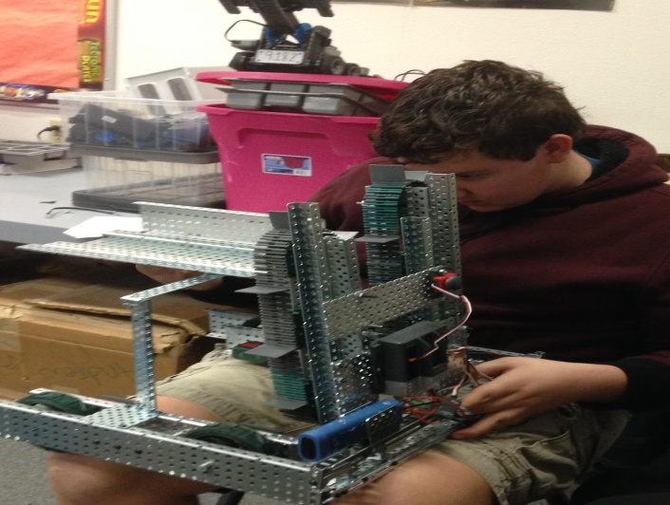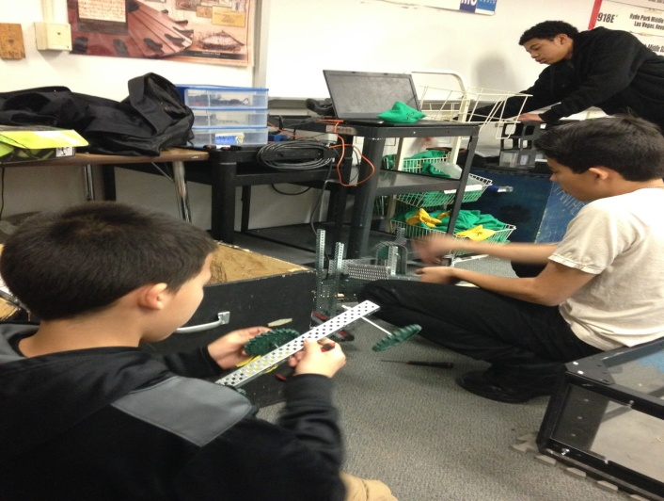

Tristan Working on the robot, to attach| Elijah working on the loader, and
the launcher more stability. | Gabriel attacking the first half ______________________________ | the loader._________________

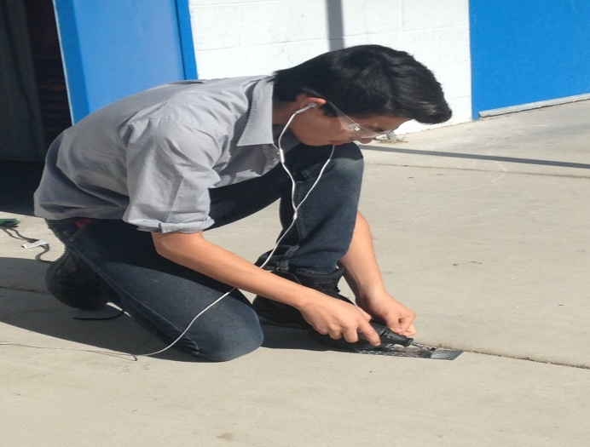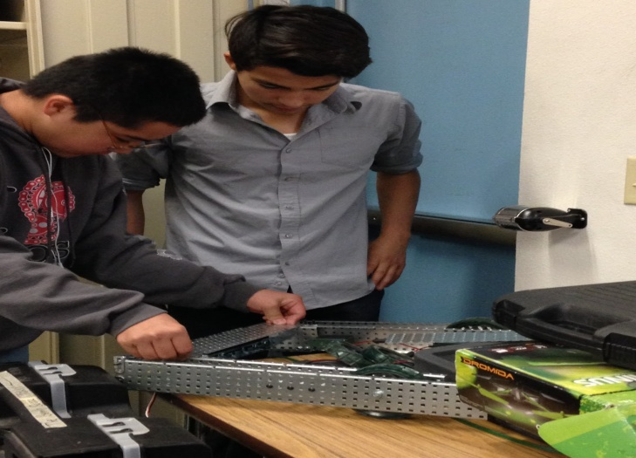
Gabriel cutting a piece of metal down| Gabriel and Kody working on the
with a buzz saw. | base of the robot to then start adding _____________________________| the loader and launcher.__________

