I chose this computer tower for the challenge because I am interested in knowing what make this computer work and to see if there are any Texas Instrument components inside of it.

In the computer, I found the power supply and I found the motherboard. I also found the processing chip and the video chip. I found the hard disk and the optical drive. Then I also found the memory cards. 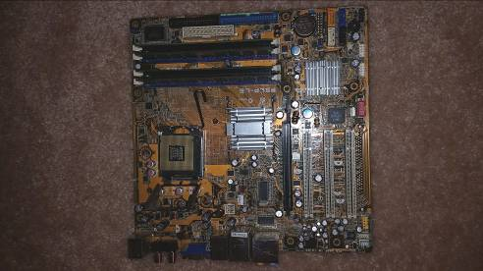
Motherboard
Video chip
Processing
chip

The power supply controls how much power gets inputted into the computer.
The motherboard has all the main components on it.
The processing chip processes all the software instructions.
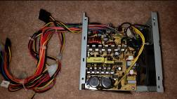
Power supply
The video chip generates output images to display. The optical disk allows disks from movies or games to be read and sent to the video chip.
The hard drive you can store files and install software.
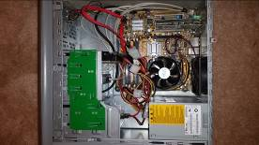
Optical
disk
The memory cards store almost all the memory for running programs and can be assessed 1000 times faster than the hard drive.

I found it very surprising that it takes that many pieces for the computer to work properly. I found no TI components inside of it. When I looked at the computer with an engineer’s eye I found the computer very interesting. An engineer’s eye means looking at a big problem that’s very complex and breaking it into to smaller less complex problems. So when I looked at this huge complex computer, my engineer eye let me break it down into smaller components to let me understand it better.

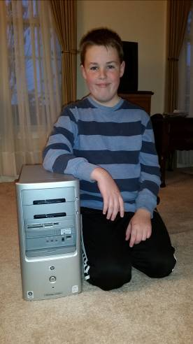
This is me with the computer tower

