Team 183
Team 183 had a treasure hunt in an electrician’s discard pile. What is the function of this blue box? The electrician said it is an inverter or a VFD. Our team dismantled the box (refer to photo for labeling of parts) and continued the treasure hunt. What is a VFD?
A VFD is a Variable Frequency Drive which is an electronic device used to control the speed of an electric motor. Electricity comes into the terminal block and enters the semiconductor. This SMVector’s semiconductor wasn’t built by Texas Instrument but by “AC Tech assembled in USA.” The semiconductor is where the AC is converted to DC voltage. The circuits smooth and hold the DC voltage at a constant level for the inverter which uses the DC voltage to pulse the motor with varying levels of voltage. The microprocessor controls the various levels of voltage that are needed. The microprocessor is programmable (see EPM on photo) to change the motor speed and rotational direction of the motor. For example, when a motor is driving a conveyor belt that needs to go either faster/slower or forward/reverse.
We learned how this electronic device controls the rotational speed of an electric motor and how it controls the frequency of electricity supplied. The inverter changes the electrical source to run a motor at many different speeds instead of having the electrical source go directly to the motor and have it run at full speed all the time.
We also learned that VFD’s can save energy. The VFD’s technology could save 20% of the energy used in the millions of motors in the United States. In conclusion, if all the industries in the world would use these VFDs, there could be a global energy savings.

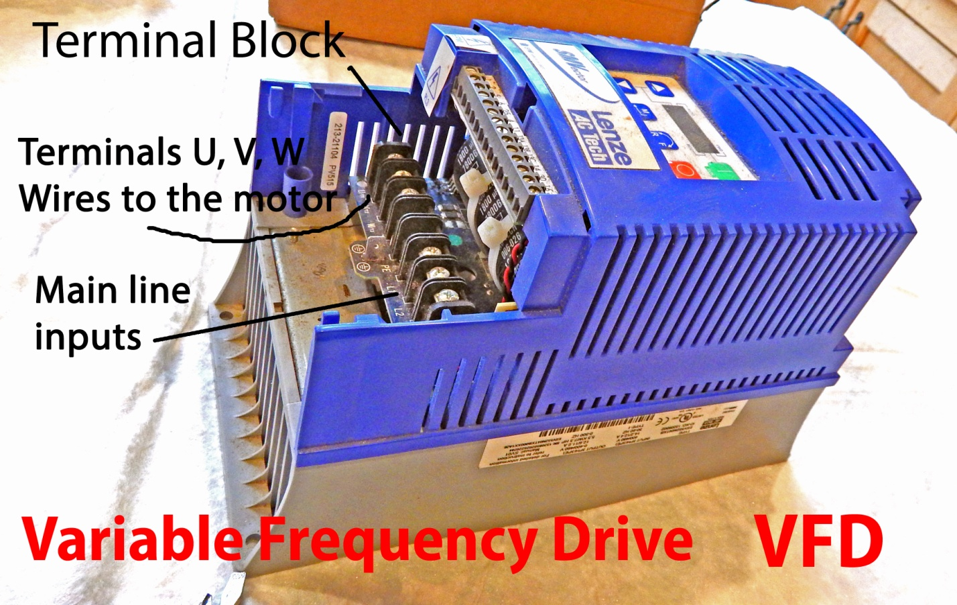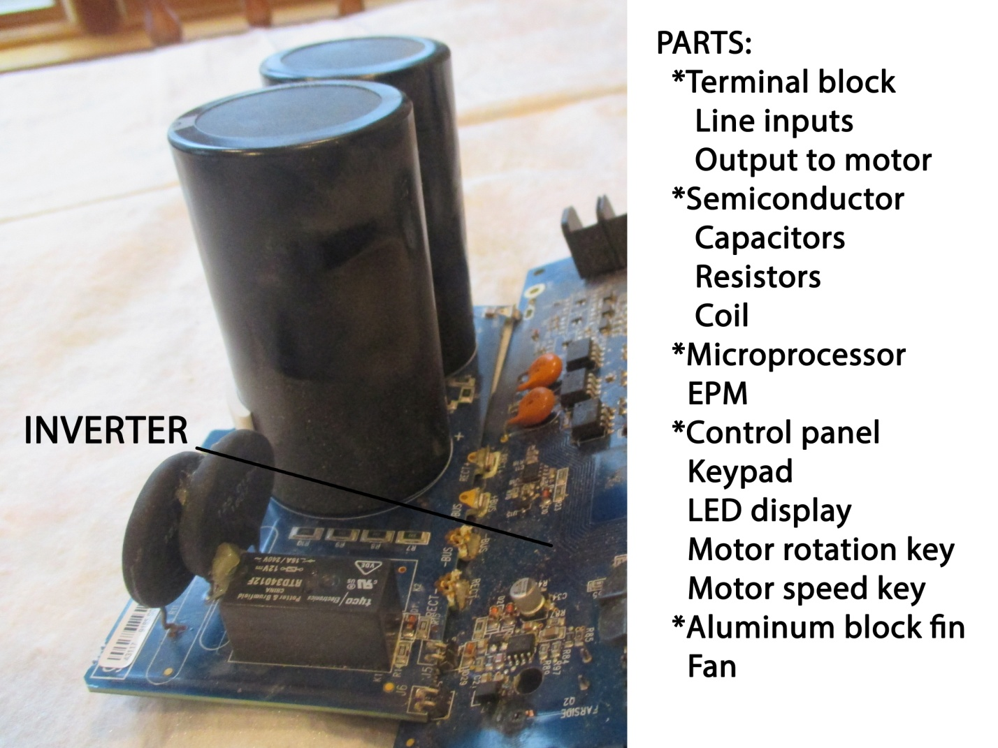
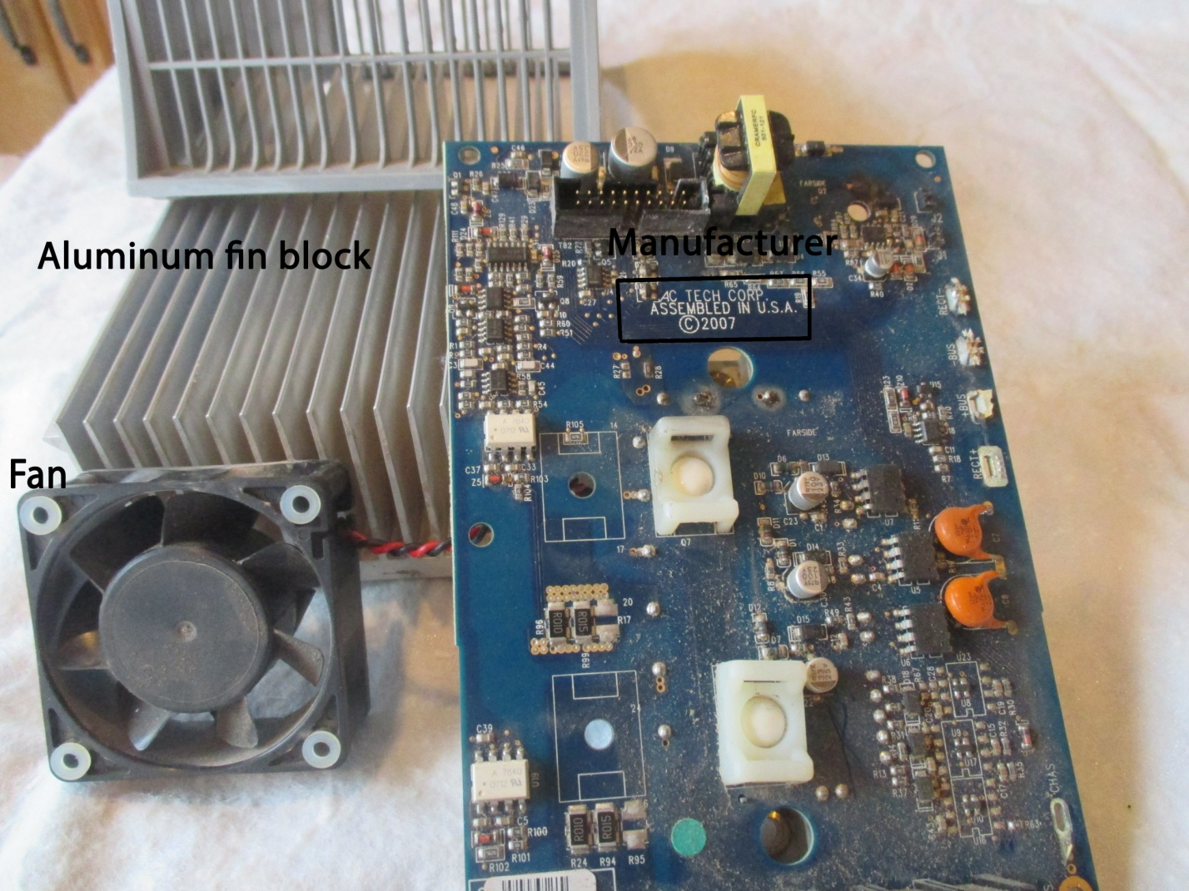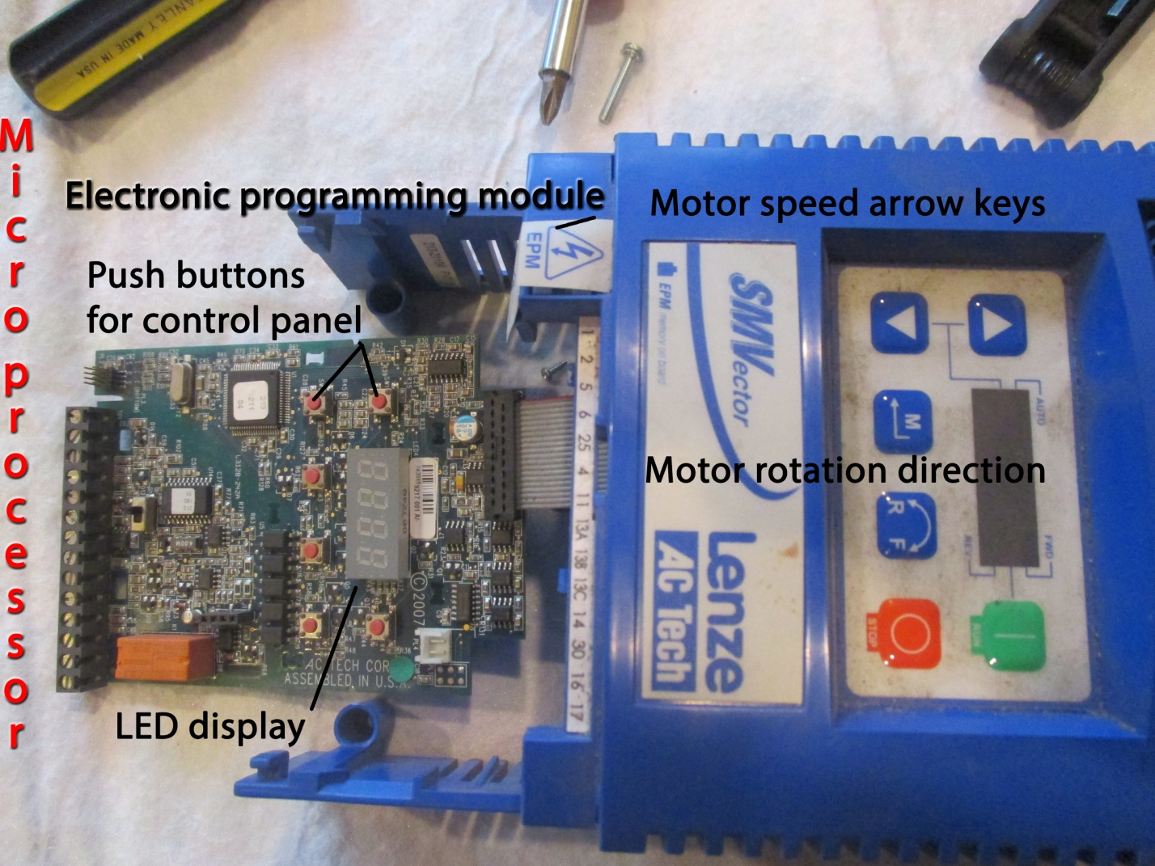
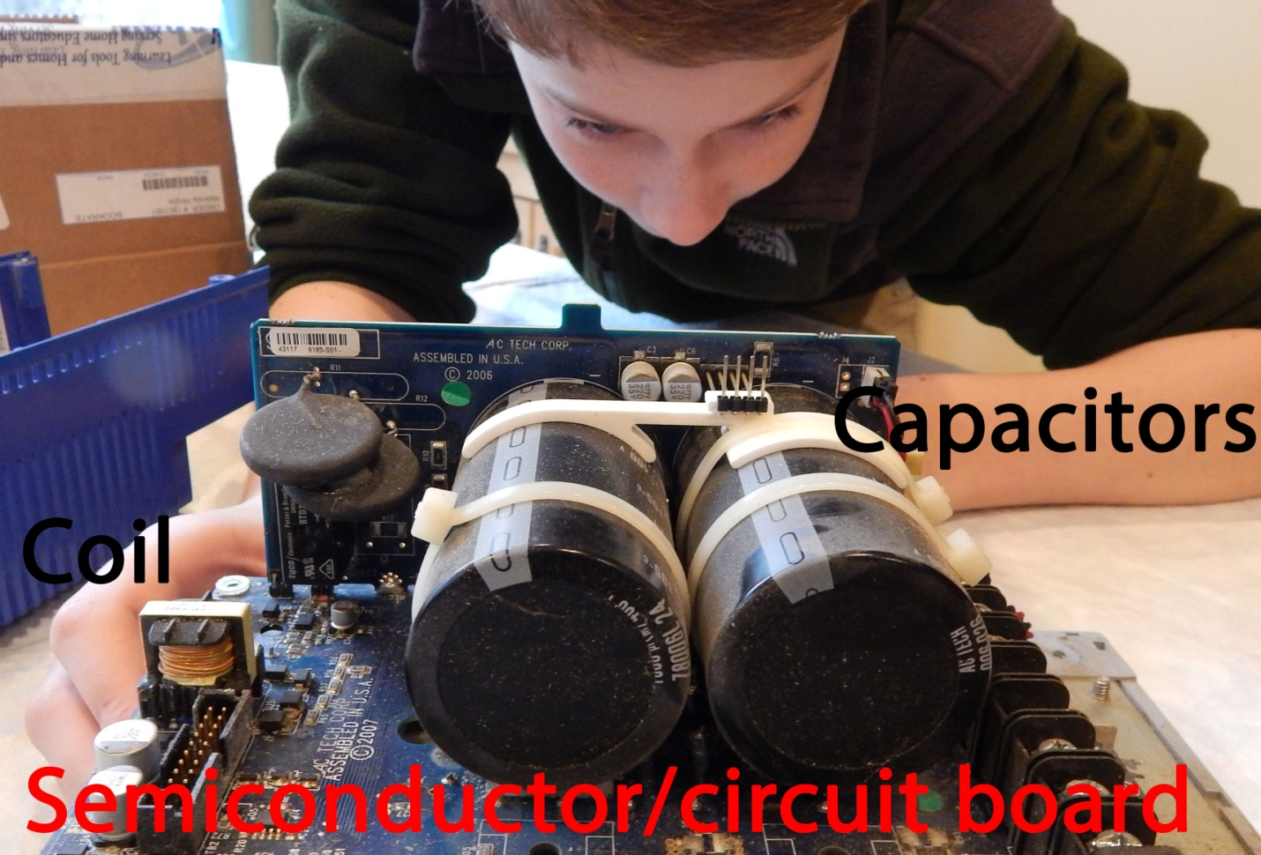

Sources:
www.actechdrives.com
www.lenze.com
www.vltdrives.danfoss.us
www.wikipedia.com

TEAM 183

