The device we selected to take apart to attempt to find TI components was a control board manufactured by the Amateur radio relay league attached to a boe-bot made by the company Parallax, a boe-bot is a self running robot. We selected this as it was a convenient find in the Olde Towne robotics lab and it would be an interesting subject to research. Inside the boe-bot we found two circuit boards that interacted with each other by transmitting information back and forth between our TI component, the TI SN74LS08. The SN74LSO8 is described as quadruple 2-input positive-AND gates. The function of AND gates is to provide an output based on the input, if the input is not positive, neither is the output. For example, if the robot is traveling forward and there is not a wall, the output is negative which means the robot can move forward, likewise if there is a wall the output is positive, which means the robot needs to stop. This makes the chip’s function on the control board managing and gathering information, storing it and sending it to the macro-controllers of the boe-bot. This assists the bot in knowing what its surroundings are and how it needs to respond. This type of chip is something that covers something that is essential to this type of robot, since the robot runs autonomously it has no human control over it, as such it would need to gauge it’s surroundings as to avoid a crash of such. Overall this research has allowed me to discover the boe-bot and work on hand with Texas Instrument hardware. It has also let me observe different ways of robots autonomously observing their surroundings by using TI chips rather than ultrasonic, sound, or other types of sensors.

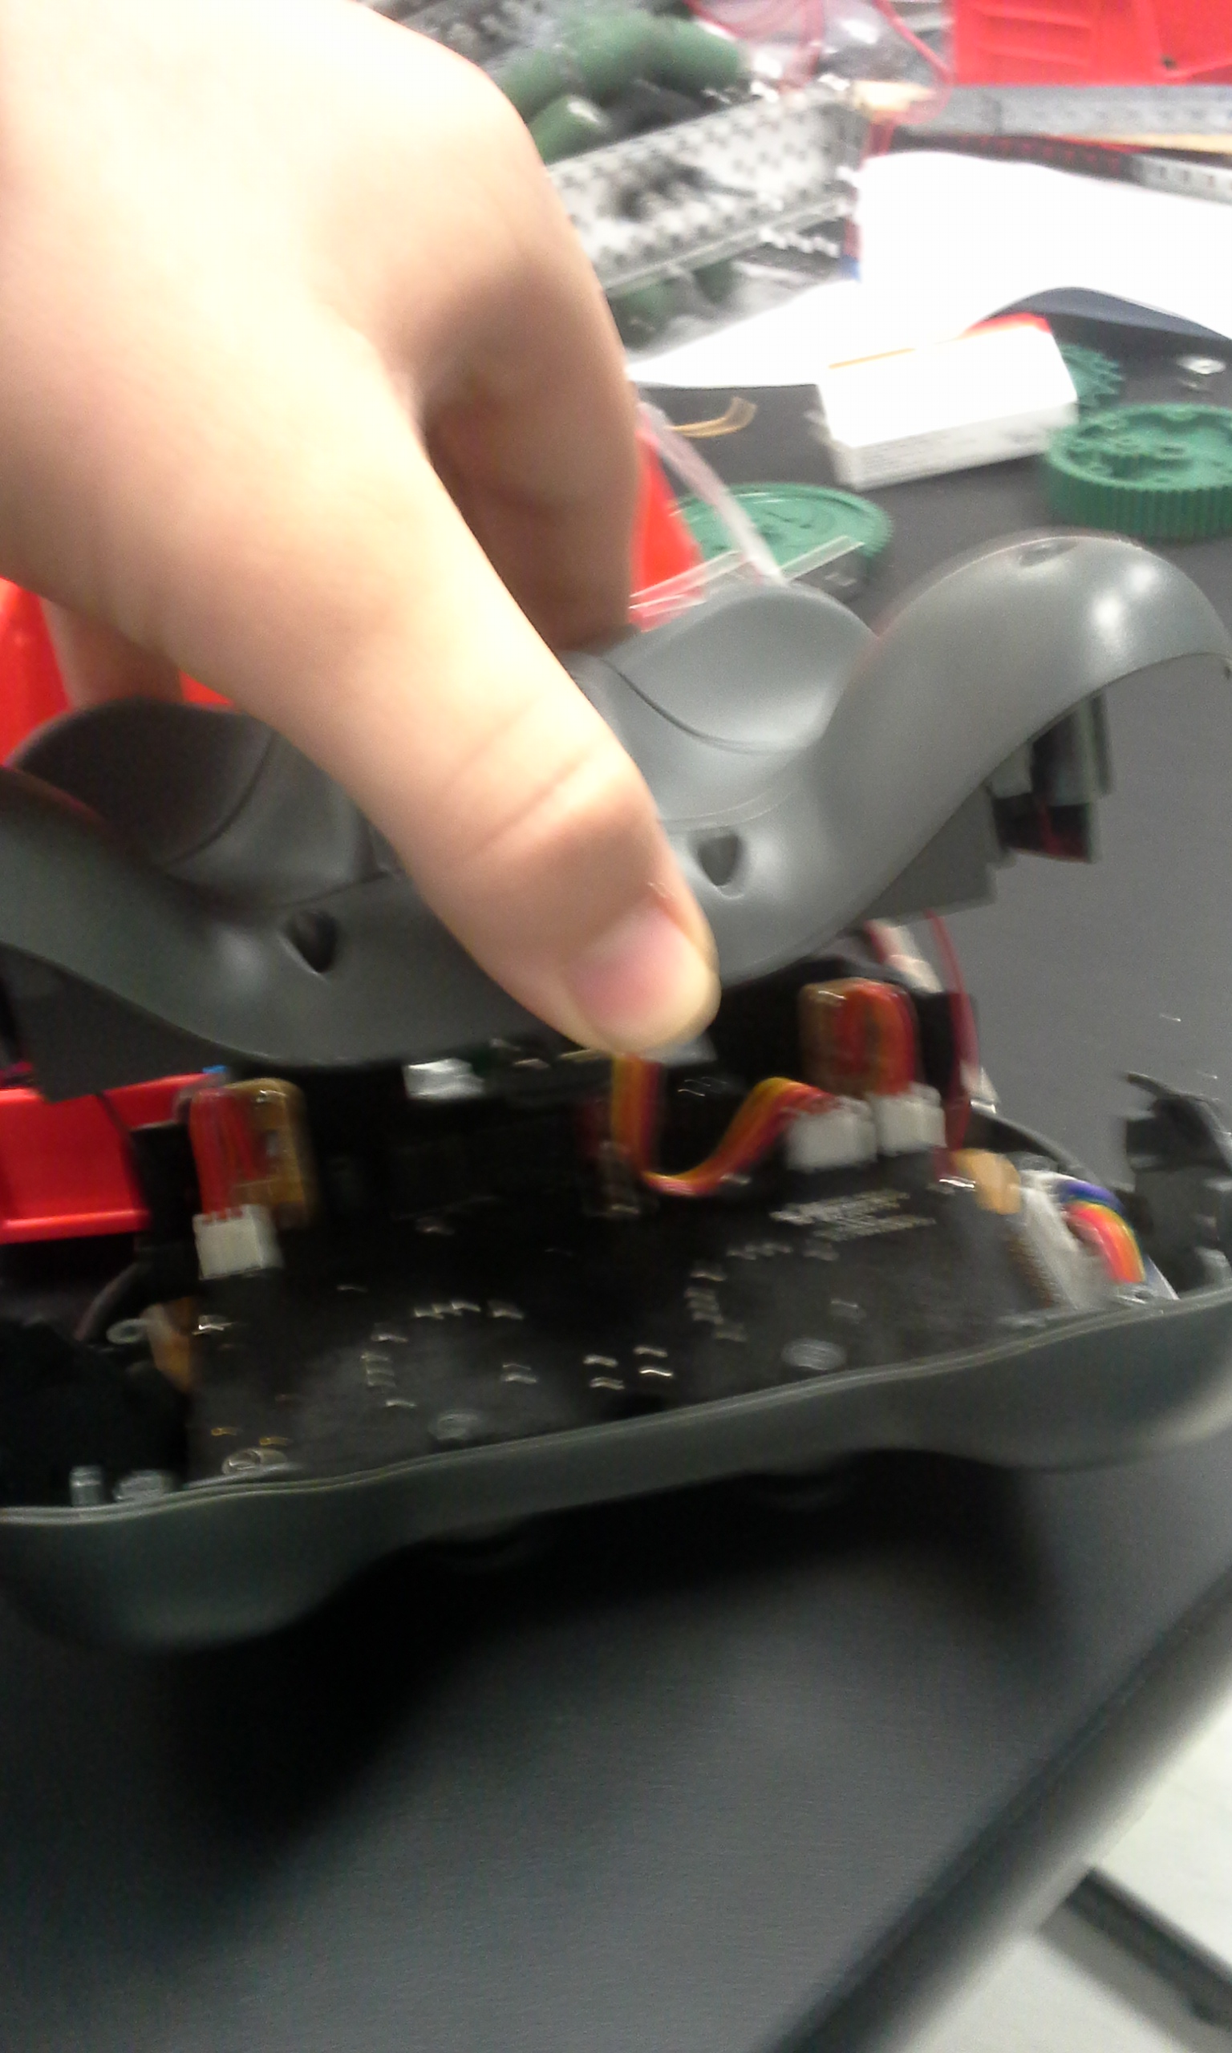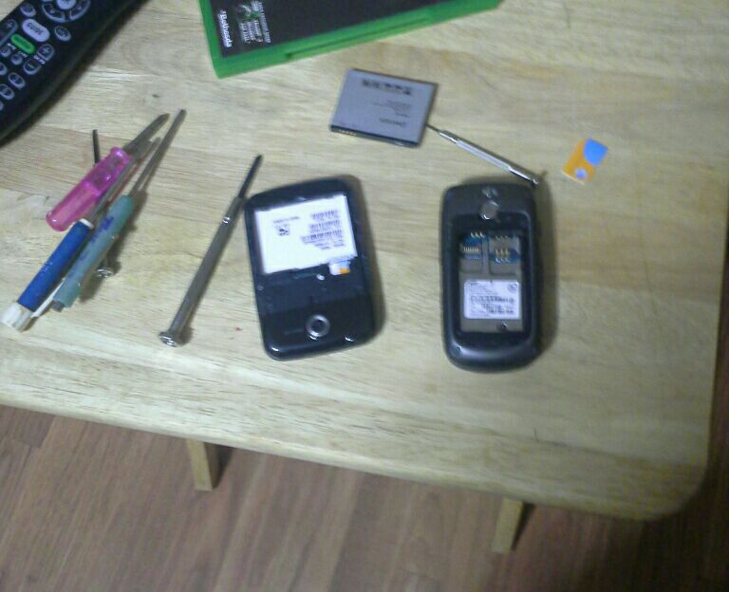

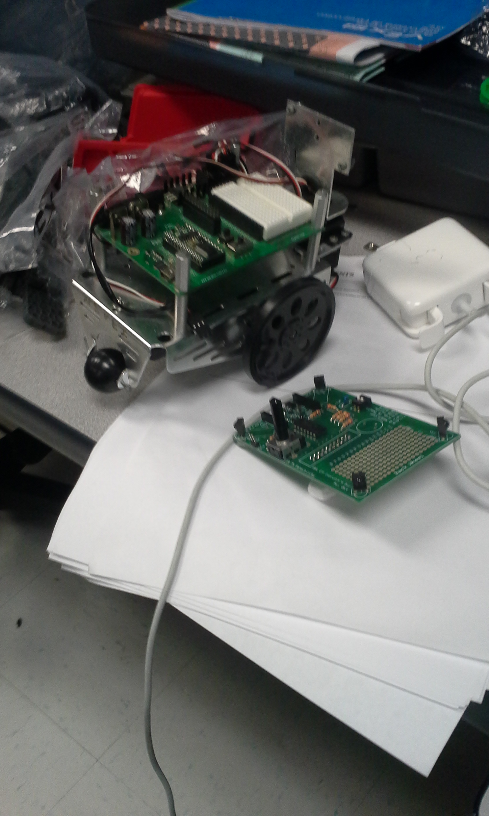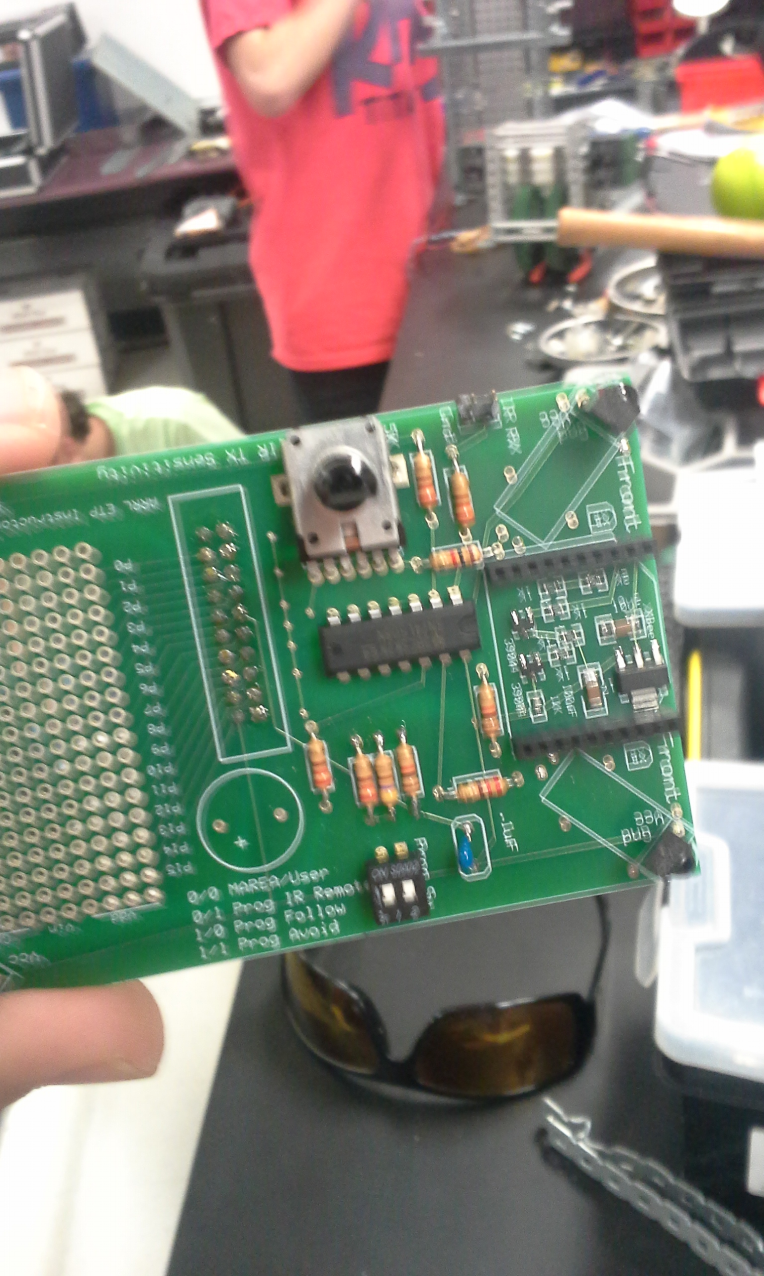

The board that contained the TI SN74LSO8.

The first attempt at finding a chip by disassembling two old Samsung phones.

The Boe-bot along with the board the TI chip was attached to.

The attempt at taking apart a Vex Robotics controller.