I chose an IBM Thinkpad T41 computer which runs Windows XP. It was manufactured in 2000. This electronic device was chosen because computer have many parts from many producers. It also was sitting around gaining dust. This challenge was a good way to put it out of business.

Parts I Found:

* Processor: Intel Pentium M
* Graphics: ATI Mobility Radeon 7500
* Battery: Lithium Ion
* Memory: 64-bit DDR SDRAM
* RAM: 512mb
* Speakers: SoundMAX Dual

No TI components were found in the computer.

The processor is necessary for all computers since it interprets all coding from other hardware. It is sometimes called the brain of the computer. Every computer screen is made of pixels. The graphics card controls the all of the pixels. The battery gives power to the entire device. Memory stores electronic data to an extent. RAM is temporary memory that is used to speed up the CPU finding data. The speakers allow external sound to be produced.

I learned that electronics are complex machines. They are very delicate when moving internal properties. Almost all components have been researched and redesigned.

Before

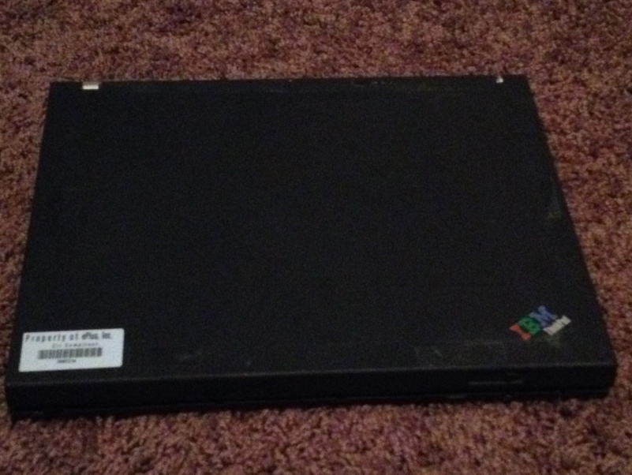

After

