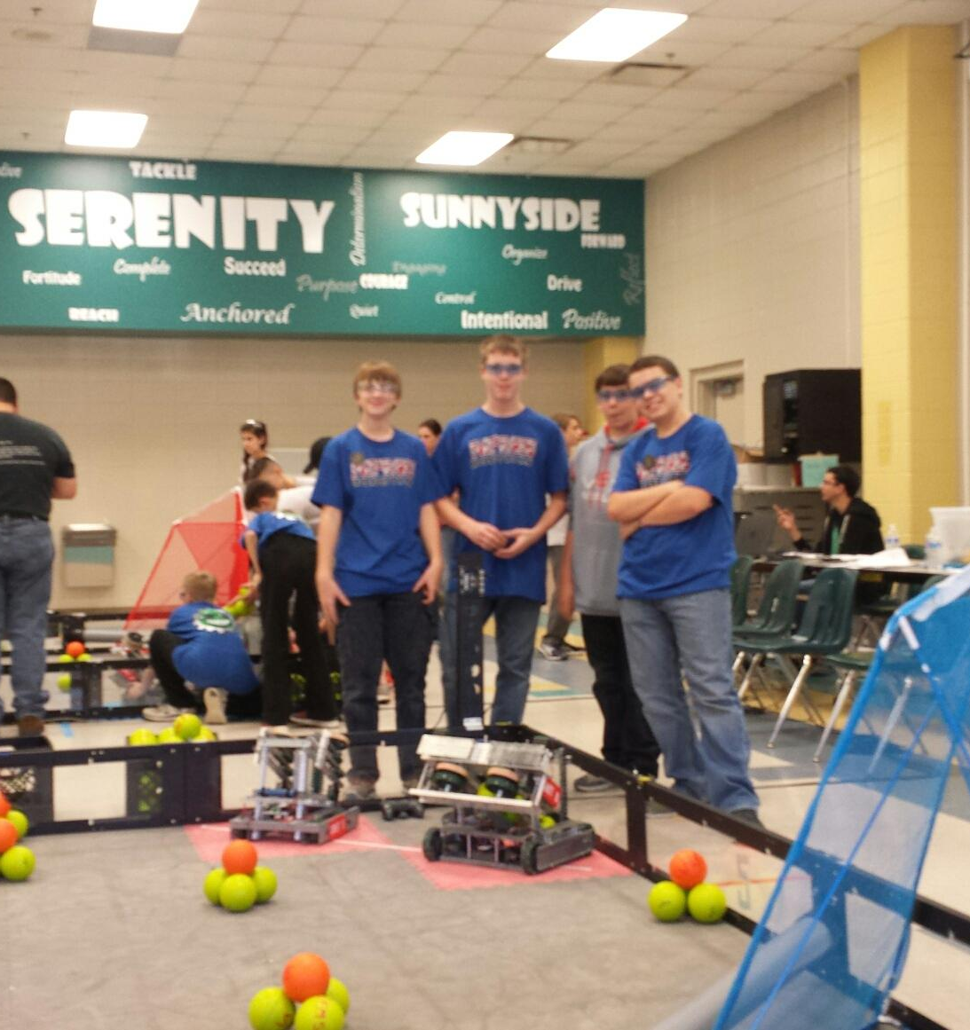

This picture was taken on November 14. We were at Vickery Creek Middle for a competition. Our team got to the Quarterfinals and were able to get this photo in before the match.

