The Screw Bearing
The Problem: Long axles have no way to be supported easily and without clutter, and angled trusses are difficult to make without destroying parts needed elsewhere on the robot.
The screw bearing was created to solve a few problems in VEX Robotics: how to support a long axle easily, and how to make angled trusses using standoffs. Our solution is the Screw Bearing. It screws into a standoff or a standard 8-32 UNC nut to place a single hole for use in bracing an axle or bracing an object unable to be reached by normal metal.
There were two initial designs we had in mind: a stationary bearing, similar to the already existing bearing flats, and a moving bearing similar to a bushing which acts as both a high strength axle bushing and a bushing to support normal axles using the metal or round gear inserts.
Metal Screw Bearing with inserts 1: This bearing has the gear inserts installed to support a normal Vex axle better than a standard bearing.
Metal Screw Bearing 1: This bearing has a moving center which supports the size of a high strength VEX axle.
Plastic Screw Bearing: The stationary Screw Bearing designed to be made of a plastic material.

This part is designed to be screwed into normal standoffs, keps nuts, and locknuts to support axles and screws in a wide variety of situations. This bearing also can better be used to support long axles which have very little room for bracing, such as those on lifts or specific types of Nothing But Net launchers.
Creating the Part:
We used Autodesk Inventor Professional to create the Screw Bearing with ease. By taking measurements from the bearings and screws from the official Autodesk library of VEX parts, the Screw Bearing could be custom made to work with VEX parts and robots. By creating sketches initially to get the shape and later projecting the geometry of the bearing to create the screw portion, the perfect part was created for the job of odd braces on robots. The parts were then placed in drawing files to create Multiview drawings and explosions of the parts to better get an idea of the overall shape of the Screw Bearing.

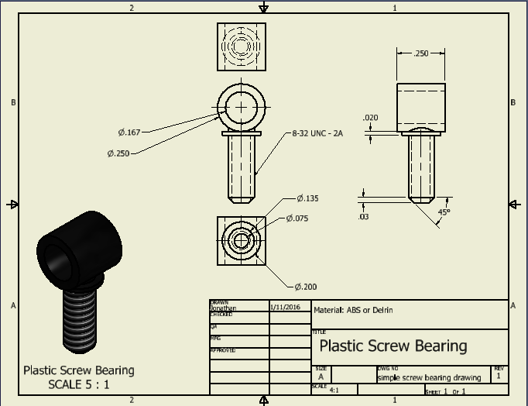

Conclusion:
From this project we learned how joining a design team to create a part for a specific solution actually feels and works. We also learned how some simpler parts end up being more useful than many complicated parts which could be prone to failure. We will continue to use Autodesk Inventor for as long as we need three-dimensional CAD software we trust because we learned how to use it effectively in our Project Lead the Way Introduction to Engineering and Design class. We will use it to plan how a robot will be made, or to design machine parts and assemblies if we become Mechanical engineers in the future. Inventor helps with competitive robotics because the robot can be planned out ahead of time to get a general idea of how the robot will look, and the comprehensive analysis tools can analyze how applying stress to certain portions can affect the robot’s performance. Using three-dimensional design software will help us become mechanical or structural engineers as we will know how to use industry standard software many firms use throughout the design and production process. It ultimately results in better engineers because those who use the software can better design and analyze how a part would fit into an actual design.

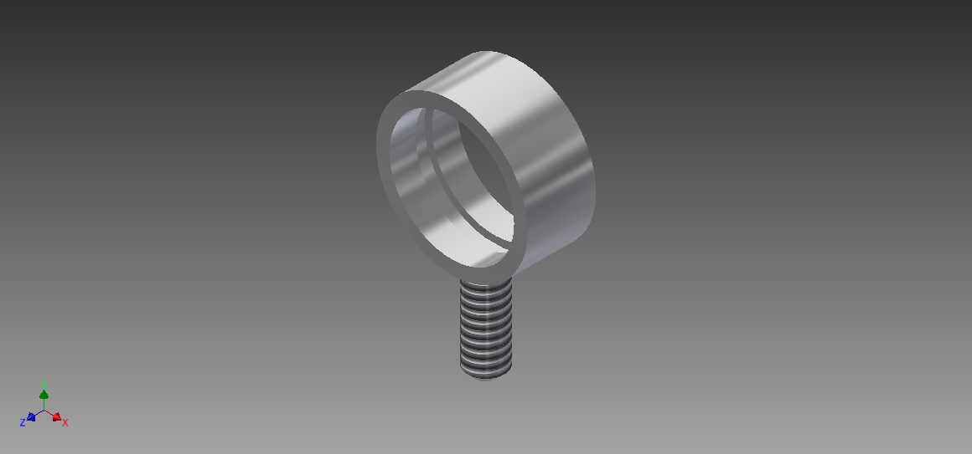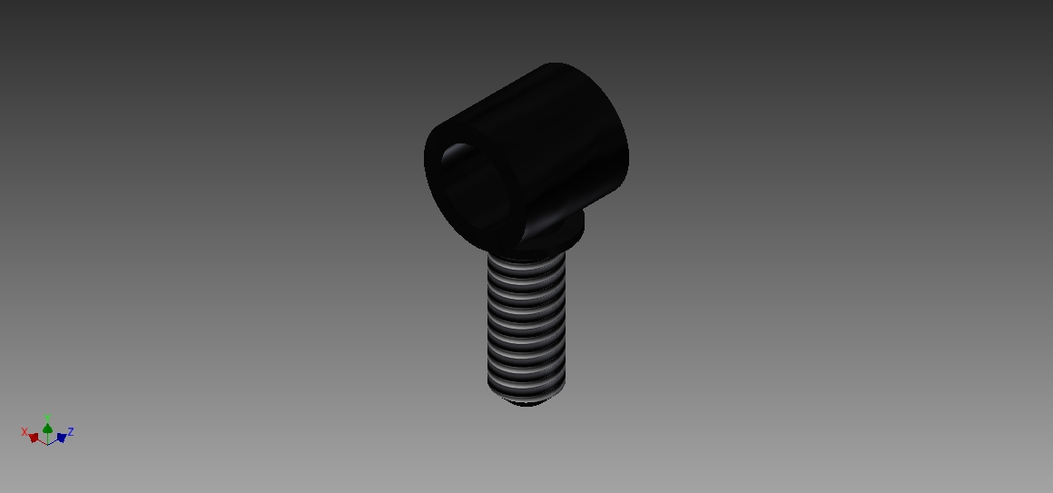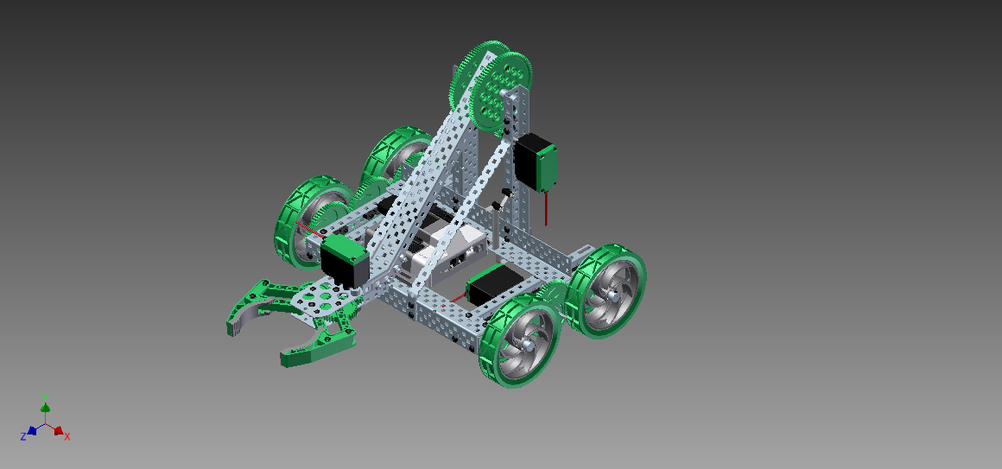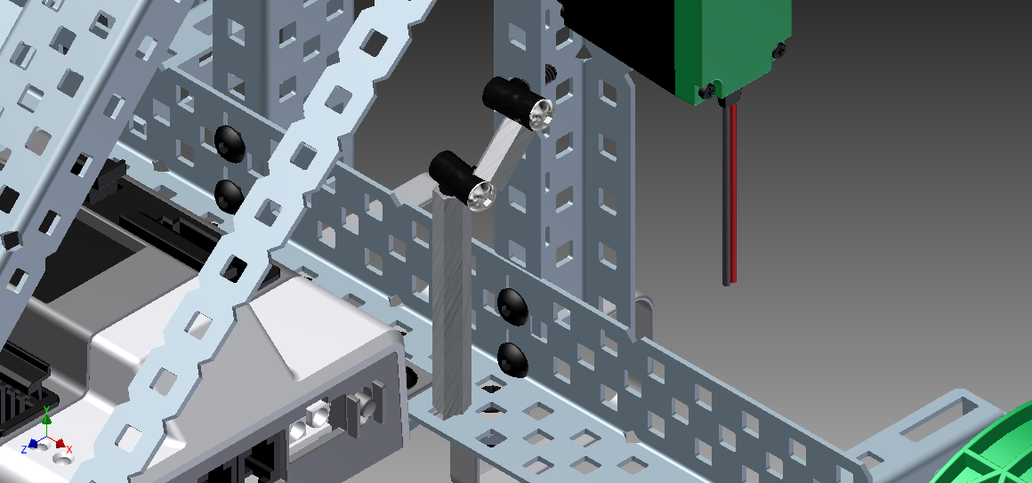
Figure 1: How to make a brace using the Screw Bearing in the place of an axle collar and two screws.
