New Components Creation for VEX
Introducing the Proposed Structures
Three new components are created. The first one is used for corner stable (Fig 1). The second one is used for axle strengthen(Fig 2). The third one is used for 90 degree support.
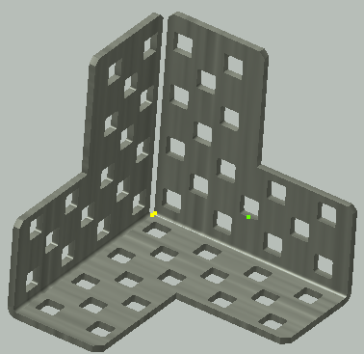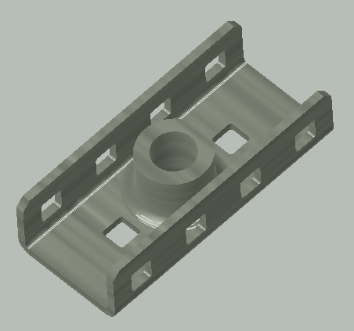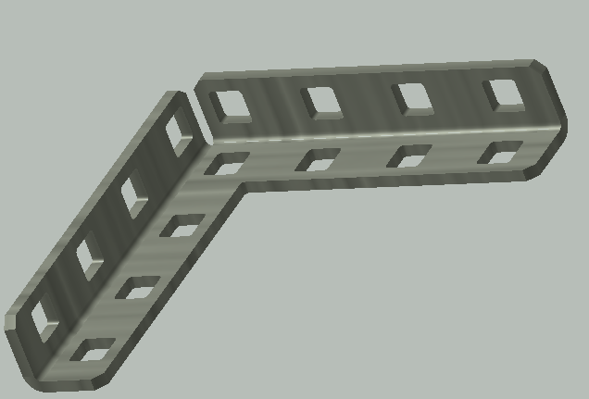
Figure 1 Figure 2 Figure 3
Application Areas of The New Parts for Current Robotics Designs
Part 1 - Corner stabilizer. In previous structures, two overlapping pieces were needed to create stable corners which also resulted in differing thicknesses between holes within and outside of these structures. This new structure is to combat this problem while also creating an easier corner fixing solution.
Part 2 – Axle Strengthener. This structure can be nested within a general C-type structure but also has two C-shaped structural connections. The central through hole can play an excellent role in stabilizing axle’s and other shafts.

Part 3 – 90degree Support. Considering the high volume of 90degree connections used by most individuals in construction, having a thin support for these connections with the ability to also connect vertically if needed is very practical and useful.

Overview of the Production Process
Figure 1 Production Process
- The part can be constructed in 2D, and then molded into the final 3D shape.
- The square holes would be punched out while the whole model is still in a flat 2D shape.
- Figure (a) shows the array of holes that would be punched into the 2D shape.
- A combination of three identical pieces all joined (1 on the left side and one of the top of figure (a)) would then be able to be folded into the final design as shown in figure (b).
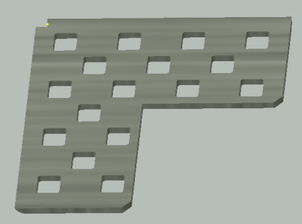
Figure a Figure b
Figure 2 Production Process
- Start with a 2D stretch ready to be transformed into a U-section
- Fold the two sides to create the U-section
- Square cut holes would be predrilled to enable the final design as shown in Figure (c).
- The circular support would then be attached as shown in Figure (d)
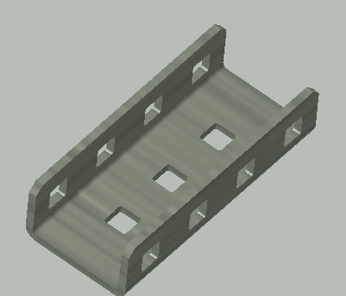
Figure c Figure d

Figure 3 Production Process
- Starting from a 2D object, the final object would be created by folding up the two outside edges.
- The L-shaped surface would be punched with square holes
- The final hole array would be a series of 4X1 holes as shown in Figure (e)
- The two sides would then be connected and folded as shown in Figure (f)
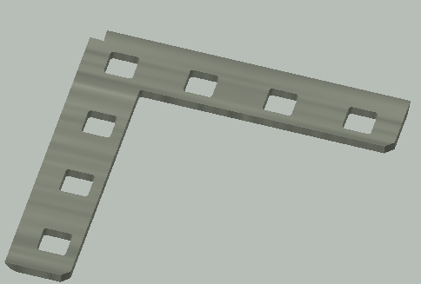
Figure e Figure f
Conclusions
This process of going from concept to design through the use of Inventor has given a greater appreciation and understanding of structure and functionality. Being new to the Inventor software, some parts of the interface felt somewhat unclear and difficult to understand. Searching for further information through the internet and other resources helped to show how the process of starting with a 2D design could then be molded into a 3D entity. The next step was understanding how to create an array of punched holes and gain a greater familiarity and proficiency with the use of Inventor.

Growing familiarity made the process of design increasingly smooth and straightforward. The key to being able to own new ideas through the implementation of this software was very meaningful.

