Disassembling a Hard Drive
The device we chose to disassemble was an old five hundred gigabyte hard drive; we wanted to deconstruct a hard drive to discover what components were used inside the device because we were already familiar with the innards of other electronics such as cellphones and calculators.
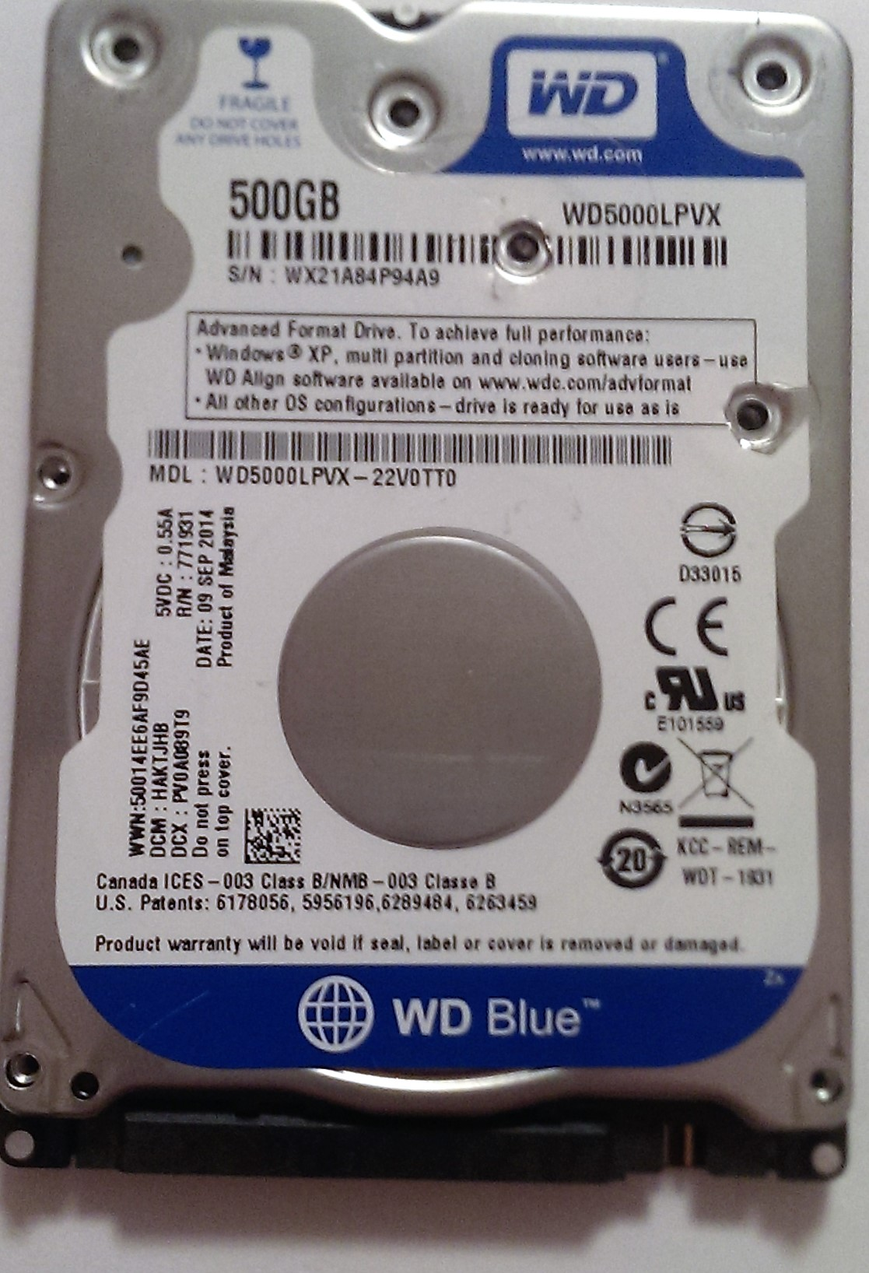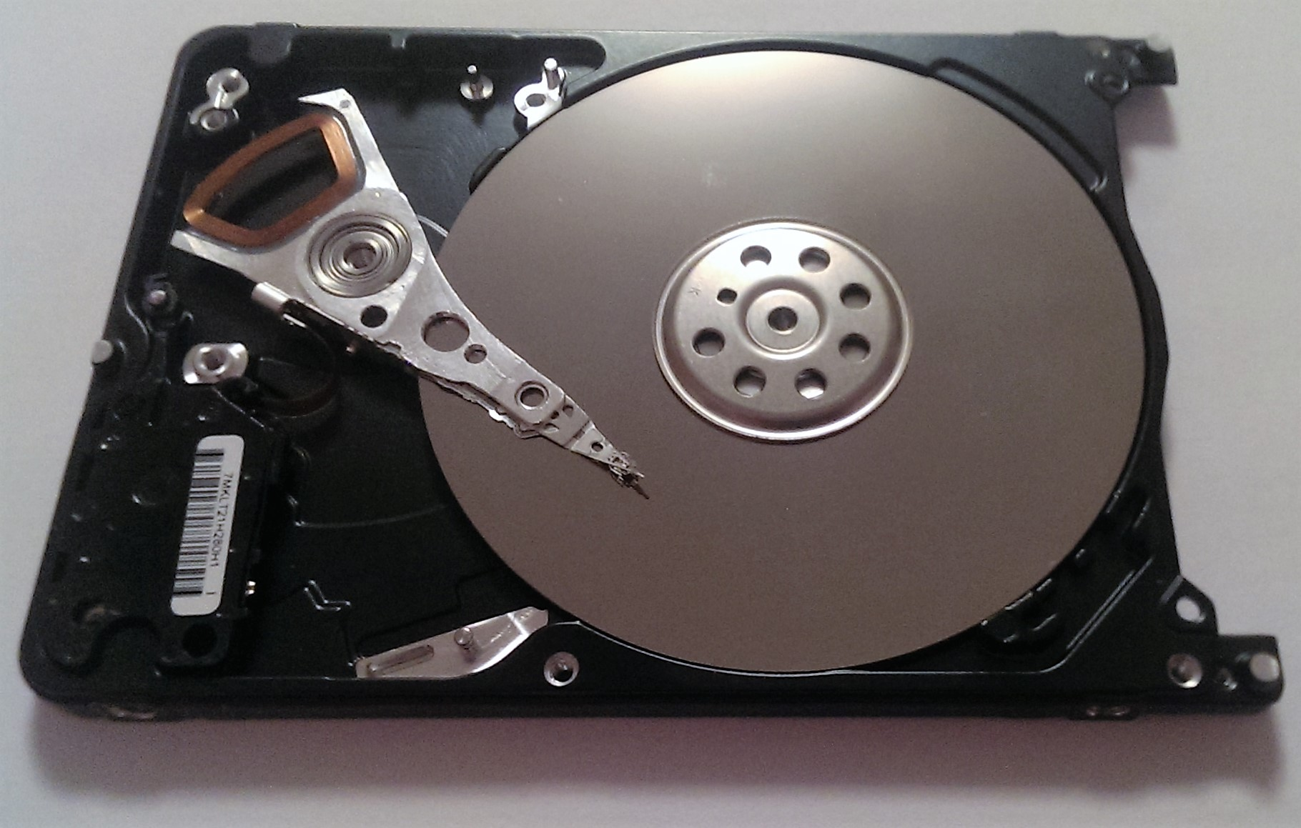
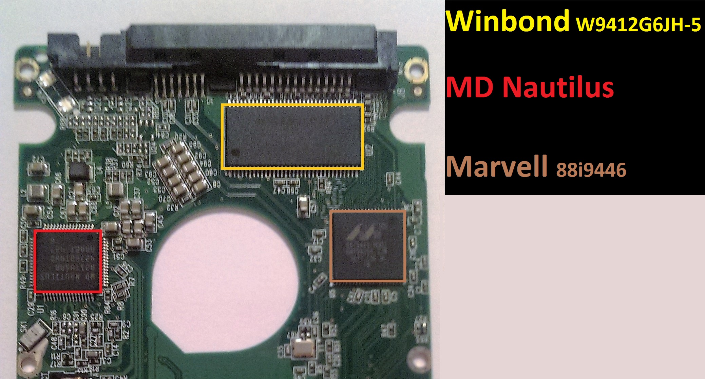We found three main chips on the PCB of the hard drive: the Winbond W9412G6JH-5, the Marvell 88i9446 controller, and the WD Nautilus.
The first chip on the board is the Winbond. It is an SDRAM chip that has a 128 megabyte capacity running at two hundred megahertz. It is used to hold the device’s firmware.
The chip on the left is the MD Nautilus. It is the device’s voltage regulator that ensures the hard drive will have a steady amount of power.
The last chip is the device’s dual core processor, the Marvell high performance storage controller. This chip handles the tasks given to the hard drive.
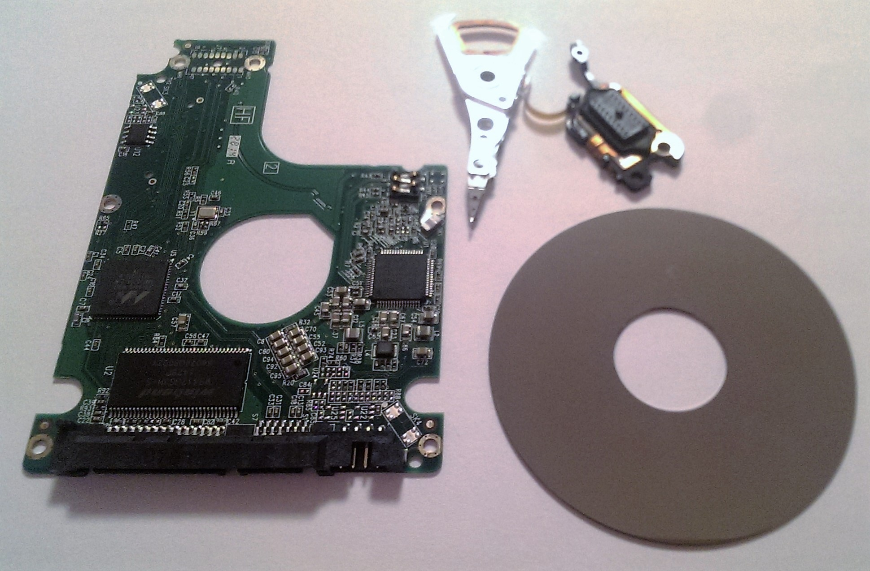
We learned much throughout this process and we are glad we chose to disassemble a hard drive, as we gained insight as to how they operate and the different components that work together to make a functioning storage device.

