**Slip Gear Set**

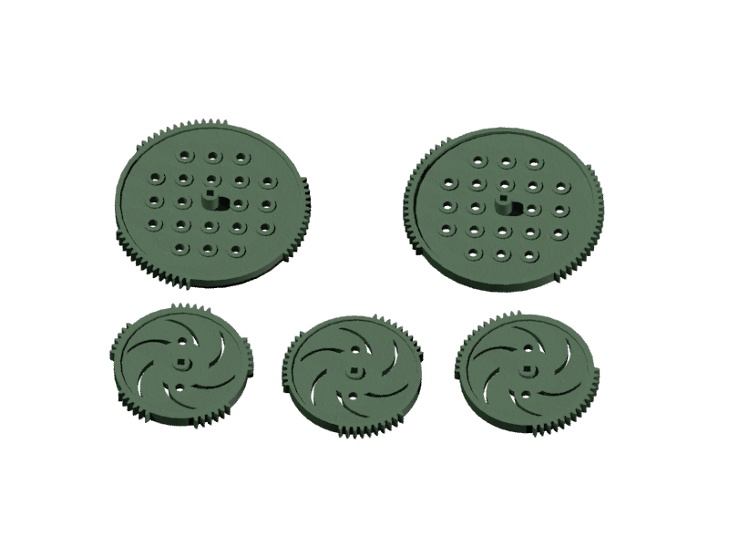Anne Junker

Bryant, AR

**Brief Introduction**

I created this set of gears in order to allow a user to have a gear that systematically and quickly link and disconnect from a corresponding part. This can be used to allow robots to perform different actions, like a “hammering” motion, or have an internal gear and its system repeatedly connect and disconnect to the gear and its following system as needed. Each slip gear allows for different size gears and different ticks between linkage and disconnection to the corresponding part, which is why it is important for them to come in a set.

**Fitting into a Complete Robot Design**

These gears would be used to have a quick and consistent connection-disconnection between the slip gear and a fellow gear. Like in a pinball machine -the user can pull back a knob, which turns the slip gear and its teeth against its corresponding gear and pulls the ball and launcher back, preparing it for launch into the game. Then, when the user pulls the knob far enough, the slip gear will continue to rotate- to the side with no teeth. This will stop linkage with the corresponding gear, allowing the launcher to spring forward and launch the ball into the game. The makes it so the user doesn’t have to manually let go of the knob to launch the ball.

**How I Used CAD**

I used the VEX 60-tooth and 84-tooth gear .ipt files from Autodesk Inventor as a source file and aid in my creation of the slip gears. I made a file of reference measurements for me to use from the .ipt file of each gear as well. Next, I exported the .ipt files to .dwg files and opened each individually in AutoCAD 2016. I used a process of exploding, copying the outline of the gear, and manually removing the teeth where needed to create the slip gears. Then, I extruded and restarted that process for the details on the gear, like the designs and shaft-hole. I created a custom material in AutoCAD and rendered using AutoCAD as well.

**Brief Conclusion**

I learned many commands and features of both Autodesk Inventor (exporting .ipt to .dwg, for example) and AutoCAD (materials, region, rendering) because of this project. I definitely foresee using Inventor to aid in creation and recreation of different projects for my engineering classes, as well as my engineering club and competitive robotics team. Creating a part or assembly in Inventor can help the team visualize the robot and obtain the proper measurements and positions of each part of the robot. Learning 3D design will be critical for my chosen career path, as I desire to become an Architectural Engineer. It will help me accurately and easily create house models and show them to my future clients. My career would be significantly more difficult without using a form of CAD.