**The Bearing Flat Plus by 569C Nighhawk Robotics Club**

One of the best parts that the VEX arsenal provides us with is the Bearing Flat. It keep everything spinning and smooth. Though we as 569C have run into our fair share of issues with them. They can be awkward to fit, unless there is a ton of un-needed modification. Which then can cause issues with structure with the Bearing Flat even making it come loose and eat through the metal. So we have come up with one of the Plus Bearing Flat.

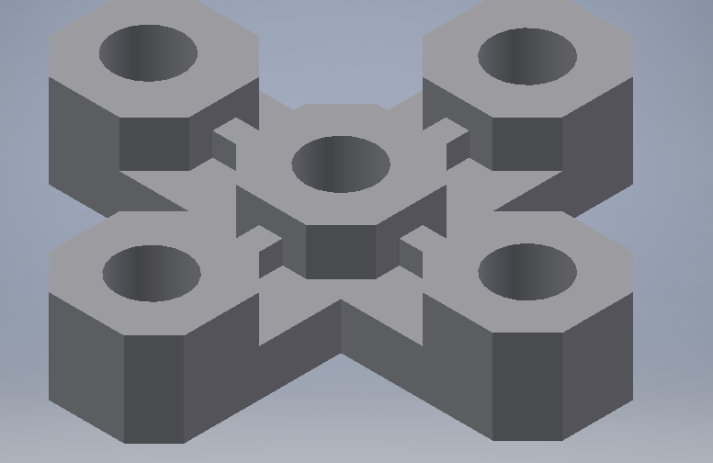

Which as you can see here has five holes instead of the three that normally come with the current VEX Bearing Flats. This allows for stronger Bearing Flats, as well as many more options and avenues for more innovation in the VEX robotics competitions. During VEX Skyrise last year we had a reverse double four bar design for our lift. Which could easily gain the title as the strongest in our Club, Southern California, and maybe even the nation being able to beat out any others that it was pitted against. As could easily be imagined that would take exorbitant amounts of torque and power from our VEX motors as well as our gearing. Which proved to be abusive to our C-Channel

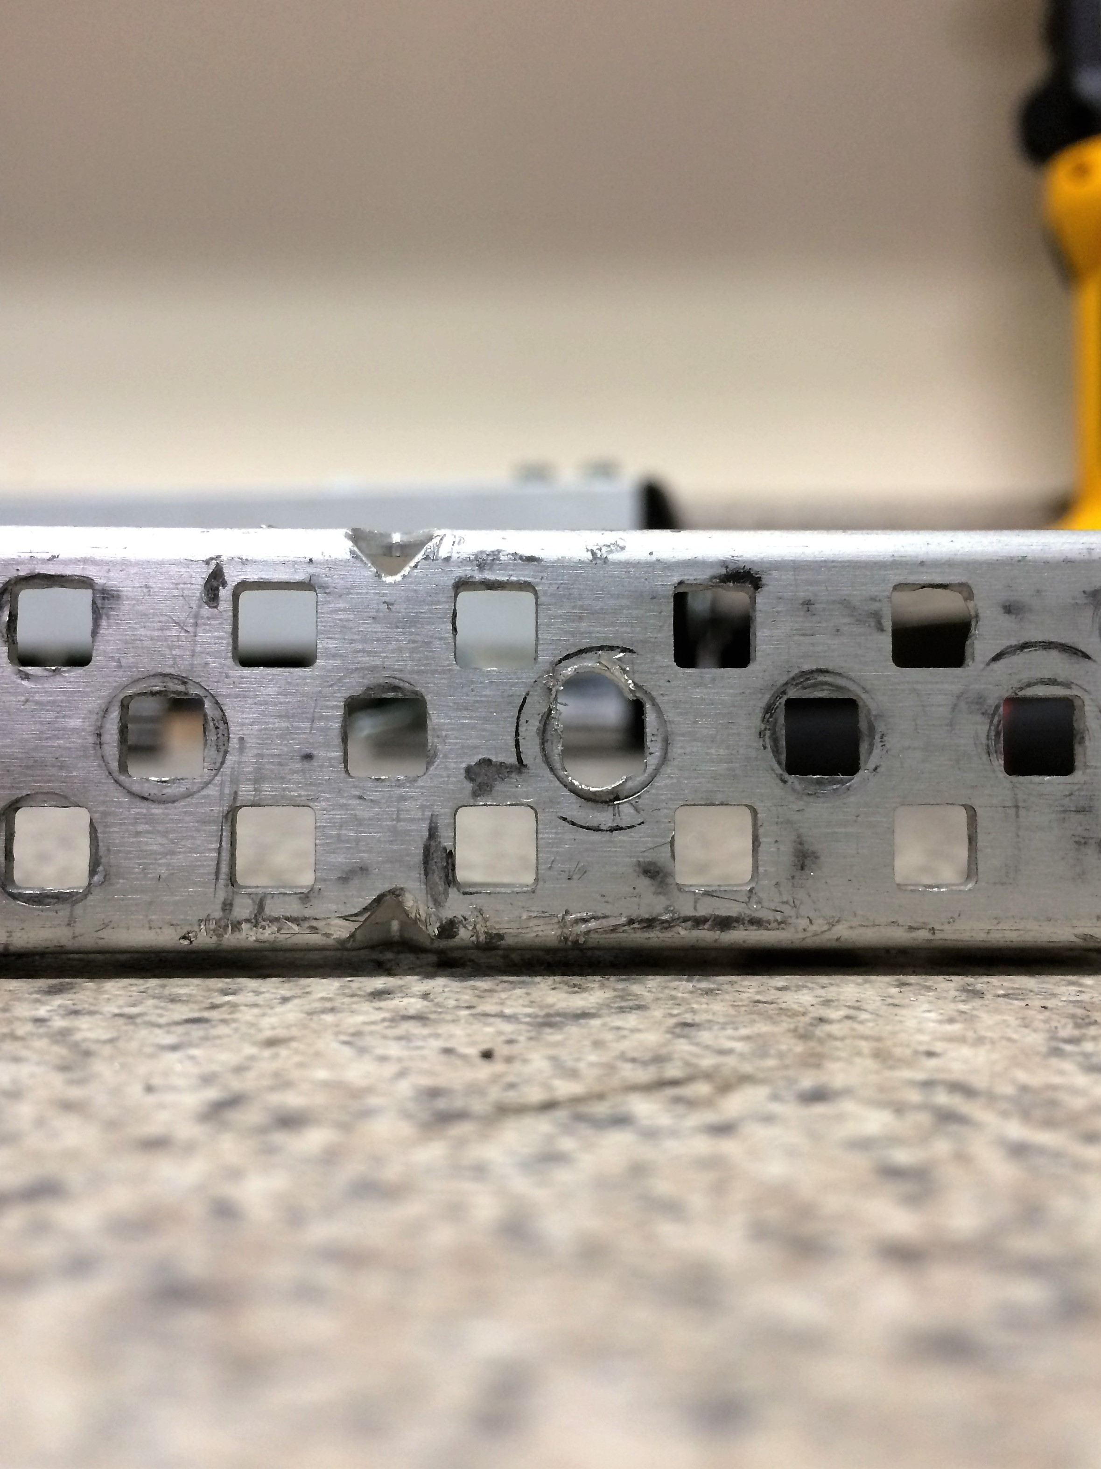

Which you can see the square bar being to tear through our C-Channel which caused our gearing to slip and completely destroy our arms gearing…. The day before a tournament. Which obviously was not fun. The Bearing Flat Plus is able to solve this just in a simple way four screws.

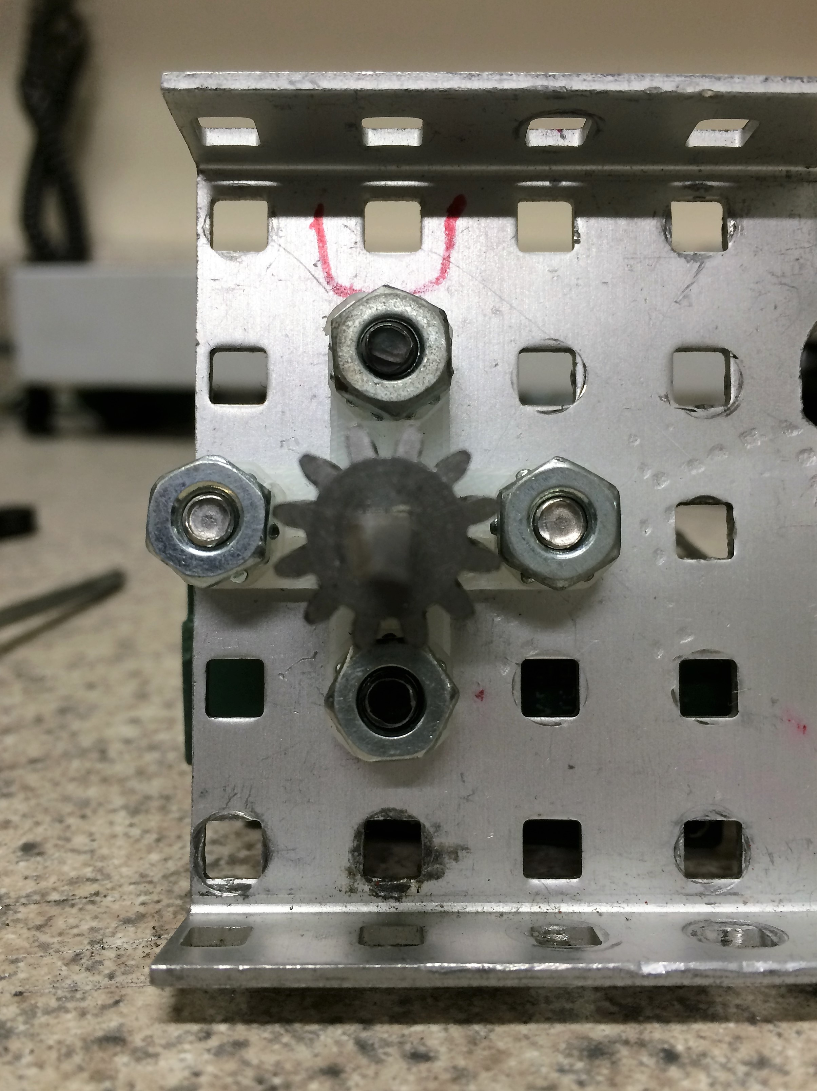

As you can see here now that square bar will not be able to go anywhere. Taking away all of the Head and Heart Aches that were caused the day before our tournament.

In the sense of innovation as talked about earlier, these are a few of the things that we were able to come up with.

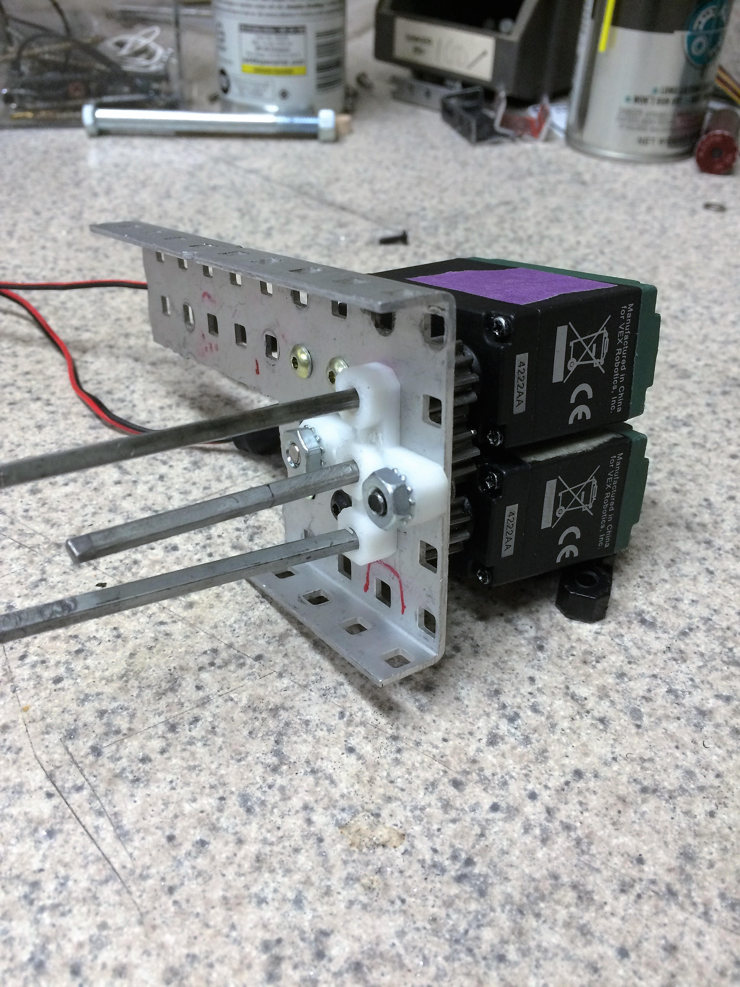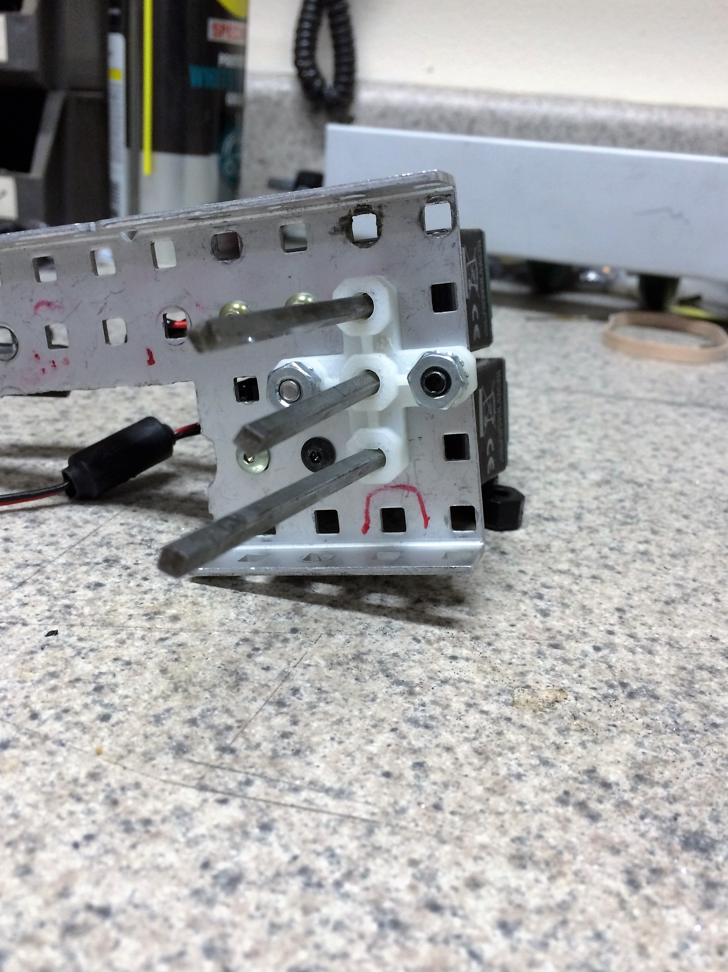

On Team C we love to be able to use these designs we call the Two Motor Three pinion transfers. Which takes two motors combines the power of both of them through three pinions into one causing a super strong motor. Which would normally take an absurd amount of Bearing Flats to create. But when the Bearing Flat Plus exists it only take one.

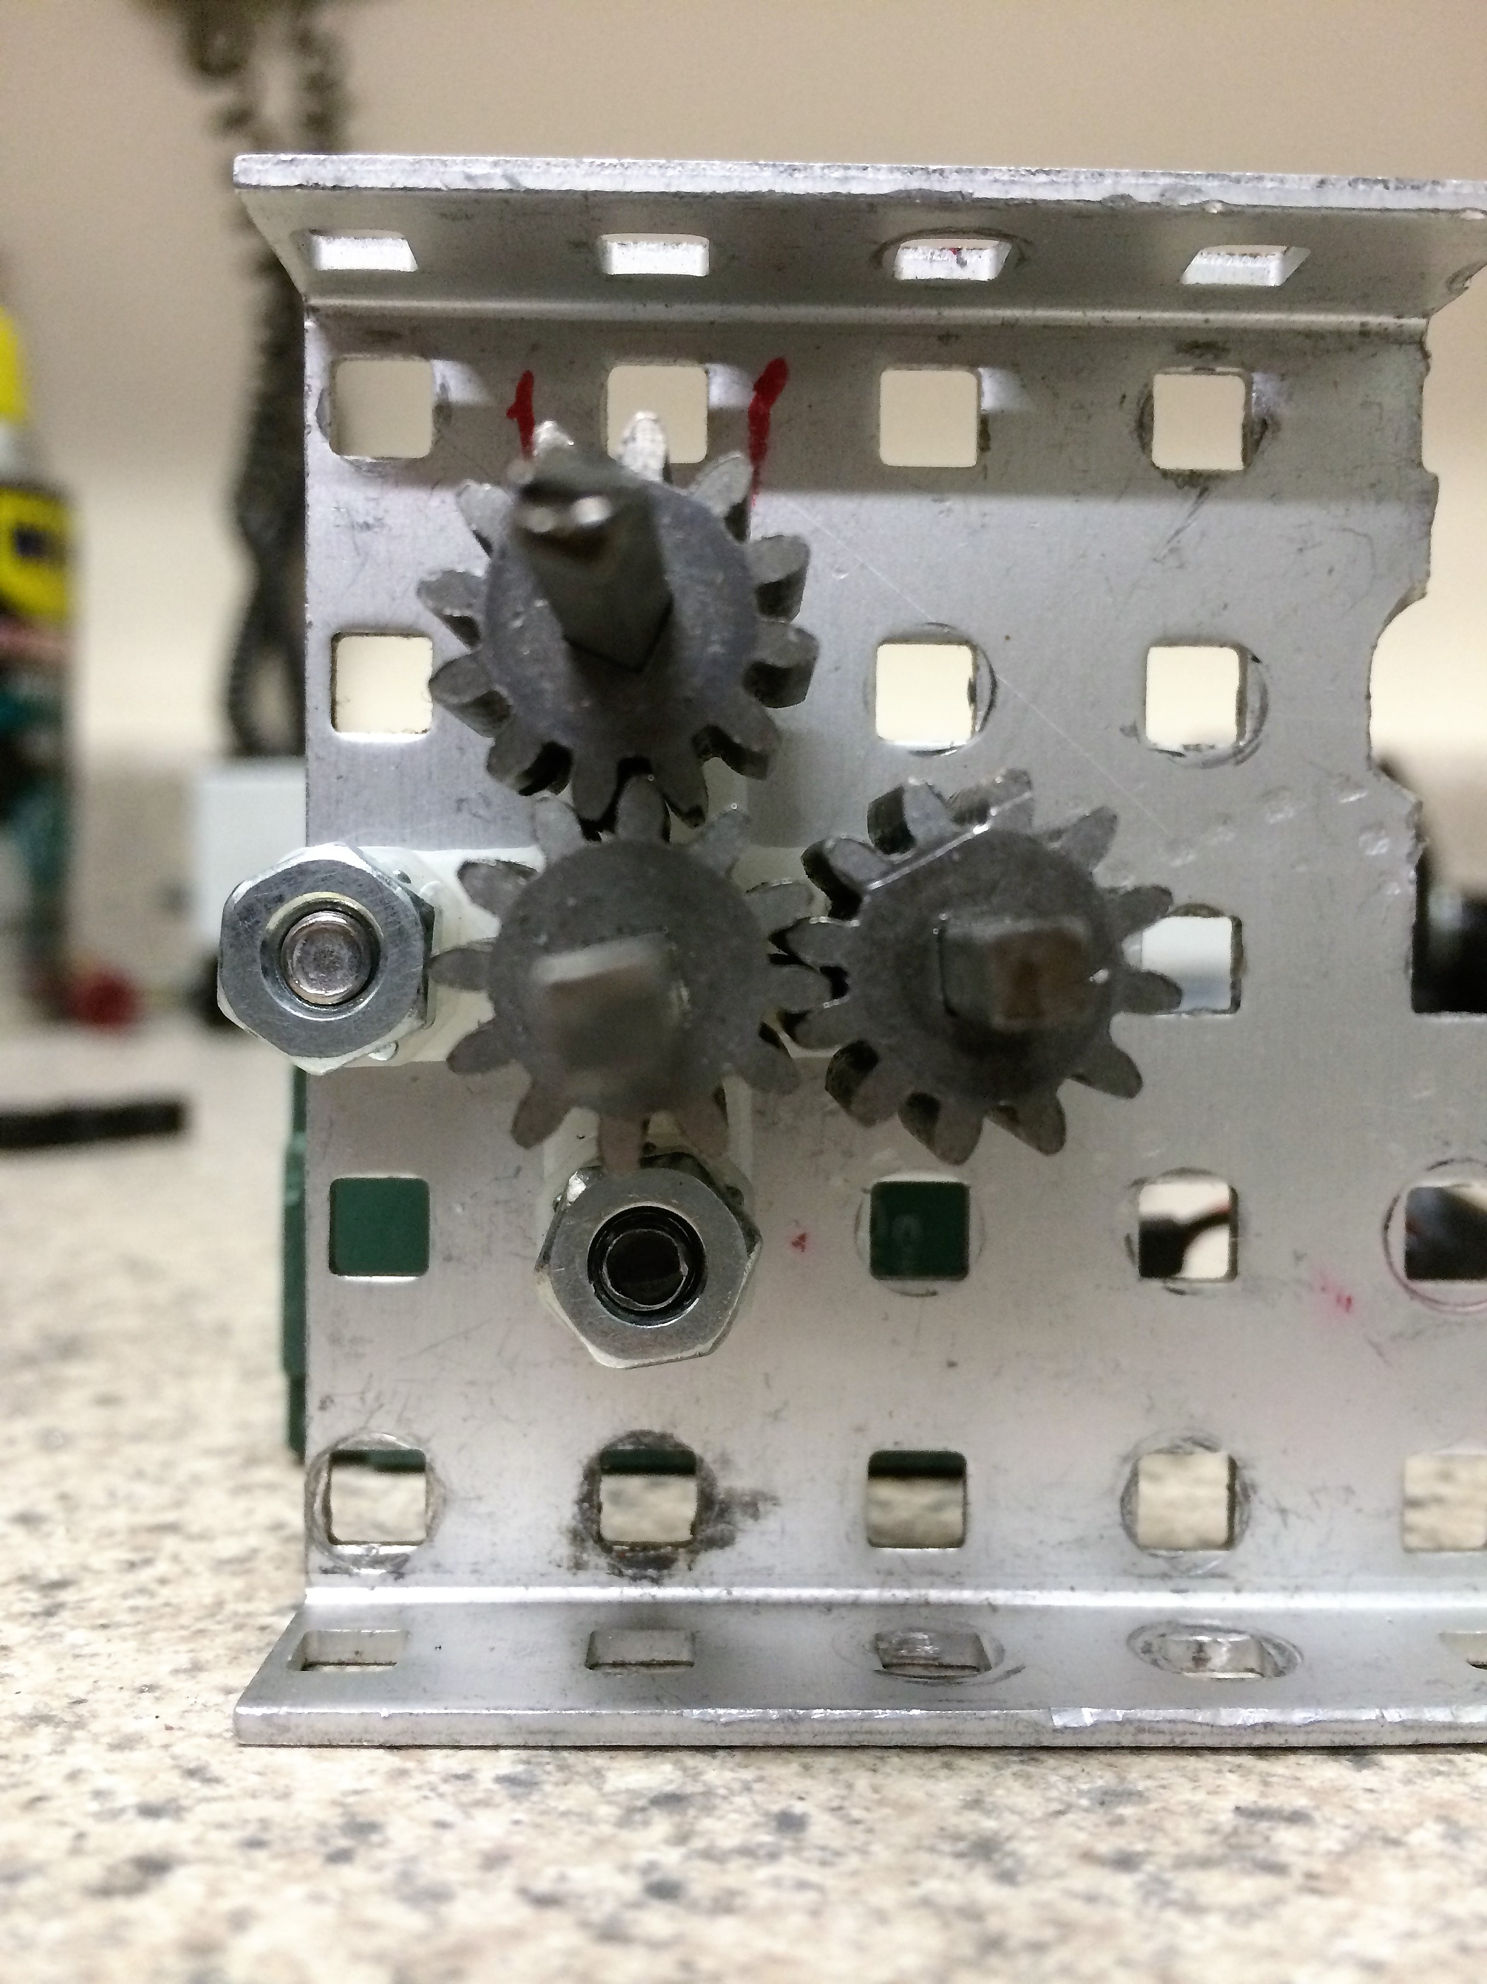

Another that we were able to come up with is the ninety degree gearing transfer, which would not be possible with current Bearing Flats because the spacing would be off. Which is able to compact gear ratios with still providing the structure of at least two secured points to the metal. These are some of the many designs that the bearing Flat Plus is able to provide.

We constructed the piece using Autodesk Inventor. Beginning with two rectangular prisms, we slowly extruded the holes one by one, each with the same measurements. Great care was taken in keeping the same hole parameters seen in the original bearing flat to fit the other parts. Because of Inventor, we were able to complete the task at hand with ease.

After completing this project, we learned the numerous parts and systems that could be created with Inventor. It could help our team with creating the framework of a robot, allowing us to keep a sole design in mind when building. We plan on using this software with our future careers if we need to create or innovate new parts.