Corey Preston and Jeremy Marinello – Team 5203
Texas Instruments Electronics Online Challenge
The technology inside of the every common cell phone is light years ahead of what is was ten years ago. It's true, in 2005 companies like Motorola and Nokia were just coming out with their latest and greatest flip phones that took five minutes to text one simple sentence. Ten years later, there’s touch screens, fingerprint scanners, heart beat sensors, and the list goes on and on. In the midst of all this, have you ever wondered what small pieces makes yours so great? That is exactly why we chose Samsung’s Galaxy S3 to enlighten us.

Upon carefully taking apart components and examining them, we found a variety of different items. The most important ones would be Samsung’s Exynos processor along with a 16 gigabyte eMMC onboard memory, and the most noticeable a 8 megapixel camera.
Starting off with the Exynos 4412 processor, it has 4 cores and clocks at a 1400 megahertz refresh rate. The processor, or Central Processing Unit, is the powerhouse of the phone which fetches and decodes information to be sent anywhere throughout the phone. It has two gigabytes of Random Access Memory (RAM) which is much less noticeable than the 16 gigabyte eMMC Read Only Memory (ROM) that read and stores information respectively. With these components, there are many other pieces such Wi-Fi adaptors, stereo codecs, power controllers, and many individual small pieces of one whole piece of hardware.

This project has been an eye opener on just how the world works. It must be important to not take advantage of the age we live in and learn to appreciate and understand the smaller pieces that make up our lives. For, if there was not these little pieces working together to make up a large part of our lives, where would we be now?

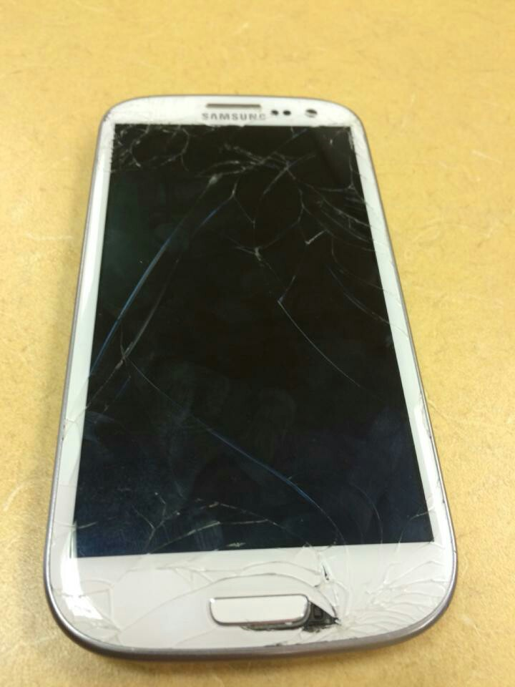
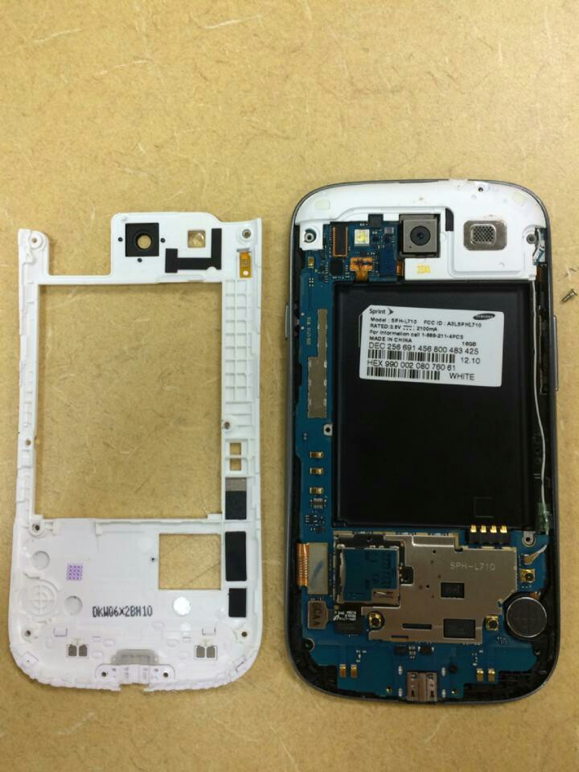
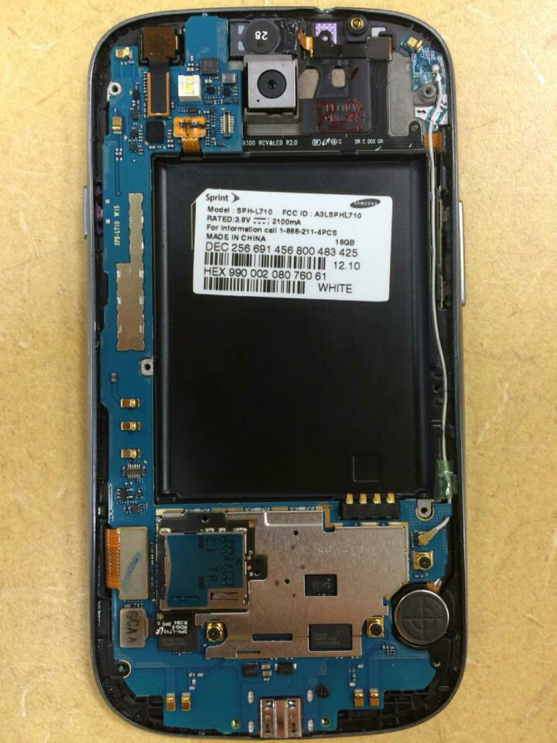
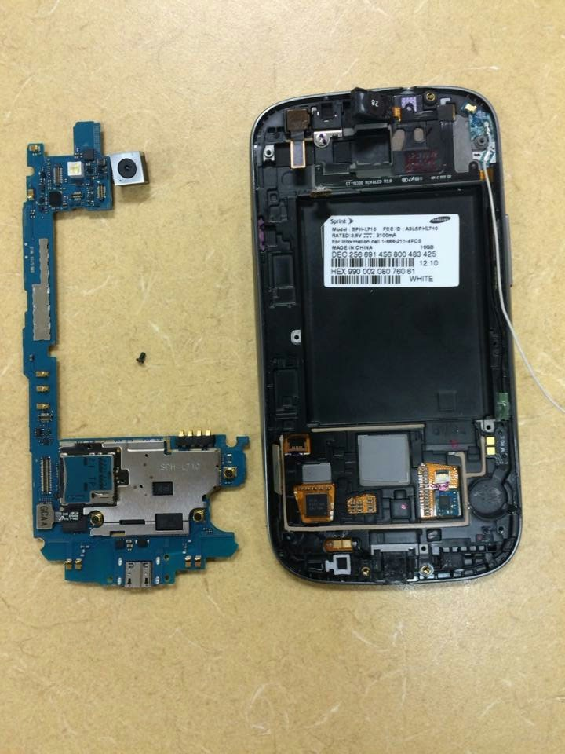
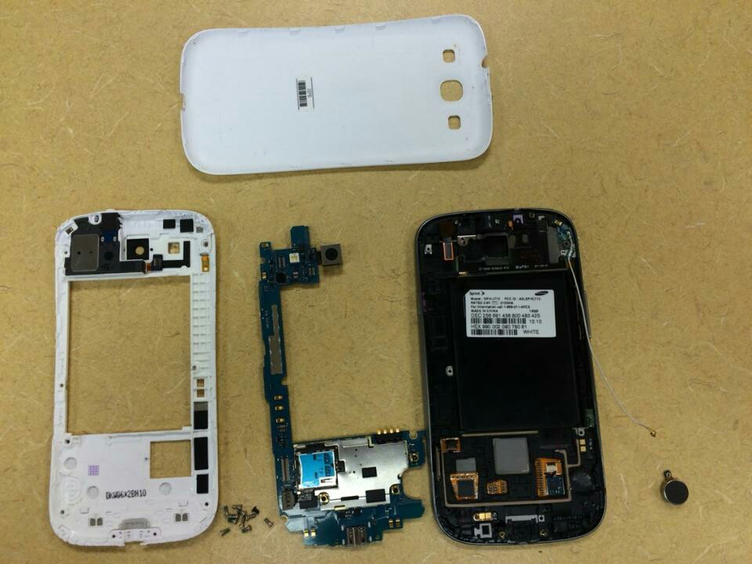
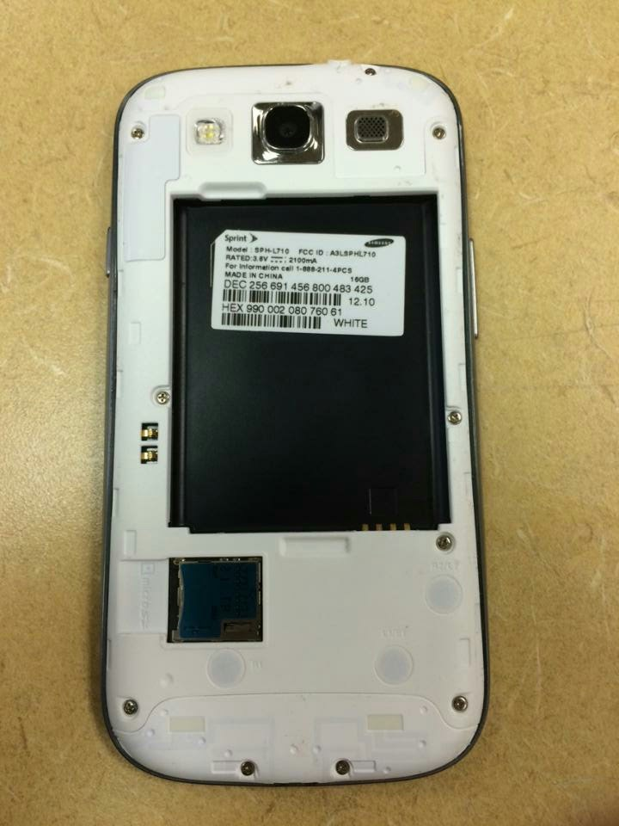
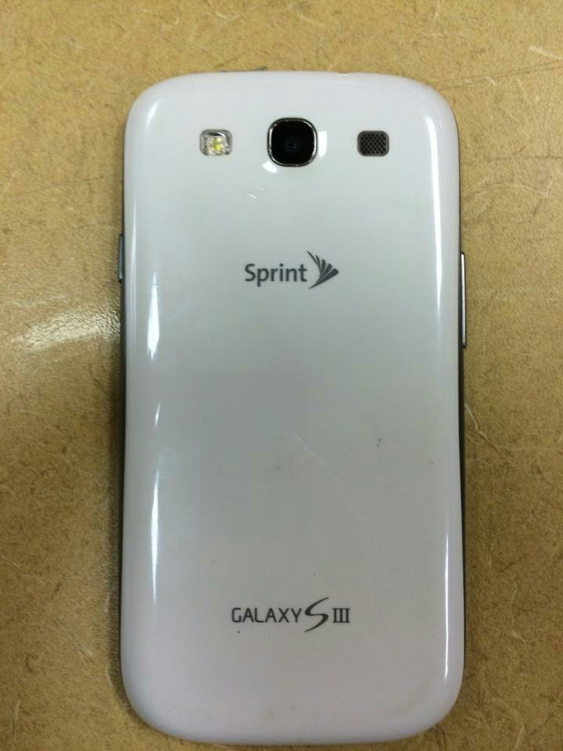
Citation

- Djuric, Miroslav. "Samsung Galaxy S III Teardown." IFIXIT. 1 July 2012. Web. 15 Dec. 2015. <https://www.ifixit.com/Teardown/Samsung Galaxy S III Teardown/9391>.
- "Samsung I9300 Galaxy S III." - Full Phone Specifications. GSMArena. Web. 15 Dec. 2016. <http://www.gsmarena.com/samsung_i9300_galaxy_s_iii-4238.php>.

