**Disassembling a TI-36X Pro**

**VEX Team 5203**

Calculator Taken Apart:

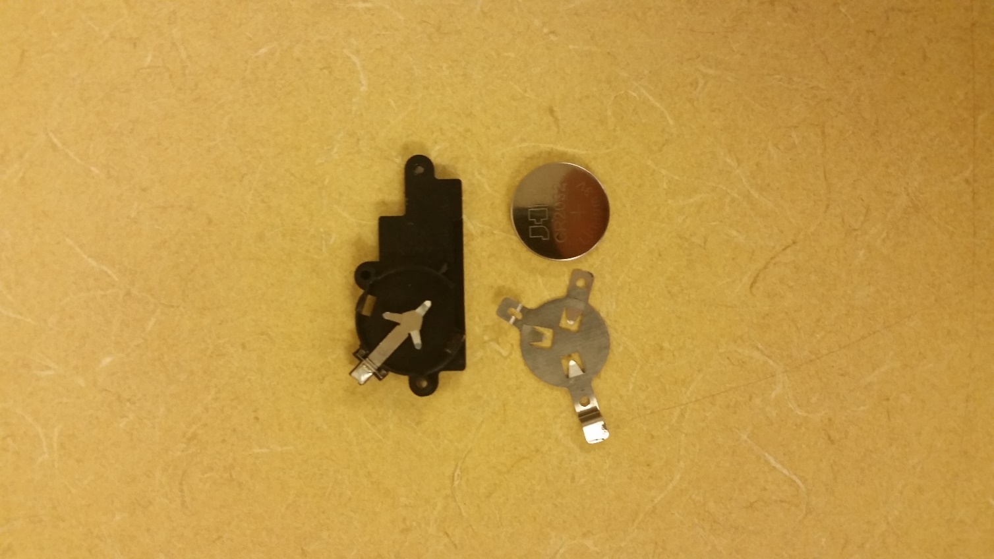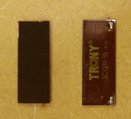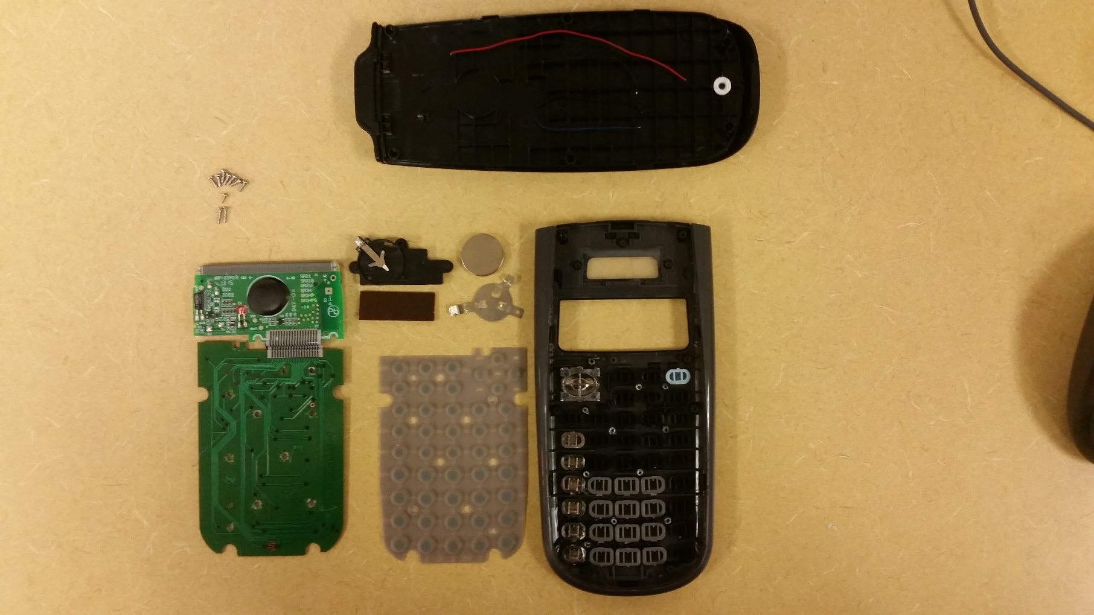

**1**

**1**

**2**

**2**

**3**

* **3**

**4**

* **3**

**5**

* **3**

**7**

* **3**

**7**

* **3**

Lithium Ion Battery: Solar Panel:

Processor and LCD:

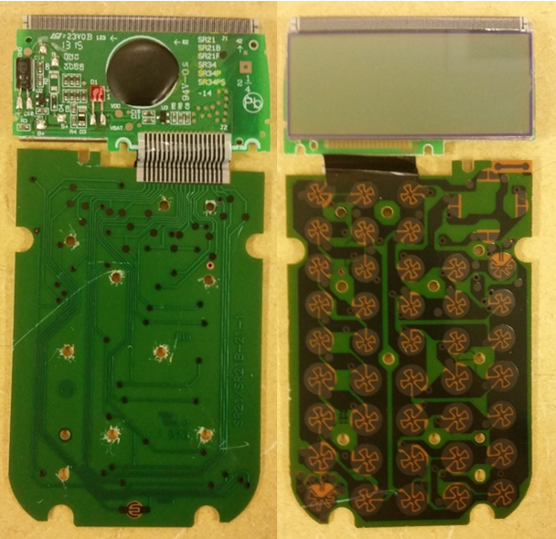

**3**

* **3**

**4**

* **3**

**6**

* **3**

1. Solar Panel
2. Lithium Ion Battery
3. Processor Chip
4. Keyboard Sensors
5. Keyboard Membrane
6. LCD Display
7. Cover

We chose to disassemble a TI-36X Pro calculator. We chose this particular calculator to disassemble because we had an extra one lying about and were curious as to how it worked after having had used it for so long. Inside the calculator we found a lithium battery, a solar panel, keyboard membrane and sensors, buttons, and the processor. However, despite being in a Texas Instrument calculator none appeared to be Texas Instrument components. After some research we found that the buttons and button sensors work together in order to input numbers to the processor. The buttons each represent a different binary code. Once pressed, the code is sent to the processor, and the processor then after having translated the binary into the actual number sends it to the LCD screen. Other than translating binary code the processor also performs many of the operations essential to the calculator like multiplication, exponents, and logarithms. The processor is aided in its performance with some memory which stores the recently entered numbers for easy access by the processor. The calculator uses both a lithium battery and solar power to provide energy to its components. This mini-project allowed us to truly appreciate the advancements of technology and its benefits like the replacement of the light-producing LED screens with light-rearranging LCD screens which decreased calculators’ power consumption.