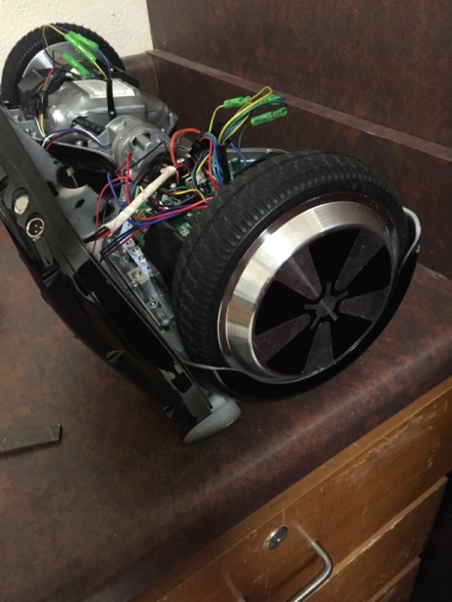
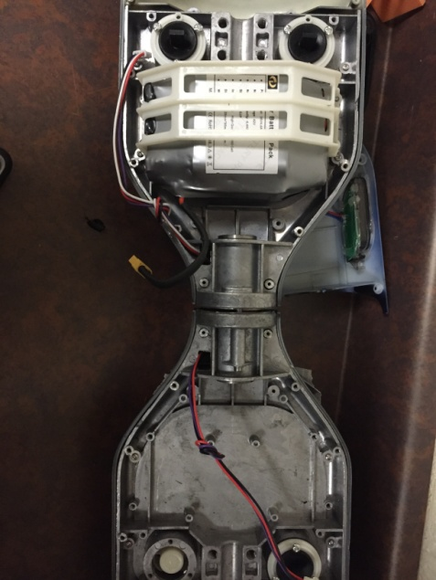
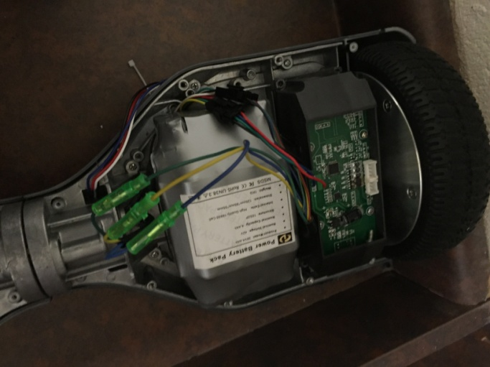
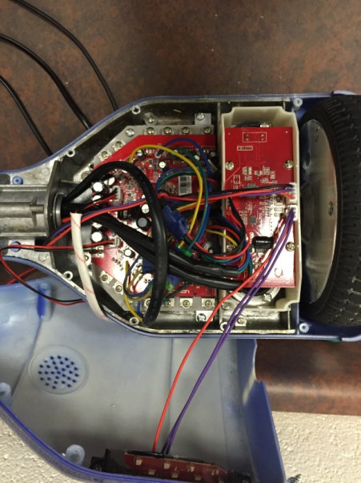
Hoverboards or balance wheels have become very popular recently. A hoverboard is not a floating device like one might think, instead it is a two wheeled vehicle designed to move with the weight that you distribute with your feet. In the last month, from the help of the owner of Pull Watersports, we have had the opportunity to disassemble, recreate and repair these motorized vehicles. The hoverboard consists of several electronic parts: 2 circuit boards to register when pressure is applied to part of the pad, and therefore makes it move forward, a main motherboard or logic board, a lithium battery, and 2 electromagnetic motors. Through research, I found that none of the parts used to create the hoverboard are made by Texas Instruments however similar products are made. The main piece, or the motherboard, is designed to connect all pieces of the component together and have them communicate. Without this piece, nothing will cooperate. The lithium battery is designed to produce a power flow throughout the whole system; it consists of several cells combined. Without power, the device cannot operate because it will not have an energy source. On each side, there are smaller logic boards intended to send a signal back to the motherboard. This signal is defined through sensors that are activated when the beam is broken. When the motherboard reads this signal, the electromagnet inside the motor reads and causes the electromagnet to activate. In conclusion, I learned without one of any key parts, a device cannot function properly or entirely. Each component is vital.

