VEX U Team MASON CAD Engineering Challenge Submission
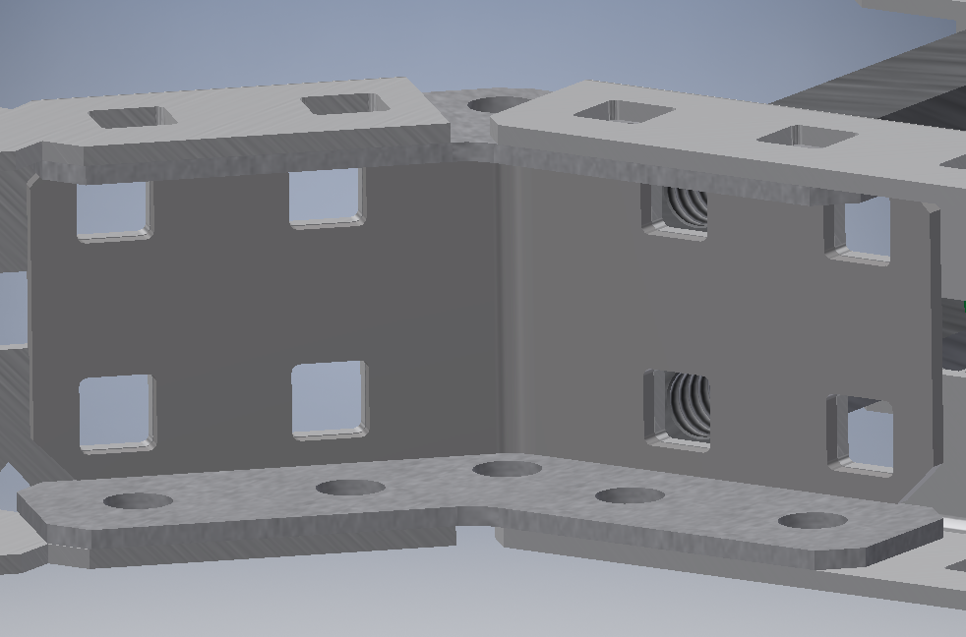

One problem several teams face is how to create the holonomic drivetrain commonly referred to as an “x-drive.” Many teams use the 45-degree angle gussets, however, this method can often be tedious as the current gussets have “slop” when attaching metal together. This “slop” refers to the amount of area allowed for the metal to not be screwed in at a perfect 45-degree angle. So, we created our 45-degree angle coupler to ameliorate the aforementioned problems. The 45-degree angle coupler allows teams to create a holonomic base easily and efficiently. It was also designed to work concurrently with the current 45-degree angle gusset.

We used the dimensions of VEX’s 45 degree gusset to create this part. We already had the VEX gusset in our parts library, so we used the inspect tool in Inventor to get the arc dimensions we needed for one side of the 45 degree coupler. We then measured the length we needed again using the inspect tool. We then used the offset tool to offset our arc and 2 lines 0.046 inches apart (thickness of other gussets). Then, we simply connected the ends of the two lines with the line tool. After we had our sketch viewing the part from above, we extruded the part 0.8in. After we had the skeleton we simply extruded a cut into the sides for the screw holes and chamfered the edges.

We learned how to be more adaptive with using the 2D sketch feature in Inventor. Getting the perfect angle and distance at the same time can be a very tricky process, but after making this part, we are more comfortable making angled parts. We do plan to use it in the future for other projects; in fact we use CAD to create custom components for our VEXU robots. Inventor has been crucial on our robotics team; we use the VEX CAD parts libraries to construct our robots virtually before we even touch a c-channel. Most of us are studying mechanical engineering, electrical engineering, and computer science so we will be using 3D design software in our respective fields.

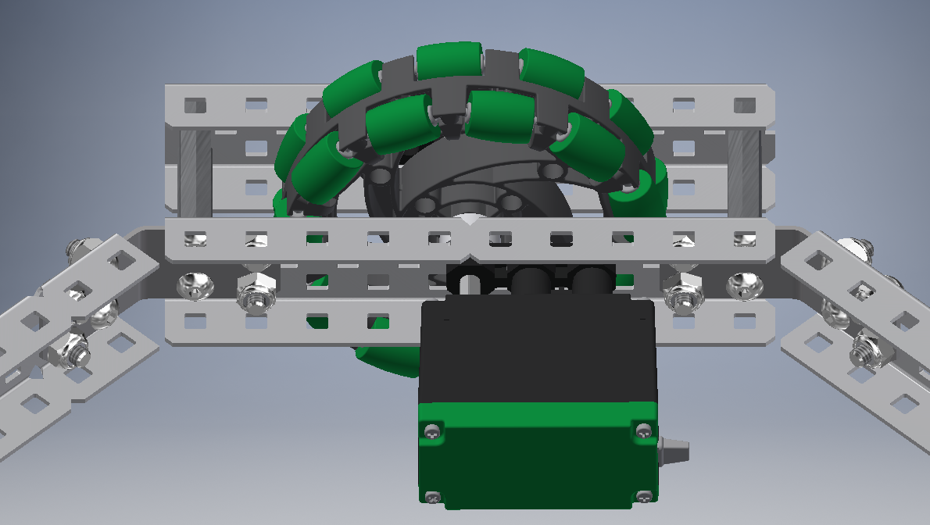
Above is an image of our part used to construct a virtual “x-drive.”

, 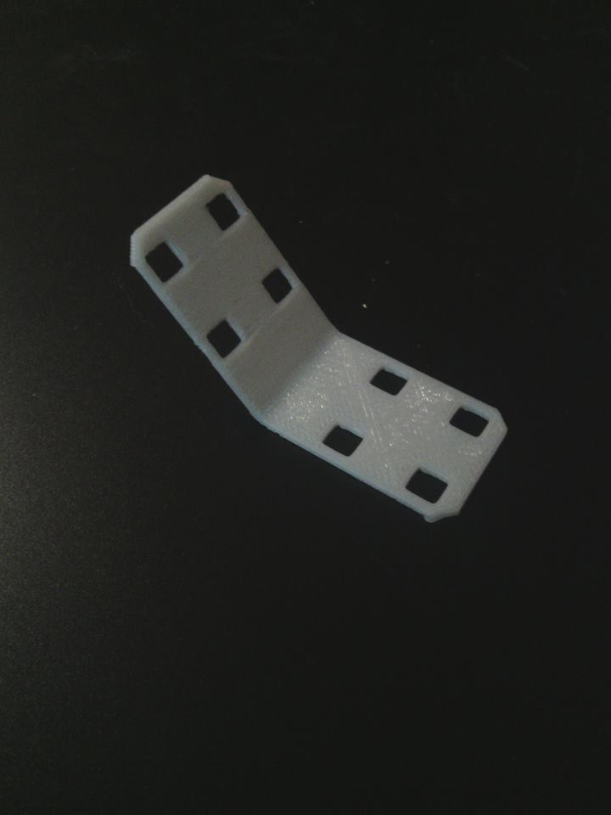 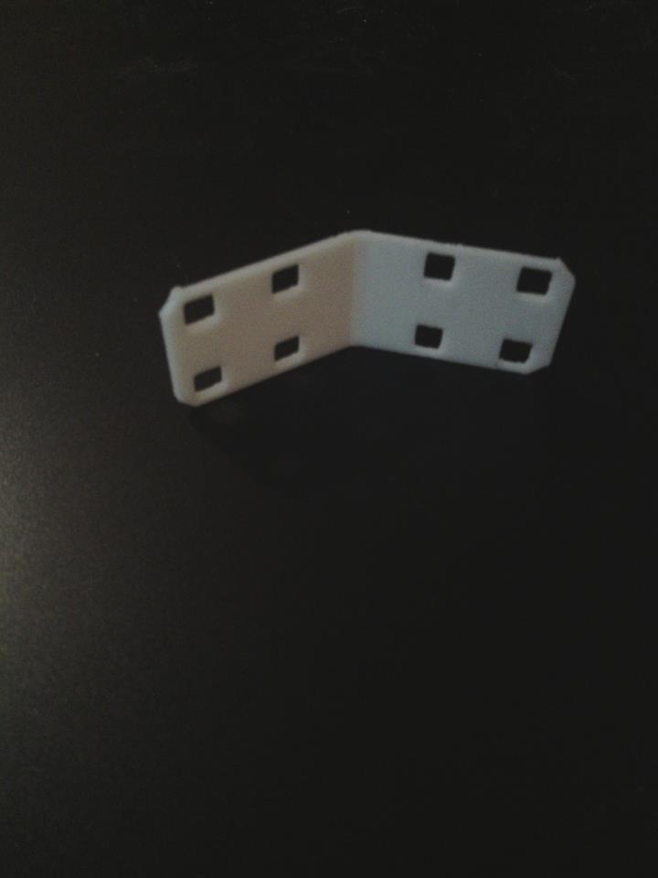
Above is 2 image of our part 3D printed using ABS plastic

VEX U Team MASON “Make” Submission - CAM

Creating this cam was actually a very interesting learning experience. We used the “equation of a line” tool in Inventor to create the Fibonacci spiral shape needed for the part. We used the Fibonacci spiral after researching how to create a spiral with an [math] increasing slope. After altering the parameters we created the partial spiral needed. Then, we made a straight line connecting the start and end points to close the shape. We also sketched a pattern of holes for screw mounts. I then extruded the whole shape and the cam was created!
We learned about the equation of a line tool and how powerful/useful it can be. This will definitely broaden my abilities for the future.
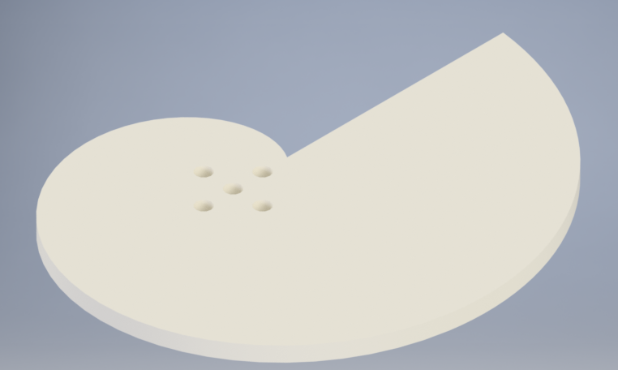
Above is a picture of the cam before we printing.

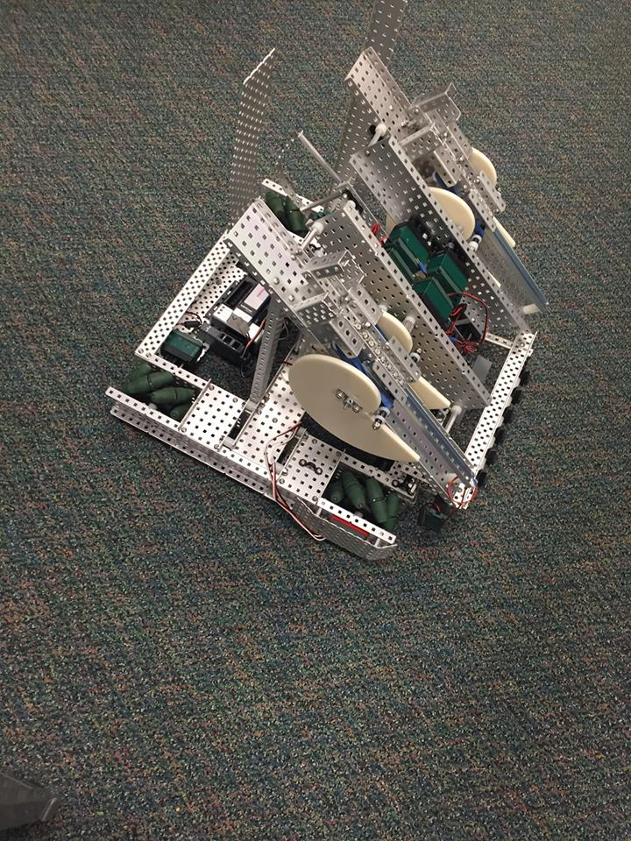
Here we have several of our cams on our 24” robot.
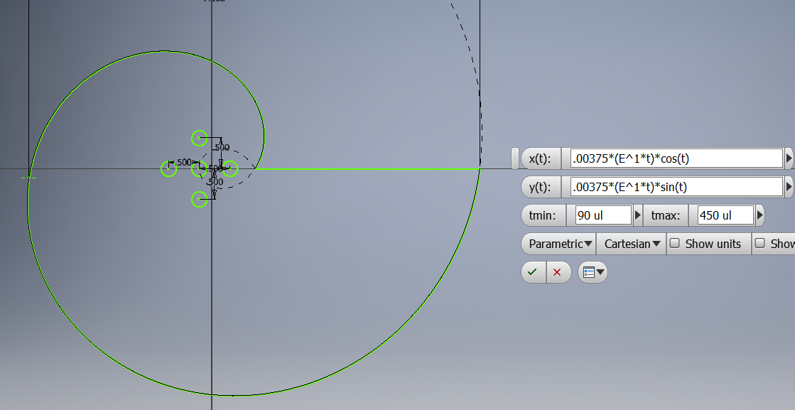
Above is a screenshot of the parametric equations we used to create the spiral.

