TI-Online Challenge
VEX Team 4104A
We chose to take apart a Casio graphing calculator. We did this because I had no use for it anymore and no-one else had anything that they were willing to take apart. It was very simple to take apart and had few components on it that we could take off. The only thing we could de-solder and take off was a capacitor. The rest of the components were so small and hard to work with, that we couldn't get any off. We separated it into a large sum of parts, most of which were the keys of the calculator and screws that held it together. There was the outer casing, which protects the screen; the battery cover, which covers the batteries and keeps them from falling out; the front cover, which holds the keys in place and stops them from falling out; and the back cover, which holds everything inside the calculator and helps the battery cover sit flush on the back of it. There was a rubber buffer for the keys. The IC chips that were on the calculator were extremely hard to find information on. We only found information on where to buy them, but nothing about what they did or how they contributed to the calculator's function.
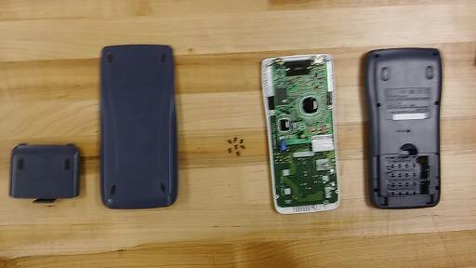
This was the first picture we took. We were already slightly in the process.
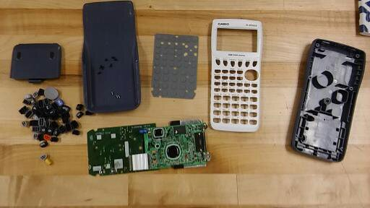
This was our second picture. We took the keys off at this point.
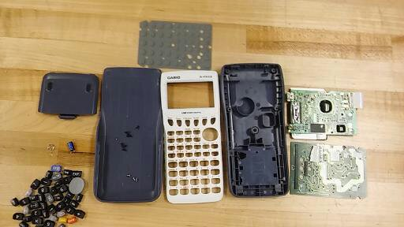
This was our third and final picture. There wasn't anything else that could be done at this point.

