Running Head: Disassembly and Research of Tyco R/C Car

Disassembly and Research of Tyco R/C Car
Texas Instruments VEX Online Challenge
Andrew Schreacke, Theron Lowe
Central Hardin Robotics 6135W

Introduction
Our team decided to disassemble a Tyco R/C car for the VEX Texas Instruments online challenge. Our logic behind this decision stems from an enduring curiosity into the inner workings of an R/C car. Inside, we found a variety of components. None of the parts were manufactured by Texas Instruments, but we did find TI counterparts too many of the transistors in the circuit.
The circuit behind the R/C car consists of transistors, resistors, capacitors, an integrated circuit chip, and a receiver. In the circuit, the function of the resistors is to limit the flow of electrons. The transistors provide the function of amplifying or “switching” electronic signals. Capacitors hold a charge in the circuit, and the integrated circuit allows 5 functions for the remote control. The receiver picks up and interprets the signal sent from the remote control.

Part Name | Part Number (If Applicable)/Color Coding | Quantity of Part | Manufacturer (If Applicable) | Use/Value
Transistor | C1815 | 5 | Toshiba | Audio Frequency Amplifier
Transistor | S8050 | 4 | Unisonic Technologies | Small Signal NPN transistor (Push Pull audio)
Transistor | C3279 | 2 | Toshiba | Medium power Amplifier
Transistor | A1300 | 2 | Toshiba | Low Speed Switching Power Amplifier
Transistor | A1015 | 1 | Weitron Technology | Low Frequency Amplifier
Ceramic Capacitors | n/a | 9 | n/a | Can store amounts from 1pF - 200nF - Store a charge
Polyester Capacitors | n/a | 2 | n/a | Store a charge - 2.2nF
Aluminum Capacitors | n/a | 2 | n/a | 100uF 20V Power Storage
Aluminum Capacitor | n/a | 1 | n/a | 4.7uF 50V
Polystyrene Capacitors | n/a | 1 | n/a | 3V Capacitor
Resistor | Brown, Black, Red, Gold | 4 | n/a | 1kΩ +/- 5%
Resistor | Red, Red, Green, Gold | 2 | n/a | 2.2MΩ +/- 5%
Resistor | Violet, Green, Red, Gold | 2 | n/a | 7.5kΩ +/- 5%
Resistor | Brown, Green, Orange, Silver | 1 | n/a | 15kΩ +/- 10%
Resistor | Orange, Orange, Gold, Silver | 1 | n/a | 33Ω +/- 10%
Resistor | Green, Red, Violet, Gold | 1 | n/a | 52GΩ +/- 5%
Resistor | Red, Violet, Brown, Gold | 2 | n/a | 270Ω +/- 5%
Resistor | Yellow, Violet, Black, Gold | 2 | n/a | 47Ω +/- 5%
Resistor | Red, Red, Yellow, Gold | 1 | n/a | 220kΩ +/- 5%
Resistor | Red, Red, Red, Gold | 2 | n/a | 2.2kΩ +/- 5%
Resistor | Yellow, Orange, Red, Gold | 5 | n/a | 430Ω +/- 5%
Resistor | Orange, Orange, Brown, Gold | 1 | n/a | 330Ω +/- 5%
Resistor | Brown, Blue, Yellow, Gold | 1 | n/a | 160kΩ +/- 5%
Integrated Circuit | RX-2B | 1 | Silan Microelectronics | Remote Controller with 5 Functions
Receiver | n/a | 1 | n/a | Wireless Radio Frequency Receiver
DC Motor | n/a | 2 | n/a | Drive the axles and wheels, also handle turning the axle
Screws | n/a | 8 | n/a | Connecting sections of chassis with each other and the shell
Chassis | n/a | 1 | Tyco R/C | Frame of the vehicle,
Body | n/a | 2 | Tyco R/C | Exterior Shell (Visual)

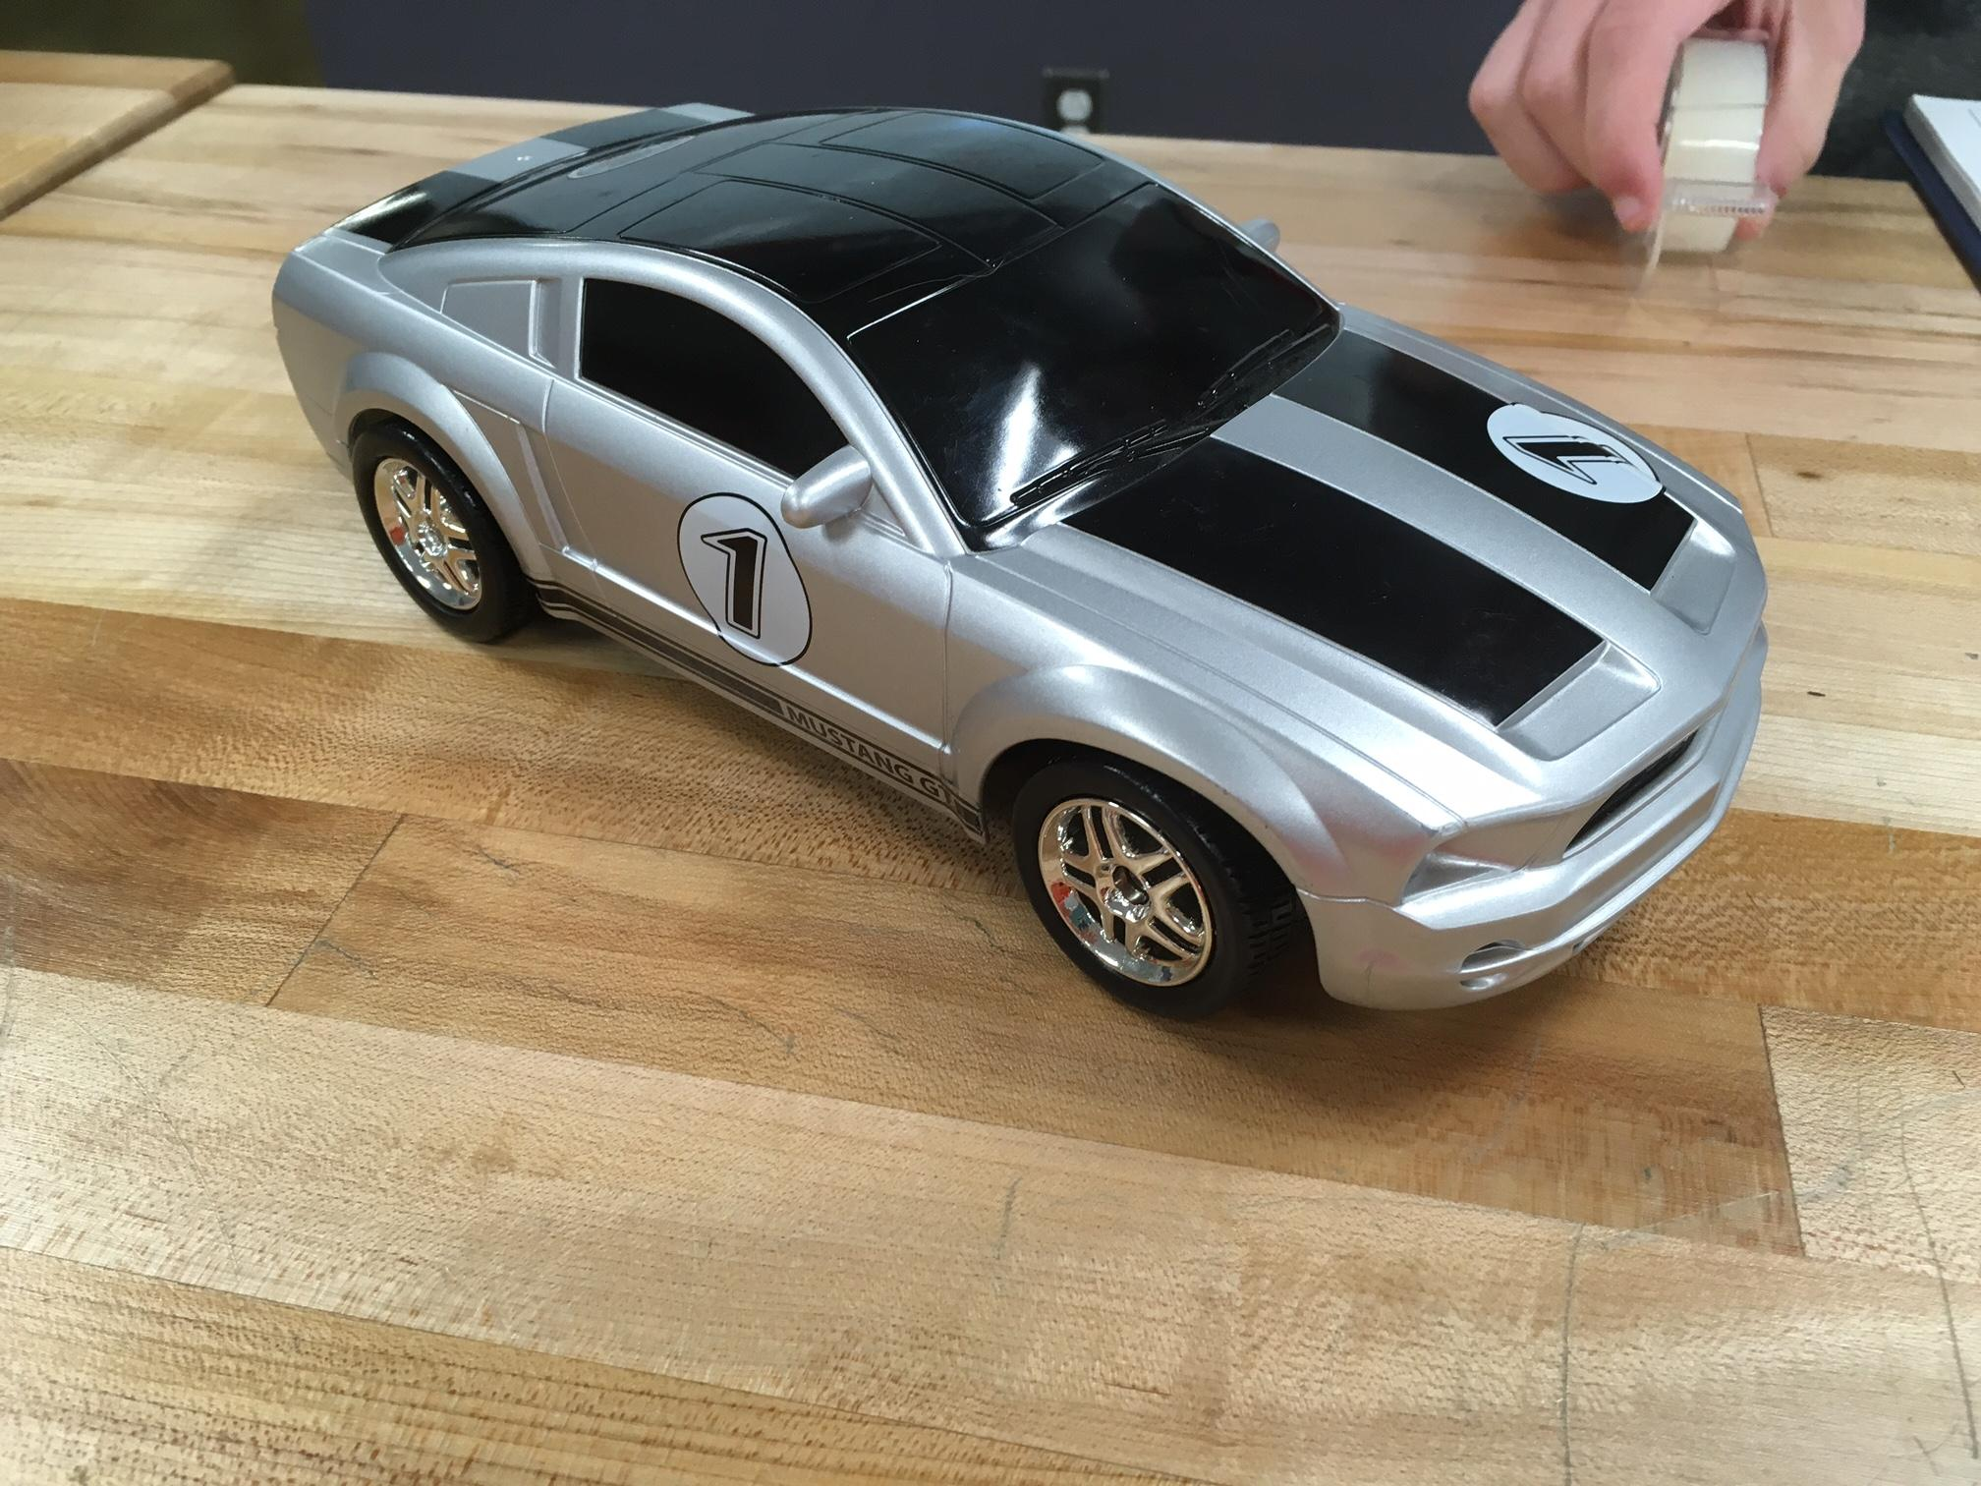This is an establishing shot of the R/C car before disassembly.
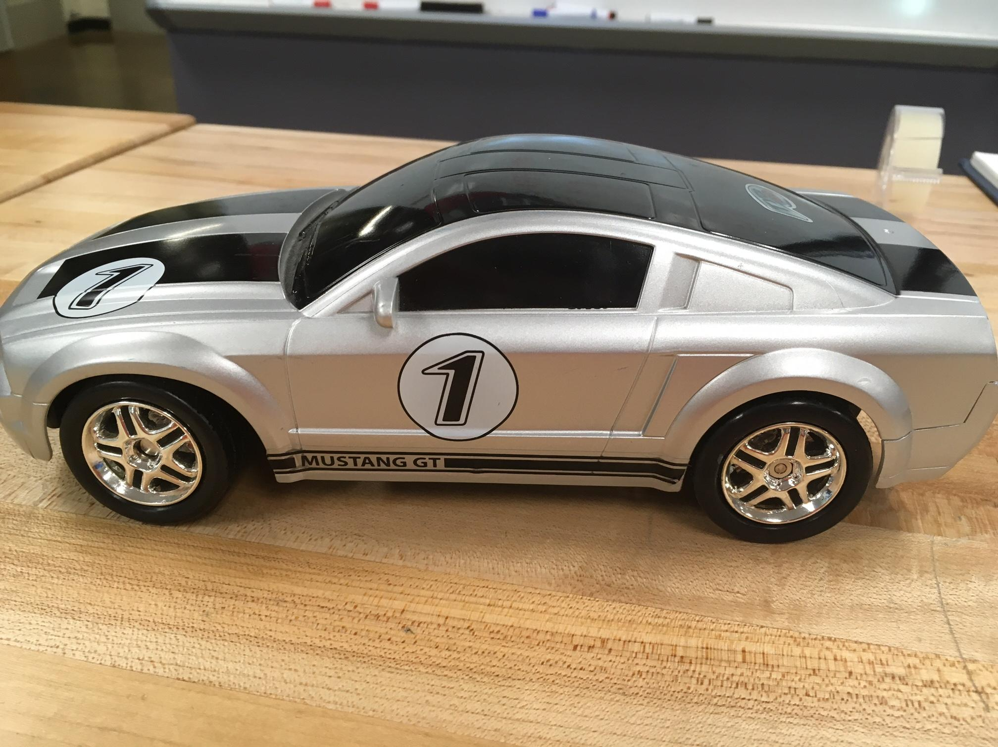
Side view of external shell
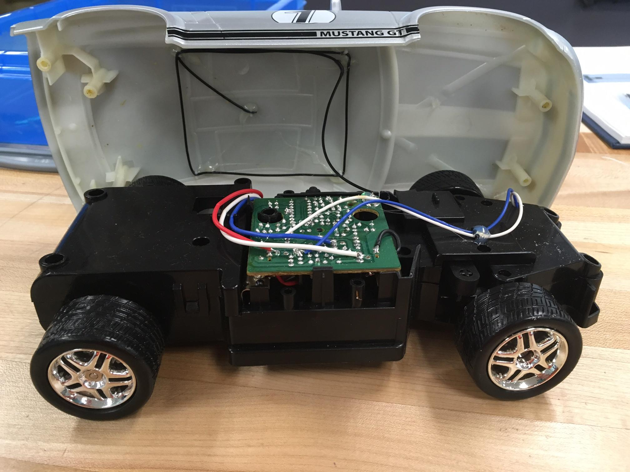View of chassis without external shell. This is the bottom of circuit board with wire connections to front and back DC motors, and antennae.
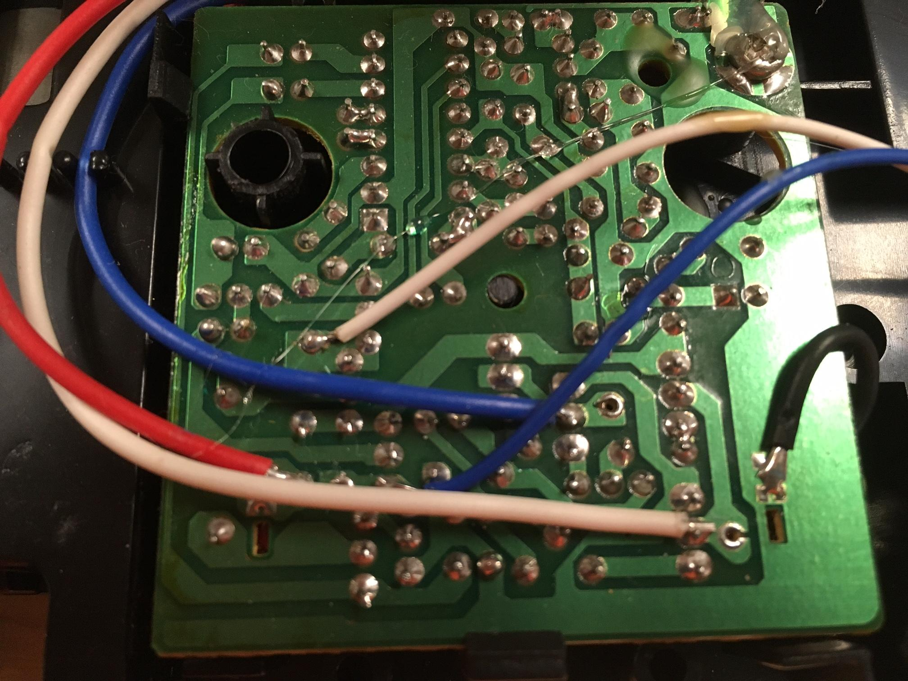
Soldering for the components of the circuit board, and wire connections. As you can see here, this board was soldered by hand and not mechanized.
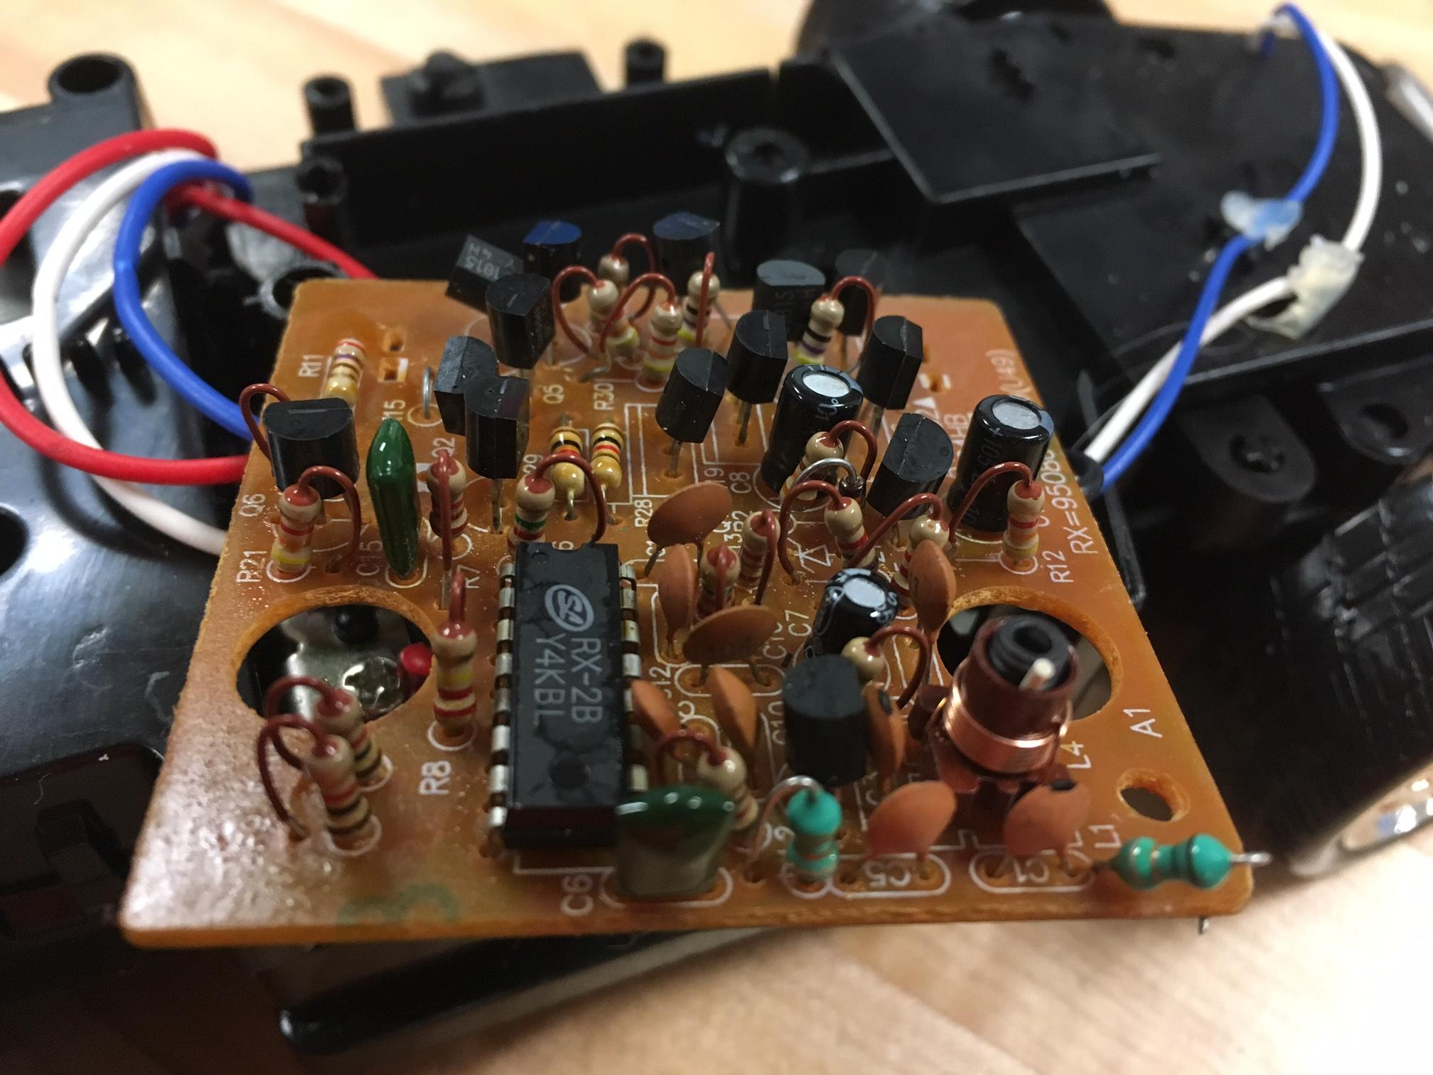
Polyester Capacitor
Receiver
Ceramic Capacitor
Integrated Circuit Chip
Transistor
First look at the circuit board.
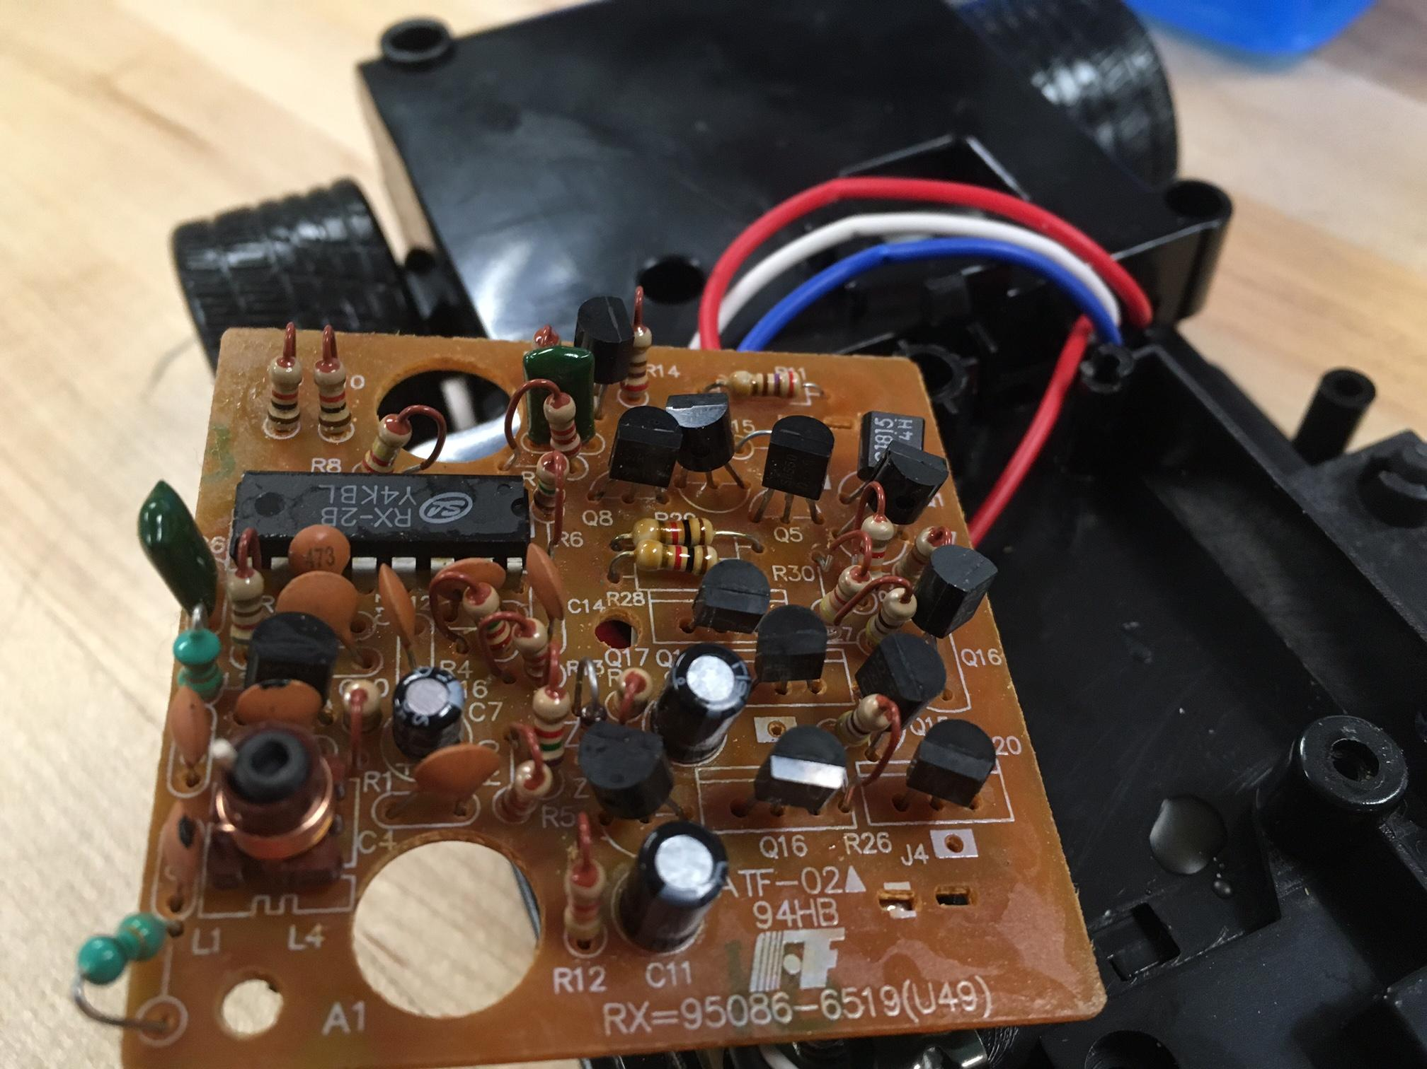This is the top view of circuit board.
Resistors
Resistor
Aluminum Capacitor
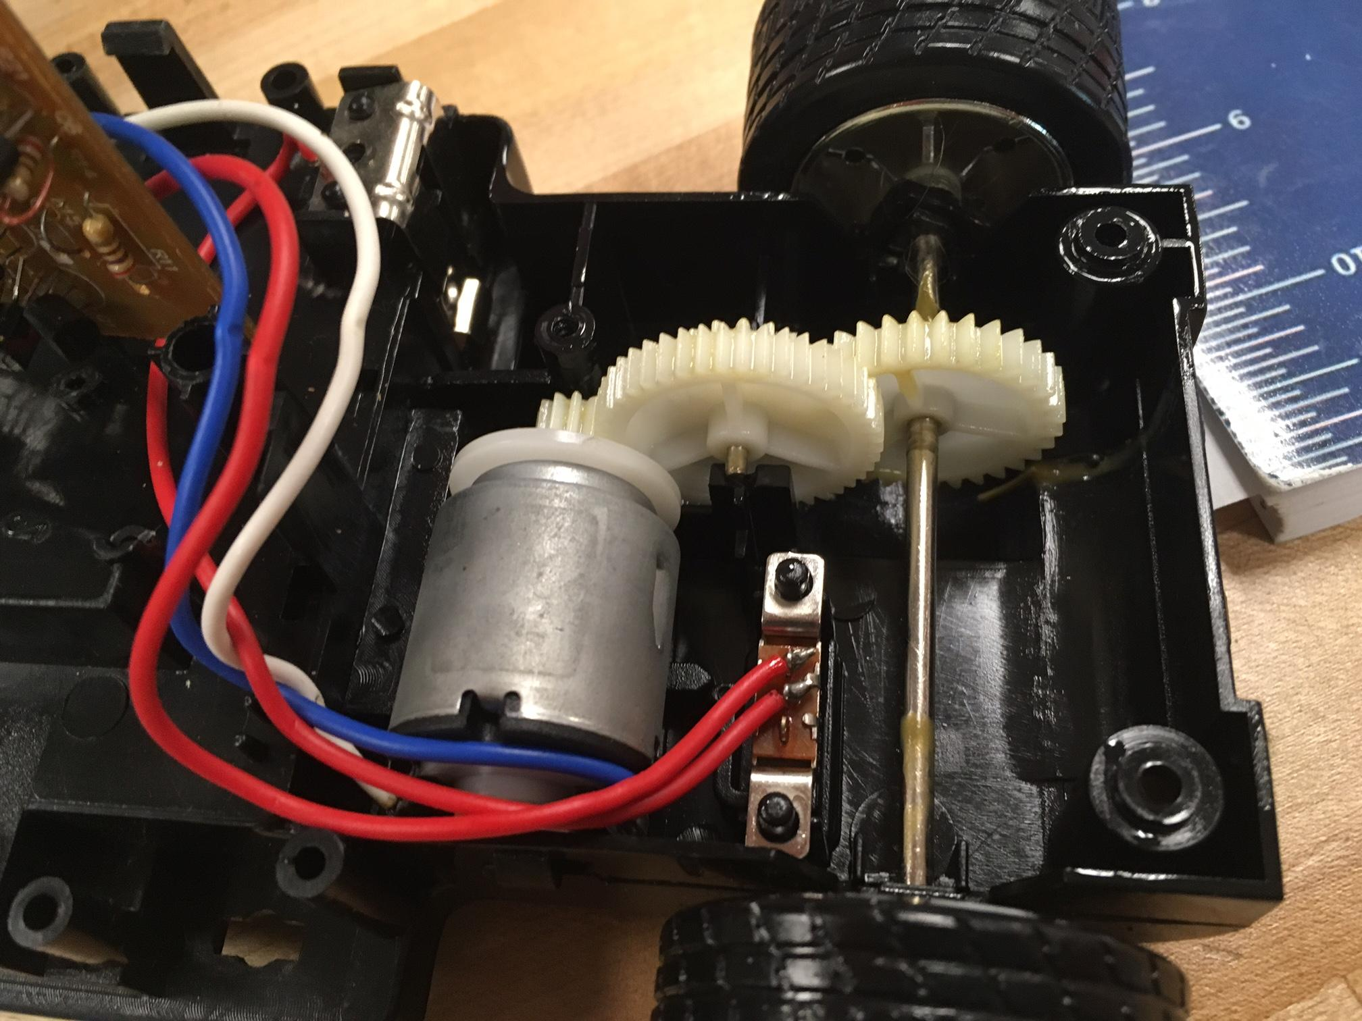Brushed DC motor connection and gears for back wheels.
6:23
5:12
5:46=Overall
Gear Ratio to increase wheel speed
Direct Current Motor
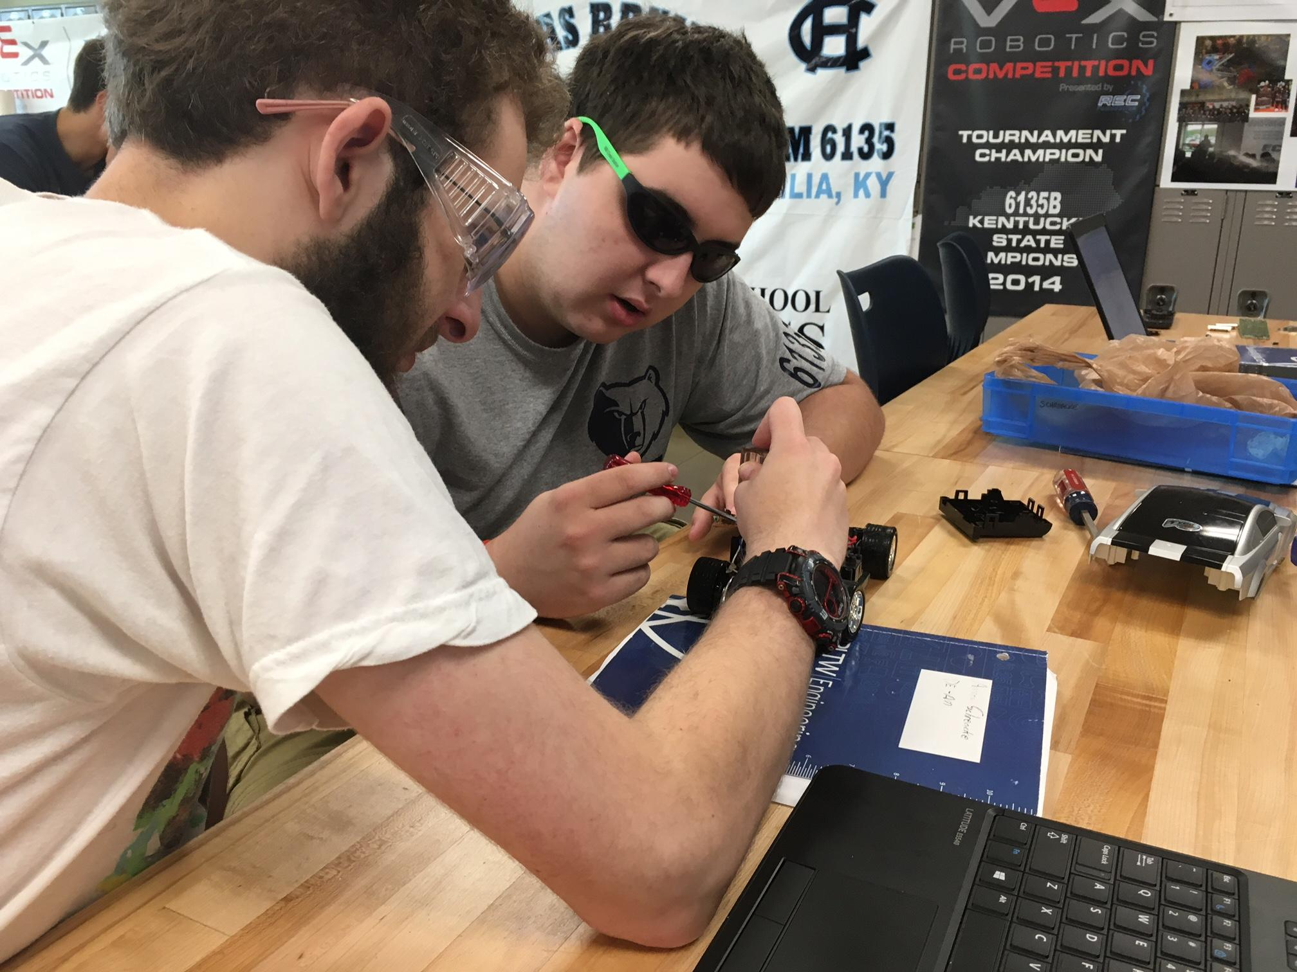Team members are discussing how the components are connected in the circuit.
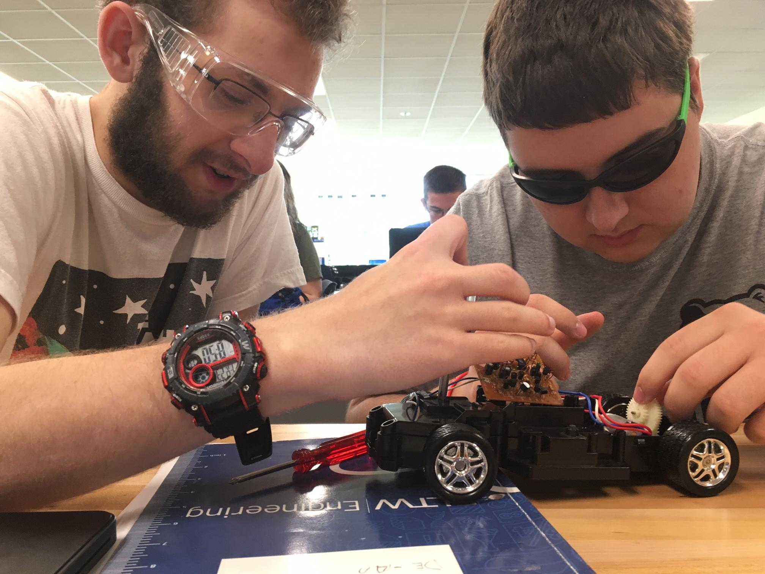The team is examining the circuit board and how it connects to power the motor for the wheels.
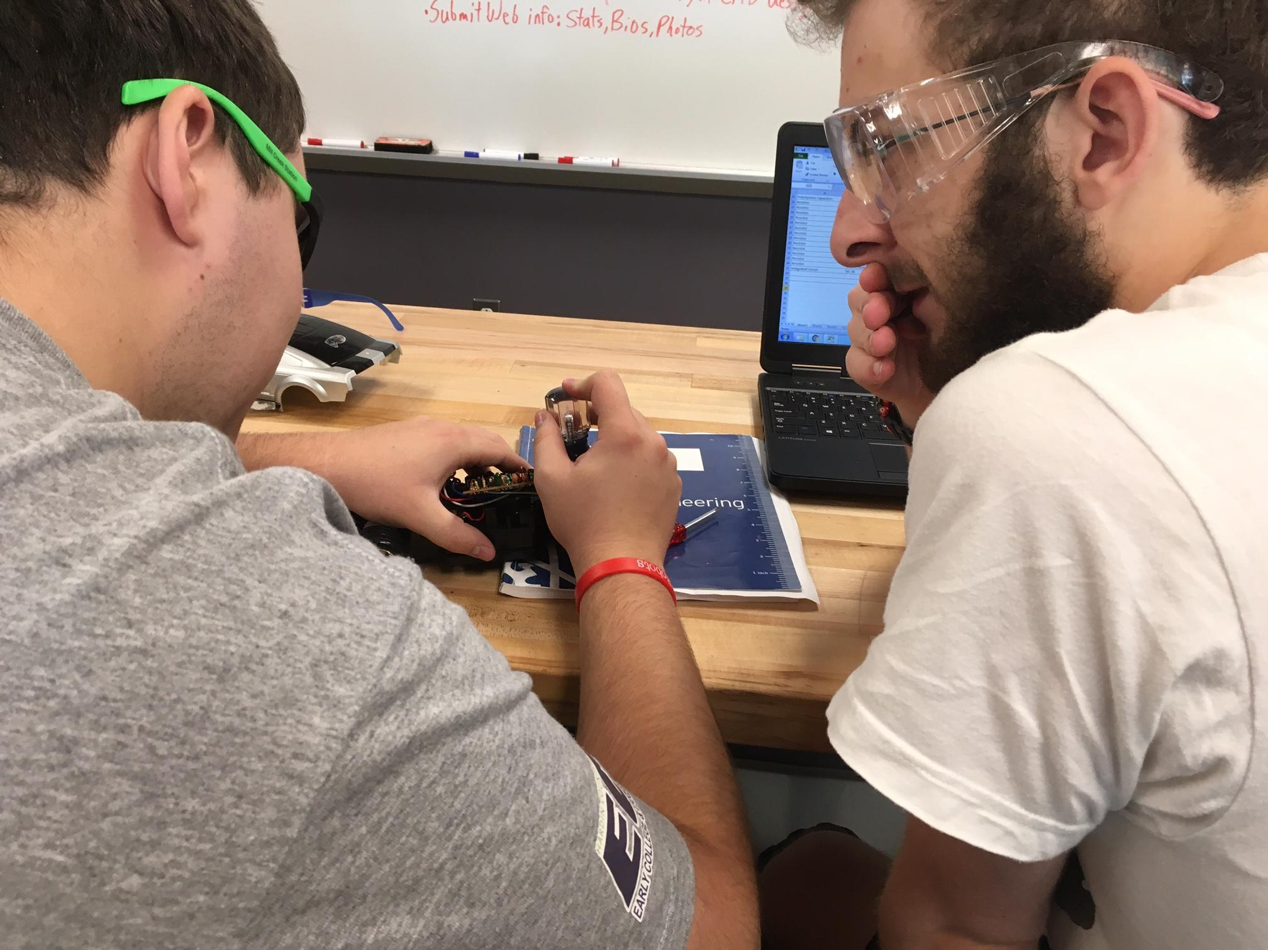
Andrew is disassembling the chassis, while Theron makes note of the progress.

Conclusion
While disassembling this radio controlled car, we have learned a lot. We came to realize just how many components go into even the simplest of things. Inside of the circuit, we noticed how each component was connected to each other through the circuit board: this was a major note we made because this is the first time we have noted how every individual component flowed into each other to accomplish its task. It was a unique experience to see how the different components were used in the real world and not just in theory.

Research and Resources
ALLDATASHEET.COM - Datasheet search site for Electronic Components and Semiconductors and other semiconductors. (n.d.). Retrieved from http://www.alldatasheet.com
Datasheet PDF Datasheets Search & Download :: DatasheetsPDF.com. (n.d.). Retrieved from http://www.datasheetspdf.com
Elite Enterprises (H.K.) Co., Ltd. – Professional LED Light Source Provider。. (n.d.). Retrieved from http://www.elite-ent.com.hk/
Fastest way to Hack RC Car H-Bridge - All. (n.d.). Retrieved from http://www.instructables.com/id/Fastest-way-to-Hack-RC-Car-H-Bridge-1/
Make a Simple RC (Remote Controlled) Robot Car. (n.d.). Retrieved from http://embedjournal.com/make-a-rc-robot-car/
NXP Semiconductors | Automotive, Security, IoT. (n.d.). Retrieved from http://www.nxp.com
SmartLearner. (n.d.). Retrieved from http://www.smartlearner.mobi/science/VideoPastPapers/Electrodynamics/Electrodynamics.htm

