Texas Instruments Electronics Online Challenge
Team 6891A

For this challenge our group chose to disassemble a MadCatz wired controller for the Nintendo Game Cube entertainment system. Most of the members in our group have played or used some type of gaming controller before and were curious about how they worked internally, so we decided to take apart this older and more obsolete controller to understand what was inside. After deconstructing it we identified a few of the parts on the circuit board. Two large boxes that have a metal stick sticking straight up that can move in every direction contain potentiometers that can be rotated in a full circle and give different binary values depending on which direction the analog sticks are moved. Another part that was identified was an uxcell Radial Electrolytic Capacitor. There are two of them on the circuit board. We also identified different types of resistors and transistors on the circuit board, but couldn’t find which company made them or where they came from. A small direct current motor was attached to the back of the board as well, but its manufacturer could not be found. Out of all the components we found and identified Texas Instruments manufactured none. The way the buttons work is that each time a button is pressed it pushes a circular conductive plate onto the circuit board and completes a circuit. This information would be sent through the controller to the console, which would search through the game’s program to see what action on the screen the button will cause. The same process happens on the triggers on the back side of the controller except pressing those would call a small wheel with a metal plate on it to rotate. This metal plate would then complete a circuit for as long as the trigger is held. The analog directional sticks use two potentiometers to measure which direction it is being pushed. These have a constant current flowing through them, but when the stick is moved in a certain direction the flow of electricity is increased or decreased depending on the direction. This change in current will be sent to the console, which will follow the instructions in the program for that directional stick. The small motor in the controller is used to give force feedback to the user. This means that when the player does a certain action in the game the console will cause the motor to turn on and this will cause the controller to vibrate in the user’s hands. It is meant to give games a more realistic feel and show something has happened in the game. A wire connected to the controller connects to the console and sends data to and from it. Overall our group learned more about what goes on inside of a controller and more about circuit boards in general. We learned how simple yet complex this electronic device and others really are and how incredible and innovative technology is.
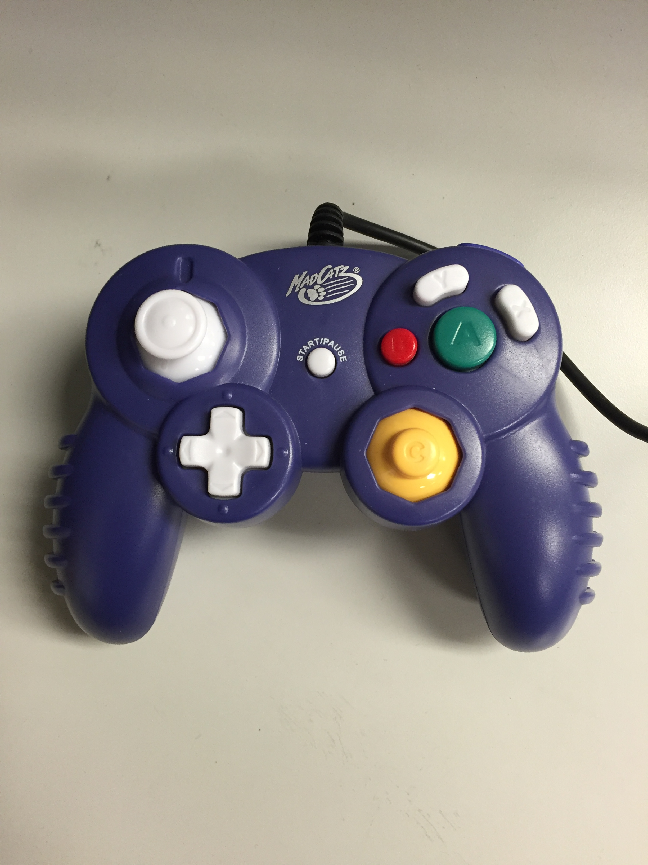

Photo of the top of the controller before disassembly

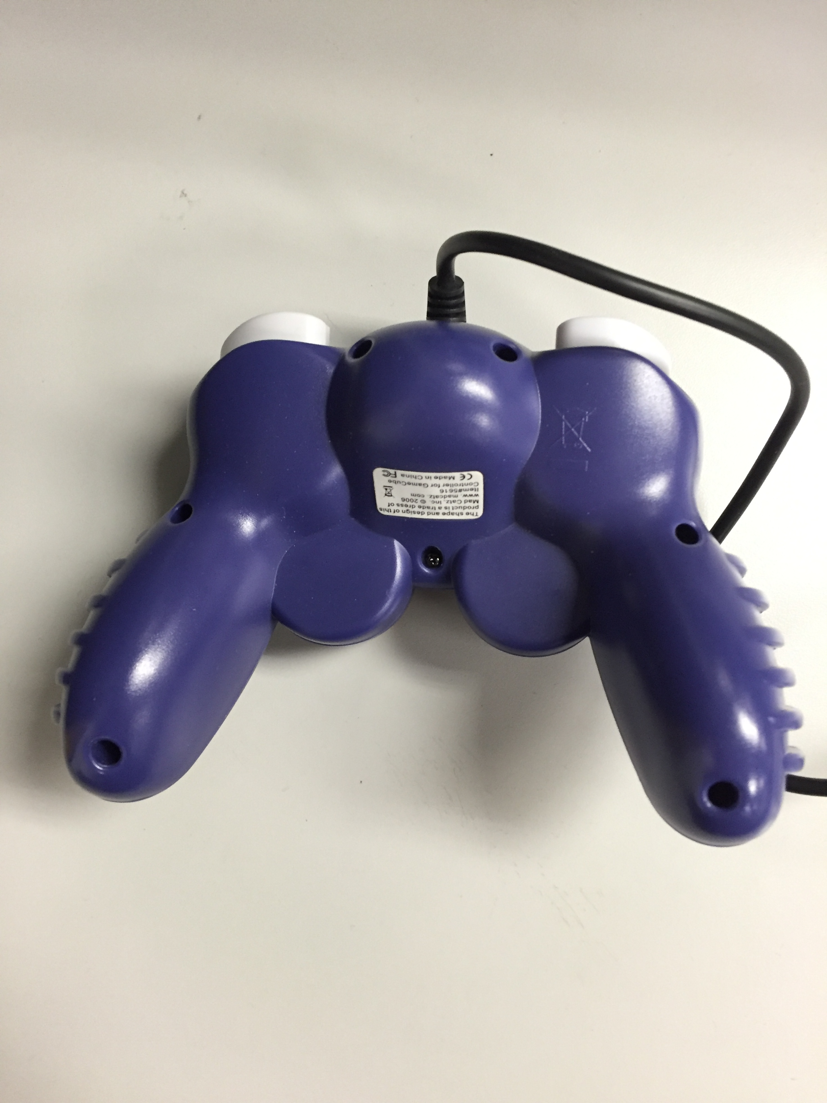

Photo of the bottom of the controller before disassembly
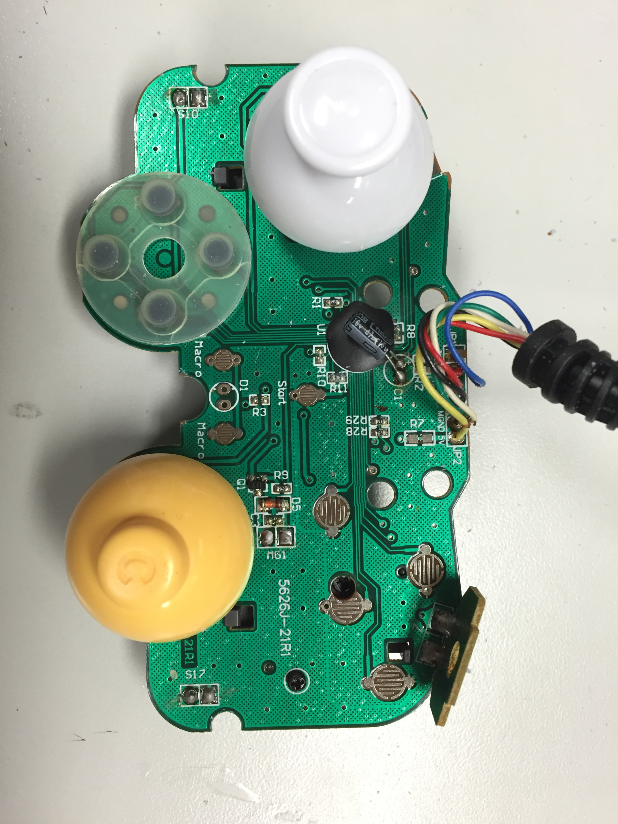

Photo of circuit board with analog sticks still attached
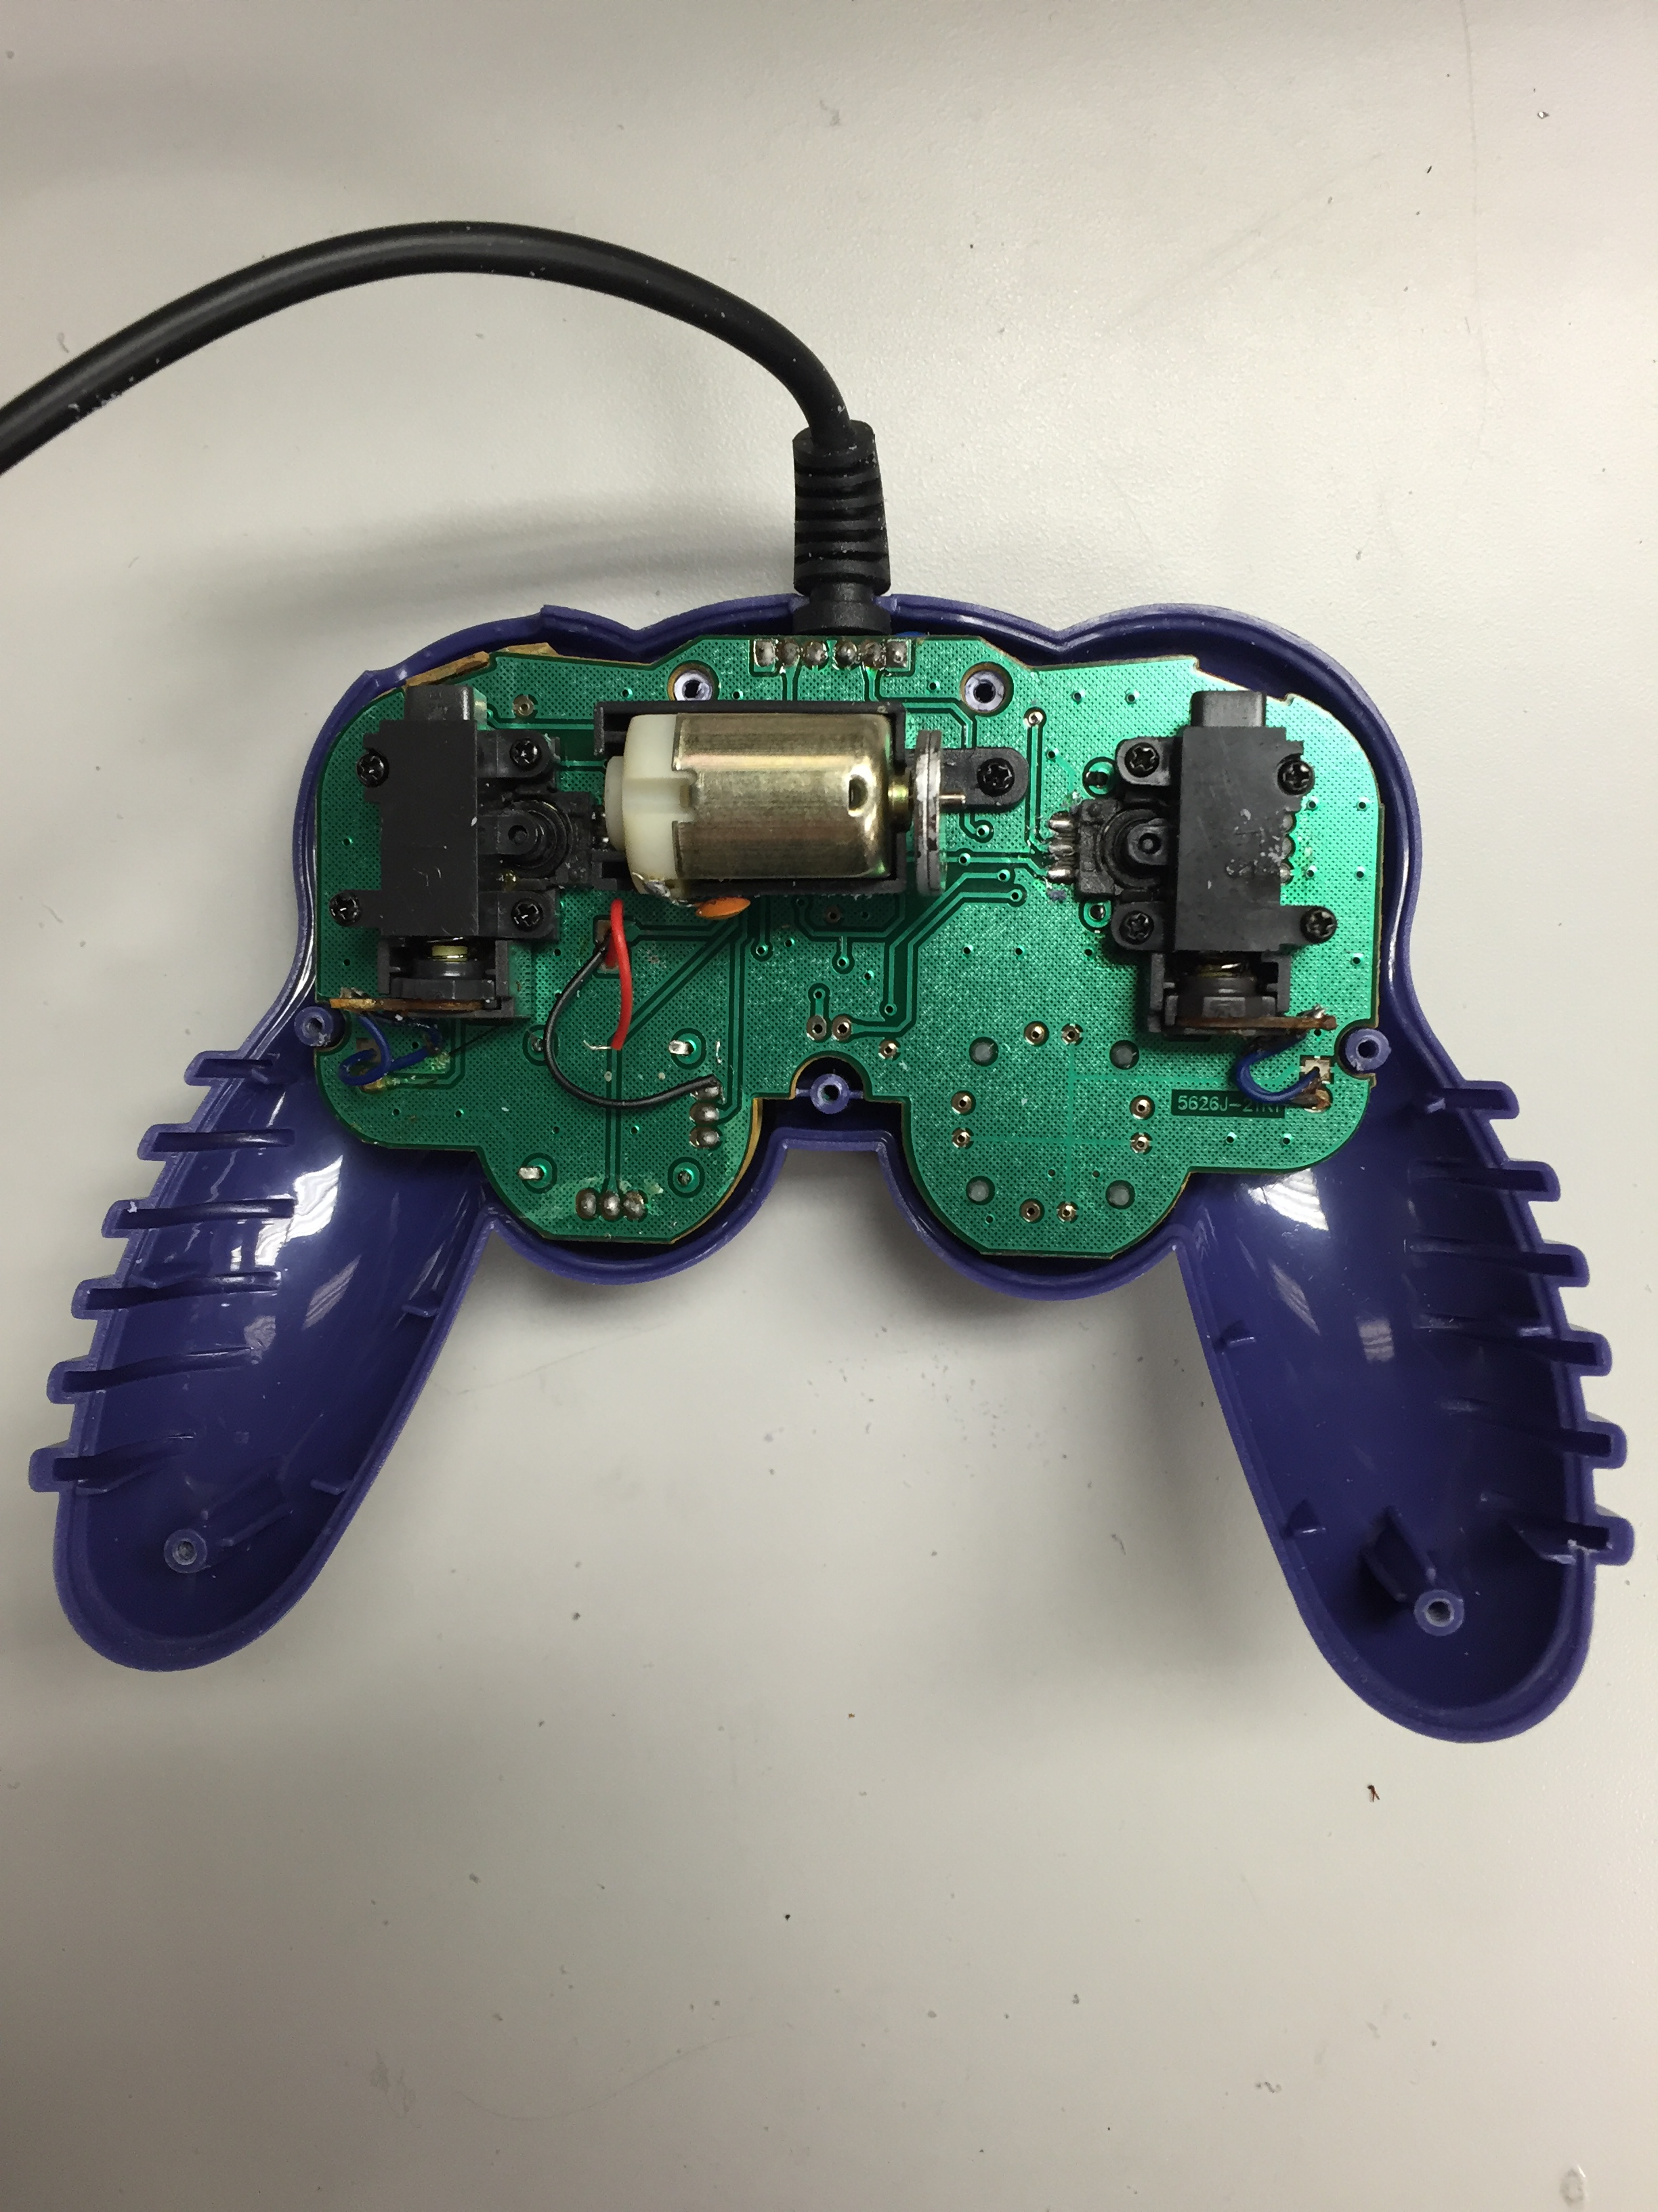

Photo of the back of the circuit board with the motor
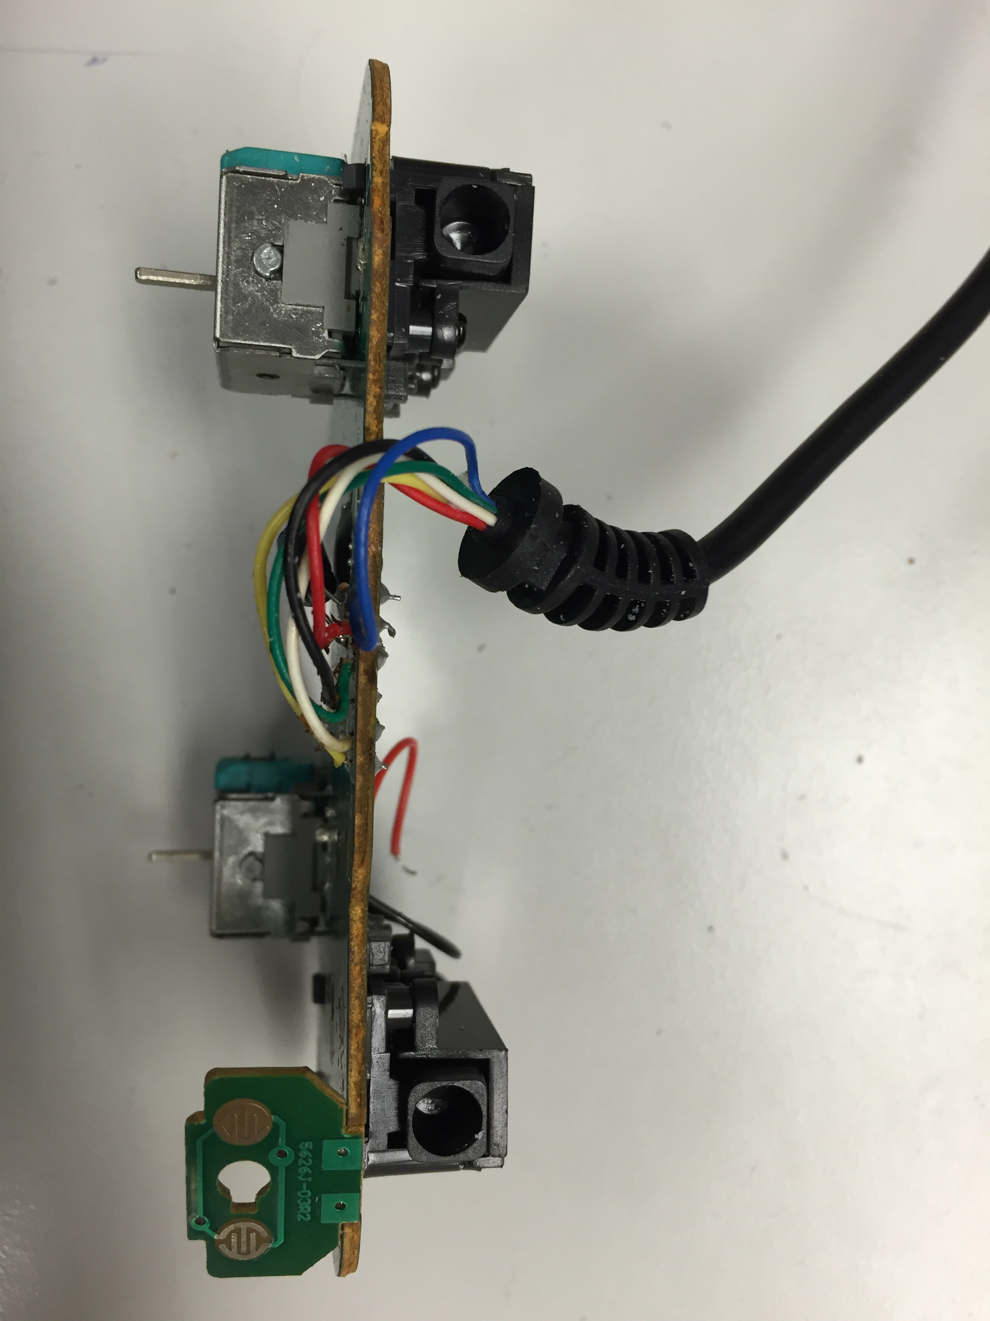

Photo of the side of the circuit board and trigger buttons

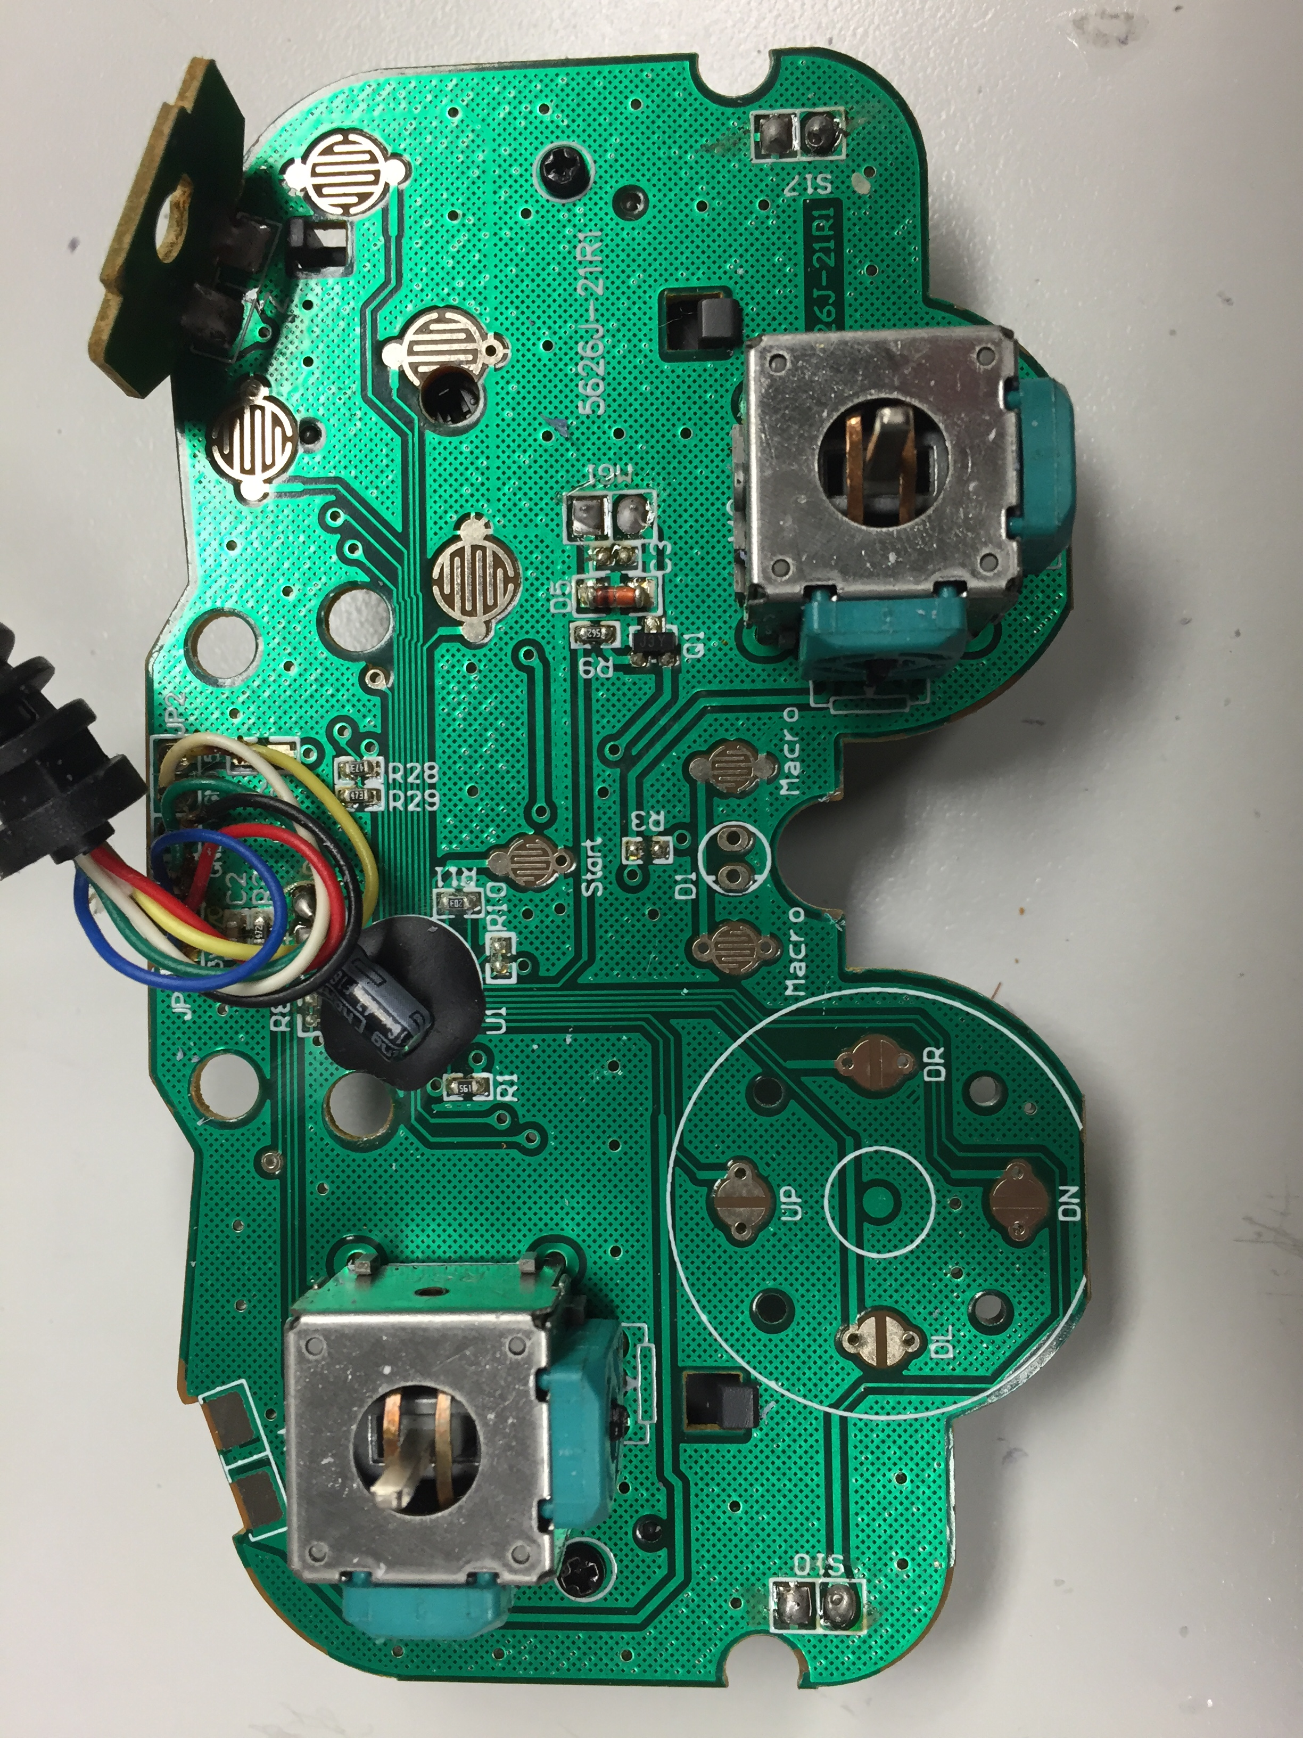

Photo of the circuit board without any buttons or sticks
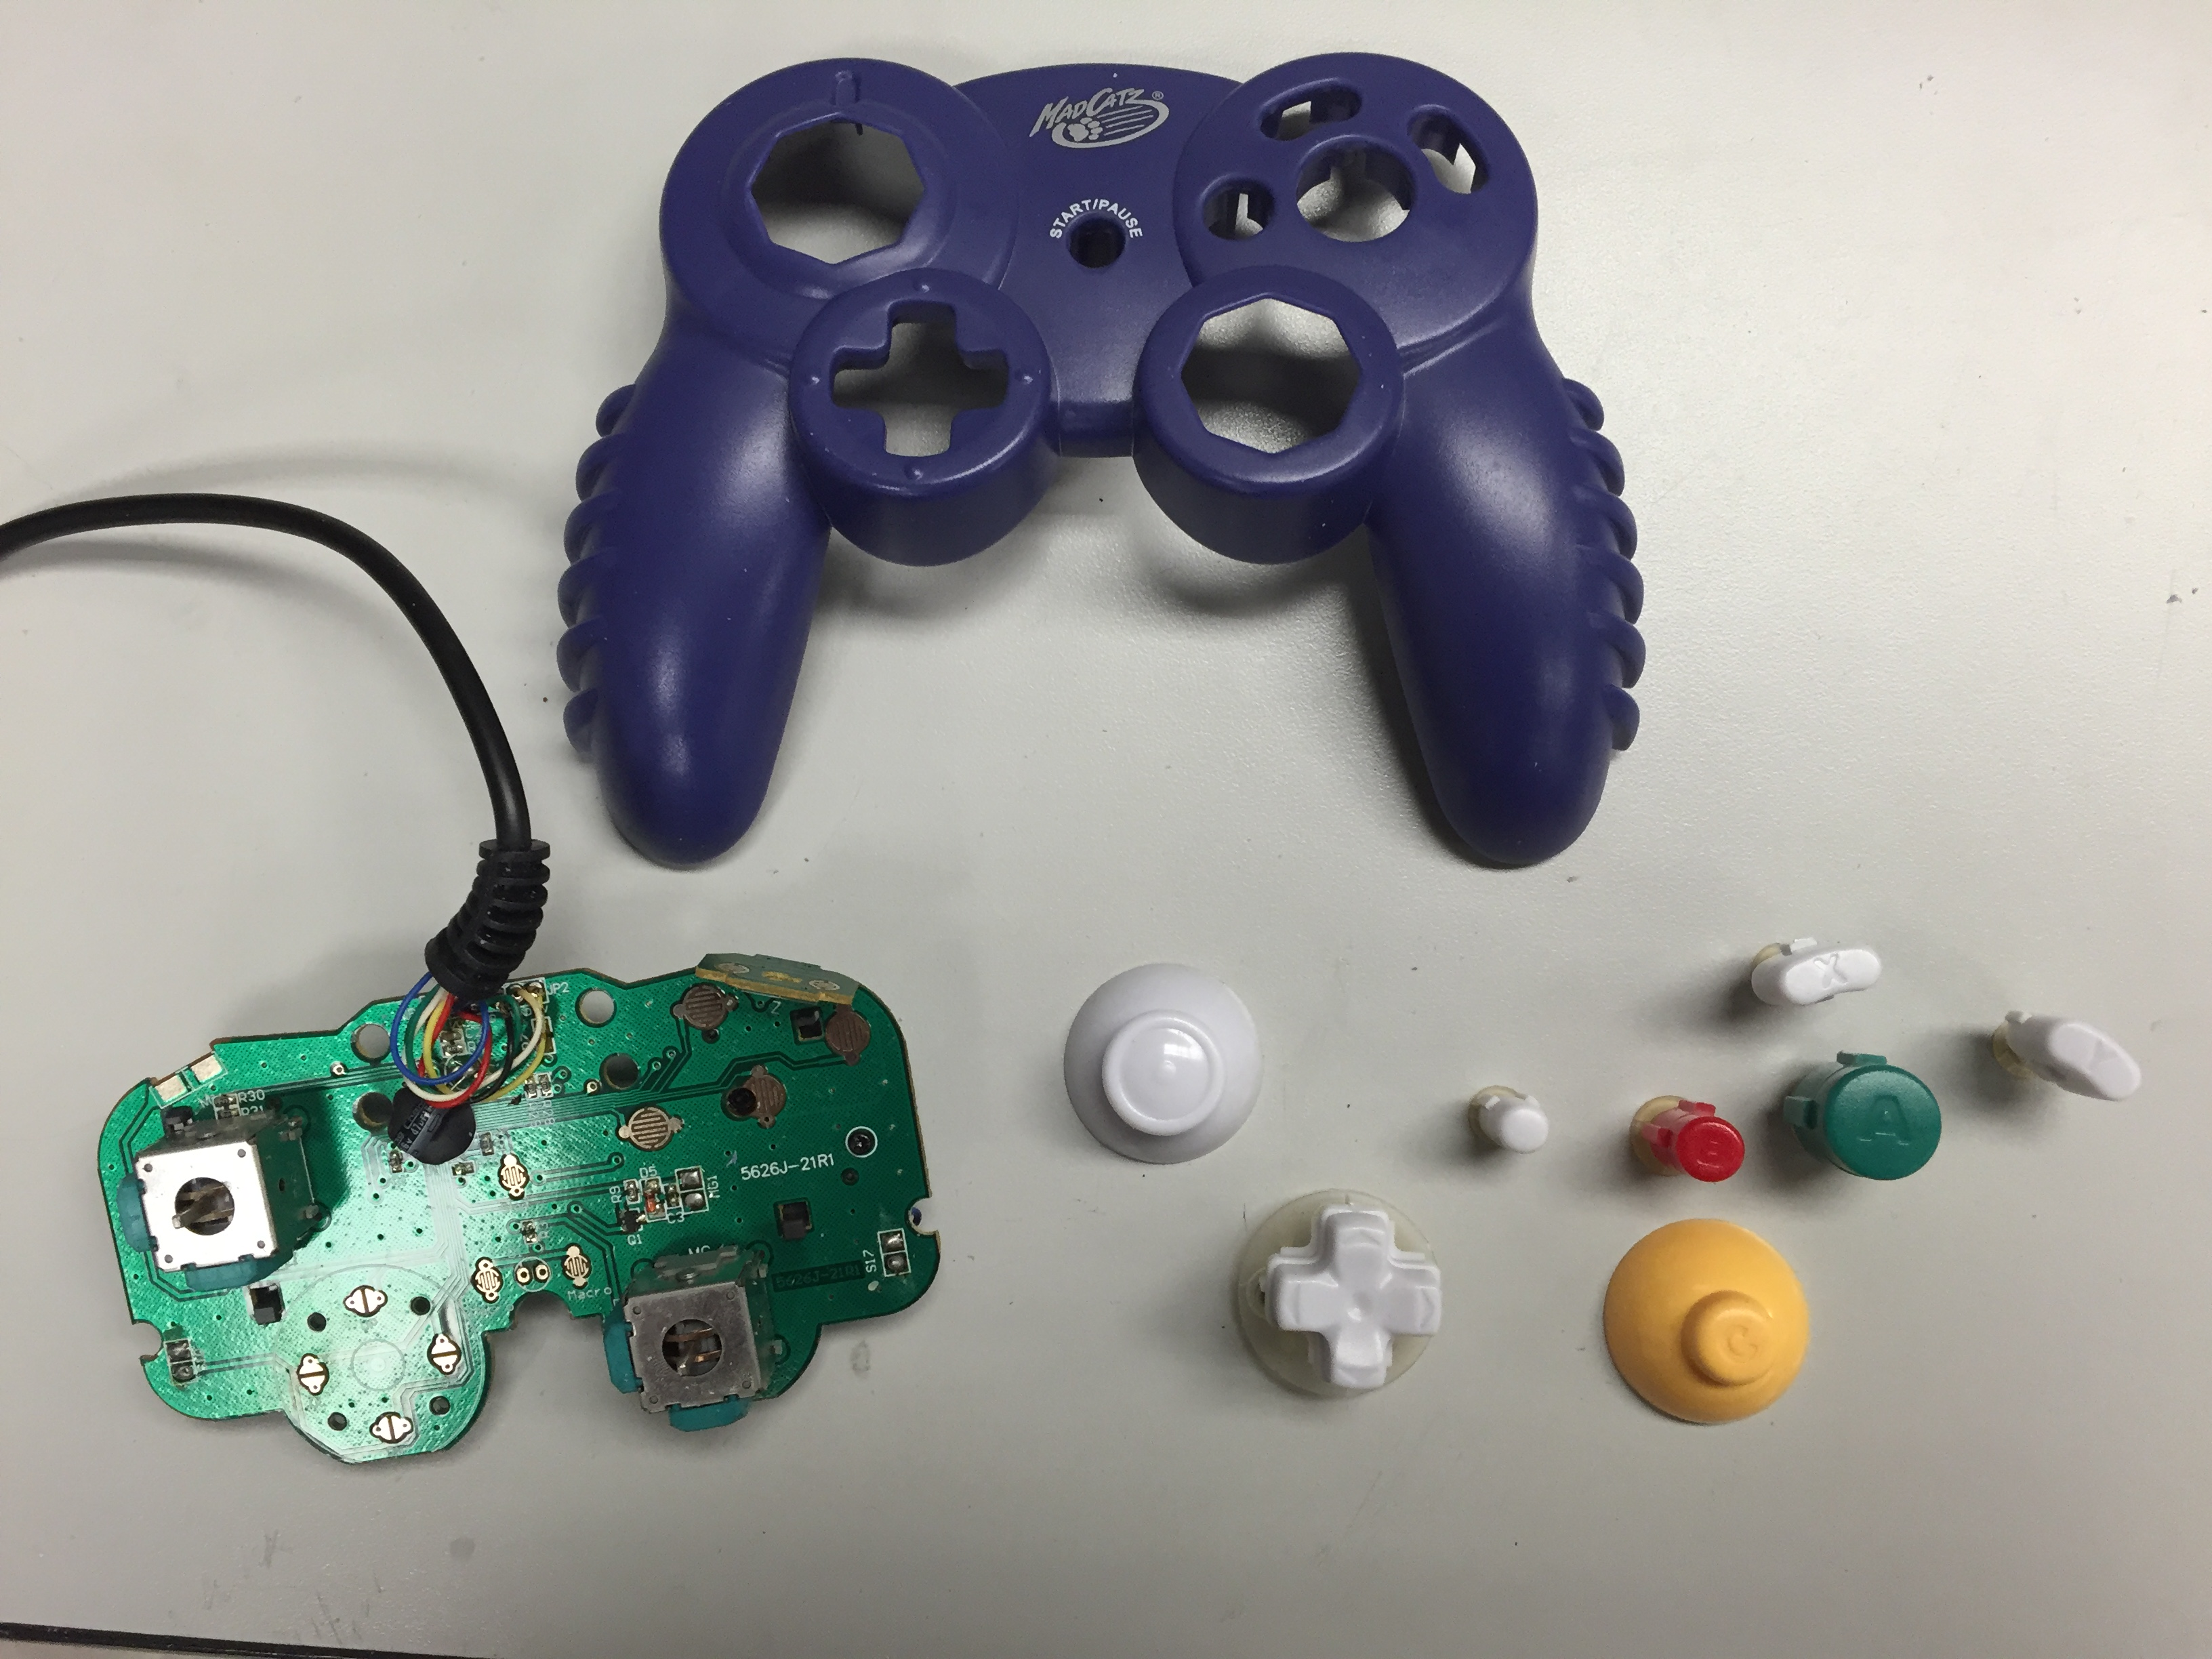

Photo showing the circuit board, controller casing, and buttons in their original layout

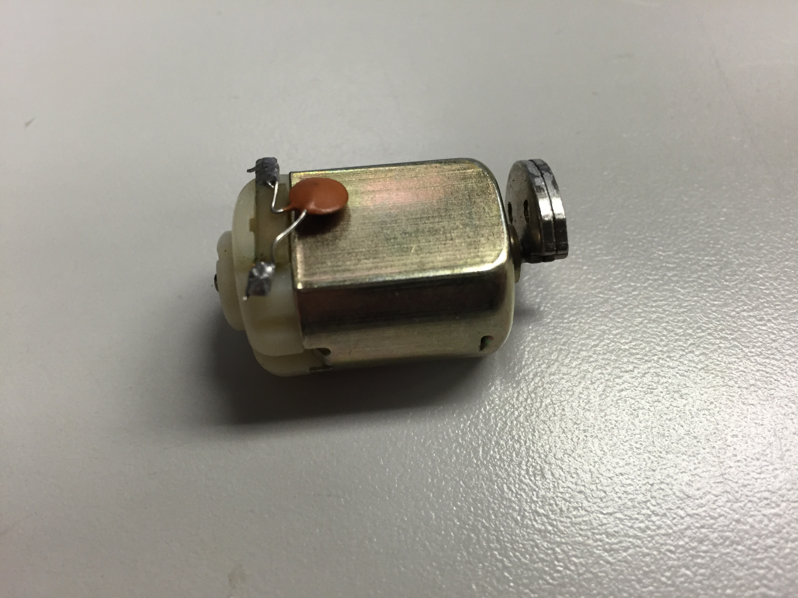

Close-up of the small DC motor in the back of the controller

