+++++++++++++++++++++++++++++++++++++++++++++++++++++++++++++++++++Texas Instruments Electronics Online Challenge

Texas Instruments Electronics Online Challenge

Texas Instruments Electronics Online Challenge

Texas Instruments Electronics Online Challenge
Texas Instruments Electronics Online Challenge

For this online challenge we decided to deconstruct and evaluate a Texas Instruments 1706SV model calculator. We decided to pick this because it had visible screws for easy removal and it was donated to us by our math teacher.

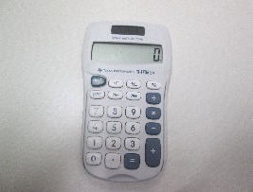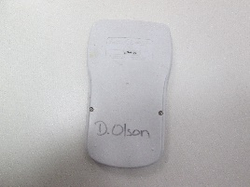

The components we found inside consisted of a 706T-10 motherboard and sensors on the back, a L13154 processor chip, a Panasonic brand LED display, 4 red and black wires connecting to the S+, B-, B+, C3, C2 and C1 outlets, a grey and black keyboard membrane, one little battery, a glass screen, and of course 23 keys.
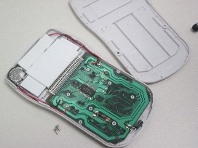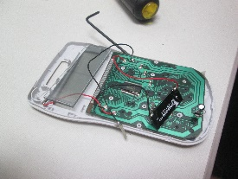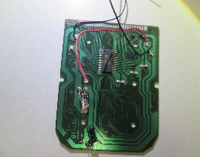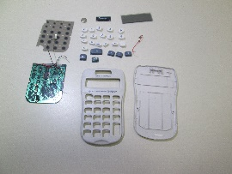
These components all have a function in the calculator, such as the processor chip, it is the 'brain' of the calculator, it does all of the math. The keyboard sensors and membrane allow you to type the numbers by pressing the keys. The wires connect the sensors to the display and send information, allowing you to see what you type.
We learned a lot from this challenge, many of us did not know how much technology was in a calculator, and we probably would have never wondered! This challenge also opened our eyes to the world of technology we overlook everyday. This also allowed us to gain more knowledge on the components that we use all the time in everyday object, and as a bonus we had fun doing it!

