Texas Instruments Challenge: iPod Touch Dissection
Team 5735B

Technology is incredibly impactful on everyday life as well as robotics; in fact, it will hold the key to our futures as engineers. For this reason, it is useful for students of STEM to learn about the functionality of electronics as we interact with them in our robotics-related work. Our Vex team undertook the Texas Instruments Electronics Online Challenge to further our knowledge of technology on the subject of semiconductors.
To begin our team’s research on semiconductors, it was decided to disassemble an iPod Touch, 4th Generation. This device was designed in 2010 as an alternative to the smart phone, with similar functionality to the iPhone, albeit without cellular communication. It was chosen because of the versatility of smart phones, with their wide variety of sensors and chips. One team member possessed a nonfunctional model of this device, which was used by the team for disassembly and research.
Removing the screen from the iPod revealed many cables connecting input and output devices to a central motherboard. The cables were labeled with serial numbers and manufacturer names of the devices that connected to each cable. Each article belonged to the same production family: “Apple 821.” In addition to the wiring, the headphone port and motherboard contained information about the make of the devices.
In removing the screen, two semiconductor labels were discovered. They were marked as “Apple 821-1125-A” and “Apple 821-1174-A,” with Apple being the manufacturer and the numbers being their serial designations. Research shows that these components controlled the combined LCD (screen display) and digitizer (touch-screen input sensor).
Another semiconductor was marked “Apple 821-1069-A,” evidently related to the other two components by its serial number. This device detected input in the form of a button on the iPod’s front face.
One final cable was labeled “Apple 821-1096-A.” According to research, this cable connected the motherboard to a Wi-Fi signal antenna.
The iPod’s sound apparatus was labeled “Foxconn” with no serial numbers. Research shows that Foxconn is the company which assembles iPods. They also produce some components used in Apple devices.
The motherboard itself read “Apple 820-2991-B.” It is meant to facilitate communications between all the input, output, and processing devices in the iPod, using semiconductors to transfer information.
Most of the components found in the iPod were made by Apple, as Apple uses proprietary devices whenever possible. However—research shows that in earlier models of the iPod Touch, many components were produced by other semiconductor manufacturers, including Texas Instruments.
In conclusion, the iPod Touch is a complex machine which uses many semiconductors produced by Apple to enable electronic communication. In dissecting the iPod, our team enriched our technological knowledge. We learned how semiconductors carry information by conducting electricity with high resistance. We also saw how prevalent semiconductor usage is in modern electronics.
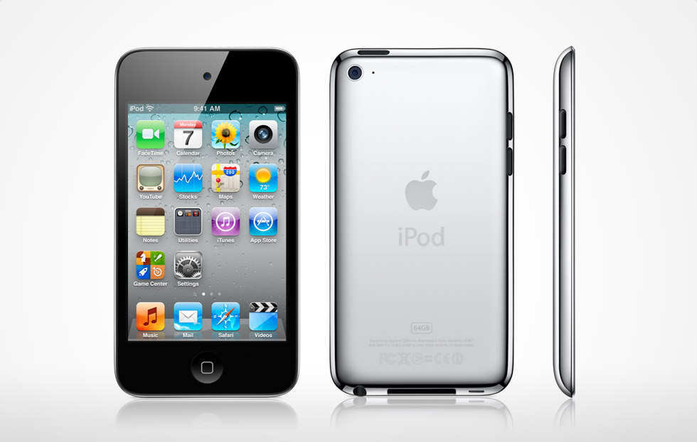
The intact iPod Touch, 4th Generation—the subject of this dissection.

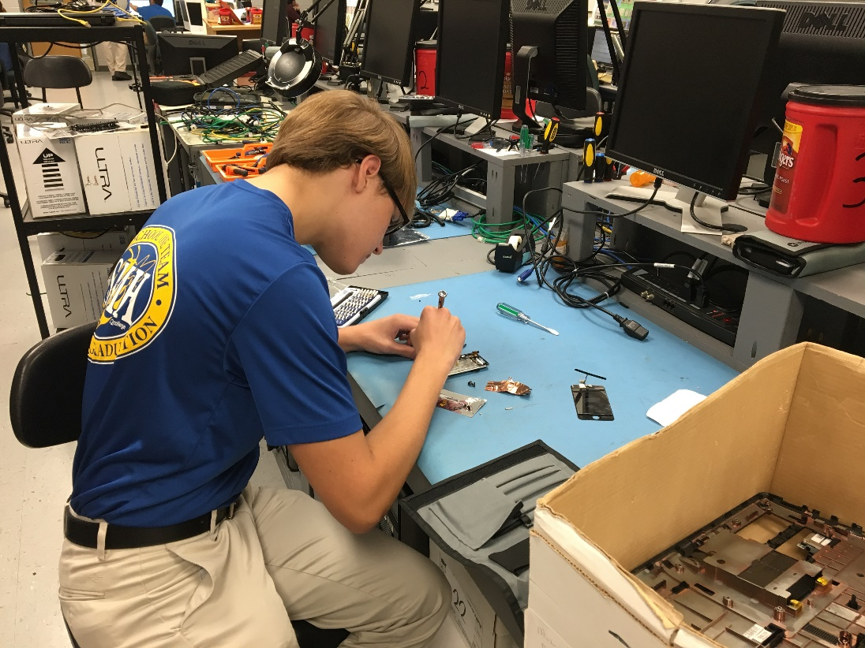
One team member working on the deconstruction of the iPod.
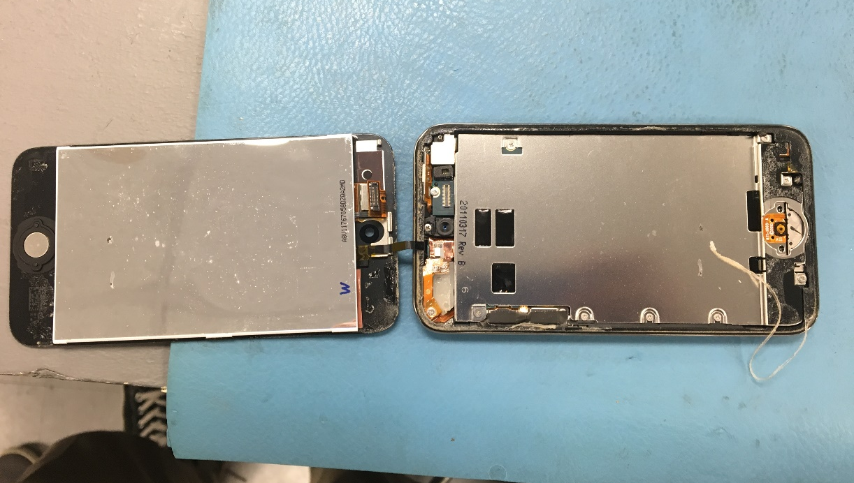
The screen of the iPod has been removed, but it is still attached to the rest of the iPod by a ribbon cable.

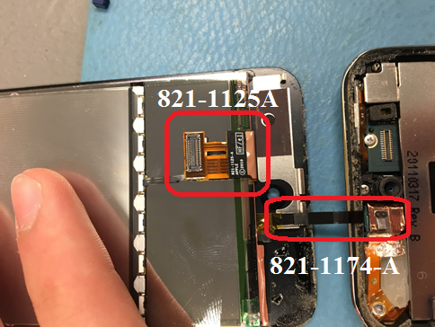
The LCD and digitizer cables—821-1125-A disconnected from its motherboard connector on the right, 821-1174-A connected to the motherboard.
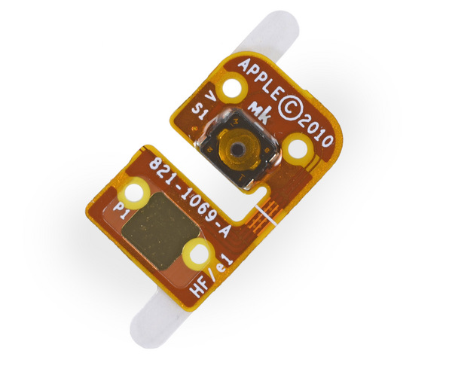
Front face button control chip—821-1069-A.

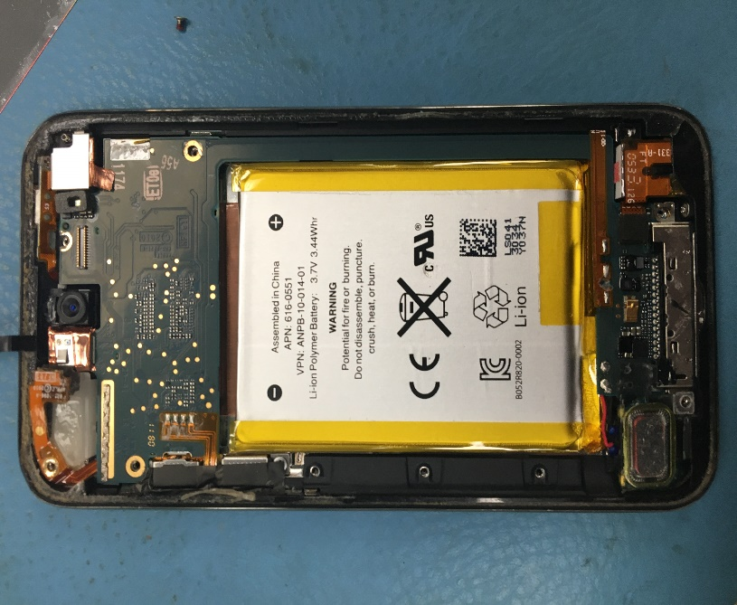
iPod after removing the screen. The motherboard extends from the top to the bottom of the frame, wrapping around the side of the battery.

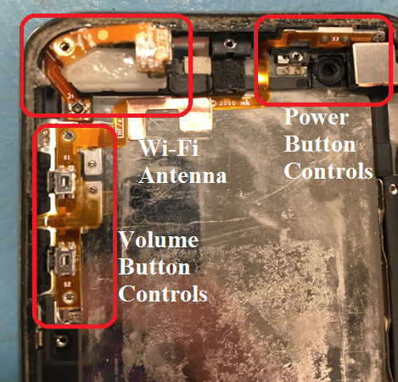
iPod after removing motherboard and battery. The Wi-Fi antenna and button controls are visible on the outside of the iPod frame.

Sources:
http://www.powerbookmedic.com/parts/GS178171/Logic-Board-64GB.html
https://www.semiwiki.com/forum/content/3119-brief-history-apple-ipod.html
https://support.apple.com/kb/sp594?locale=en_US
http://vi.raptor.ebaydesc.com/ws/eBayISAPI.dll?ViewItemDescV4&item=321369067939&category=48680&pm=1&ds=0&t=1482341540489

Special thanks to Mr. Rickey Corker for providing our team the opportunity to participate in this project.

