Developing Robots to Ease the Use of Household Fixtures and Appliances
by Amanda “Alex” Hindelang

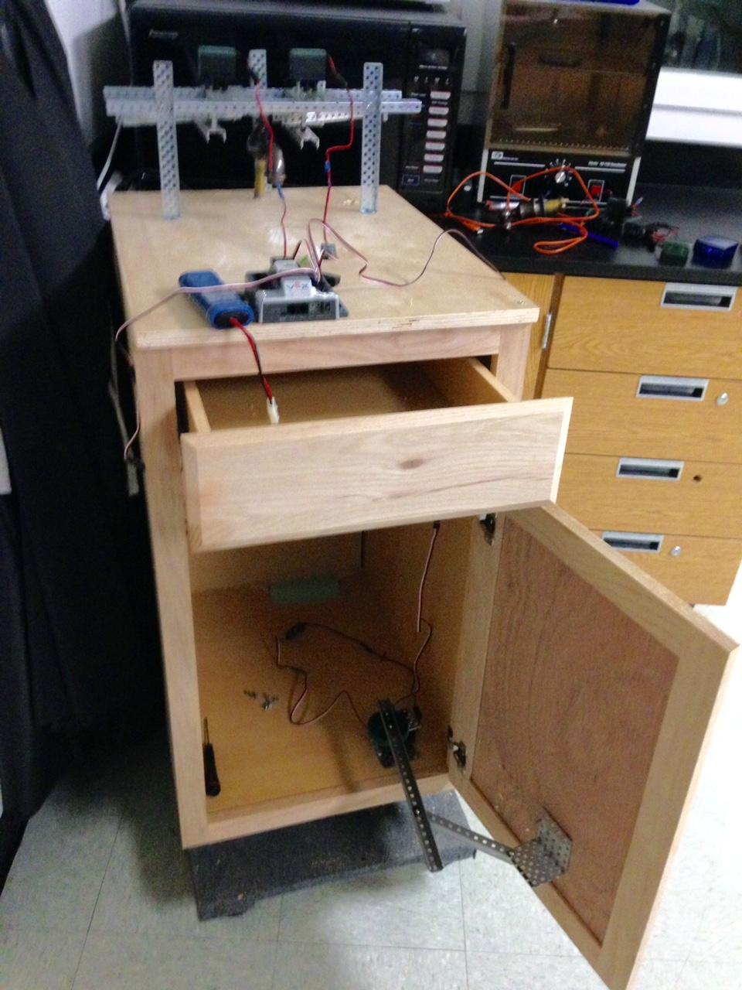

Introduction
The idea of an autonomous household has been experimented with in science fiction for years. Luxuries like kitchens that prepare and cook meals, bedrooms that can adjust their conditions for optimal comfort, and plenty of other things have captured people’s imaginations. While some of this may remain a dream, robots absolutely can be useful in households, especially when completing everyday tasks is a challenge.
For disabled and chronically ill people, grasping handles, opening and closing doors, and bending to reach things can be difficult--if not impossible. While methods of coping with these disabilities are available, there are few solutions that ease the use of appliances that might otherwise be troublesome. Current robotic systems are expensive or in early development; caretakers can help but reduce one’s ability for independent life, and can also be expensive to hire, unreliable, or even abusive.
Robots that can complete these tasks at the push of a button make a home more accessible and allow for a more independent lifestyle. The challenge is making a series of robots that can effectively simplify tasks involved in cooking, cleaning, and using appliances, while remaining cost effective and easy to use and install.

Materials and Methods
Item | Quantity
393 Motor | 4
1x2x25 C-Channel | ~7
Angle Coupler | 4
Axles (usually ~3 in) | 4
Linear Motion Rail | 1 set
Rack gears | ~16
Motor Mount Channel | 2
Angle Gusset | 1
Compatible Microcontroller | 1
Joystick Controller | 1
Wi-F/i Keys | 2
Motor module | ~4
7.2V Battery (&Charger) | 1
Bearing Flats | excess
Screws | excess
Nuts | excess

To construct the robots, you will also need screwdrivers, hex keys, a saw, self-boring screws or adhesive, and a drill for mounting the robots.

Drawer Construction

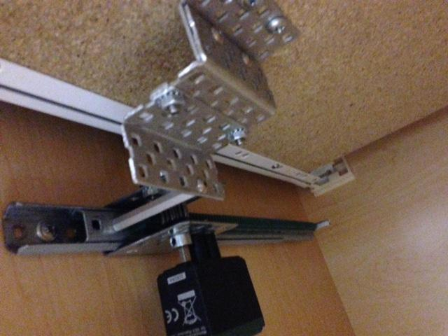

- Prepare a linear motion rail.
- Attach rack gears to almost the whole length of the thinner rail, leaving two holes on either side.
- You will now create a holder that will be attached to the bottom of the drawer, pushing and pulling it forward and backward. Prepare 3 angle gussets and 1 standoff.
- Create a stair-step pattern with the angle gussets, screwing them to each other.
- Mount the holder to the rack gear with standoffs and add a motor.
- Installation: Hold the drawer opener to one side of the fixture below it. Make sure the connector is touching the bottom of the drawer. Mark this location with a pencil. Place self-boring screws inside the lower track (without the rack gear). Move the top track aside to reach the screw. Aligning the drawer opener with the marks, screw it into place on both ends. Then, holding the drawer, screw the holder into its bottom. Ensure this is stable, with at least two screws; movement will disrupt the drawer and the robot alike. This procedure can be replicated with a strong adhesive taking the place of the screws.

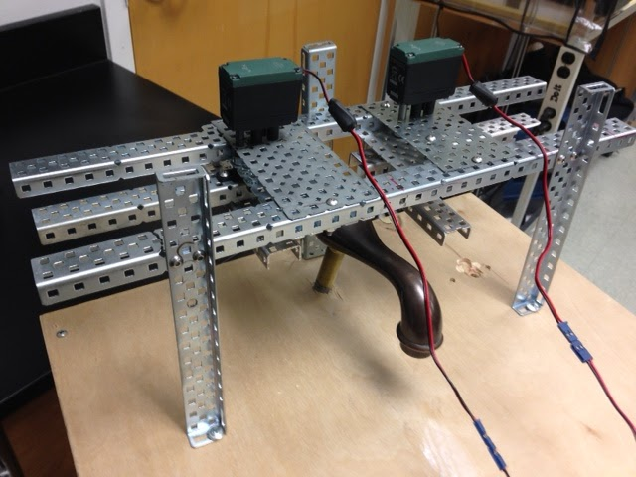
2-Handle Sink Construction

- Prepare two medium-sized c-channels to hold the handles. Attach bearing flats to the inside of the c-channels depending on the thickness of your handles to keep a tight grip.
- Opposite of the bearing flats (without bearing flats, simply to one side) attach lock plates to both channels.
- Now, you will start the base. Place two long c-channels parallel to one another. The space in between them should be roughly 2 centimeters wider than the width of the actual sink’s base, but less wide than the countertop area for the sink. Use plates on either side to bridge them, then use chassis rails to create legs.
- Mount motors to the metal plates, then add axles and affix the handle holders.
- Installation: This robot can simply be placed over the faucet, though the height and spacing of the plates may need to be adjusted.

Cabinet Construction
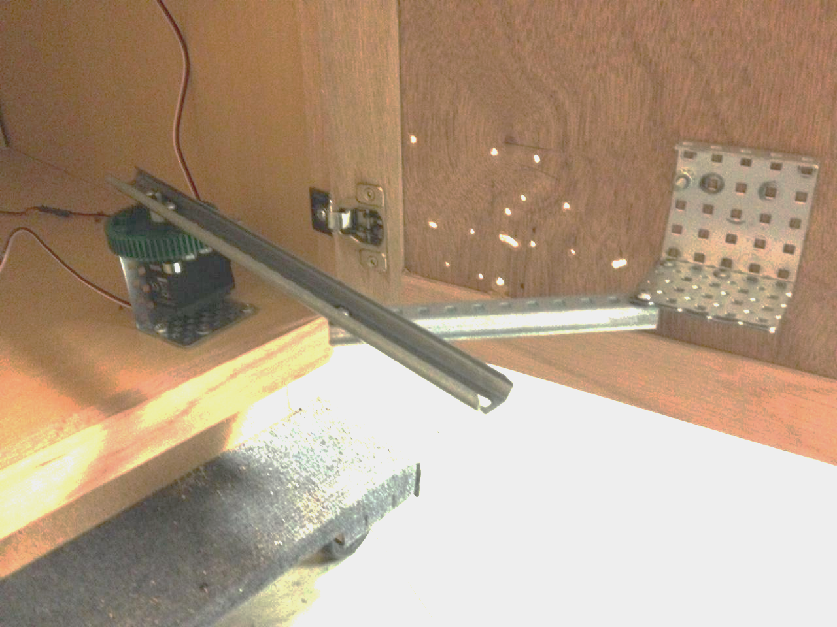

- Prepare 1 winch bracket, a motor, an axle, a sprocket (optional), a bearing flat, a motor coupler and coupling axle, and collar locks and screws.
- Screw the motor to one of the parallel sides of the winch bracket, including a bearing flat.
- Attach a c-channel or angle gusset to the inside door of the cabinet.
- Prepare two short linear tracks, attaching a lock plate to one end. About ¾ down from the lock plate, screw one rail to the other. Then, screw the angle gusset or c-channel into the shorter rail’s end, ensuring the part with the greatest surface area is perpendicular to the rail. This forms the arm.
- Now, slip the arm onto the motor’s axle and secure it well.
- Installation: Screw the arm’s holder (c-channel or angle) onto the door of the cabinet, towards the middle of the door. Hold the other base in place a few inches from the side closest to the door and gently push the door closed to ensure the angle is correct. If so, mark the location with a pencil and then screw the base of the winch bracket into the floor securely.

Programming and Wiring
- Example of a motor map with speeds and Joystick channels: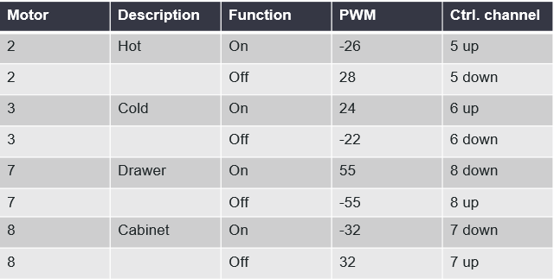
- Program example: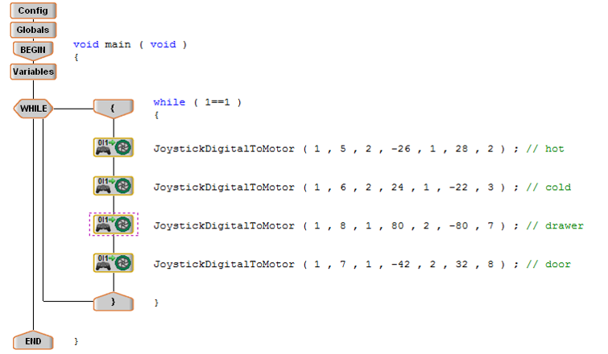

Applications
The CDC has found that around 33% of noninstitutionalized American adults have difficulties completing basic and/or complex tasks due to physical disability. This means a large population of people are unable to complete tasks that able-bodied people might find easy, including using fixtures in one’s home. Many methods of coping are expensive, in early stages of development, or unreliable, so more, better developments must be made. Any way of reducing the strain on one’s body can help someone in need. These robots are able to automate many of the movements and processes that give people difficulty, making them useful in everyday life. While there is no guarantee that these robots can replace pre-existing coping mechanisms, they will provide greater autonomy for users overall. Once perfected, these robots and others could be produced and marketed, so they could be utilized in homes or even professional settings.

