Introduction:
Throughout Team 22283A's years in robotics, we always came across the problem where we run out of spaces for gears to make a high torque four bar lift, six bar lift, scissor lift, etc. Because of this problem, we decided to create a gearbox that increases torque by adding more "chains" of the gearbox in front of the next. Our project is a 3D printed epicyclic gear kit/set which incorporates an Epicyclic gear box that can be continuously added on to increase the torque of a system; the more epicyclic gear chains added, the greater the torque. Unlike a single epicyclic gear, our epicyclic gear box uses multiple incorporations of epicyclic gears revolving against a ring gear which generates the movement of a secondary sun gear that turns more epicyclic gears. The entire gear set is able to be connected to both vex plates, panels, C- Channels, etc. on one end and a VEX 393 motor on another end. The epicyclic gears inside are not directly compatible with regular VEX Gears, meaning the interior planetary gears cannot move regular VEX Gears; the gear box itself is very VEX-friendly. Once again, we are pioneering the VEX-friendly planetary/epicyclic gear box, due to the fact that VEX gears can already be made into an epicyclic design (however, VEX doesn’t include gear rings), not the planetary gear itself.

How it works: *Note: Below is an explanation of the 3 different parts. Not the entire gearbox itself

- 393 Motor Attachment End
This end of the gearbox which consists of a part where a standard VEX 393 motor can be attached to. On this end of the gearbox, there is a part that elongates out of the gearbox itself. This elongated "shaft" has the same design as a VEX Drive Shaft. The shaft then is able to be inserted into the 393 motor. Inside the Motor Attachment end consists of a sun gear and multiple planet gears that revolve when the sun gears move (explained in the Inner Gear Chain/Link description). The only difference between the Motor Attachment End and the Inner Link/Chains is that the Shaft Motor end has the sun gear attached to the elongated motor shaft that is controlled by the motor. More or less, in the Motor Attachment End, the sun gear is moved by the 393 motor.
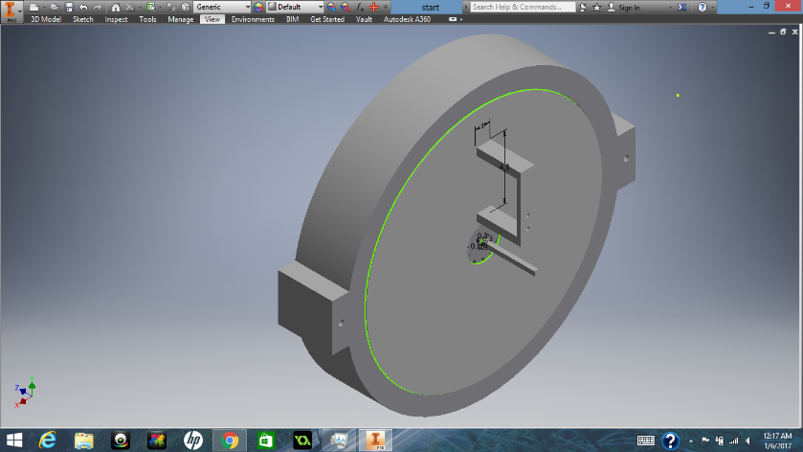
A back view of the end gear link where the 393 motor should be attached. The elevated “C” on the back of this gearbox link consists of 2 holes of which small screws can be inserted through and attach with a 393 motor. The shaft that can be seen coming out of the gearbox is what is attached to the opening of the 393 motor. The motor moves the shaft, which is directly connected to the first sun gear.
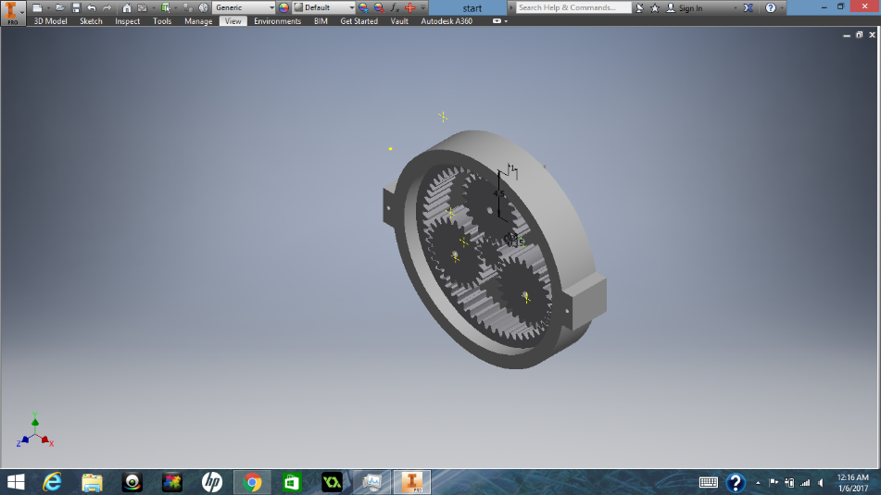
A side view of the starting gear
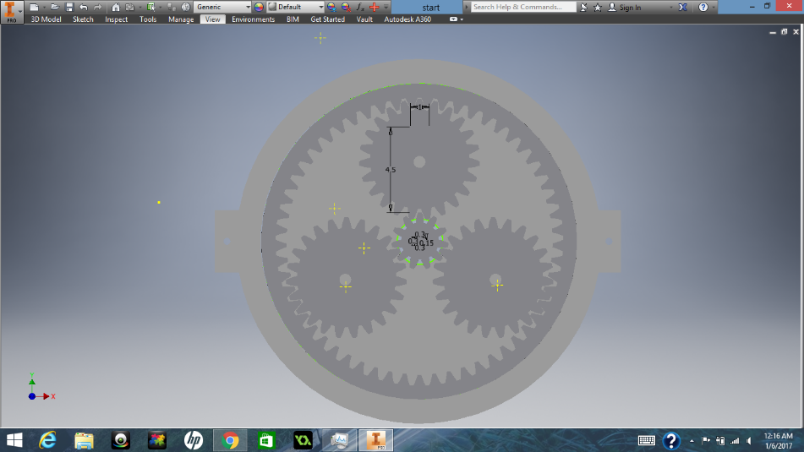
A front view of the starting gear. All planetary gears/sun gear are aligned

- Shaft Insertion End
The shaft Insertion End is the end that has an opening where a standard VEX motor shaft can be inserted into. This end includes a revolving opening end that grasps onto a VEX shaft, which it would then turn. Basically, this is the end where torque is the highest, and it can be used to lift heavier objects. This end also consists of a cap that keeps the planetary gears attached to the opening (shaft insertion square) from falling out of the gearbox. In the middle of the cap, there is an opening that directs a VEX shaft to the shaft Insertion module inside the gearbox.
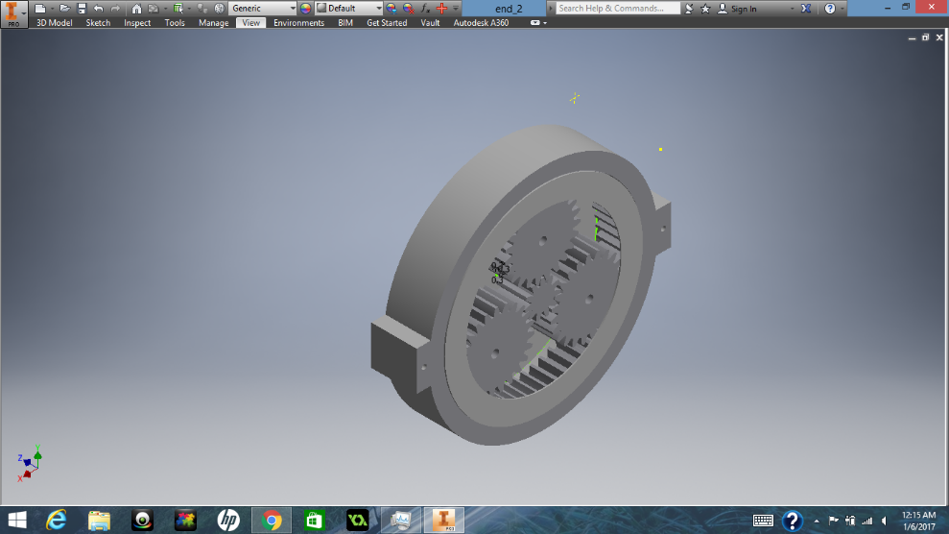
This is a back view of the shaft insertion end. The sun gear in this part of the gearbox has an opening that allows a standard VEX shaft to be inserted. Furthermore, on the back side, the walls caves in to avoid the planetary gears from falling off from its position. Once again, the planetary gears are connected with the triangle.

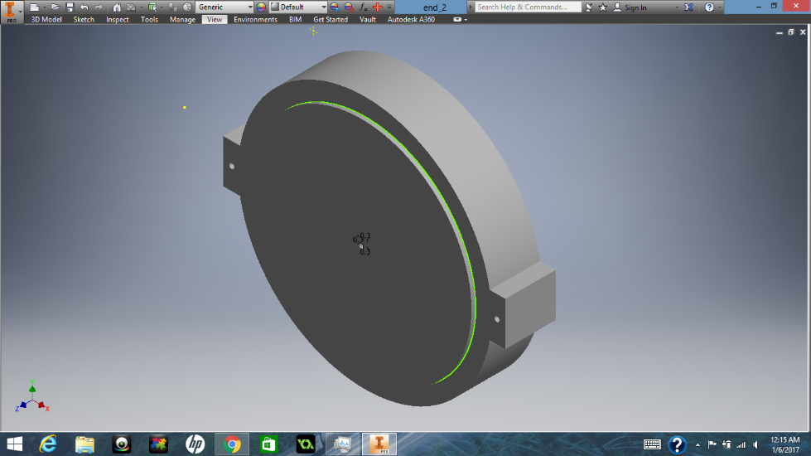
A front view of the shaft insertion end. There is a hole in the center that acts as an opening for the VEX shaft. The two nubs on the sides allow the entire gearbox to be held together as well as to secure the gearbox on almost anything with standard VEX holes.

- Inner Gear Chain/Link
The Inner Gear Chain/Link is the basis of torque increase and speed reduction for the gearbox system. The more Inner Gear Chain/Link in place, the more the torque increases. The movement created by the Inner Gear Chain/Link is through the movement of the sun gears that are passed on from one Inner Gear Chain/Link to the next. As one sun gear turns the planet gears of another link, the sun gear of the other link would rotate, creating a rotation of the sun gear that is attached to its planet gears. In return, the sun gear of this Link would continuously move the planet gears of another Link, etc. The planet gears move along a ring, which keeps the planet gears in place and also act as the exterior of the gear box itself. The ring acts like the shell of the Inner Link.

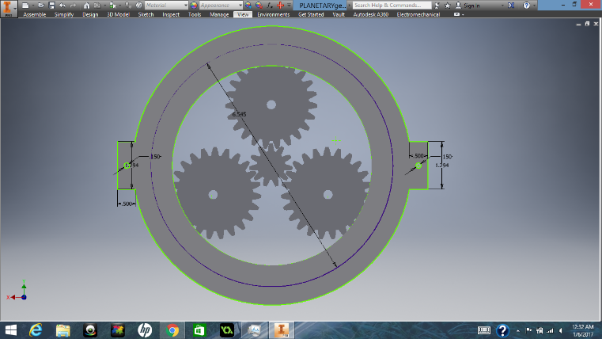
This is a back view of an inner gear link. The walls of the sides slightly cave in on one side to avoid the gears from falling from its place. The sun gear in this picture acts as a placeholder; when assembled, the middle sun gear would be attached to a triangle that holds onto the prior planetary gears.
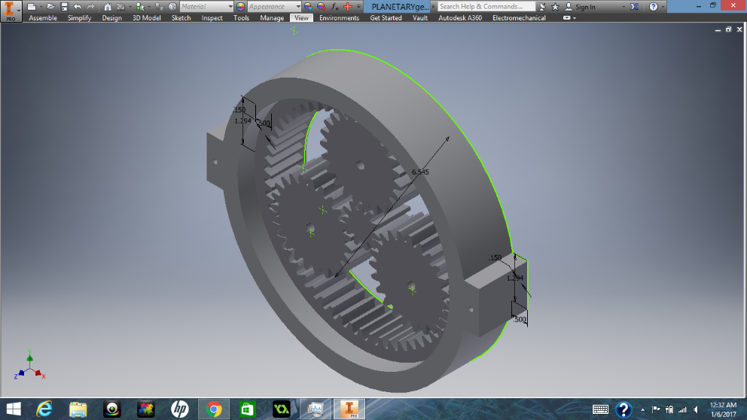
An upper side view of the mid-gear link. All sizes of the gears are unanimous for all gearbox links.
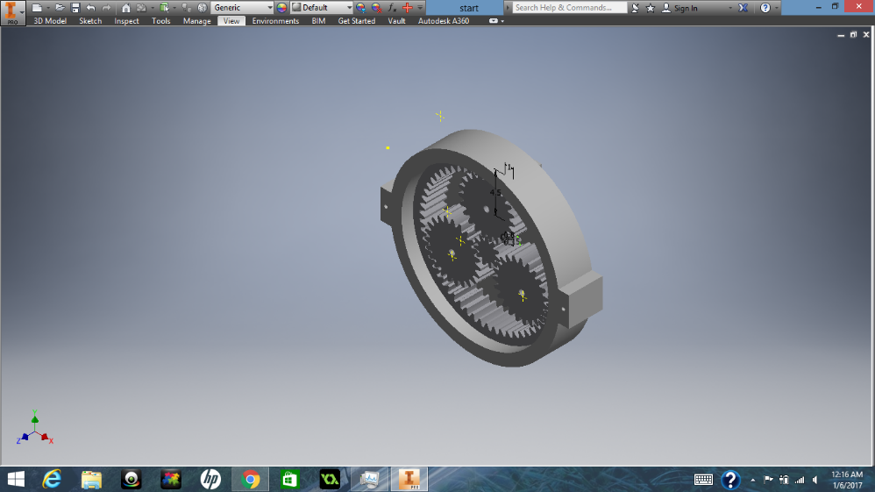
Another upper side view of the inner gearbox link.

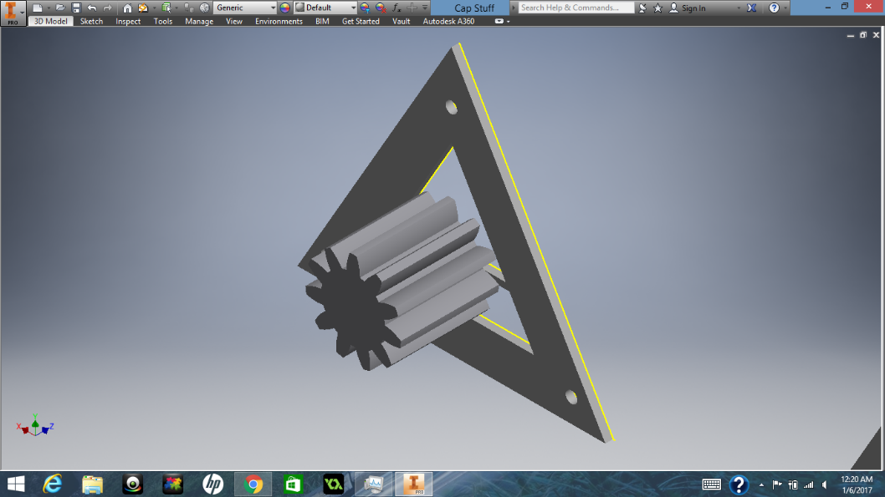
This is the cap of the triangle that holds planetary gears together. The gear on top of the cap is a sun gear which revolves with the planetary gears before it and turn the planetary gears of the gearbox in front of it.
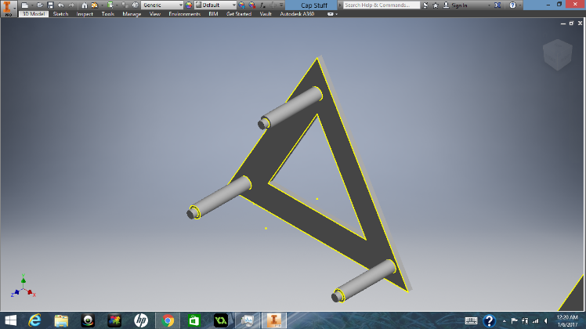
This is the triangle that holds the 3 planetary gears in a certain position every time it revolves. The top of the pillars leave room for a cap to be inserted (mentioned above).
Interaction With VEX Parts:
This VEX part would connect to c channels and other VEX panels with its holes in the two nubs of the gearbox. It would connect with the holes of the vex channels/panels, and a shaft would be able to be inserted into the middle hole. In the complete design, the gearbox acts as a torque increaser. It is attached one part to a channel or VEX panel and another with a 393 motor. The gearbox is between the two hardware.

Conclusion:
With the help of Autodesk Inventor and Fusion, my team members and I have established a much more concrete idea of the 3D designing process within VEX Robotics. We have found that simply building objects or robots without any preplanning can have some hazardous drawbacks. With inventor, we are able to assemble robots using the CAD Library and easily test/design the best robot for our competitions. Being able to make a complex gearing system specifically for vex parts was a challenge. However, as we learned more about how Inventor/Fusion works, creating complex designs started to become easier for us. We would definitely use CAD to create a representation of our robots before we build them next year. We would most like major in engineering in college, so knowledge in CAD is very important to us in our career paths.

