VEX PHOTO CHALLANGE
Jenni’s Submission

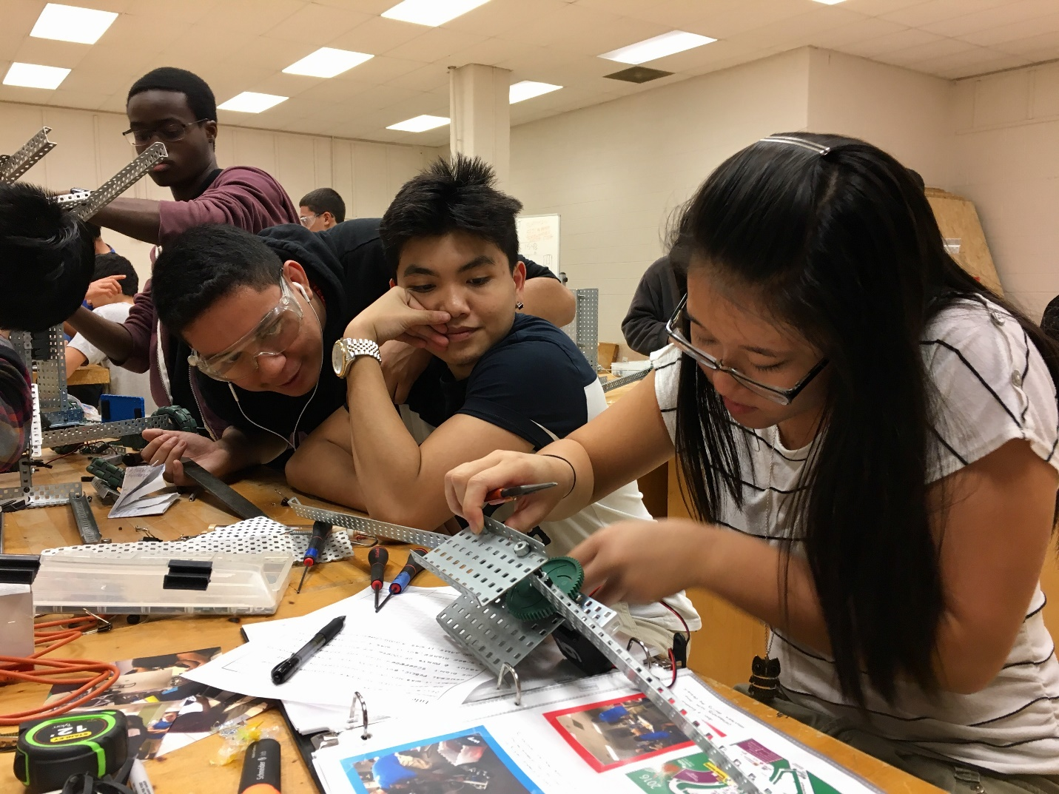

Weeks before our second competition, Tuan, Brian, and I were assembling the claw for our robot. I choose this photo because it depicts us learning from one another. Everyday we learn something new, whether it’s from our instructors or peers. Three heads are better than one in completing an obstacle.

Natalie’s Submission
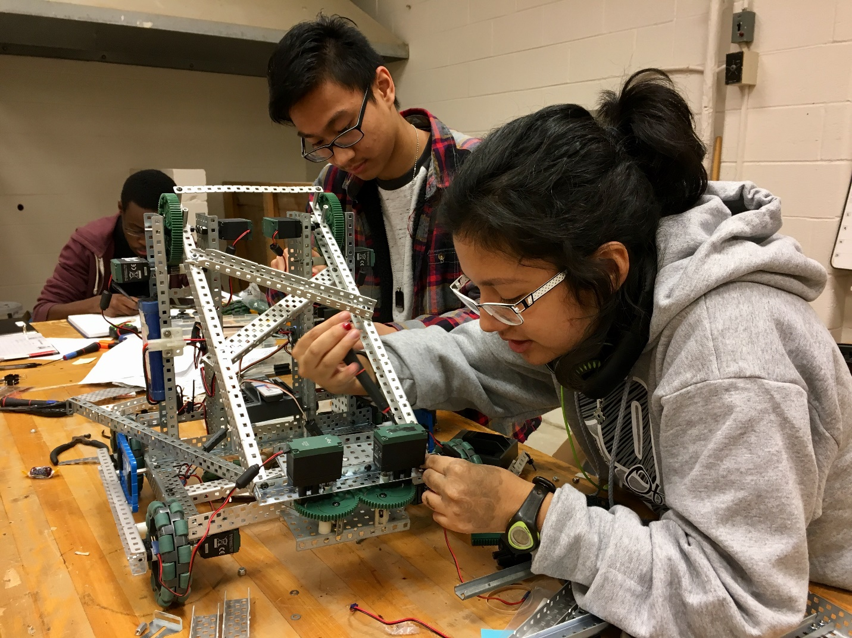
October 27th was very productive day in our workstation. With Kwadwo documenting the day’s progress in the background, Jhaysonel tightening up the robot from behind, and I putting the final adjustments on our arm structure, it’s easy to see how we reflect a STEM value with this candid picture: teamwork.

