Star Box

(ITS 5400 Original components)

For Vex Texas Instruments Online Challenge, we chose to deconstruct a Star Box ITS 5400 Original Receiver.

We chose this receiver because we thought it will contain new components that we want to discover.

**List of Internal Components:**

**1. SMSC IC (LAN91C113-NU)**

**2. Capacitors**

**3. Resistors**

**4. Memory Chips**

**5. Fuses**

Image of the receiver before being deconstructed:

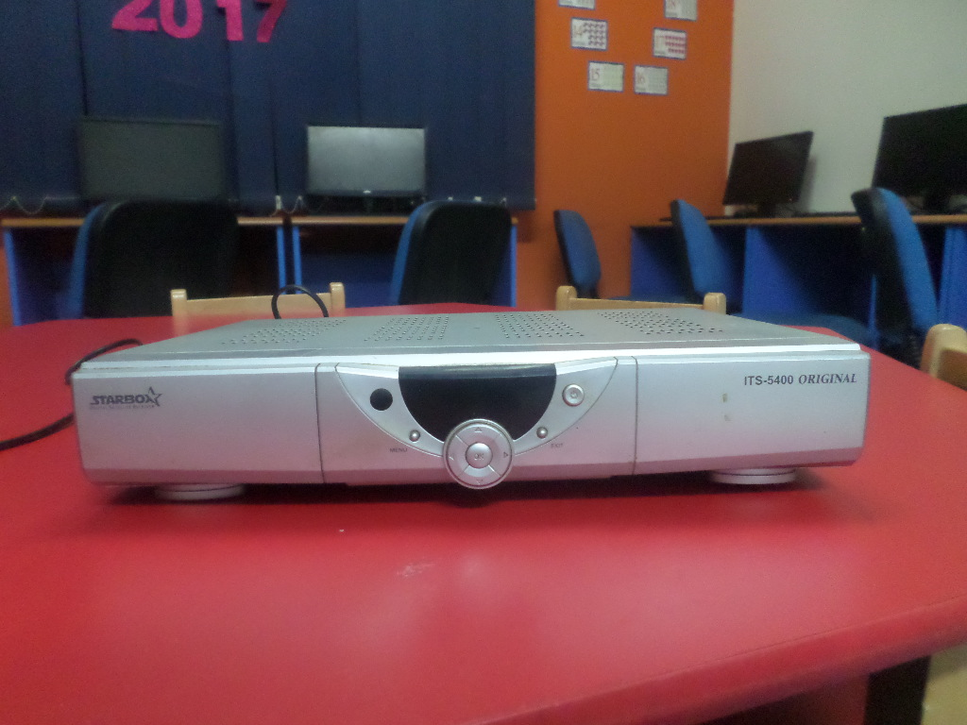

Star Box ITS 5400 Original

Digital Satellite Receiver with LAN/Ethernet Connector.

First glimpse of the inner components of the transcriber

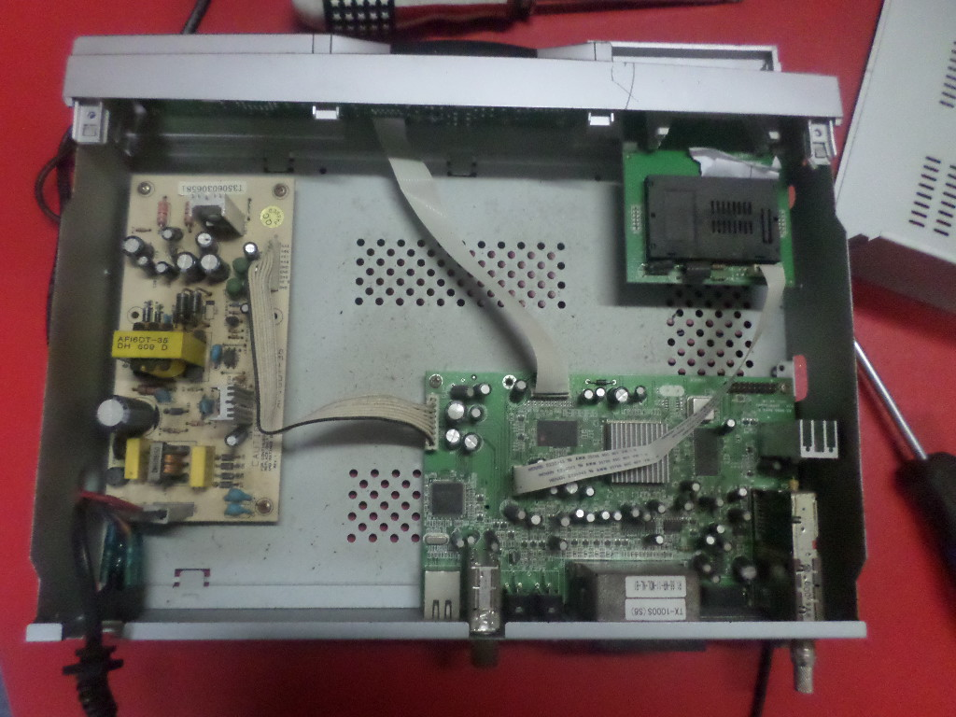

Components

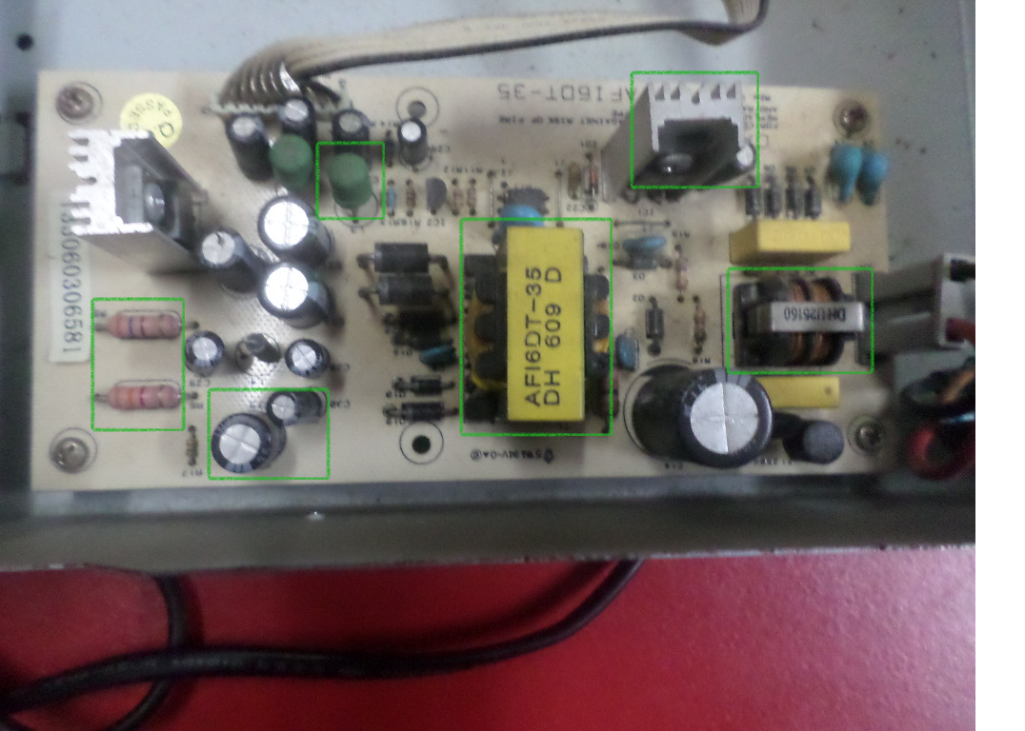

G

F

E

D

C

B

A

1. Capacitors
2. Resistors
3. V
4. Capacitors
5. Heat Sink
6. b
7. Fuse