I love going to robotics because I get to have fun with my team 224W VEX MASTERS. My name is Nahomi and it is a great opportunity for me to do an important thing that I have never tried in my life. For the TI challenge I had to open a used Galaxy S. I selected this device because on the instruction it says that it might contain some parts made by TI. I hope that I will be able to find some of these components.

I use many tools, one of them is a screwdriver. This was to open the phone as see if I could see find TI components. This was not the first time I had open a phone. What I saw inside the phone was a speaker, camera, battery and a PCB board or motherboard with different components attached to it.

The role of the camera in the phone is to take pictures of anything that people want to save in the phone. The speaker is an important thing that is inside a phone that helps people to hear anything with sound. The most important thing that helps work everything inside a phone is the PCB board that is connected to every things in a phone. Without this no other parts will work together.

Once I saw the motherboard /large PCB board, I saw all the little components and some of them had numbers in them. I started to insert those numbers and started to research them on the internet. Some of those numbers were very hard to read. I went and got a magnifying glass and tried to do my best to read them. For example, some of the numbers were 042721, H45C TTT, HN01FA21D, G-FCR1.

This experiment was a great opportunity because I got to learn an impressive amount of things I did not know before, for example I did not know that TI parts existed, until I looked them up in the internet. Unfortunately I could not find any TI parts in the Galaxy S phone. The lesson I learned doing this challenge was that everything has its own function even if it is a very small thing it all comes together in its own way.

That’s me. Nahomi.

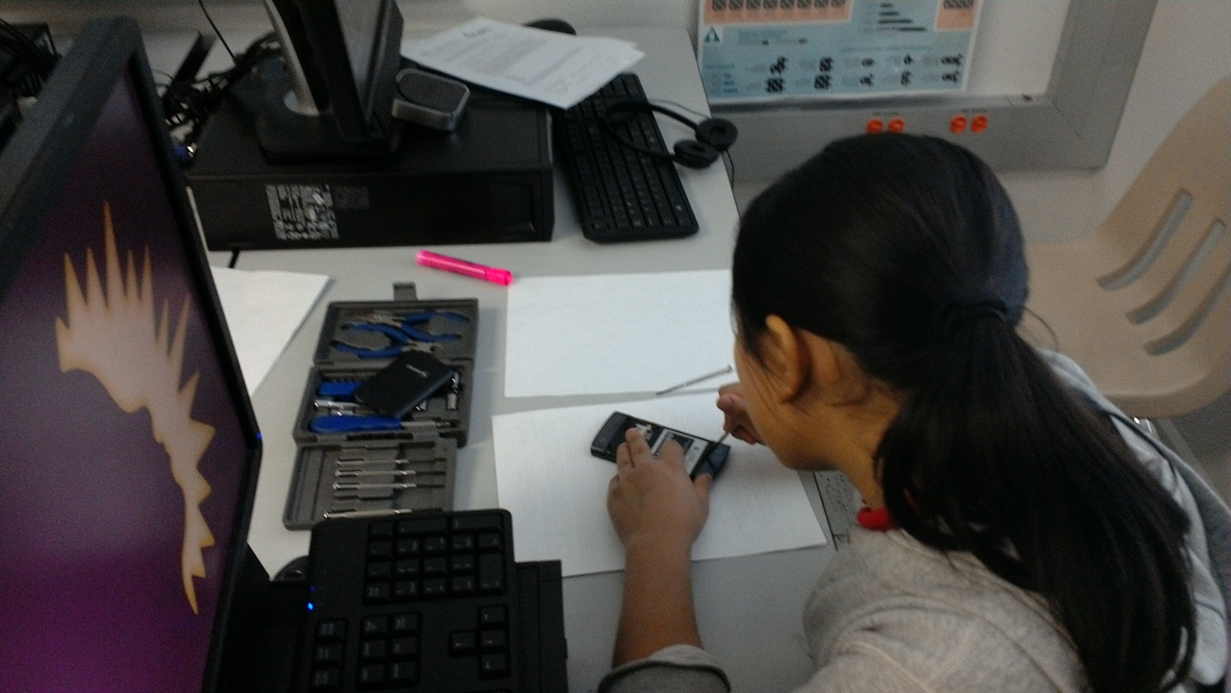I am using a screwdriver to take apart the small screws that hold the phone together . 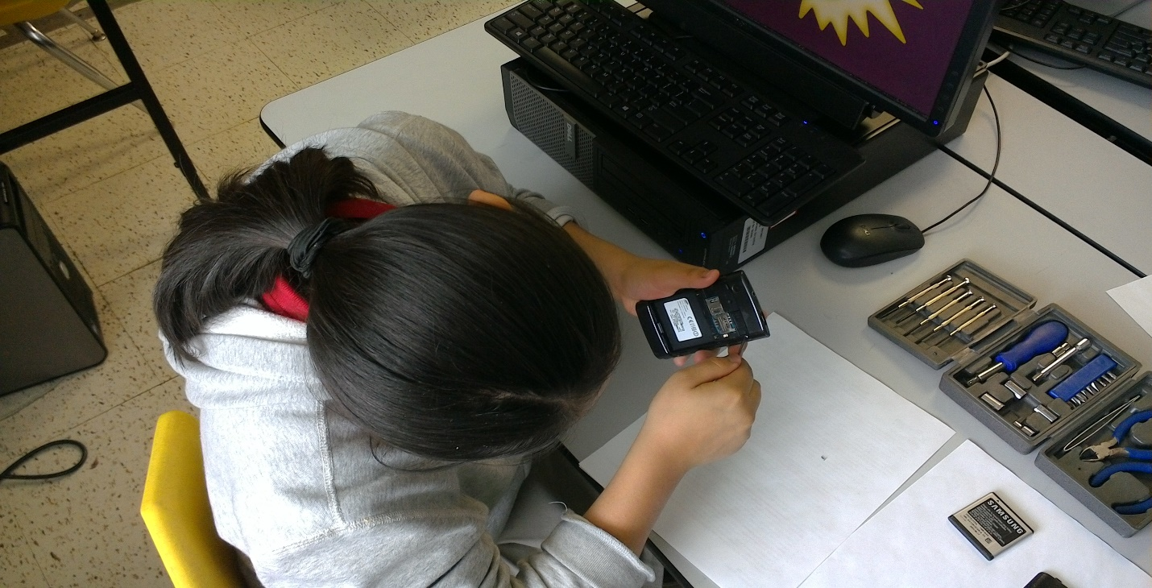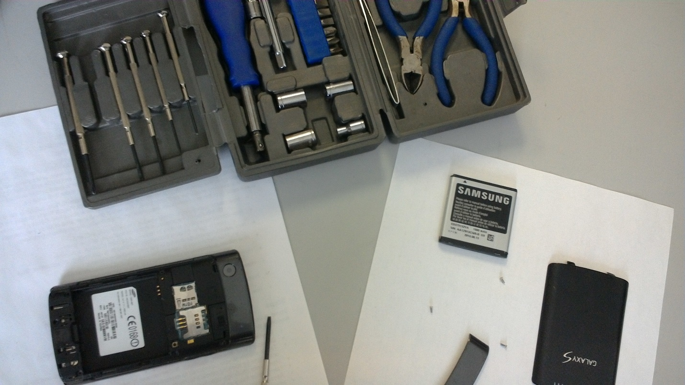After taking all the small screws I am about to open the phone to check out the PCB board and look for TI parts.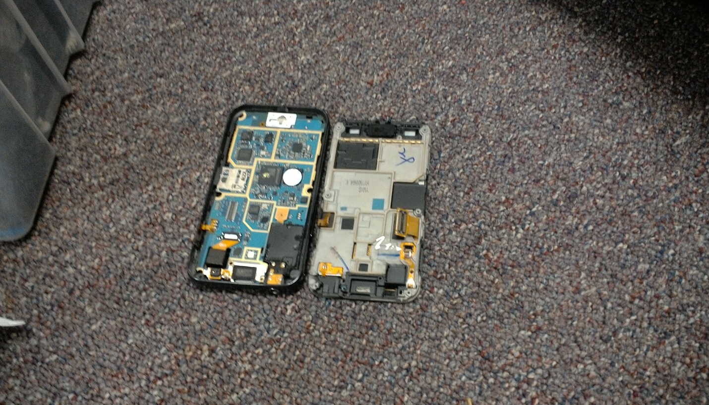This is what it looks like inside a galaxy s phone after taking apart the back cover.

I am having a very hard time whit a screws that was very tiny and hard to get it out because they have glue.

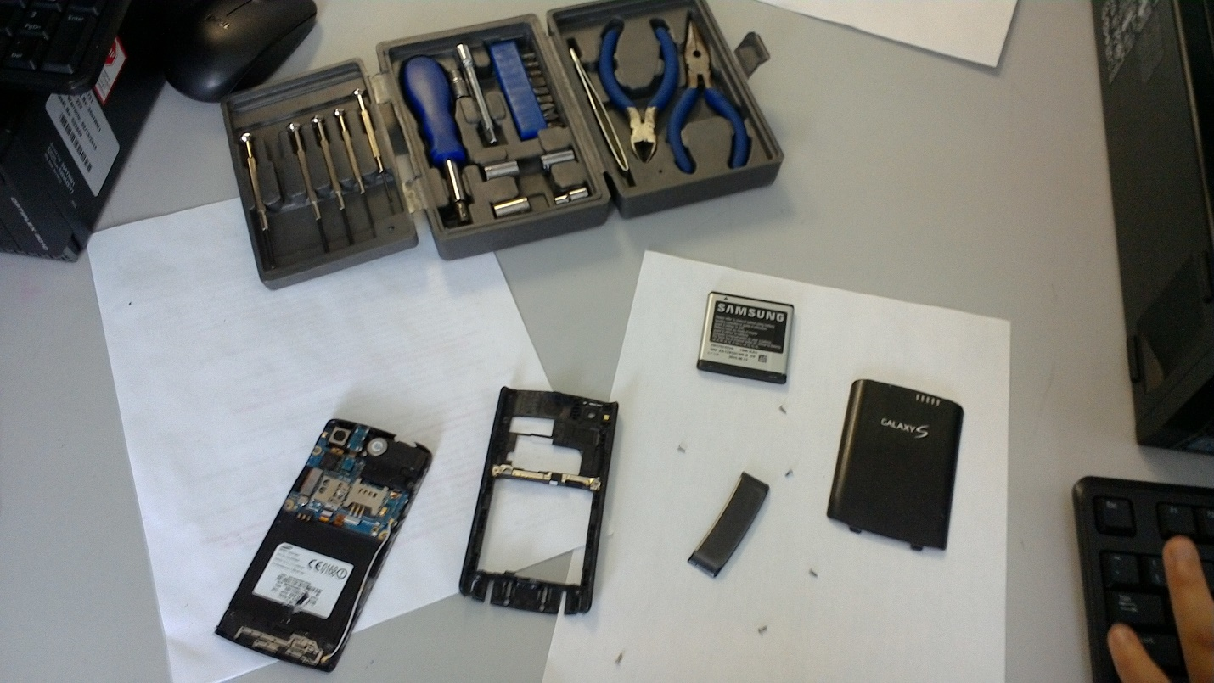

I am taking apart everything from the phone step by step and I see the PCB board/motherboard no the phone. Also, all the other components like the camera and speaker.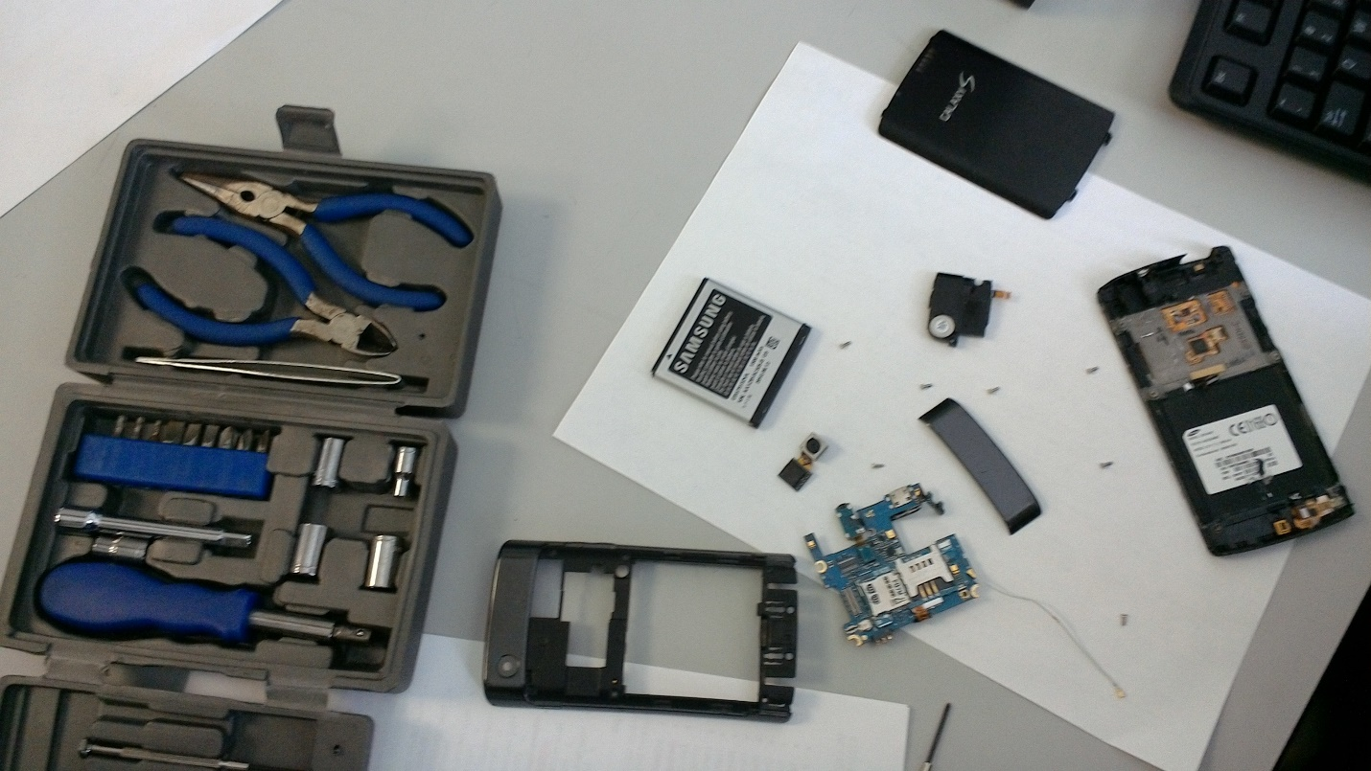

This is the speaker

This the camera