**Texas Instruments Electronics Online Challenge**

I took apart a Lenovo IdeaPad Flex 15 15.6-Inch Touchscreen Ultrabook.

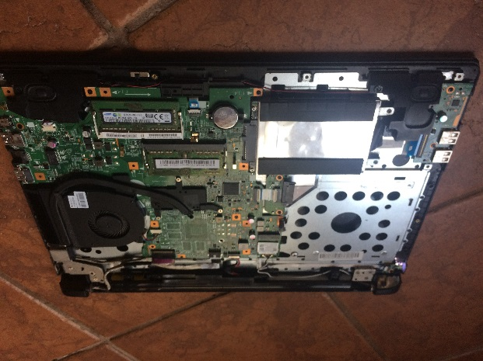 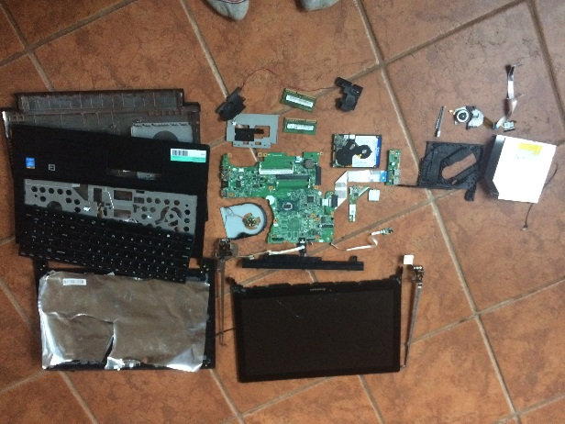

I chose this laptop because it’s decently new and it just broke. The current theory is that the cooldown fan broke causing the screen to overheat and the LCD to break1. The computer could still boot-up and function but the screen became a just didn’t function enough to still be considered “working.”

**What's Inside?**

Of the many parts I found in the Laptop, these are the parts that looked important and necessary to list.

* Model WD10SPCX-24H WST1 Storage Drive
* Model UJ8FBSDLM1-B DVD Player
* Model 023.1000.0002 Cooling Fan
* Lenovo RTL8723BE 802.11BGN Mini PCI-E WiFi Adapter 20-200570 04X6025
* Two (2) Samsung 4GB PC3-12800 DDR3-1600MHz non-ECC Unbuffered CL11 204-Pin SoDimm 1.35V Low Voltage Single Rank Memory Module Mfr P/N M471B5173DB0-YK0
* Western Devices Seagate Expansion Desktop 94V-0 E153302 Controller Board 3TB/4TB USB 3.0
* 25214633 Lenovo IdeaPad Flex 2-15 20405 US Keyboard
* Lenovo IdeaPad Flex 2 15 Series Laptop Webcam Bnc4vhttd-302
* Lenovo Genuine Speakers set Left and Right 023.4001W.0001 6-3-4-7
* Lenovo Flex 2 15 Battery 7.2V 2INR19/66-2 L13L4A61
* Panasonic Lithium CR2032
* LF14M MB 13281-1 448.00X01.0011 Motherboard
* Lenovo LCD 15.6 LED Touch LP156WF4 (SP)(L1) / 8S5D10F86071 / 6091L-2696C / b37

Sadly there were no TI components, it seemed Lenovo uses Western Devices instead if Texas Instrument.

**How It Works**

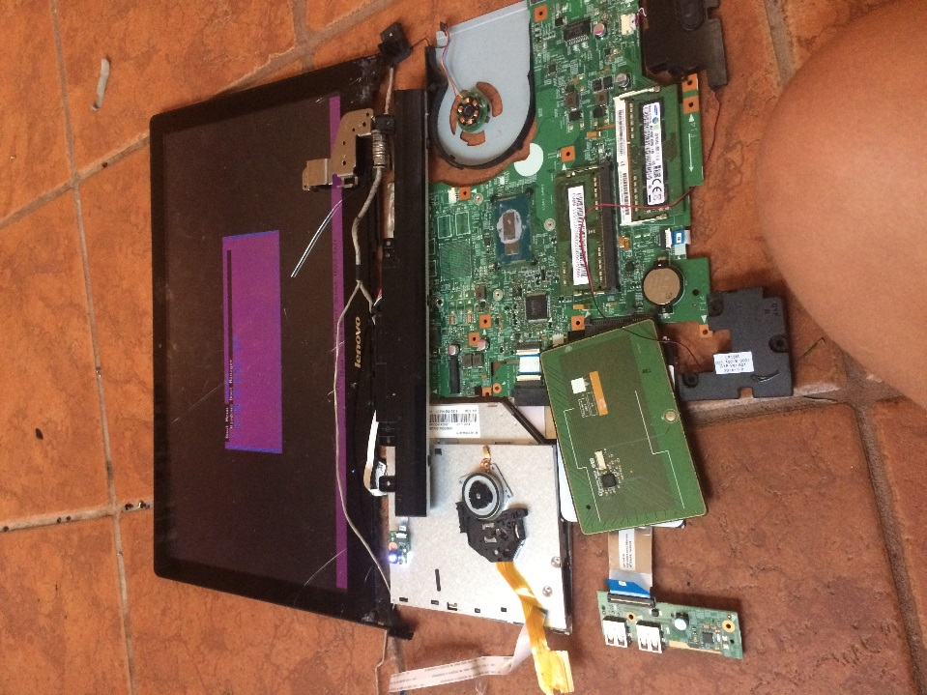To describe how the computer works as a whole, we will imagine we turned on the computer. So we pressed the power button. The motherboard “lights up” with electricity as the battery supplies the current. The battery is a Lithium-ion battery, which means that it’s a battery where the cell’s cathode is made of a Lithium oxide and anode is made of graphite2. The battery is charged when positively charged lithium oxide going to the negatively charged graphite. When the battery is being used, the positively charged material back to the cathode. The Lithium CR2032 is another minicell of a lithium battery and serves like an internet extender, boosting the energy charge so the current can flow through the entire circuit3. The software and hardware boot-up, the software will execute commands and activate things like the fan, wifi adapter, and the screen. It will then continue to look for commands to do in the hardware memory. It will continue this cycle until the computer turns off. There are two 4GB software chips to make a computer with 8GB of software4. The cool down fan turns on, the motor spinning to turn the propellers and cool down the computer. The screen then boots up displaying the lock screen and such. The memory tells the LCD screen to display certain colored pixels making up the big picture. Different colors are displayed by mixing the colors of blue, green, and red in different amounts5. The colors are displayed as triangles with each of the vertices as colors. Our minds fill in the leftover space to give is those pixels of colors. The wifi adapter will start sending out radio waves to connect to the internet and other computers on internet6.

The software has now everything it needs to for us to operate the computer, so say we put a disc in the DVD Player. The DVD player would send light to the DVD which then reflects it back. DVD’s have 2 different types of surfaces, lands (flat) and pits (bump). The lands directly reflect back at the sensor, so it computes it as a 1, and pits spread the light so the sensor doesn’t pick it up. It computes it as a zero. It repeats over and over until the disc is converted to a long binary sequence. The DAC then turns the binary sequence into a bunch of electronic impulses, which are picked up by the speakers, the impulses then flow into the voice coil, which is next to a magnet. When the impulse is stronger, it creates a magnetic field and moves away from the magnet. When the impulses are weaker, the magnetic field ceases and the coil goes to the magnet. The coil is attached to the speaker cone, which is a flexible piece of paper or cloth with moves with the coil. The small movements generate sound waves which we hear. Now we opened word started typing. Every key we pressed turns on a switch which completes the circuit. A processor in the keyboard then keeps track of all the circuit that were turned on and in what order. The processor then send it to the software to be handled, then displayed on the screen. The touchpad uses the fact that we conduct electricity to tell our location on the touchpad. It sends this data to the software to be handled and delivered to the screen7.

**So to wrap it up**

This was a very interesting experiment. I learned all about the internals of a computer. Some things I knew like how a screen works, how the fan works and how the speakers work. I didn’t know how the battery worked, a DVD player worked, and how the software interacts with the hardware. There were things that surprised me as well. For example, I was surprised to learn that the wireless adapter was so small of a chip and that a second mini cell battery existed.

As far as things I learned, I learned that screens crack and break real easily. Also that the motherboard isn’t everything, that it’s simply a circuit. I also unrelatedly learned that a lot of people sell replacement parts and chips, and that it’s hard to search up what lots of people are selling8. The biggest lesson I learned from this experiment was that Lenovo doesn’t like TI components9.

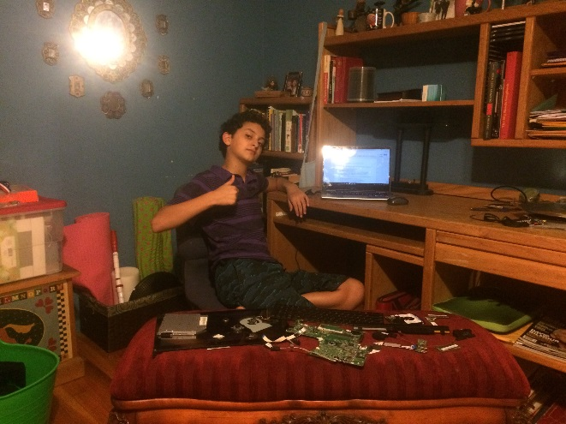

Good pictures are good

Endnotes:

1According to Geek Squad

2Lithuim-ion batteries are made of mini batteries called cells; cathode is the positively charged material, anode is the negatively charged material

3This is my best guess based on the cell’s location, no matter what I searched, all the websites where shopping sites

4#Math

5In my computer, the LCD corrupted and the colors messed up

6The standard radio frequency adapters use is 2.4GHz

7Who would have thought

8Like seriously hard

9Feels bad doesn’t it?