Overview of Device:

The device we chose to disassemble for the Texas Instruments Online Challenge was the Motorola SLVR L7. The reason we chose to use this device was because the Motorola SLVR series was a revolutionary device series in the phone industry, as it was designed to be lightweight and thin in comparison to previous phones in the Nokia and Motorola Series. The phone was released in early 2005, and was one of the only phones that offers iTunes support, meaning that the user can listen to up to 100 downloaded songs on an external microSD card. The Motorola was also one of the first to feature a web browser and web video downloader which was unique at the time.

(The Motorola SLVR L7 that we chose to use is no longer functional and has a scratched main PCB.)
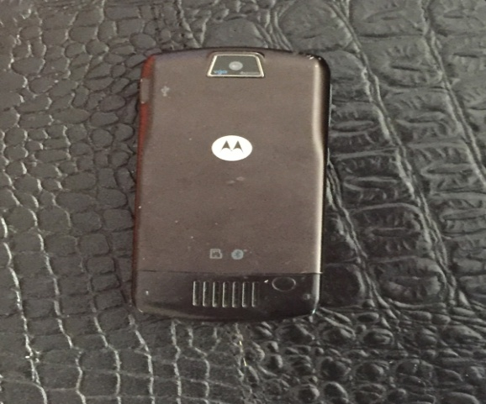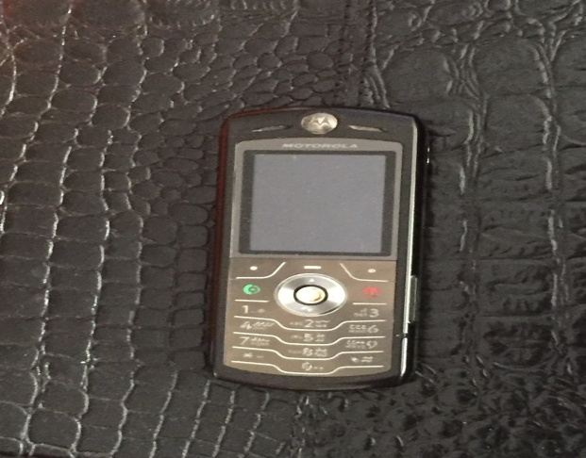

Phone Specifications:

Network: Technology GSM
Weight: 96g
Sim: Mini-SIM
Dimensions: 113 x 49 x 11.5 mm
Display Type: TFT, 256K Colors
Display Size: 1.9 inches (20.5% screen to body ratio)
Internal Memory: 11mb (5mb available to user)

Components:
- Lithium Ion Battery
- Main PCB
  - ATI - IMAGEON 2240 - Multimedia Co-Processor
  - Broadcom Bluetooth Baseband
  - RF Quad Band transceiver
  - DBB - Digital Baseband Processor - Freescale - SC29343VKP
  - ABB - Analog Baseband / Power Management - Freescale - MC13890

Disassembling the Device:

The Battery
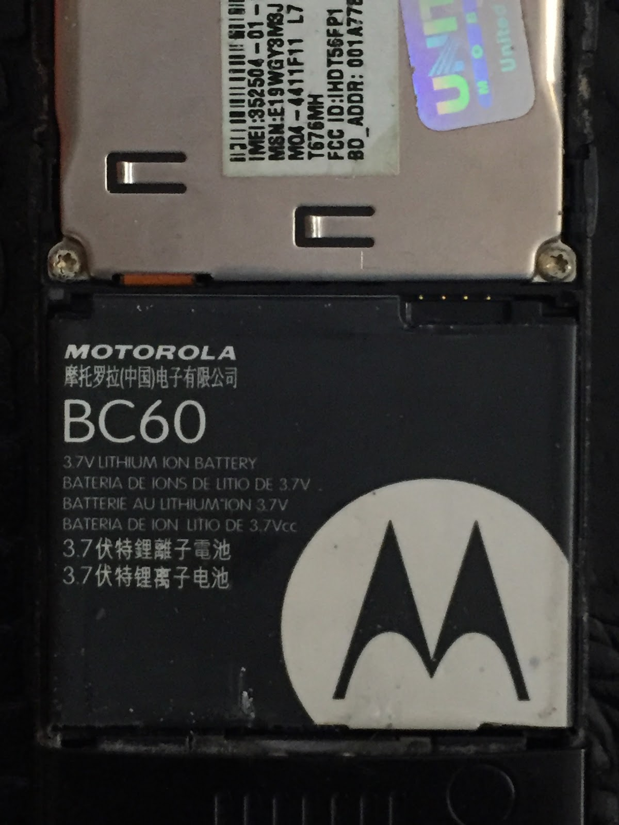

After removing the cover of the phone, the battery, camera, the cover of the main PCB was visible. The battery is a 3.7V 820mAh lithium ion battery that was manufactured by Zebra Technologies and was created specifically for Motorola phones. It was traced to China where most of Zebra Technology production takes place.
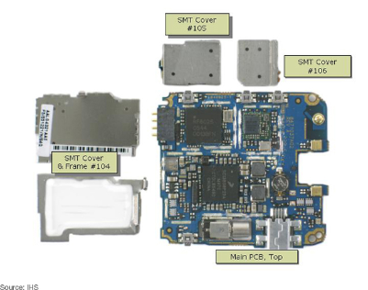
After removing its cover we found the main PCB, unfortunately the PCB was scratched badly, so a substitute photo has been used in its place. We were able to identify several things, including the vibration motor, multimedia processor, and the Bluetooth chip.

The multimedia processor is branded by ATI and is known as the IMAGEON. This chip allows the phone to view images, record videos, and special features like still-image capture. This chip also extends battery life as it takes work off of the broadband processor.

The vibration motor allows the phone to send notifications without sounds but by using vibrations. This specific vibration motor was designed by Motorola themselves and is used in all of there SLVR series.

The Bluetooth chip, Broadcom BCM2035KWB, is used in many old Motorola phones and only for basic Bluetooth connectivity.
Conclusion: Unfortunately in the device, we could not find anything that was manufactured by Texas Instruments. We have learned that within something as basic as a candy bar cell phone, there are several components that allow it to function properly. We also found that the manufacturing cost of this phone very high, with prices up to $78.

Sources:

Media, IHS Electronics &. "Motorola SLVR L7 Mobile Phone Teardown." Electronics Industry News & Analysis. N.p., n.d. Web. 15 Oct. 2016.
<http://electronics360.globalspec.com/article/2260/motorola-slvr-l7-mobile-phone-teardown>

"Motorola Expands Mobile Phone Line-up with ATI's IMAGEON'TM' Media Processors. "Press Release Distribution, EDGAR Filing, XBRL, Regulatory Filings. N.p., 2004. Web. 15 Oct. 2016.
<http://www.businesswire.com/news/home/20041129005265/en/Motorola-Expands-Mobile-Phone-Line-up-ATIs-IMAGEONTM>

"Vibration Motors." Precision Microdrives. N.p., n.d. Web. 15 Oct. 2016.
<https://www.precisionmicrodrives.com/vibration-motors>

