Online Challenge: (Take It Apart) TI Electronics Challenge

# The Electronic Device

This is a circuit board is from a Sony flat screen TV. It is used to get audio and video inputs from other devices to be displayed on the TV. This report will describe the different input connectors and what they are used for. This report will also show the different devices that can be plugged into the TV via these inputs.

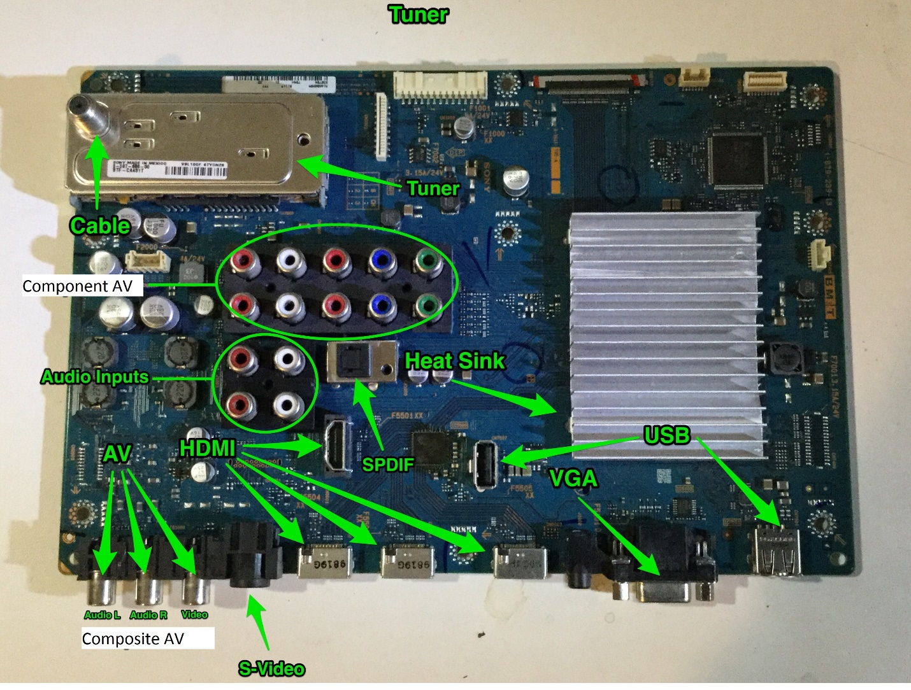

# S-Video

The S-Video input is used for a standard definition VIDEO connection. It has better video quality than composite AV, but worse than component AV. The S-Video cable is used. (No color code) An old video camcorder can plug into the input. S-Video is also know as separate video.

Video Quality

Composite AV< S-Video< Component AV< HDMI

# HDMI

HDMI stands for High Definition Multimedia Interface. It supports video up to 4K with digital audio. It superseded DVI (Digital Visual Interface) and VGA (Video Graphics Array). It was designed in December of 2002, and implements the EIA/CIA-861 standards, which define digital audio and video formats. It uses an HDMI cable. One example of something that uses this interface is a game console as the connection to the television.

(Source: Wikipedia)

VGA

A Video Graphics Array (VGA) connector is a three-row 15-pin DE-15 connector. The 15-pin VGA connector was provided on many video cards, computer monitors, laptop computers, projectors, and high definition television sets. Every one of the pins on the VGA port does somthing.  
  
Pin 1 REDRed video

Pin 2 GREENGreen video

Pin 3 BLUEBlue video

Pin 4ID2/RES formerly Monitor ID bit 2, reserved since E-DDC

Pin 5 GNDGround (HSync)

Pin 6 RED_RTNRed return

Pin 7 GREEN_RTN Green return

Pin 8BLUE_RTN Blue return

Pin 9 KEY/PWR formerly key, now +5V DC, powers EDID EEPROM chip on some monitors

Pin 10 GNDGround (VSync, DDC)

Pin 11ID0/RES formerly Monitor ID bit 0, reserved since E-DDC

Pin 12ID1/SDA formerly Monitor ID bit 1, I²C data since DDC2

Pin 13 HSyncHorizontal sync

Pin 14 VSyncVertical sync

Pin 15 ID3/SCL formerly Monitor ID bit 3, I²C clock since DDC2.

# USB port

USB stands for Universal Serial Bus. It was designed 21 years ago in January of 1996, and it superseded the Serial Port, Parallel Port, and some others. It was designed to connect computers to peripheral devices, such as a keyboard, a mouse, etc. USB transfers data between these devices and can also be used to power or charge electronics.

(Source: Wikipedia)

# (2) Audio Inputs

Audio input devices are used to capture sound. In some cases, an audio output device can be used as an input device, in order to capture produced sound.Audio input devices allow a user to send audio signals to a computer for processing, recording, or carrying out commands. Devices such as microphones allow users to speak to the computer in order to record a voice message or navigate software.Aside from recording, audio input devices are also used with speech recognition software.

# S/P DIF

SPDIF stands for Sony/Phillips digital interface. The SPDIF can only output digital audio, which are just 1s and 0s. It's better in digital because it will have higher definition. SPDIF can't output video. We connect the SPDIF by using a coax cable or a fibre optic cable. You can plug in a Sony speaker with a SPIDIF.

# Composite AV

Composite AV is originally called Composite Audio Video. The composite av connection is an input connection. It is used to connect DVD or gaming systems to the TV. These devices are used by creating composite av cables and RCA connectors. The white and red cables are right and left audio analog sound. The red, blue, and green are for video. Shown on the picture, you can put both a DVD player and gaming system on the composite AV. Just change the input.

# Component AV

The component AV is used for audio and video input and it has better video quality than composite AV. The Component AV cable is used for component AV connection. Red and white are for audio left and audio right, and red green, and blue are for video input. A DVD player can plug into the input. The component AV stands for component audio video.