John Sin

11029T

Texas Instruments Online Challenge

Introduction:

I decided to deconstruct a Zeki 7 Tablet. The reason I decided to do this was because almost everyone uses a mobile device nowadays, but most don’t know how they work. When I thought of electronics, I thought of a green board with strange patterns and devices on it, and I thought of words like capacitor and transistor, but I never knew what they meant. This is also why I chose this online challenge.

List of Internal Components:

-Printed Circuit Board

-Hynix H5TQ2G83CFR-H9C DRAM Modules

-Allwinner A10 System on Chip (SoC)

-Battery

-Micron Flash Memory Module

-Realtek Wireless Module

-Resistors (4R7)

-Schottky Rectifier (SS34)

-Capacitors (476J)

-All Assembled in Asia

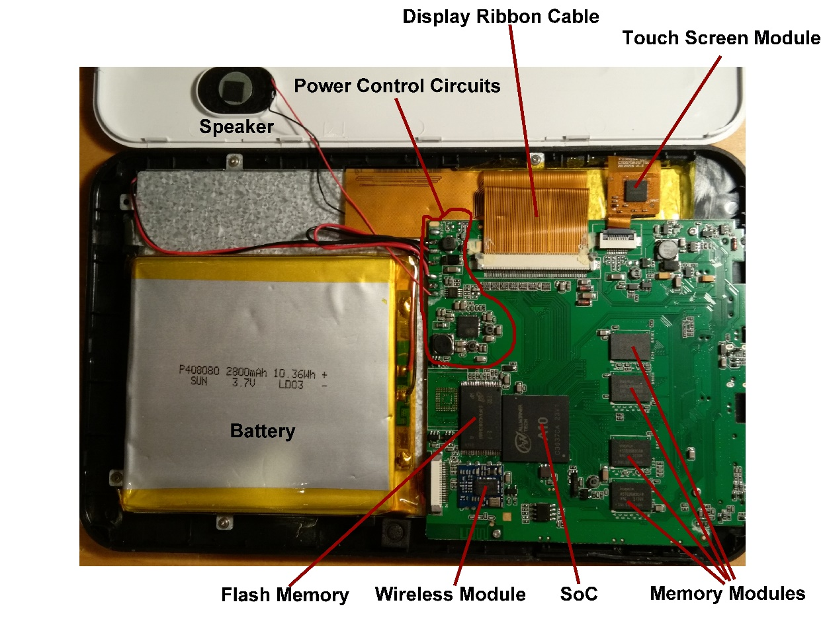

The Printed Circuit Board

The printed circuit board serves as a platform for most of the other components and has wires etched into it to connect the components in the right way. At the time of production they were all extremely cheap parts. The schottky rectifier, capacitors, and resistors, all are used for power control.

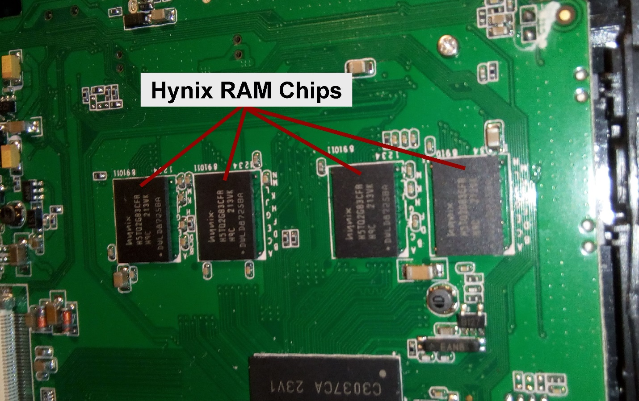

RAM Chips

RAM is fast but temporary storage. Say you have a desk and filing cabinet. The things on the desk are more easily accessible than the things in the filing cabinet. The filing cabinet is much larger though, and eventually you would clear your desk. The desk is like RAM and the filing cabinet is like flash memory. RAM is quickly accessible to the processer while reading and writing to the flash memory takes much longer in comparison. The flash memory however, is not temporary and is much larger. These four RAM chips are made by the South Korean company SK Hynix, with 256 MB each.

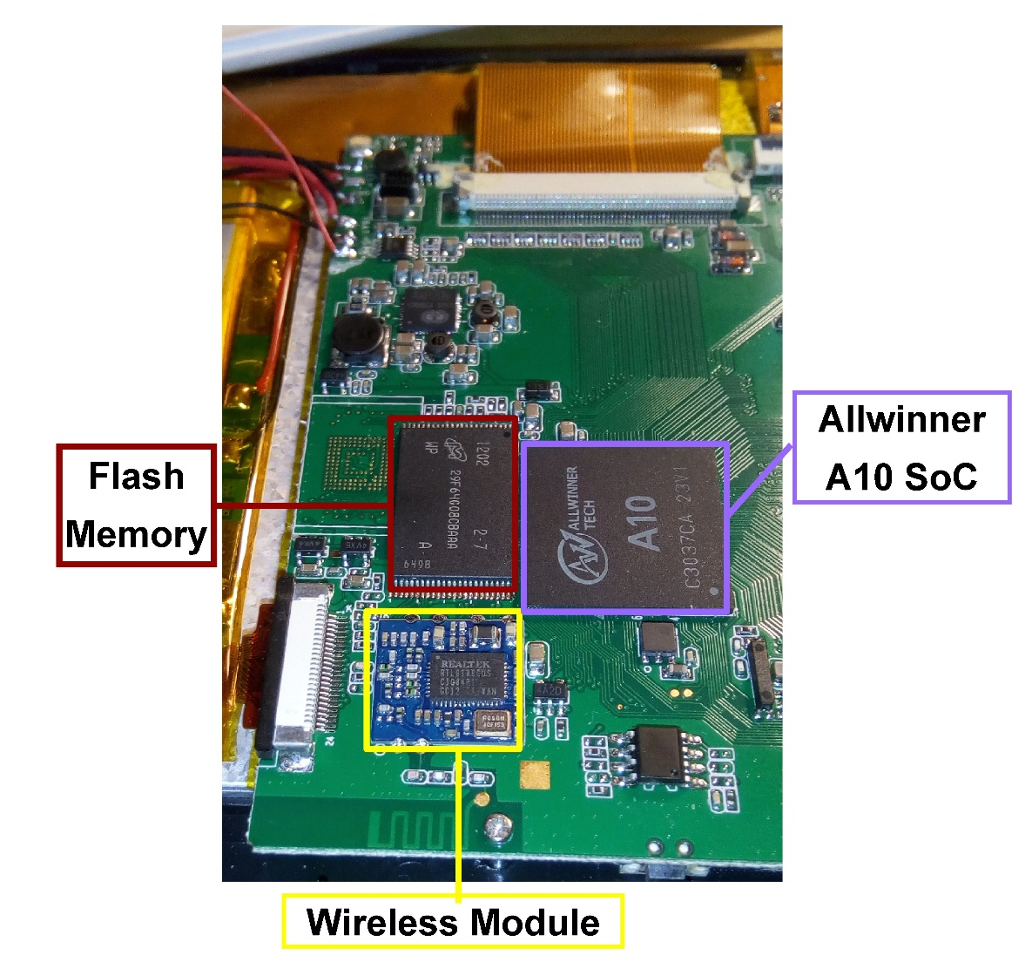

System-on-Chip (SoC)

An SoC is a microchip with all the necessary circuits and components for a given system. They are generally used in small devices. On a motherboard different components are housed on separate chips. In the ZEKI 7 tablet they are all housed on the Allwinner A10 SoC. The A10 was manufactured in China and was the most cost-effective SoC for its time.

Flash Memory

Flash Memory is used for storing data. This is because it can hold data without power, unlike RAM, and is much cheaper, though slower. Referring to the desk and filing cabinet example, the filing cabinet is a lot like flash memory, as it is bigger but harder to navigate.

Wireless Module

The wireless module provides wireless internet. The ZEKI 7 has a wireless module made by the Taiwanese company Realtek.

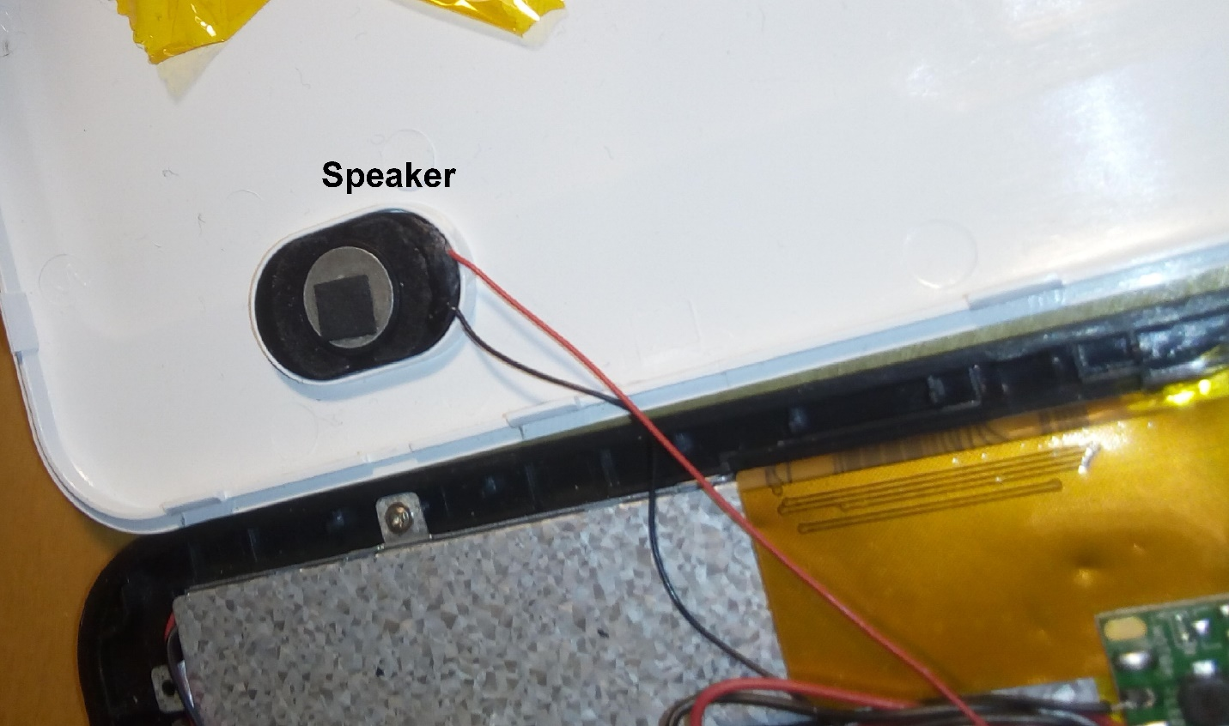

Speaker

A rather small speaker used for playing audio on the tablet.

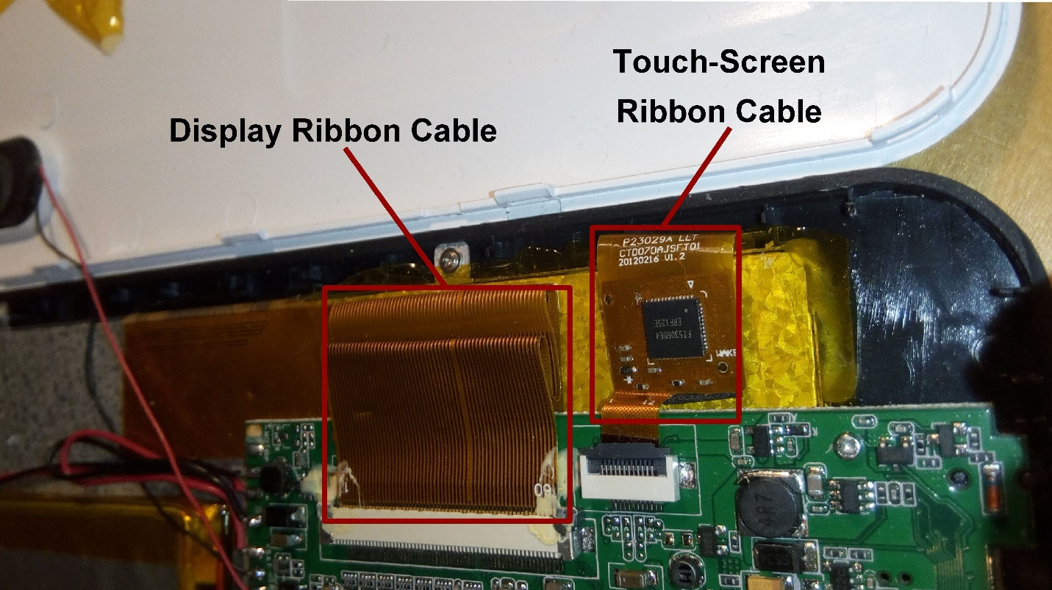

Display and Touch Screen Ribbon Cables

A ribbon cable is a wide flat cable of many parallel wires. The display ribbon cable is a ribbon cable that connects the display to the PCB. It is important to note that the display and touchscreen are separate things, though people often think of them as the same. The display is the visual while the touchscreen is a film that senses touch. The touchscreen ribbon cable connects the touchscreen to the PCB. The touchscreen module lies on the touchscreen ribbon cable.

Conclusion

By deconstructing my Zeki 7 tablet and researching what each component does I have learned a lot about electronics that I didn’t know before. There were no Texas Instruments parts in the Zeki 7. I have also learned that everyday devices can be very complex on the inside.

Cited Research

Information on SoCs and Allwinner A10

<http://www.techradar.com/news/computing/pc/system-on-a-chip-what-you-need-to-know-about-socs-1147235>

<http://internetofthingsagenda.techtarget.com/definition/system-on-a-chip-SoC>

<http://rhombus-tech.net/allwinner_a10/>

Information on Memory Modules

<http://computer.howstuffworks.com/computer-memory.htm>

<https://en.wikipedia.org/wiki/Computer_memory>

Information on the Specs of the Tablet

<https://www.cnet.com/products/zeki-7/specs/>

Information on Ribbon Cables

<http://www.wisegeek.com/what-is-a-ribbon-cable.htm>

Information on the Difference between the Touchscreen and Display

<http://www.laptopscreen.com/blog/touchscreen-vs-regular-lcd-screen/>

Information on Flash Memory vs RAM

<http://searchsolidstatestorage.techtarget.com/feature/Whats-the-difference-between-flash-memory-and-conventional-RAM>

http://www.soundsupport.biz/2012/05/06/whats-the-difference-between-computer-memory-ram-and-hard-drive-storage/