VEX Robotics FUTURE Foundation Competition
Stair Climbing Mechanism for Household Item Transport

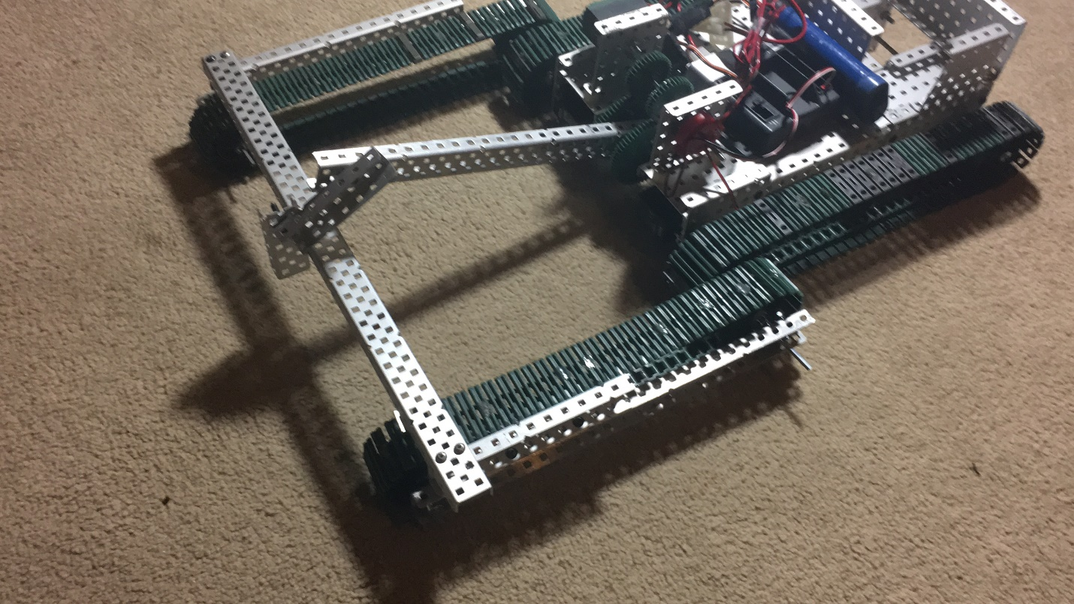

By: James Na, Akhil Sadhu
Team Bext of the VEX 22283A

Intro:
These days, when we think of the “robot” stereotype, we tend to think of transport robots that would provide food and drinks to its user. With the development of modern technology, it is definitely easy for modern technology to one day catch up with society’s vision in “servant robots”. However, the main problem with this concept is that the classic robot isn’t able to travel up/down stairwells. Although many different solutions to this problem can be seen in Youtube or other video sites, current stairclimbing robots seem unstable or unsteady while climbing. With this idea in mind, James and Akhil of Chattahoochee’s team 22283A decided to create a stair climbing robot with the ability to carry medium-small sized items. Our stairclimbing robot manipulates the traveling of stairs with the use of treads with glue dots and grip tape as traction; while we first didn’t think of this idea, the use of glue dots and grip tape definitely proved beneficial for the traction in the treads. The chassis comprises of tread-based movement powered by two motors and a lift in the front of the robot powered by another 393 DC motor. The front section of the robot comprises of c-channels that lift treads into different angles, while the central section of the robot consists of the cortex, battery, wiring housing, and a basket for load-holding. Creating this stairclimbing robots was definitely a challenge. Because this robot can climb actual wood and brick stairs (as seen in our video), it took multiple attempts and trials to perfect our stair climber bot. However, through searching and finding new solutions, we were able to complete/perfect this robot to safely and swiftly climb up a set of stairs.
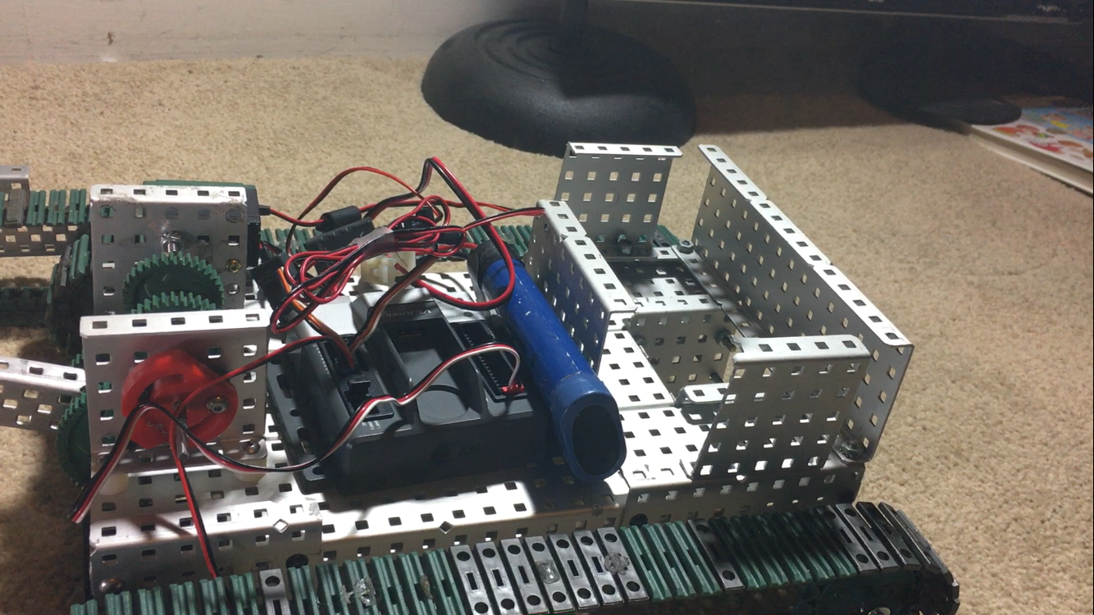
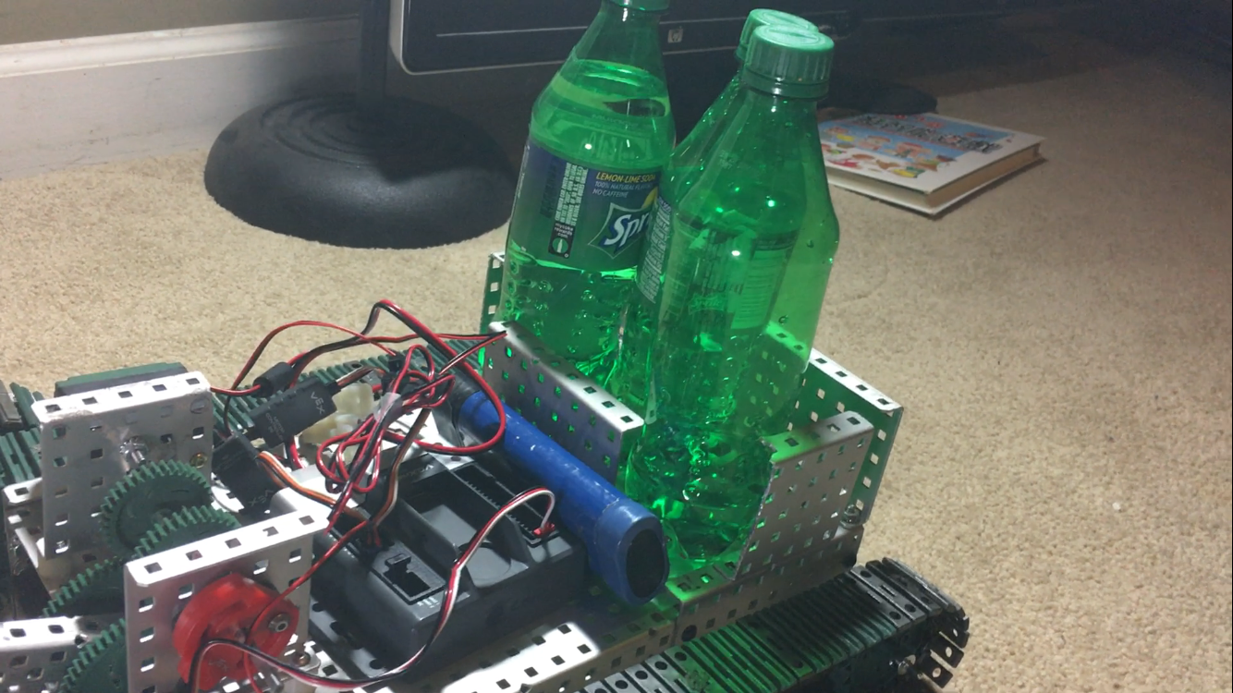

Design/Build Process:

The Chassis:
We started our design process first by searching for a simple yet safe way to combine treads with a chassis to create the very best and safe household stair-climbing that can be used in the modern home. We analyzed our options and came up with a design that utilizes two motors, each controlling one side of treads on the robot. We eventually stuck with this chassis idea due to its simplicity and its features that attributes to simple programming as well.
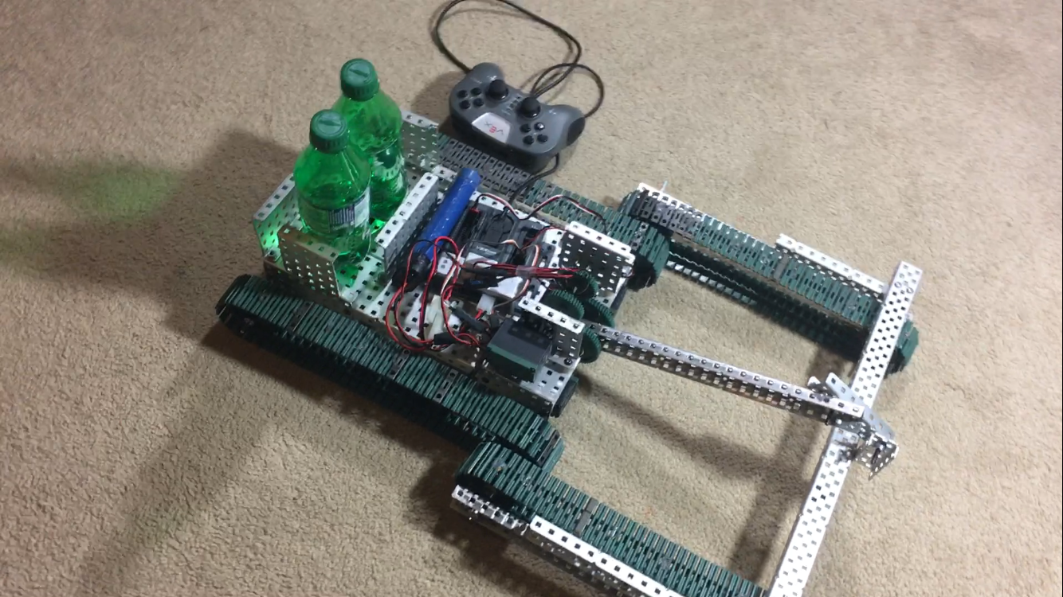
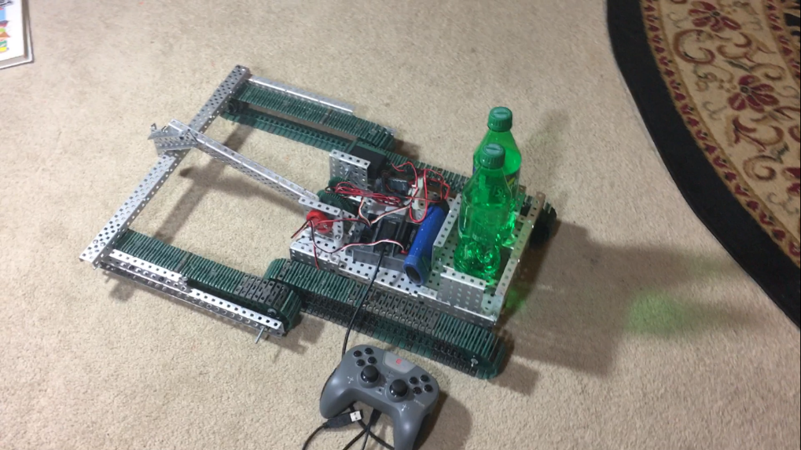
The Front Lift:
When we first started with our design process, we thought that the use of a tank-like chassis without the front lifting portion we currently have would be able to power the robot to climb a stairwell. However, as we continued experimenting with this chassis, the robot wasn’t able to climb stairs in a stable fashion. More importantly, our old design wouldn’t be safe enough for the standard home. Our engineer, Akhil Sadhu, sought to eliminate this problem by using a pivoting front tread to stabilize our robot as well as to add a counterweight to avoid the robot tilting and falling backwards. This idea was a success. Though the robot became significantly bigger, it proved to avoid all problems we had earlier with the robot. A pivot was added in the very front of the lift, so the central bar would be able to swivel the lift up and down.
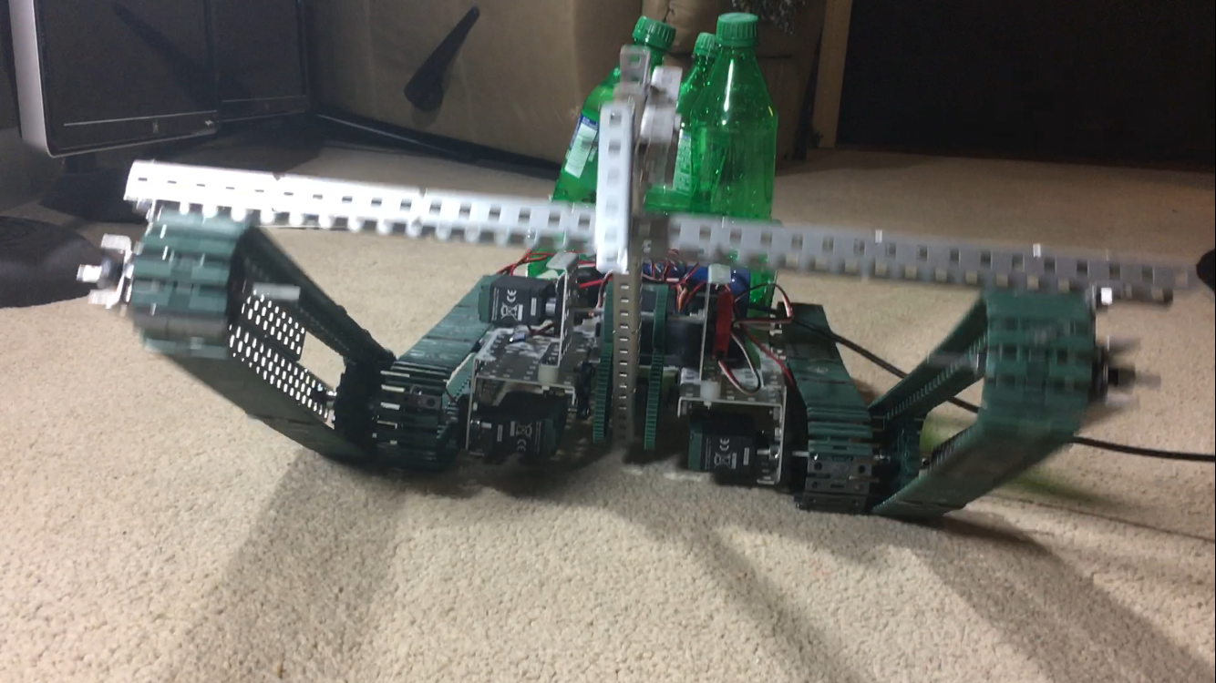

The Front Lift (pt.2) Gear Ratios and Potentiometer:
When we first used the lift, we tried to power the lift using VEX Servos due to their easy programmability. However, we later realized that the servos weren’t powerful enough to lift the bar itself, let alone the treads as well. Thus, James thought of powering the lift with a potentiometer to make the bar stay at a certain angle when a controller button is pushed, thus it benefited the autonomous/semi-autonomous movement of the robot (code described in the Programming section). However, as we continued to test our robot, it proved to have difficulties in control as well as torque. Thus, we used a medium gear with a medium-large gear to increase the torque for the lift. This idea was successful in not only control but also motor safety (since so much weight isn’t relied directly on the motor anymore).
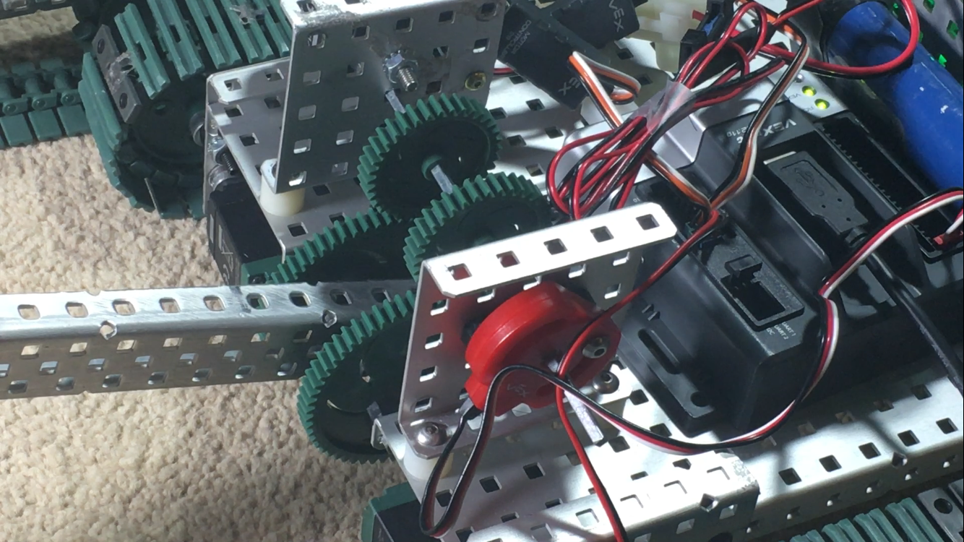

How it Works:
The robot starts with the entire robot laid flat on the ground with a stairwell in front. The robot starts by controlling the front lift, which lifts the front treads to a certain angle and allows an incline and counterweight for the robot. The robot’s chassis motors would later be powered, which prompts the robot to reach the first stair. The front bar would continue moving with the chassis to climb the stairs.

Program:
User Controlled Program:
Motor/Sensor Setup:
#pragma config(Sensor, in1, pot1, sensorPotentiometer)
#pragma config(Motor, port1, motor2, tmotorVex393_HBridge, openLoop)
#pragma config(Motor, port2, motor1, tmotorVex393_MC29, openLoop)
#pragma config(Motor, port3, motor3, tmotorVex393_MC29, openLoop)

Program 1- This was our original program for fully tele-op or user automated control over our robot. This code was used to simply test our chassis to make sure everything was fully-functioning:

task main()
{
int x = 1;
while(true)
{
motor[motor2] = vexRT[Ch3];
motor[motor1] = vexRT[Ch3];
motor[motor3] = vexRT[Ch2];}}

Program 2- semiautonomous/ autonomous
The next thing we thought to do was make the robot as autonomous as possible with little user control, we found a way to code the lift to stay at certain positions:
if(vexRT[Btn5D]==1)
{
while(x < 300)
{
if(SensorValue[pot1] <1500)
{
while(x < 300)
{
if(SensorValue[pot1] < 1460){
motor[motor3] = 0;}
else if(SensorValue[pot1]>1465) {
motor[motor3] = -30;}
else{
}
X++; //x declared in the previous section
}
}

Conclusion:
By creating a successful stair climbing robot, our team hopes to increase the potential and breakthroughs in this area of engineering. What was first a competition for our team, this project later became a huge breakthrough in the team’s knowledge. We definitely learned A LOT by building such a complex robot; our builders were able to understand new concepts and our programmers learned a lot about the implementation of math to find length of code executions as well.

