Nothing But Fetch
Team 91C’s Robot Construction Challenge Submission
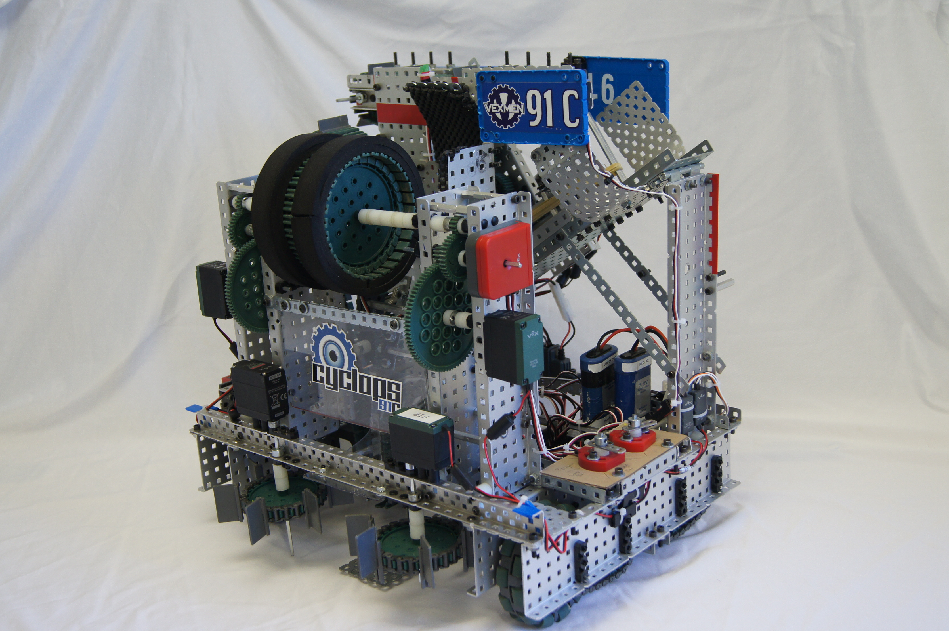
Challenge
When designing a robot to help in the house, we thought and about mobility challenges that elderly and disabled people may face in everyday life. We found a challenge that may often be overlooked, on which to spend our time. Animals are therapeutic through companionship, but disability or loss of mobility may make playing with an animal difficult.

Designing
We decided to go with a robot that would be able to throw a ball for a dog to fetch, and to pick that ball up and give it back to the owner if the dog does not return it or fetch after it. We took our previous knowledge from last year’s game, Nothing but Net, to design this robot in how it should shoot and pick up the balls.

Design of Long Range Ball Shooter
We decided on a piston with linear motion for our far range design because it only requires placing the ball in front of the robot instead of having to bend over and feed it into an intake, such as a flywheel mechanism.

Ideas:

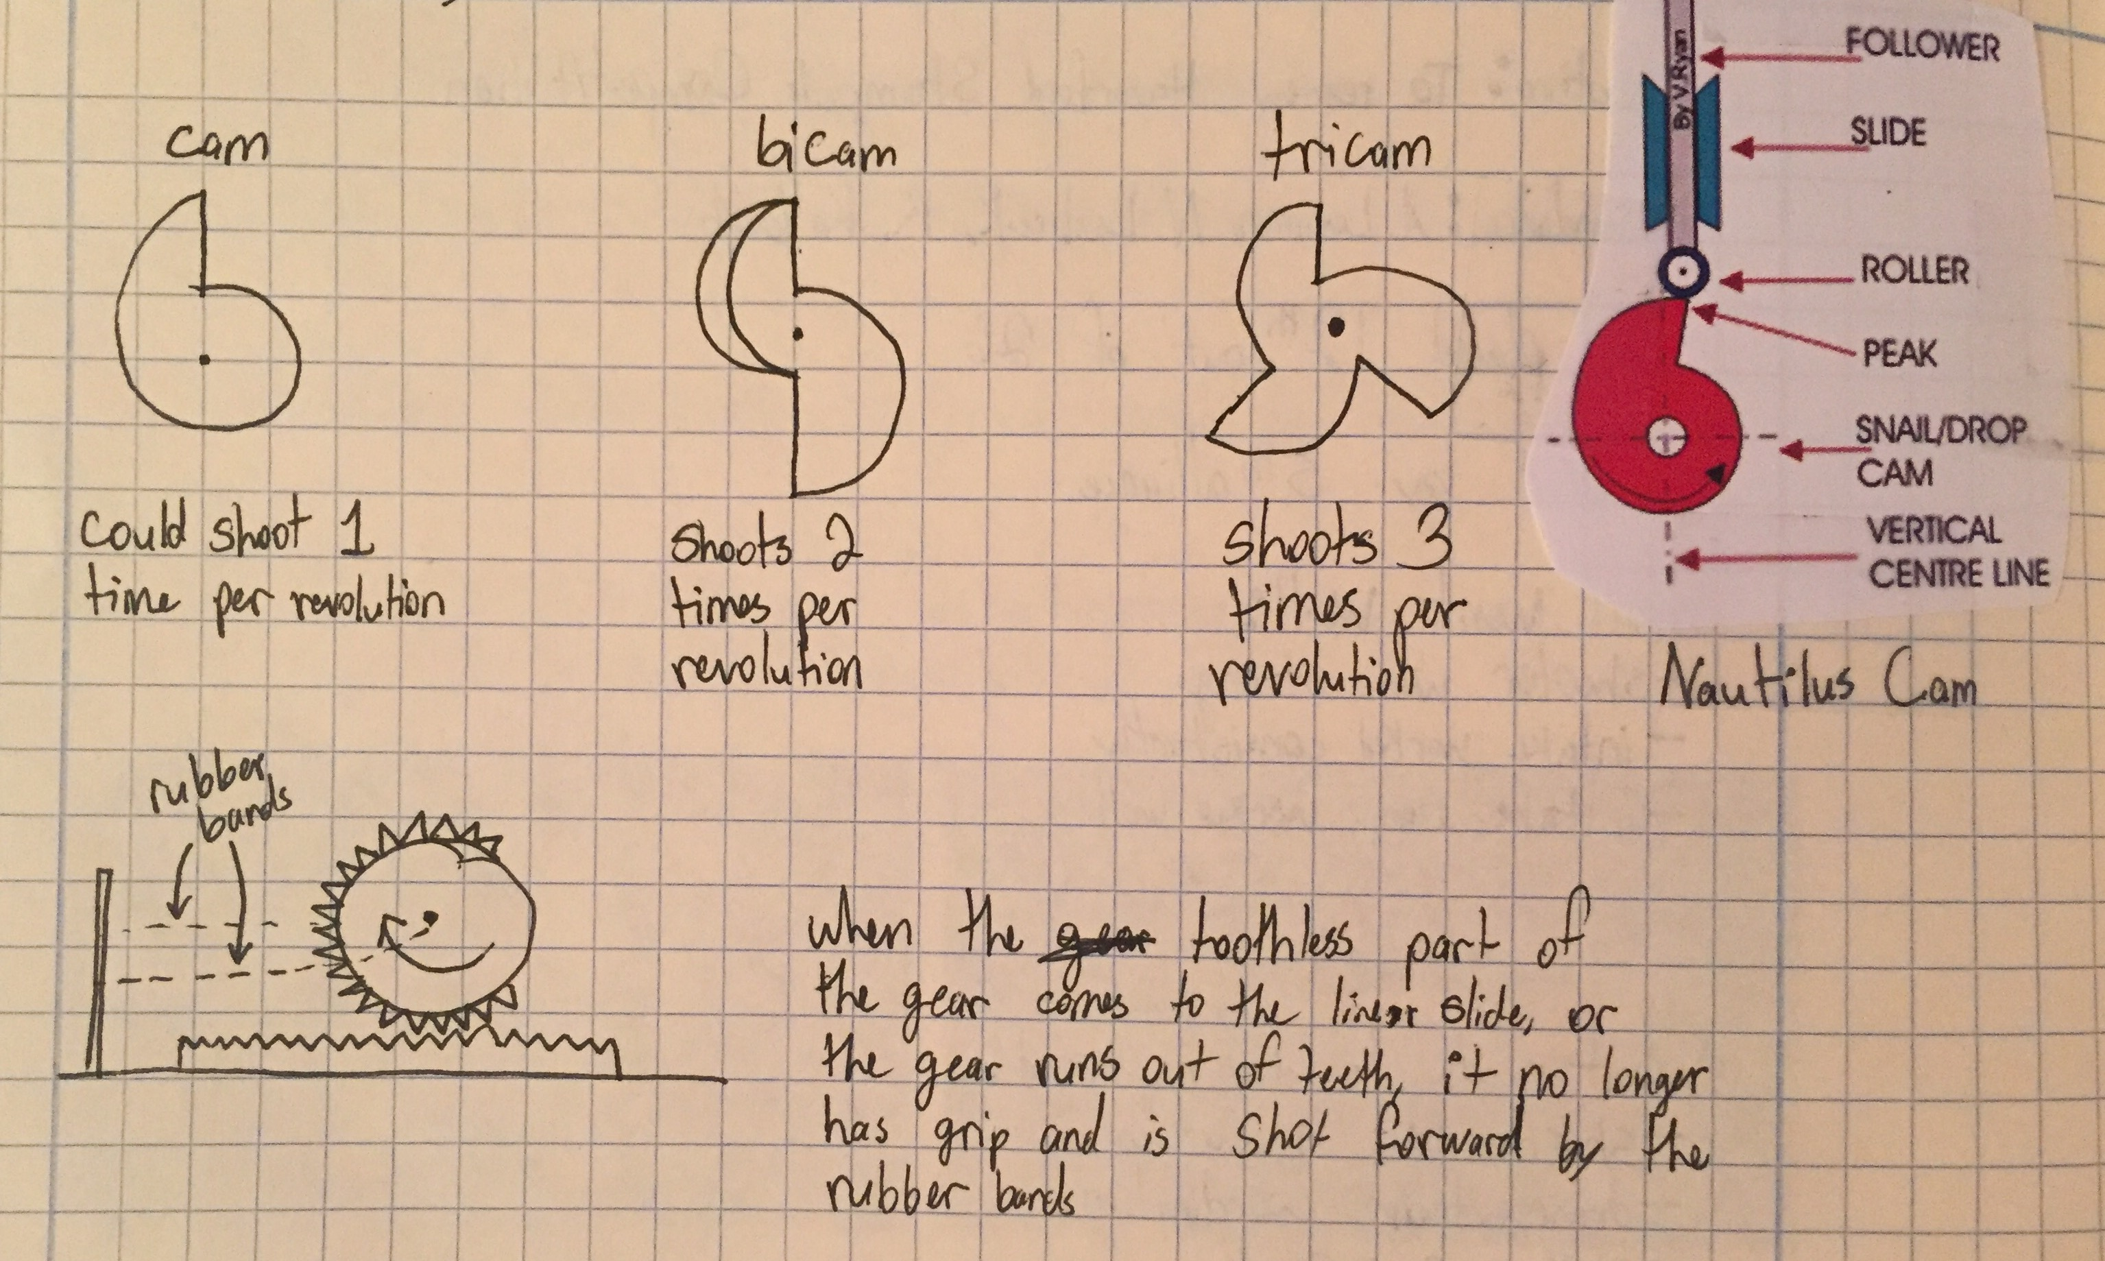
Our ideas for the punching motion of the piston.

Cam – Every rotation, the piston would be pulled back and released, allowing for one shot
per revolution. Would hook onto the piston to pull it back
Bicam – Every half rotation, the piston would be pulled back and released, allowing for two
shots per revolution. Would hook onto the piston to pull it back
Tricam – Every 1/3 rotation, the piston would be pulled back and released, allowing for three
shots per revolution. Would hook onto the piston to pull it back
Slip gear – Every rotation, the piston would be pulled back and released, allowing for one shot
per revolution. Would pull back a linear slide in a gear and rack arrangement

We started by prototyping with the cam because we have see real life examples of uses with the cam, such as in engines.

Prototyping a Cam:
We made a cam out of steel flat plates and 2 pieces of Plexiglas. The Plexiglas sandwiched the steel flat plates with the steel for strength and the Plexiglas for shape and smooth edges. We put one cam on each side of the piston and had them push on a high strength axle for the linear motion.
What we found was that the cam required too much torque from the motors to push the piston back. They also took up quite a bit of space and to make the robot space efficient for a home, we need to a smaller option

Slip Gear:
We went with a slip gear because we found that they require less torque to pull back when compared to cams. Slip gears also take up less space, keeping the robot space efficient and less bulky so it does not take up as much room.

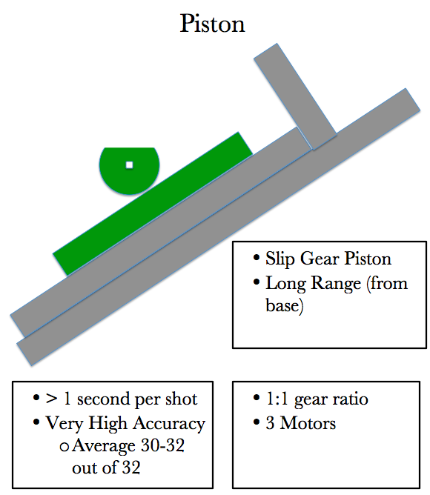
Design of a Short Range Shooter using a Flywheel
The flywheel will be used to shoot the ball a short distance and upward more rather than out. This would be used to shoot the ball to the owner or shoot it for the dog to fetch.

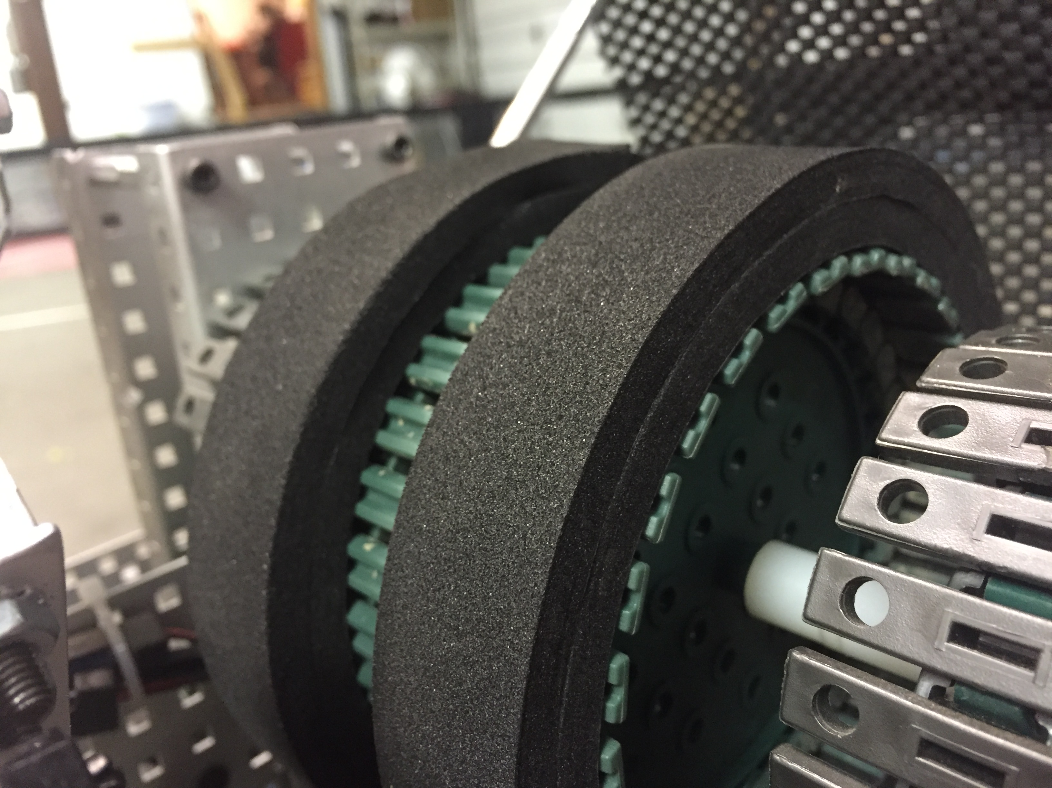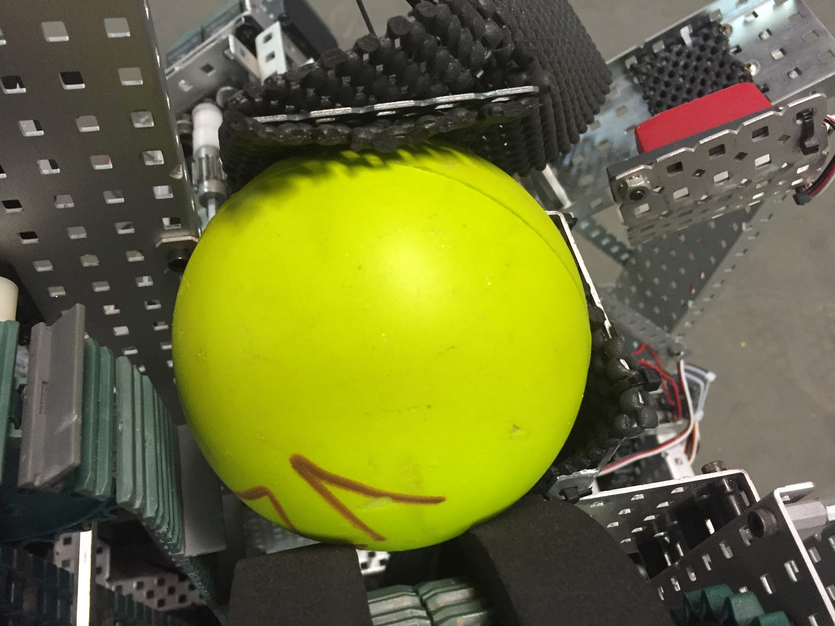

In order to allow the flywheel to get up to speed quickly, it has a light mass. It is made out of cogs and chain with foam on top. The cogs keep it light (as compared to wheels) and the foam grabs the ball to shoot it. We used two layers of foam to raise the ball off of the chain and help fit the curvature of the ball.

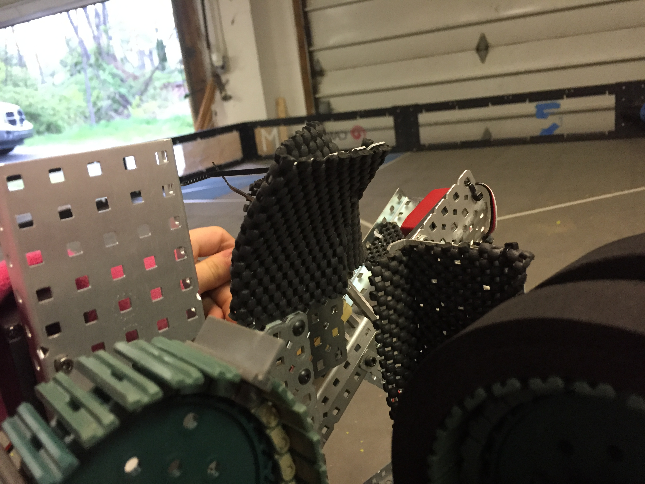

To shoot the ball, we also added a curved, metal plate to direct the ball where to go. This metal plate can be bent upwards to shoot the ball higher, or bent forwards to shoot the ball further, allowing for the ability to adapt depending on the need.

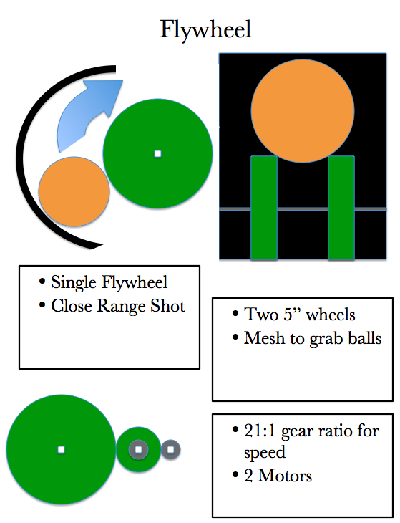

Design of an Intake to Collect the Balls
The purpose of the intake is to be able to pick up any balls that the dog does not fetch. This way, the handicapped person does not have to bend over to pick up the ball. The intake rollers suck the balls off the ground with two high-speed motors for quick operation.

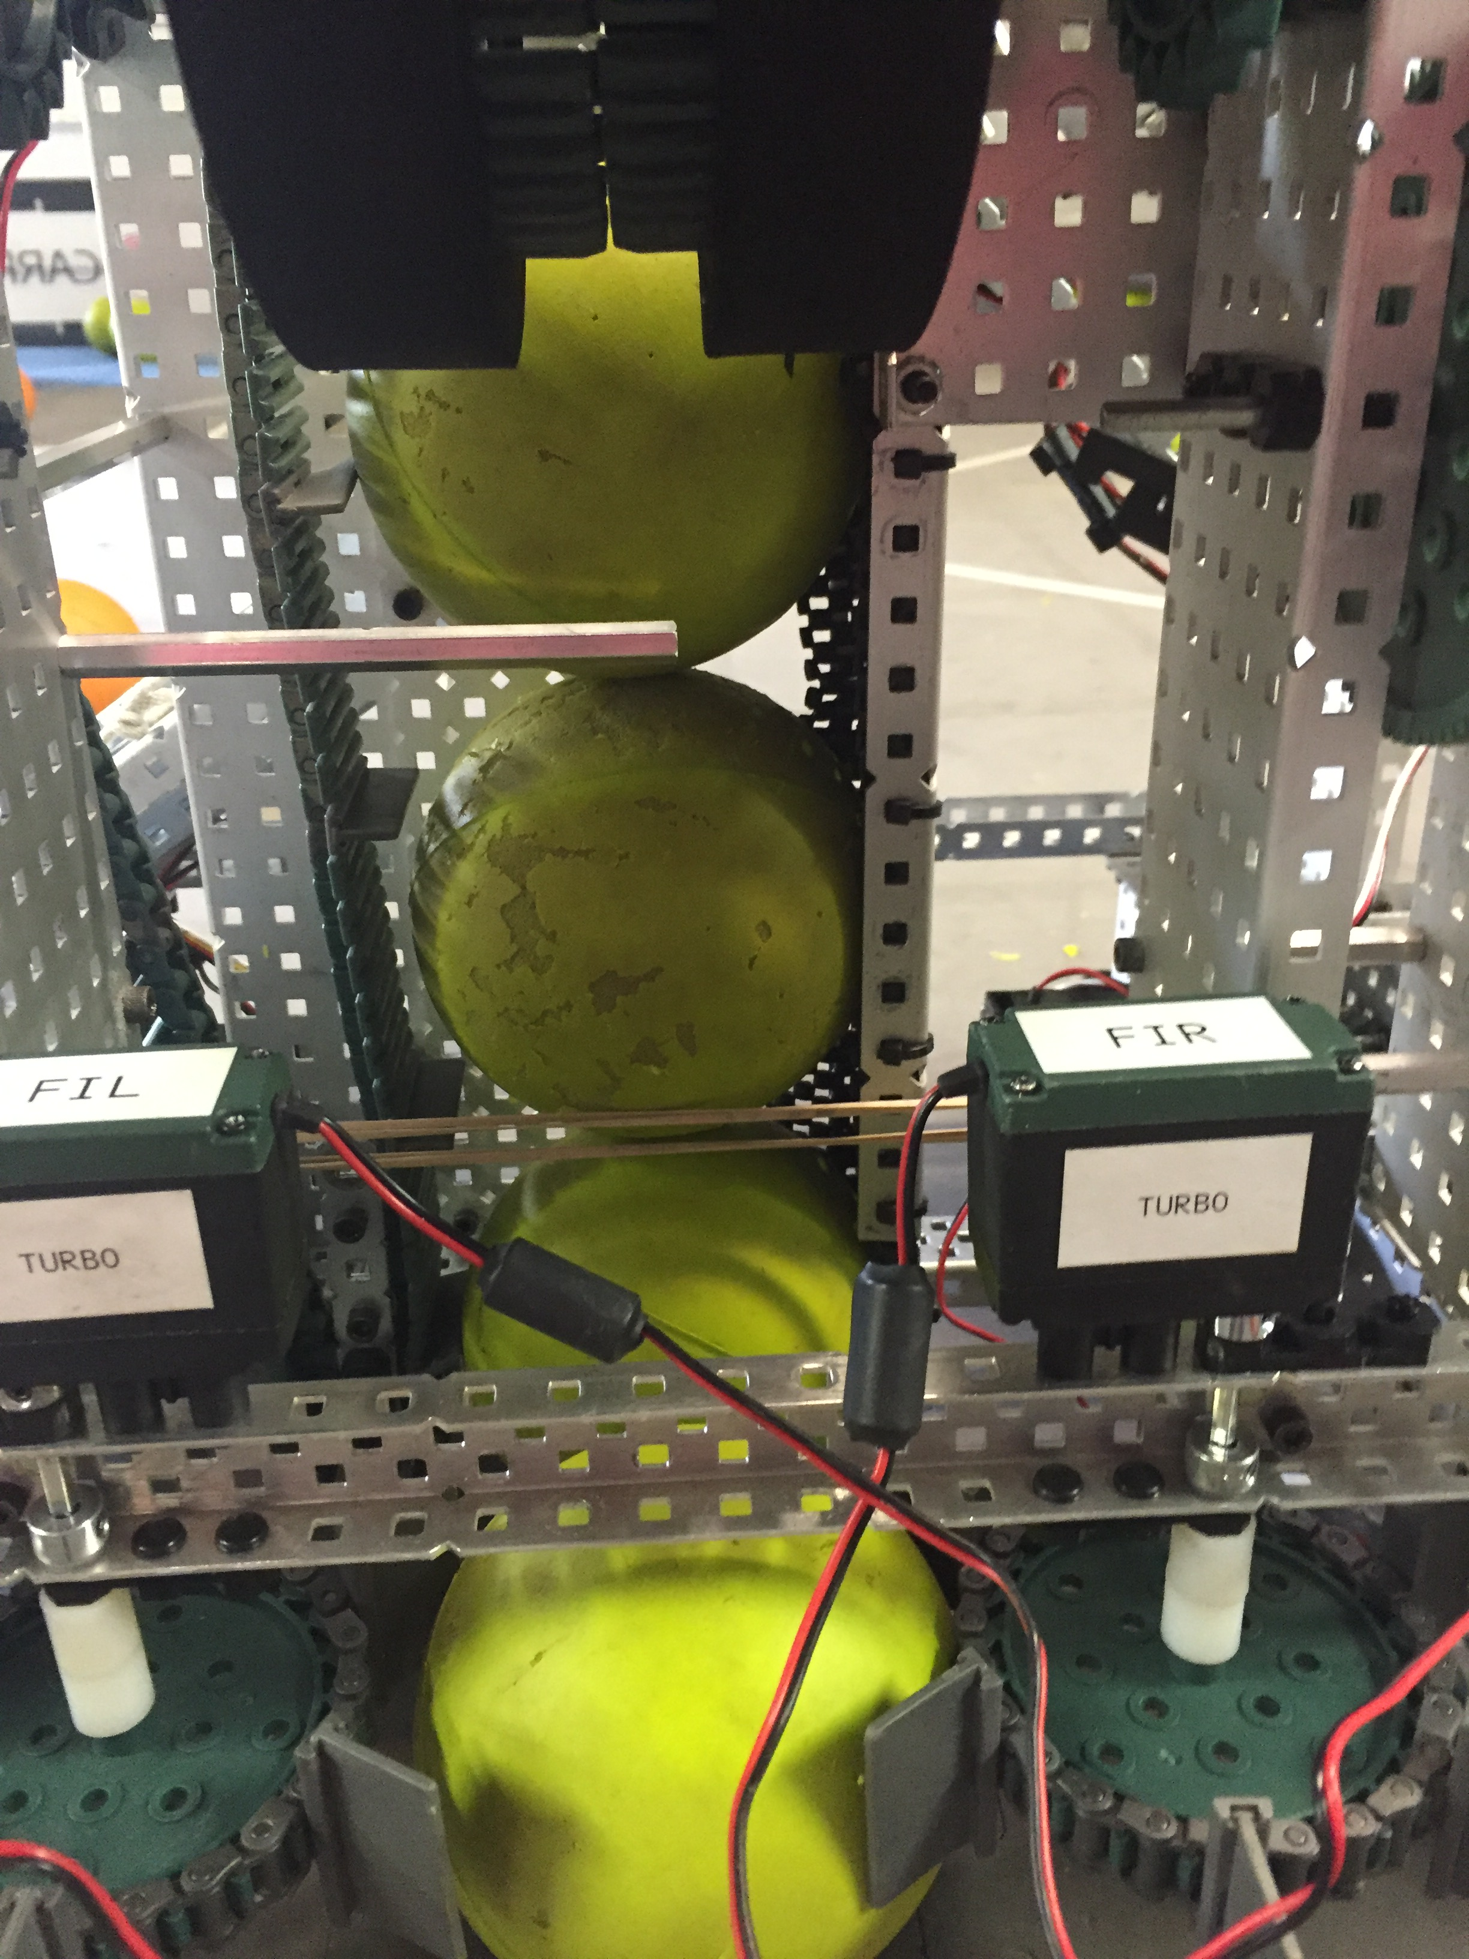
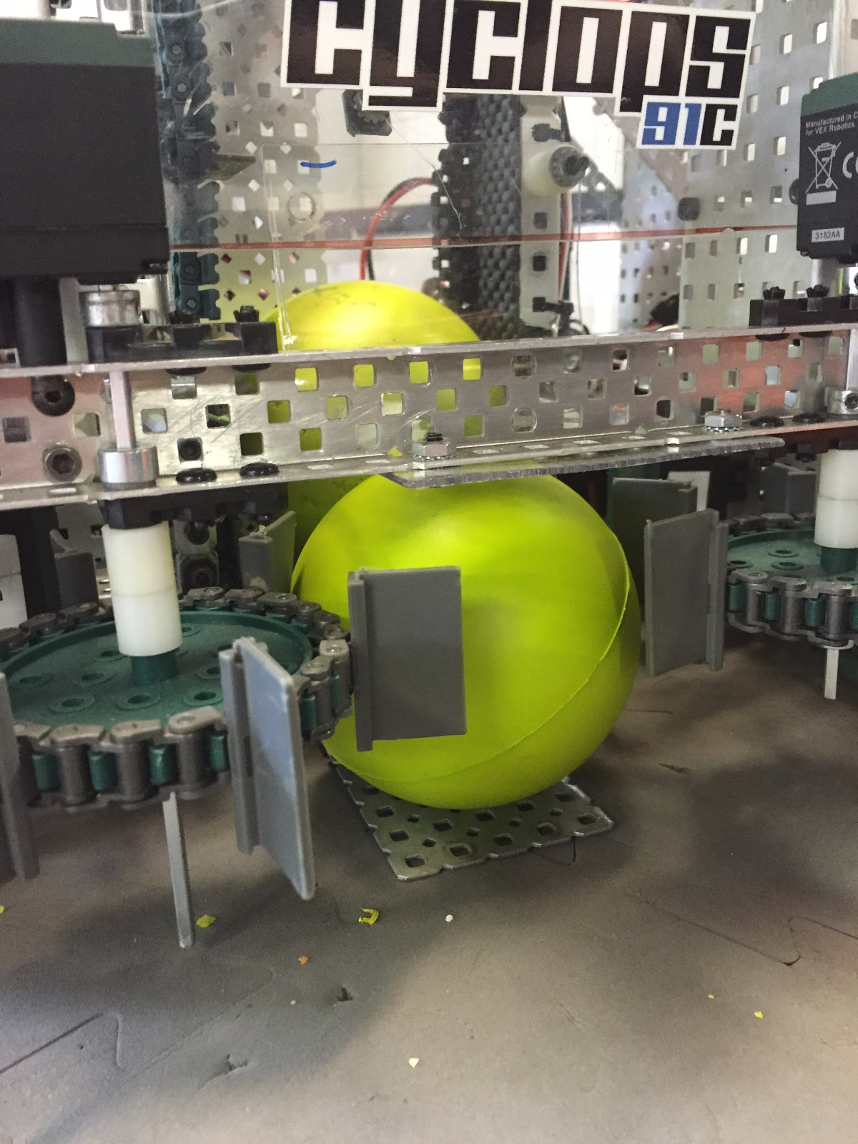

To keep the intake space efficient, a conveyor on only one side transports the balls up to the flywheel. This decreases space from having a motor on each side, along with only using a wide c-channel instead of a length of chain and flappers.

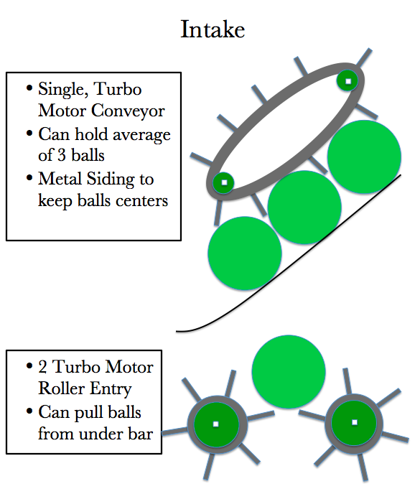

Build Process
Here is an over view of the building and designing of our robot.
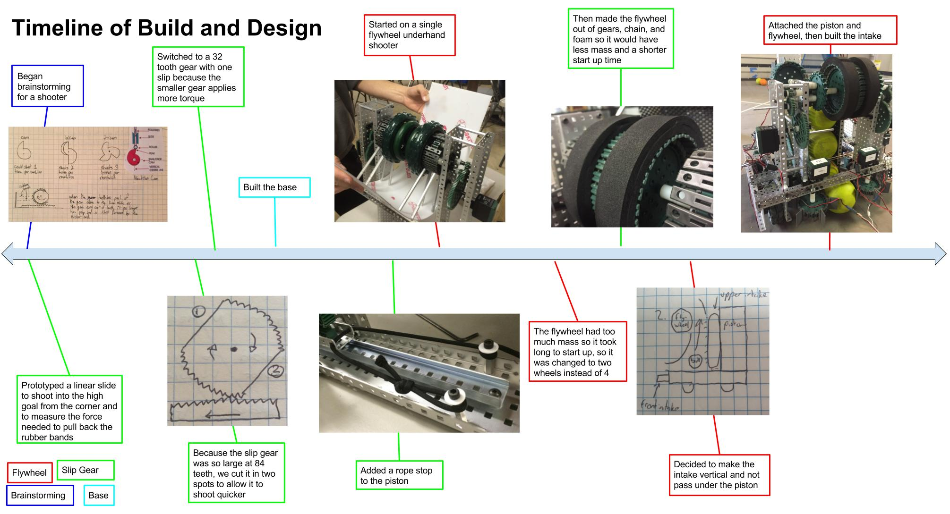

Testing and Evaluation

To test the robot, we placed the robot in a home setting and had a disabled person use it to play with some dogs. We wanted to see humans’ reactions, the dogs’ reactions, and how it would handle in a home.

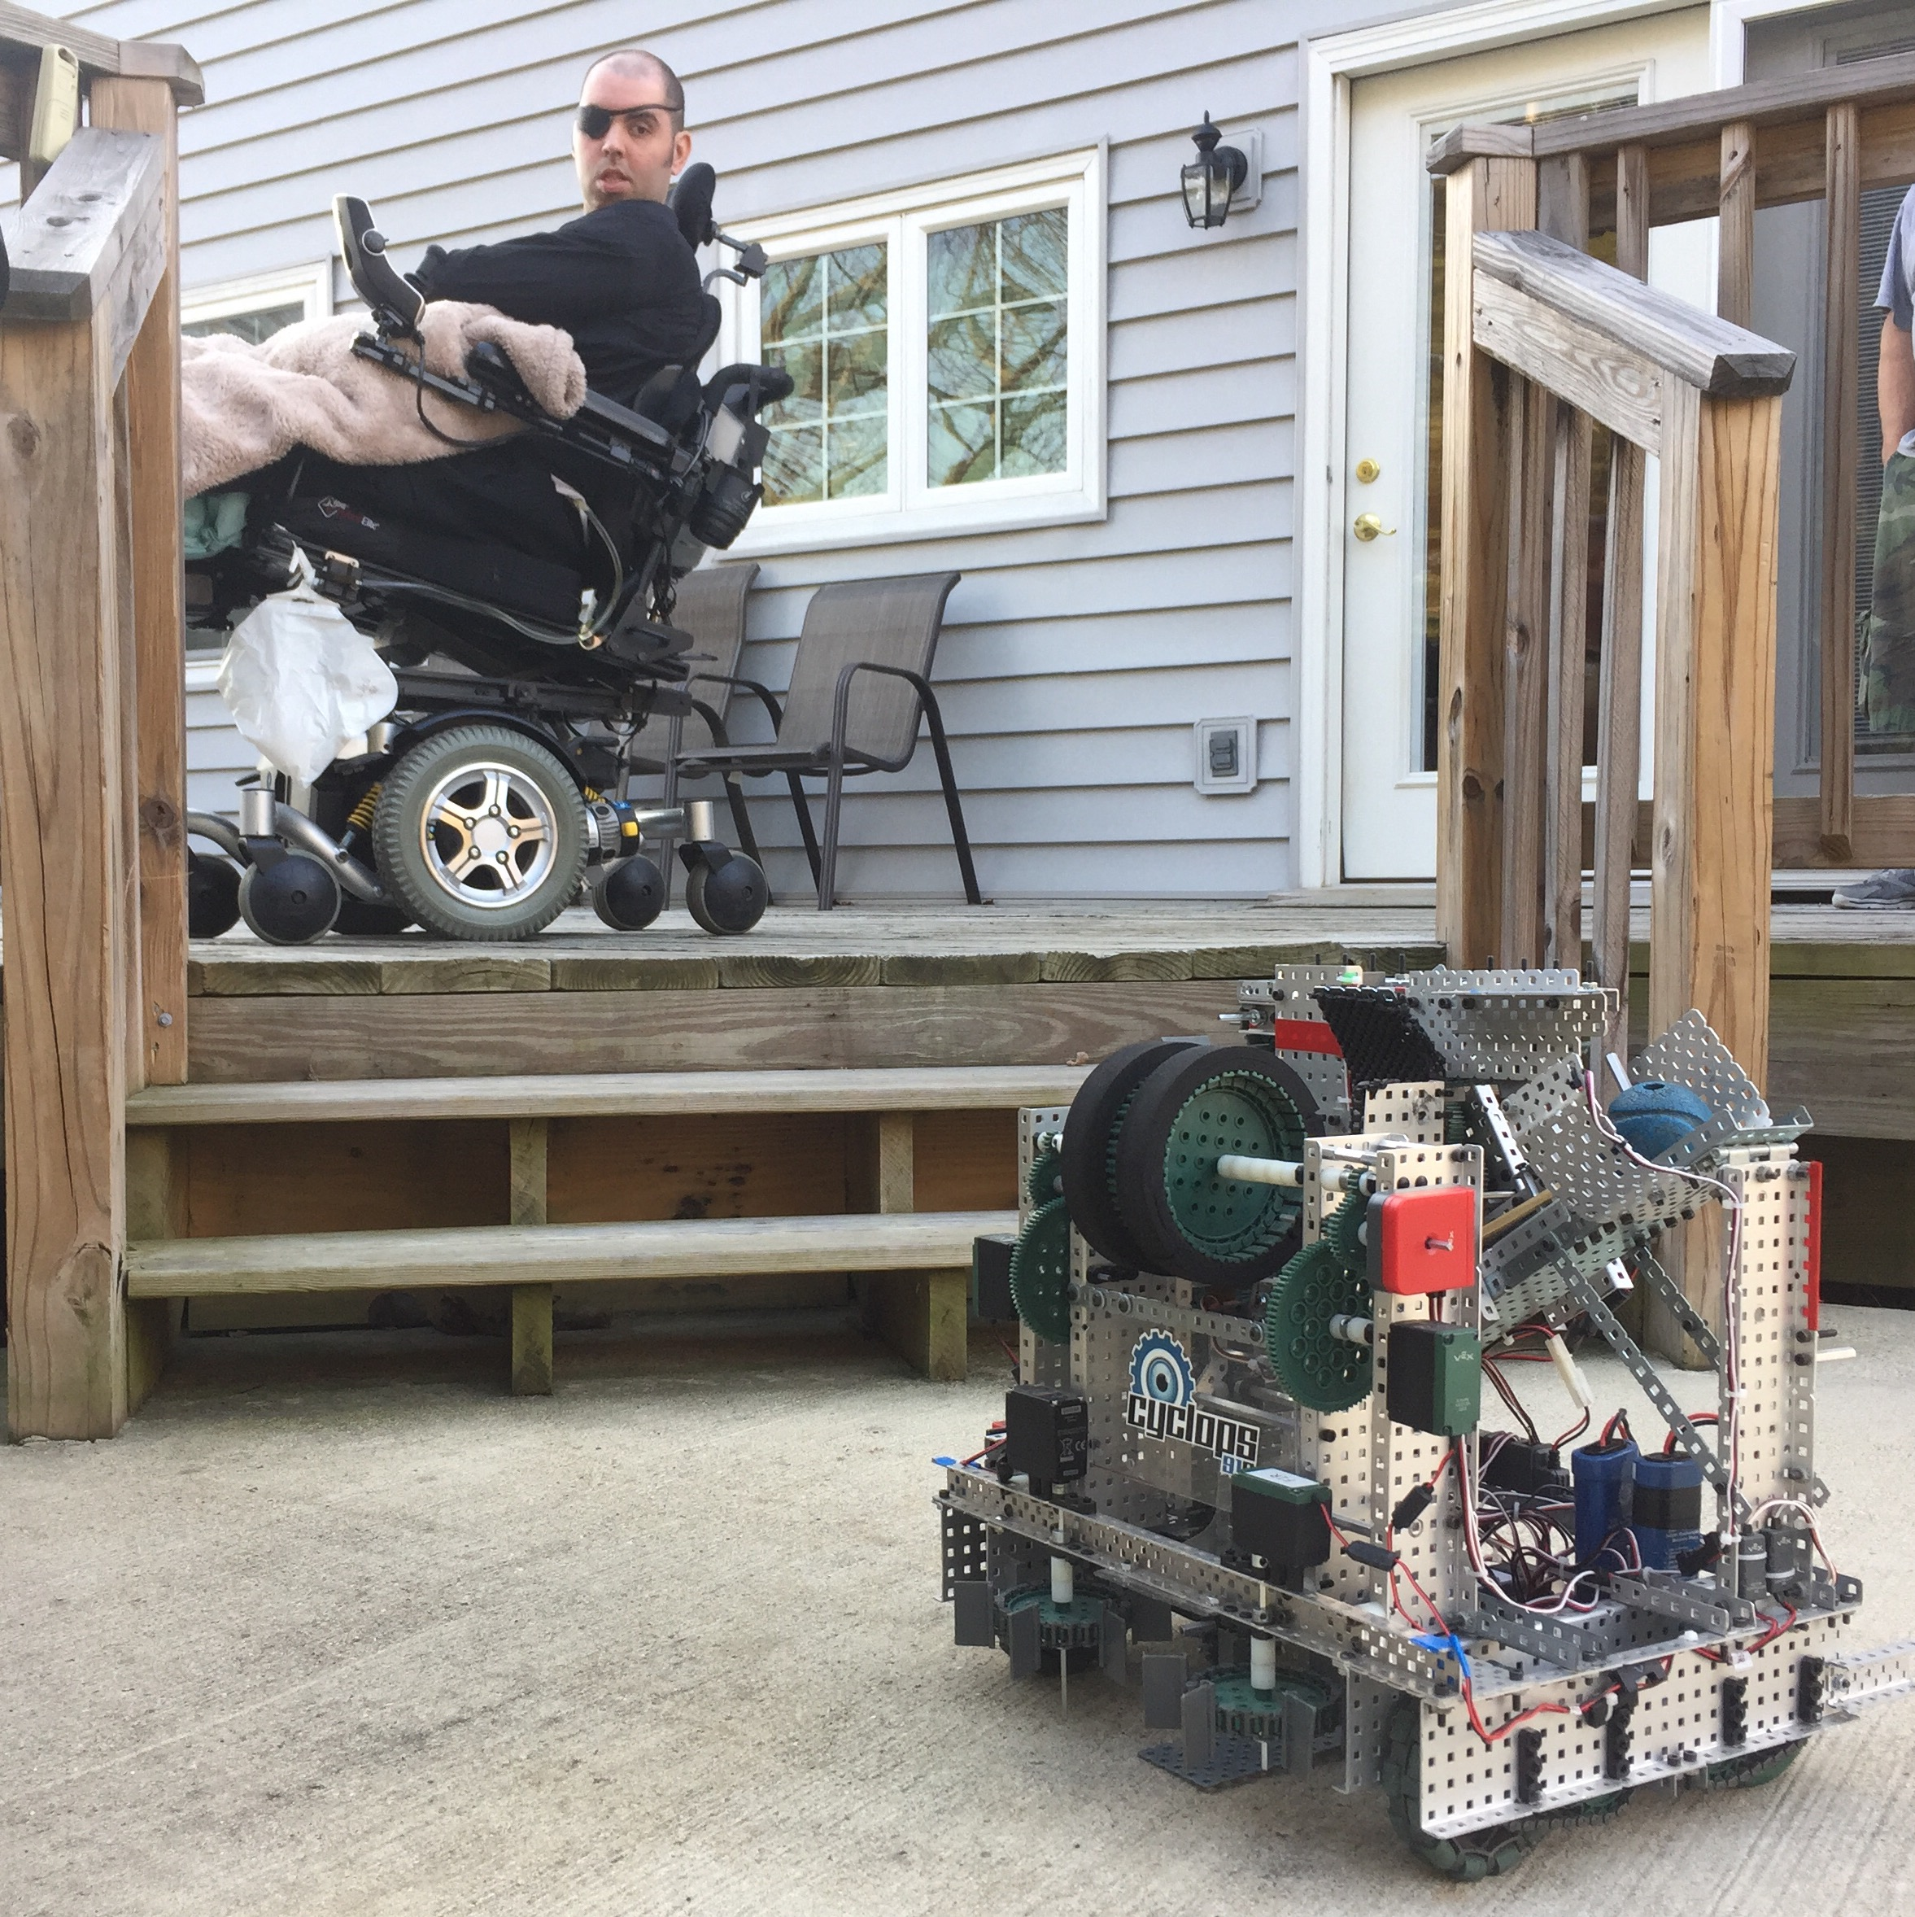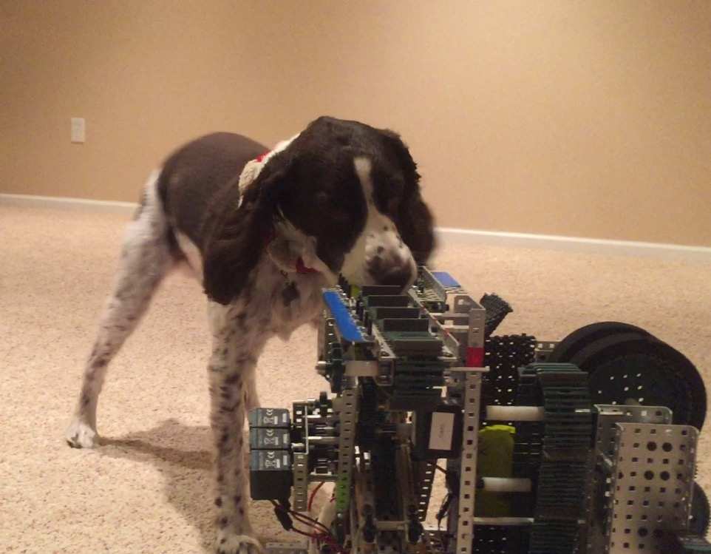

What Went Well:
- The robot was able to maneuver in a home on multiple types of surfaces and did not take up too much space
- The human testers found it easy to use and very fun
- The dogs, while weary of the robot at first, warmed up to it and were chasing after the ball

What to Improve On:
- The robot was rather loud when running
- Since a controller is required to operate the robot, not all disabled persons may be able to operate the controller with the same ease. We could improve on this by creating a different way of driving the robot, such as building the joystick controls into a wheel chair’s armrest (such as Chris’s) for easier access.

Based on our testing and results, we feel that a robot like this one would be useful in a home of the future to help accommodate disabled residents. It helps the mobility challenged play with his or her pets in a way which they may not be able to do so now. This will help build a level of companionship between disabled persons using our robot and their pets.

