Marshall MG10 Amplifier
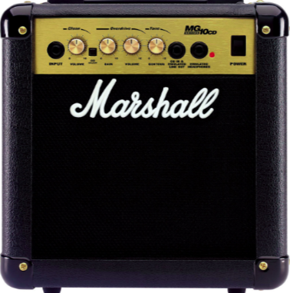

Texas Instruments Electronics Online Challenge
1138- Eagle Engineering
1/9/2017
Introduction
This report reflects our findings while deconstructing and researching the components, channels, and frequencies of the Marshall MG10 Amplifier. We decided to use this item because we feel that it reflects the loud message of positivity and hard work that we share with our fellow team mates, as well as the teams we face in competitions. In addition, the components that make up this electronic device allow the user to control the volume and frequency of that message.
Bill of Materials
1 Transformer
2 Capacitors
1 Rectifier
1 Shunt regulator
1 LED1 (Green)
1 LED2 (Red)
1 LED3 (Red 5mm)
1 Fuse
1 Speaker (8 ohm)
Internal Components Descriptions
Clipping Diodes
The clipping diodes produce the symmetric clipping on the overdrive channel which change the gain of the inverting op-amp from high value to 1 and clips the signal.
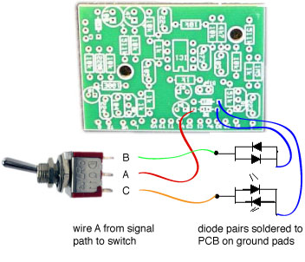
Tone Control
The Marshall amplifier that we deconstructed uses a Contour tone control to manipulate the tones that are emitted. In this case, the tone control manipulates the mid-range sounds using a device called a VR4 potentiometer, something that functions as a voltage divider that can measure voltage. These devices are found frequently in the field of volume control. Through the tone control system, the mid-range sounds can be changed while keeping the bass and treble the same, as this system does not have the ability to change the bass and treble. This ultimately results in a distinct sound known as a scooped sound commonly used in some types of music.
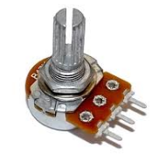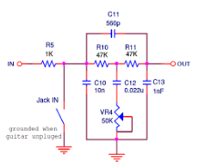

Speaker Cone
At a nominal diameter of approximately 160 mm and a power rating of 10 watts RMS, the speaker cone releases the sound by allowing the frequency response to roll off heavily after 5 KHz.
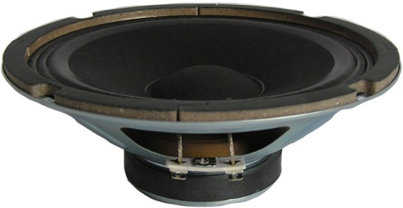

Transformer
The Transformer converts AC power to DC power.
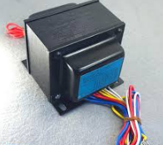
Capacitors
The two capacitors shown by CX 1 and 2 are known as surge suppressors. They are devices which are placed in an alternating current in order to protect from power spikes which are called transients. They are particularly used with semiconductor based electronic and computer hardware.
Fuse
The fuse works to protect from overcurrent of either the load or the source circuit. It acts as a sacrificial device by interrupting excessive currents.
Rectifier
The rectifier converts alternating current or AC, which periodically reverses direction, to direct current or DC which flows only in one direction.
Shunt Regulator
The shunt regulator provides a path from the supply voltage to the ground via a variable resistance. They have voltage reference diodes and are sued in very low powered circuits.
Circuits and Frequencies
Filter
Another feature in the amplifier which directly follows the Tone Control is a low-pass filter. This consists of 2nd and 3rd order Sallen keys and is used to rid the device of high frequencies before amplification to eliminate unwanted sounds. Sallen keys are commonly used in filters due to their simplicity. In fact, the Sallen keys used in the Marshall amplifier can only pass signals that have frequencies lower than the cutoff frequency on the overall sound.
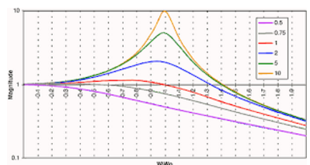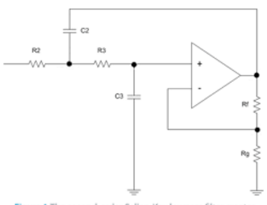
Input Stage
The input stage subtracts the feedback signal from the input in order to generate the error signal that drives the output. To begin in the input stage, a differential input must be given. This is because feedback is used to control the gain in the amp. This stage is also known to be trans-conductance, meaning voltage is put in while current is outputted. In the next stage, the gain stage, is a trans-impedance stage and is opposite to that of the first step, as current is inputted while voltage is outputted. During the gain stage, most of the gain in voltage occurs. Without this voltage gain, the amp would not have a precise signal gain. Finally, there is an output buffer stage. This ultimately allows for low-impedance load with almost no effect on the gain.
Power Supply
The power consumption of the amplifier is estimated to be about 40W. The power supply provides energy and bias voltage to every piece of circuitry.
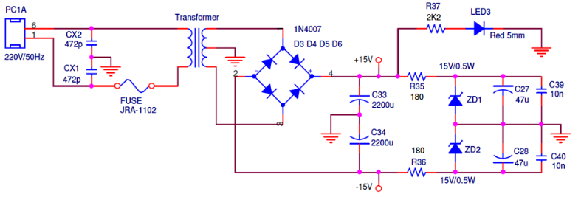
Overdrive Channel (Clipping Stage)
The overdrive channel is selected with the Double Pole Double Throw Switch1, which allows the signal to bypass this part of the circuit, resulting in a clean sound.
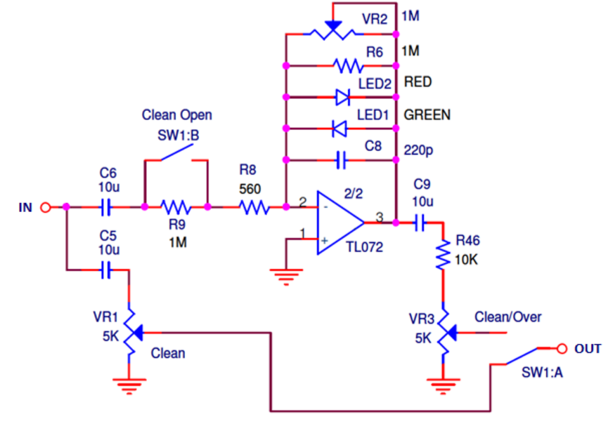
Clean Channel
The clean channel bypasses the Clipping Stage. The signal is taken from the input stage and feed into a single potentiometer. This is referred to as typical passive volume configuration.
Pictures
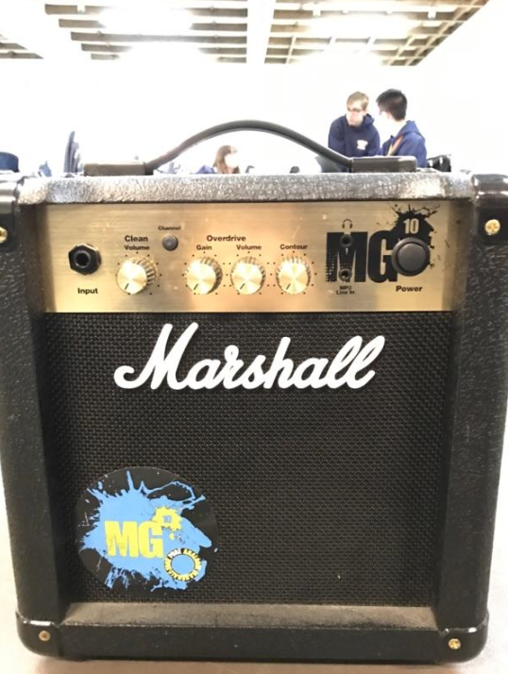
The amplifier before being disassembled
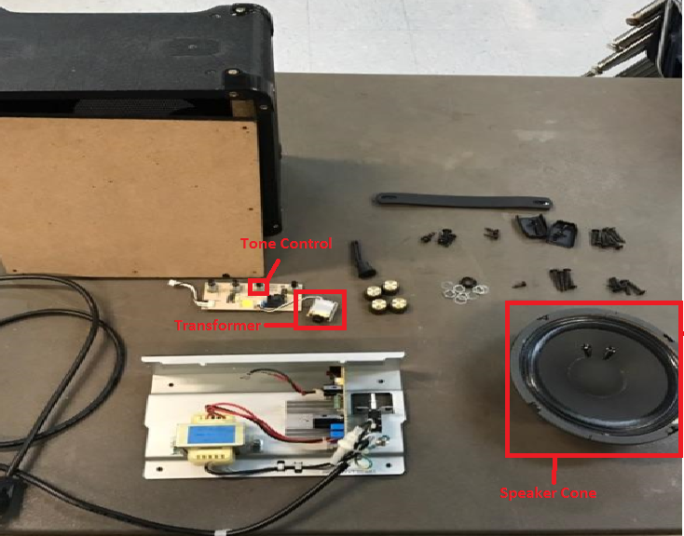
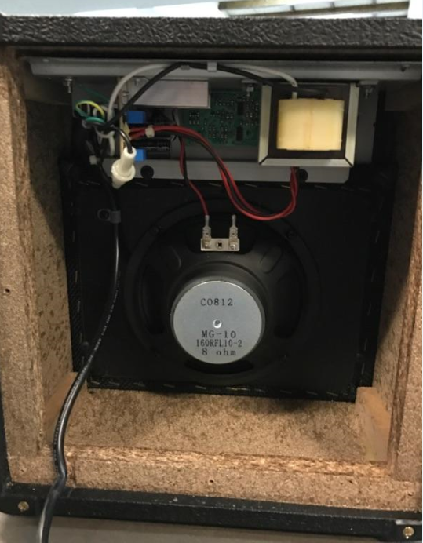
Conclusion
If we have learned anything from disassembling and researching the Marshall MG10 Amplifier, it would be that the true beauty of electronics comes from making connections. From the wires to the circuit board, ever component that we have found is linked to the larger purpose of producing a message. All and all, we are now more equipped to face the many challenges involving electronics that we will come across while constructing our robot.
Cited Sources
http://www.electrosmash.com/marshall-mg10#link1
http://www.learnabout-electronics.org/Amplifiers/amplifiers42.php
https://www.arduino.cc/en/Tutorial/Potentiometer
http://www.ecircuitcenter.com/Circuits_Audio_Amp/Basic_Amplifier/Basic_Audio_Amplifier.htm

