Combining Art and Robots

For the FUTURE Foundation Robot Construction Challenge, our team spent many days brainstorming and talking to friends, family, and teachers about what types of robots they would want to use for simple tasks in the future. We wanted to do something related to art because we feel that robotics and art are directly related. It takes a lot of creativity to design an effective robot the same way it takes a lot of creativity to create beautiful paintings. Not to mention, many 21st century artists use technology in their artwork. Therefore, we asked our art teacher what issues he encounters in his classroom, and we designed a robot that would fix them.

We came up with build plans for a small robot that efficiently cleans paintbrushes. Quality paintbrushes can be expensive, so many artists only own one or two. When they are painting they have to clean out the same paintbrush over and over in order to not mix paint colors. With our robot, it will only take a matter of seconds to clean the paintbrush. In an art classroom, art teachers often have to keep cups of water sitting in front of students so that they can clean their paintbrushes in between use. However, it is very easy to accidently knock one of these cups over and ruins a piece of artwork. Our robot will eliminate this issue. At the end of the class, the art teacher can easily collect the paintbrushes and clean them all at once in the robot. Our paintbrush-cleaning robot will save artists time, space, and money.

The robot can also be used in a home environment, even though not everyone paints on a daily basis. Many women use brushes to apply make up on a daily basis. Women rarely clean their make up brushes because they either don’t realize they should be doing cleaning, or they don’t have the time. We hope that this robot will be used in the future by women in the future to regularly clean their makeup brushes, because never washing is unsanitary. Bacteria can build up on the brushes, which are then transferred to the face potentially causing acne or infections. We are a team of three girls who all wear make up, so we know how helpful this robot would be to many women.

Materials

We used all VEX EDR components, except for the flat circle.
12” by 2 ½” Metal Sheet | 1
Regular Strength 393 Motor | 1
2” Axel | 1
Vex Cortex (and vex nets, along laptop/cords to download the program) | 1
1 1/2” C-Channel | 2
4 ¼ (diameter) Flat Circle* | 1
Long Metal Panel | 2
Screws, Nuts, Collars | As many as needed
Soap and Water** | As much as needed
Rechargeable Vex Battery Pack | 1

*We used a Tupperware Lid, however something like a plastic plate could be used

**Any type of soap can be used, but if you plan to use the robot to clean make up brushes we recommend an antibacterial soap that is safe for use on the face.

Building the Robot

The first step was to draw out build plans for the robot. The final robot varied slightly from the original design because the drawing is not to scale.

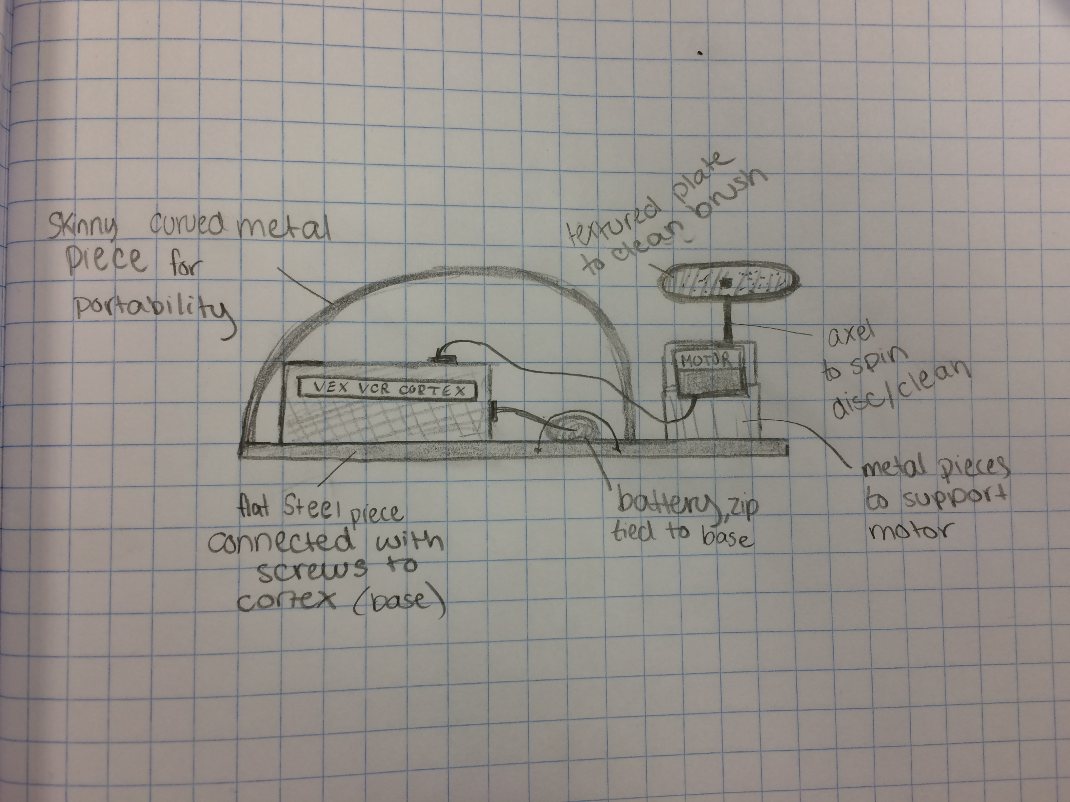

Once we had created the blue prints, we used scrap VEX parts from our competition robot to build the brush cleaner. The final product was a small robot that easily cleaned a brush that was placed in the center of the spinning piece. To activate the spinner, the cortex is turned on. In the future, a sensor could be connected to the robot so that when a paintbrush was placed inside the piece would immediately began spinning and cleaning. However, our team did not have a spare sensor to attach so it was left out in our model. When the cortex is turned on, the axel spins which in turn spins the flat circle. A small bit of water and soap is added to the spinning flat circle so that when a brush is held against it, is cleaned. A curved metal piece covers to the top of the robot to provide support and increase portability.

The Program

We purposefully used a very simple program so that anyone could design and build this robot. It only has one motor, so the program simply powers the motor at 60% speed until the cortex is turned off again.

