For the T.I. Electronics Online Challenge, I decided to dismantle the K86326 Atomic Projection Alarm Clock with Indoor/Outdoor Temperature by LA CROSSE Technology. I selected this device because it is a novelty item in many households. My family owns two of these devices, and we use it daily. So, I was interested to find out what components it uses and how it works.

Inside the atomic clock, some of the components I found were: Aluminum Electrolytic Capacitors, Oscillators, multiple Integrated Circuits (IC Chips), a Ceramic Crystal Tripod, Inductors, multiple diodes, and a time projection unit which housed an LED panel. The capacitors, ceramic crystal tripod, and oscillators were mounted onto IC units that were themselves mounted onto the circuit board. The IC chips were both mounted onto the chips and welded into the back of the circuit board. There were also two other IC units with soldered wires, one each placed in the projection unit and clock base. All of these different components work together to make the clock work. None of the components I found were manufactured by T.I.

The capacitors consist of two metallic plates, and when voltage is activated over the plates, an electric field has been created. Oscillators convert a direct current into an alternating current, and produce an electronic signal. An IC chip is a semiconductor chip where a collection of thousands of capacitors, resistors, and transistors are made. IC chips can act as various different components. A ceramic crystal tripod makes mechanical vibrations and induces an oscillating signal of a frequency when connected to an oscillator. Inductors resist erratic changes in passing electrical currents. Diodes allow an electrical current to flow in one direction only. The time projection unit syncs to the local time using radio waves and projects the time onto wherever you point it to, using LED light from the panel.

Through the disassembling of the atomic clock, I learned that there is a lot more to an electronic device than you might think. I’m working with a relatively simple projection clock and yet had so much trouble trying to figure everything out. People that engineer and work with high functioning equipment are working at much higher levels than I am, and inventing technology that helps many people daily. I use so many products today that have so many complex components behind them that I never even think about.

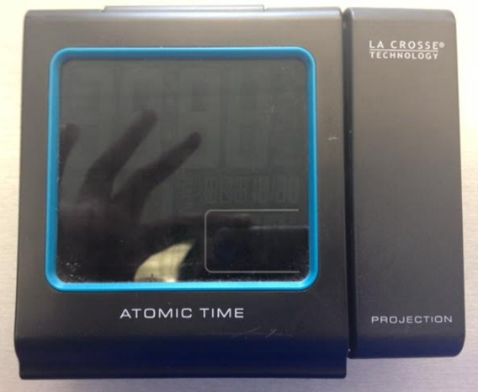 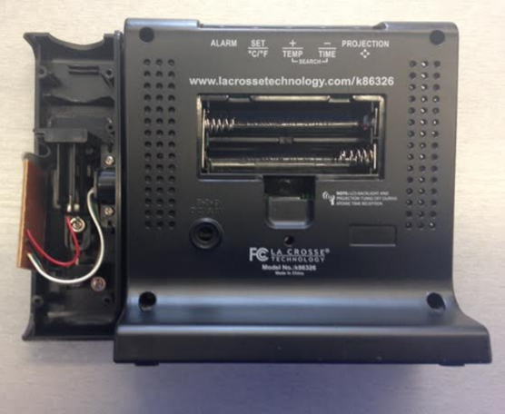

The atomic clock pre-dismantling

The back of the atomic clock with the batteries and outer casing of the projection unit taken out

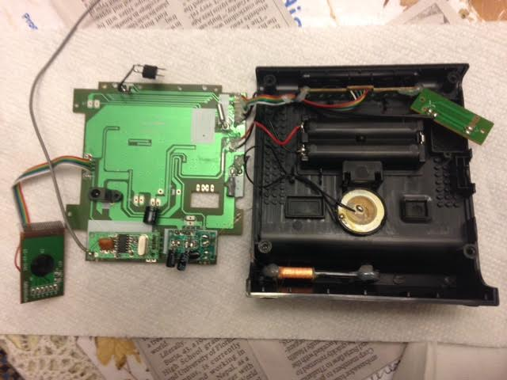

A chip from the projection unit, the circuit board, and the base of the clock (from left to right)

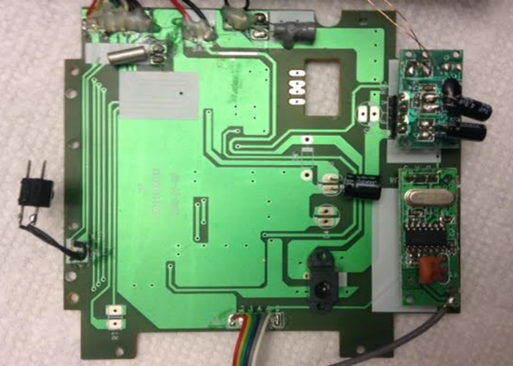

Front of circuit board after being pulled out of base

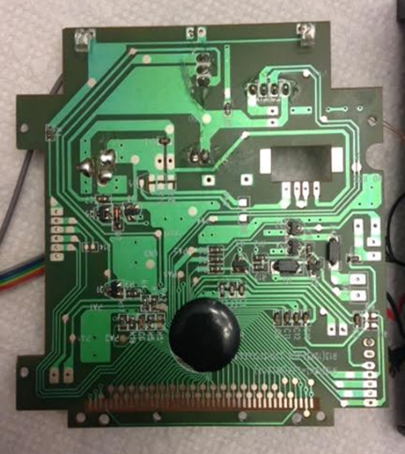 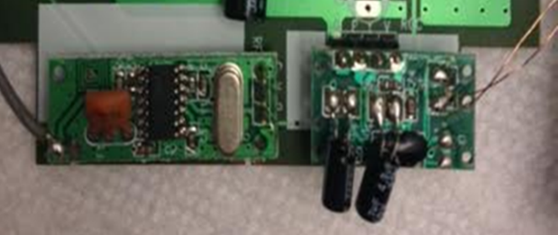

Chips on circuit board where Aluminum Electrolytic Capacitors, IC Chips, and a Ceramic Crystal Tripod is mounted onto

Back of circuit board once it was taken out of the base