Texas Instrument Online Challenge Report

By: Jeffrey J. Ríos Colón of Team PUPR

Introduction
For the Texas Instrument Electronics Online Challenge, I chose to deconstruct and analyze an old Samsung Galaxy S3 I had lying around my room. We are living in an age where technology is rapidly changing and what better device to work with than none other than the one we are most exposed to on a daily basis, our mobile device.

Summary of Components
Picking apart the device I discovered certain components. I found a battery, motherboard, touch sensor, a Wi-Fi module, quad-core processor, NAND Flash memory, Baseband processor, GNSS Receiver, Stereo codec, Multi-Band Power amplifier, MHL Transmitter, NFC Chip, RF transceiver, and finally a camera. Some of the components where familiar and some were not, so I did some research on what they were and what were their functions. I noticed that when I took the phone apart I saw several brands like Samsung, Skyworks, and Murata, but none TI. This was odd since TI components are usually inside Samsung Galaxy.

Research on Components
- Battery: Is the power source of the smartphone.
- Motherboard: It holds and allows communication between many of the crucial electronic components of the device.
- Touch Sensor: Allows touch interaction with the smartphone.
- Wi-Fi Module: Gives the device access to a Wi-Fi network.
- GNSS Receiver: Allows communication with a GNSS satellite for functions such as GPS navigation.
- Quad-Core Processor: This allows the smartphone to run multiple instructions at the same time with overall speed.
- NAND Flash memory: Reduces the cost per bit and increases maximum chip capacity of the smartphone so that flash memory can compete with magnetic storage devices like hard disks.
- Baseband processor: Manages all the radio functions that require antenna of the device.
- Stereo Codec: Codes or decodes a digital data stream of audio on the smartphone.
- Multi-Band Power amplifier: Strengthens low-power, inaudible electronic audio signals to a level that is strong enough for driving (or powering) the phone’s speakers or headphones.
- MHL Transmitter: Is a mobile audio/video interface that allows the smartphone to connect to HDTVs, monitors, music players, etc.
- NFC Chip: Enables the smartphone to establish wireless communication by bringing it to another device within 4 cm (1.57 in) of each other. This allows the smartphone to make contactless payments, social networking or simply to share contacts, photos, etc.
- RF transceiver: An RF (Radio Frequency) transceiver is a module that both receives and transmit radio signals to allow the smartphone to make and receive calls with other phone devices.
- Camera: Optical instrument where the phone records or captures images or videos, which may be stored locally, transmitted to another location, or both.

Conclusion
By deconstructing the smartphone, I could further understand the engineering behind what once was a simple calling apparatus. Never could I imagine the complexity and many components that a smartphone possesses. I learned how many of the advanced functions and interfaces responsible by small electrical components. Thanks to this challenge I can appreciate and further understand how today’s technology work and impact our daily lives.

Gallery

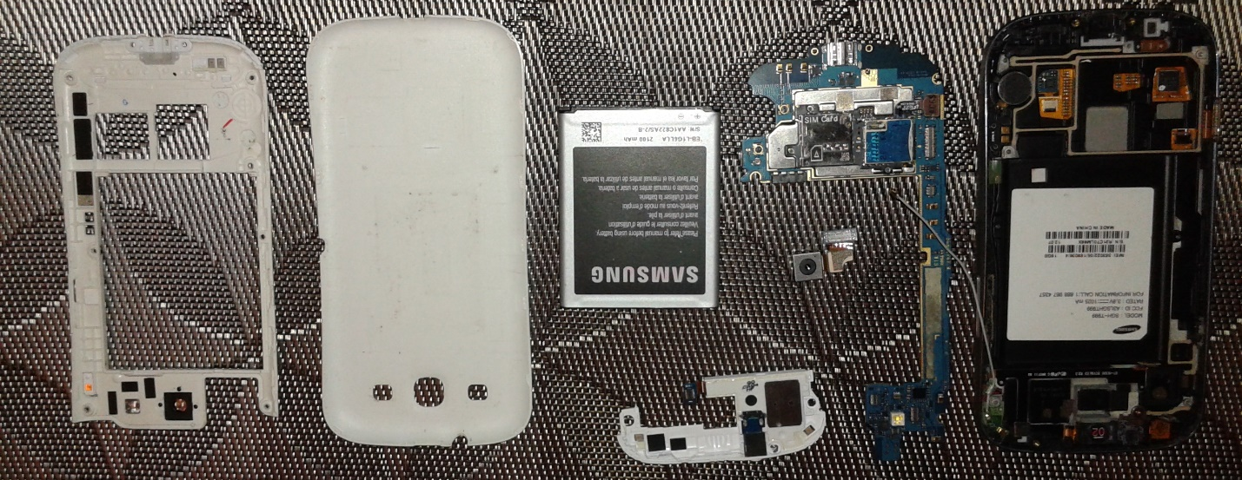
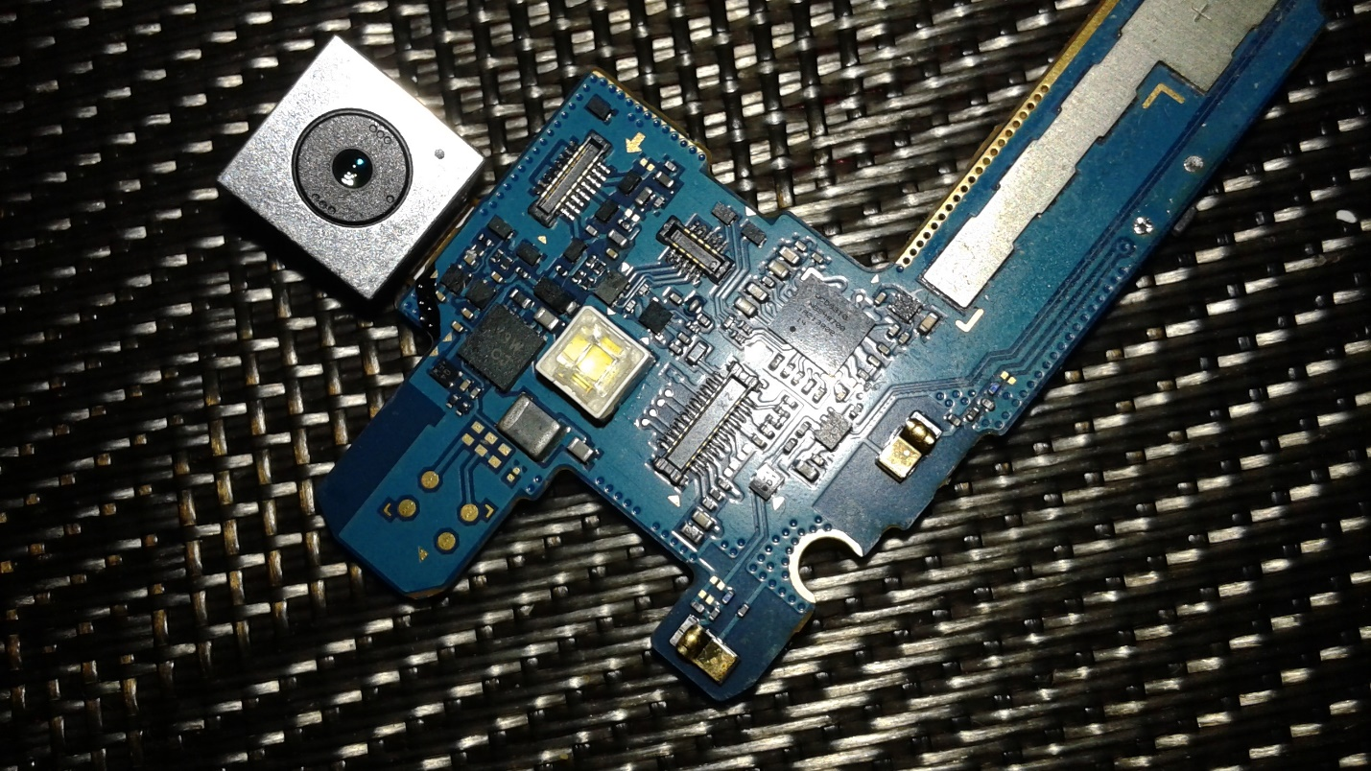
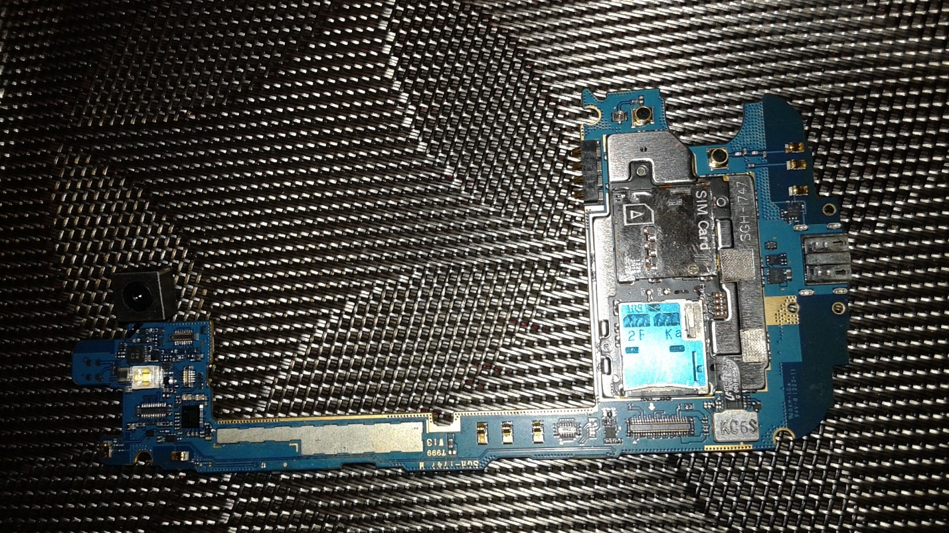
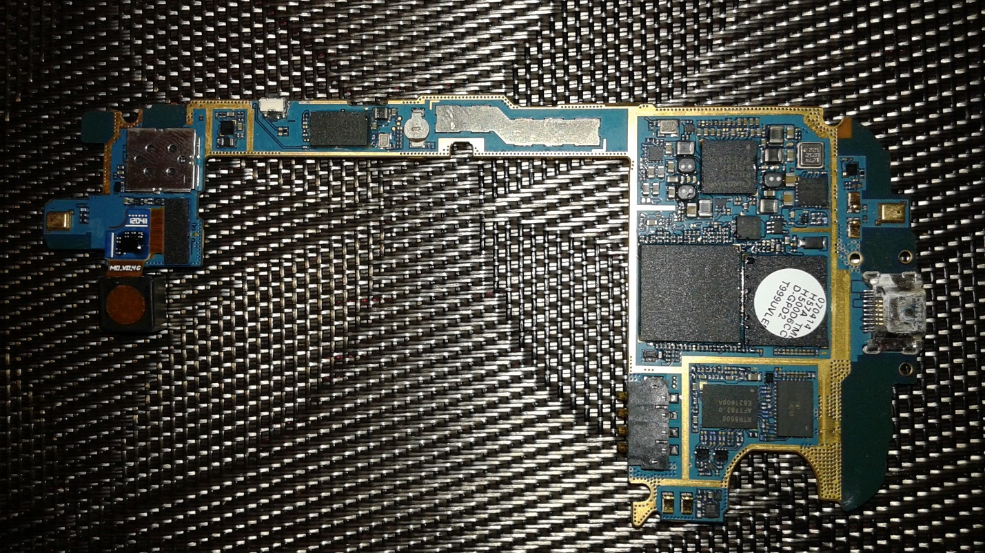

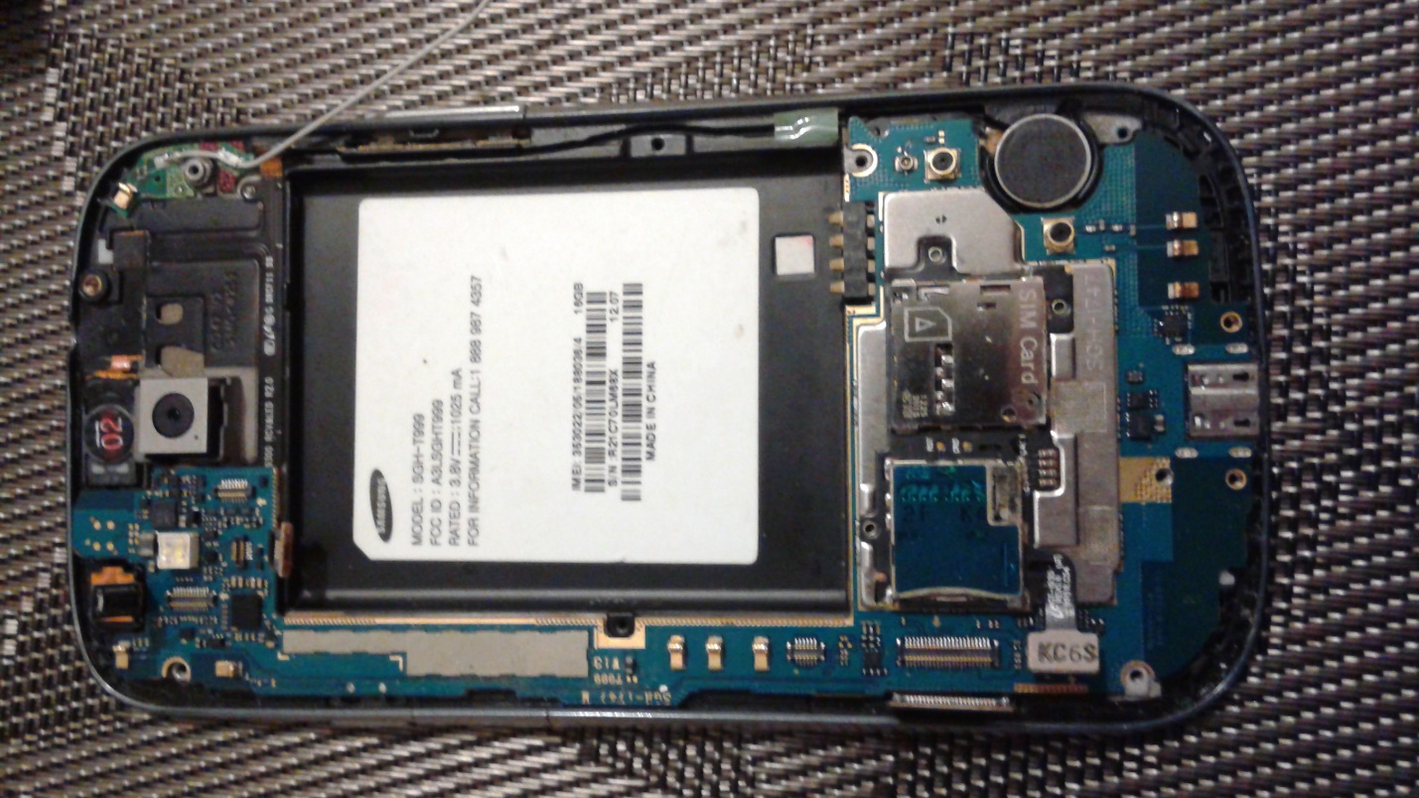
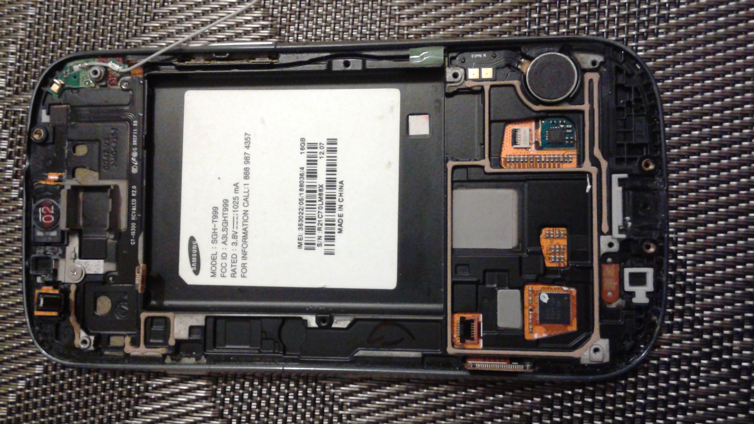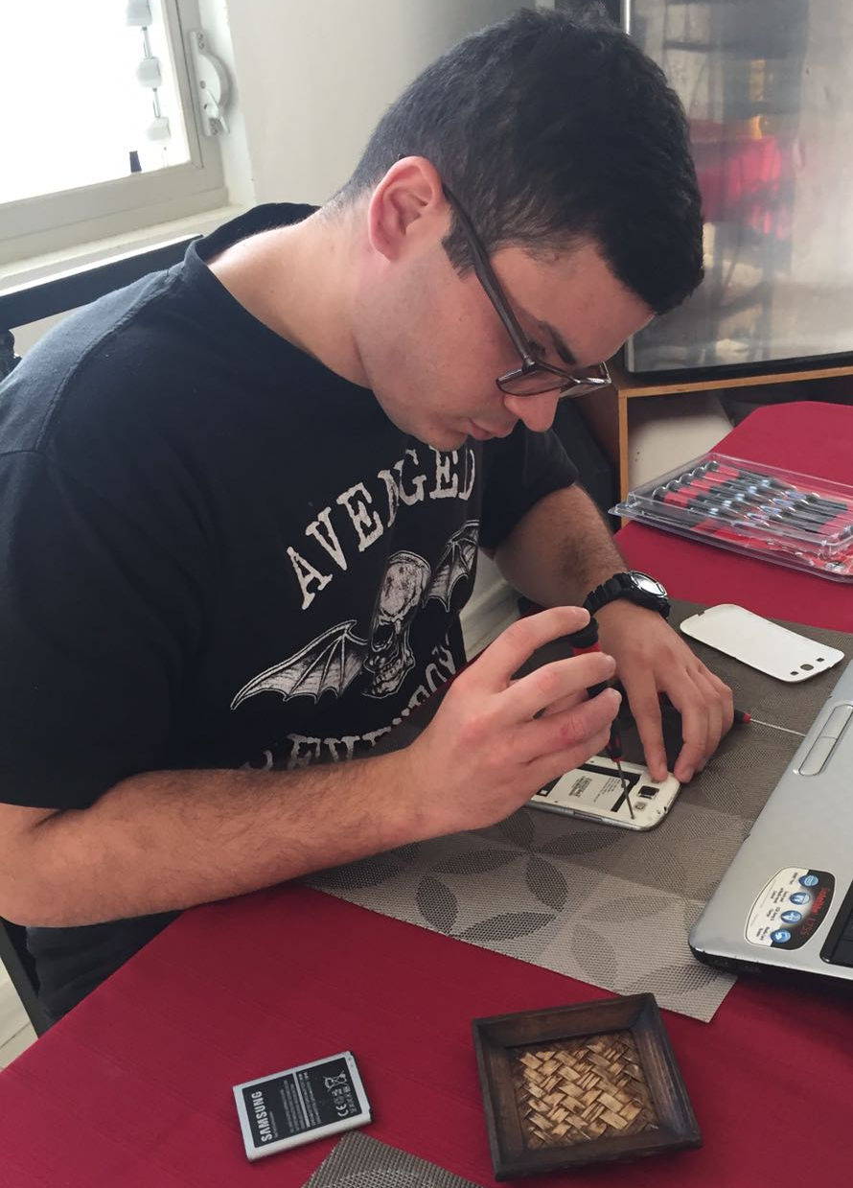
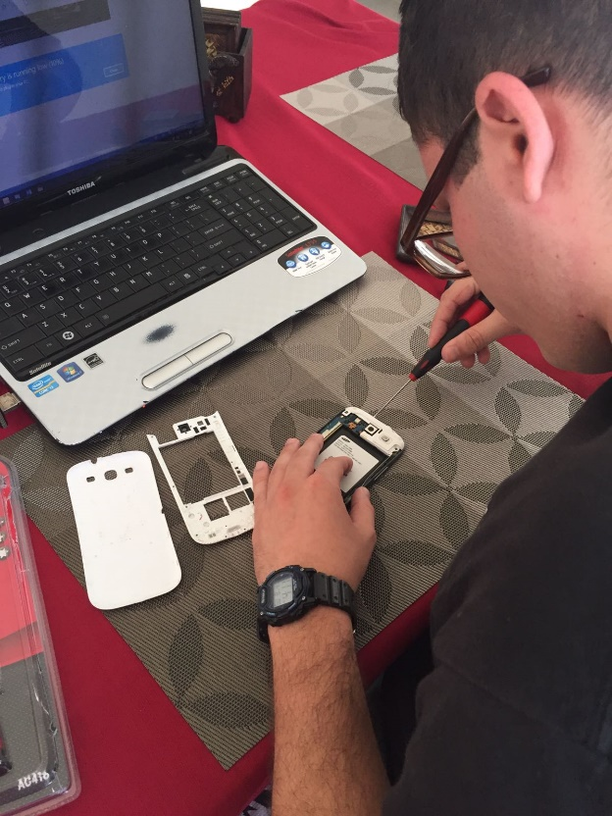
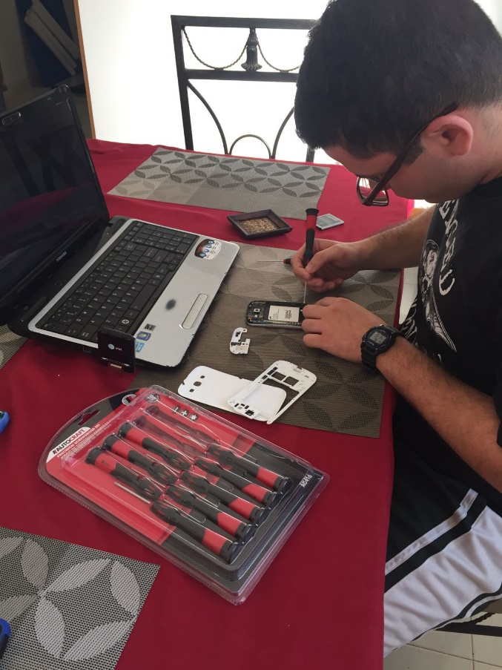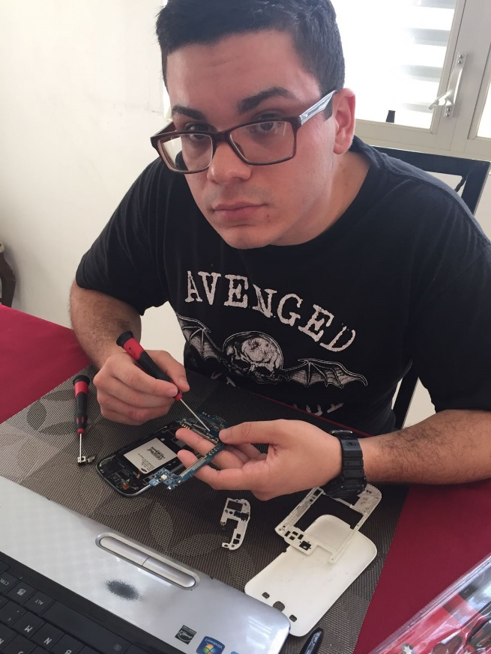

References
Nilsson, James William., and Susan A. Riedel. Electric Circuits. 9th ed. Boston: Prentice Hall, 2011. Print.
"What Is Transceiver? - Definition from WhatIs.com." SearchNetworking. N.p., n.d. Web. 08 Jan. 2017.
Http://www.pongcase.com/blog/author/ron/. "How Do Cell Phones Work?" Pong: Making the Case for Cell Phone Radiation Protection. N.p., 15 Apr. 2015. Web. 08 Jan. 2017.
Https://www.facebook.com/TechRadar. "What Is NFC? Everything You Need to Know." TechRadar. TechRadar The Source for Tech Buying Advice, 17 Nov. 2015. Web. 08 Jan. 2017.
"What Is Quad-core Processor? - Definition from WhatIs.com." WhatIs.com. N.p., n.d. Web. 08 Jan. 2017.
"Walter Galan." IFixit. N.p., 14 July 2014. Web. 08 Jan. 2017.
"RF Module." Wikipedia. Wikimedia Foundation, n.d. Web. 08 Jan. 2017.

