We’ve decided to deconstruct a digital camera Panasonic DMC-F2, which did not work anymore because its screen was damaged and its battery was lost. Furthermore, we had curiosity about its internal structure.

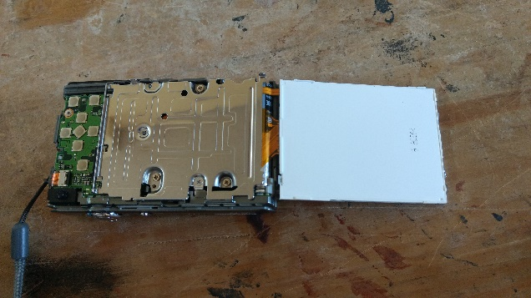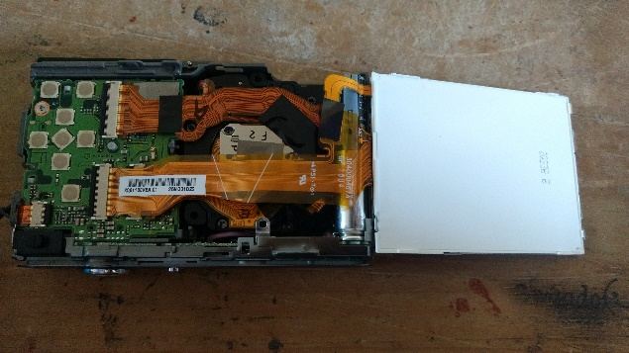When taking off the front cover we found the camera lens and a metal plate, which protects the battery and the memory card. On the other side of the camera, when taking off the rear cover we found the screen and the motherboard, which makes the buttons and the screen function, protected with a metal plate. This metal plate was taken off in order to leave the screen and motherboard exposed.

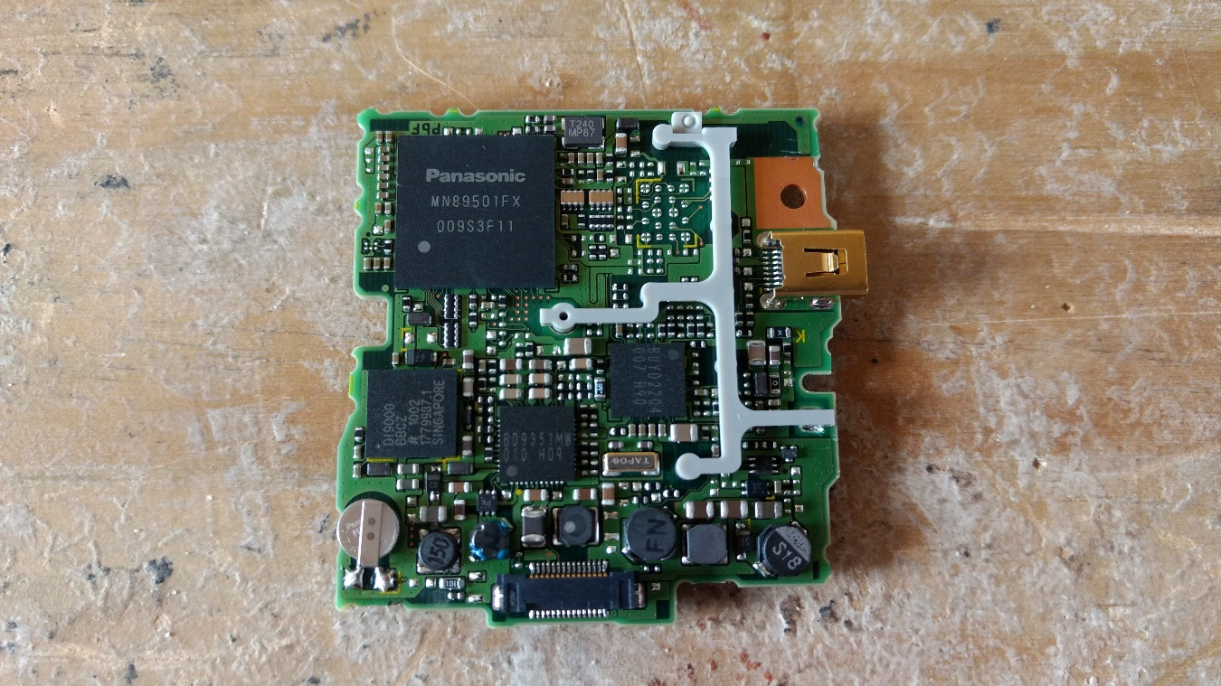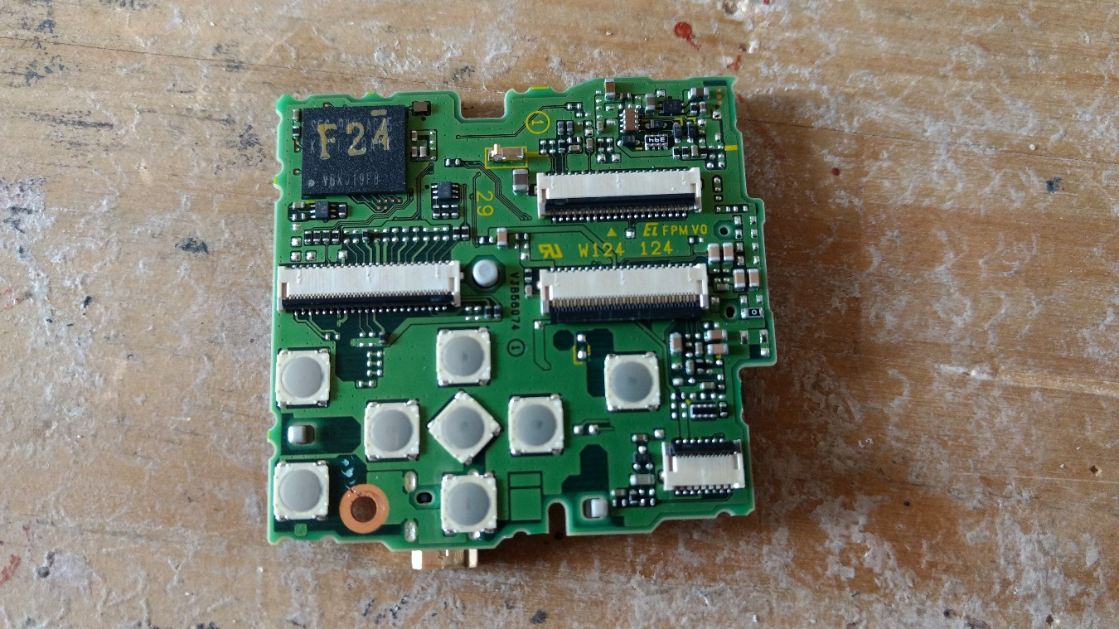There we could notice the USB terminal. Also, on one of its sides there were some grooves which connect the motherboard with the screen, the camera lens, the memory and the battery of the camera. On the other side we found several pieces. However, none was fabricated by TI.

* Camera lens
* Screen
* Memory and battery
* USB terminal

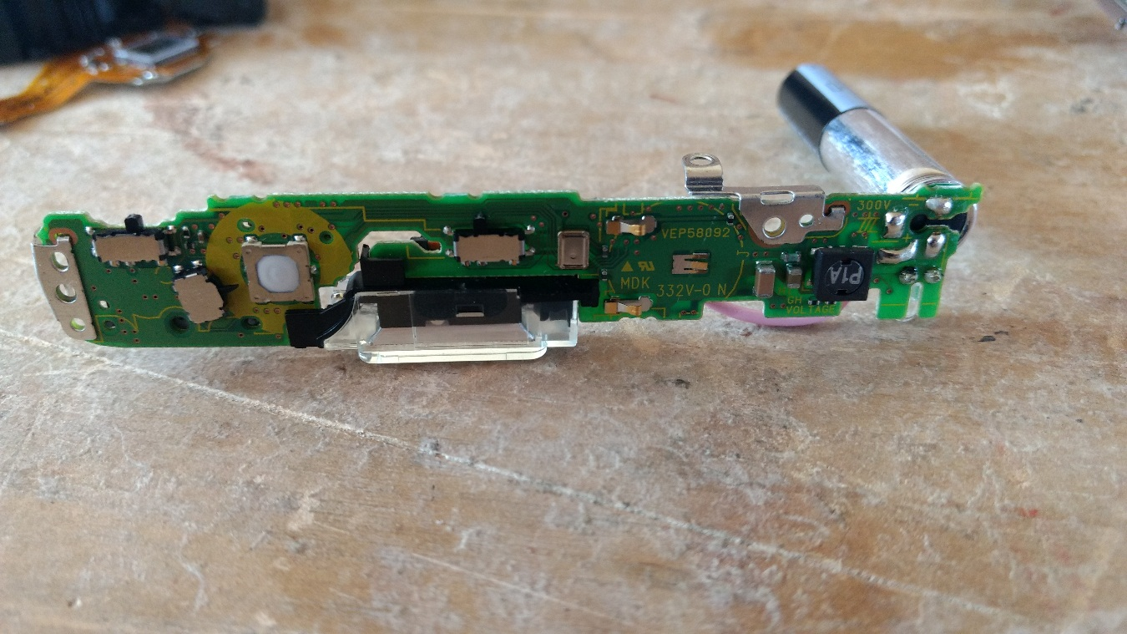In the upper part of the camera we found another plate, which make function the ON/OFF switch, the shutter release, the zoom lens and the photo gallery/camera switch. Furthermore, it has the loudspeaker. However, in this motherboard there were no TI components either.

* Photo gallery/camera switch
* Zoom
* Shutter release
* ON/OFF switch
* Loudspeaker

With this challenge our team learned more about circuits and connections, and that despite of the small size of the camera, it has complicated circuits that let it works correctly.