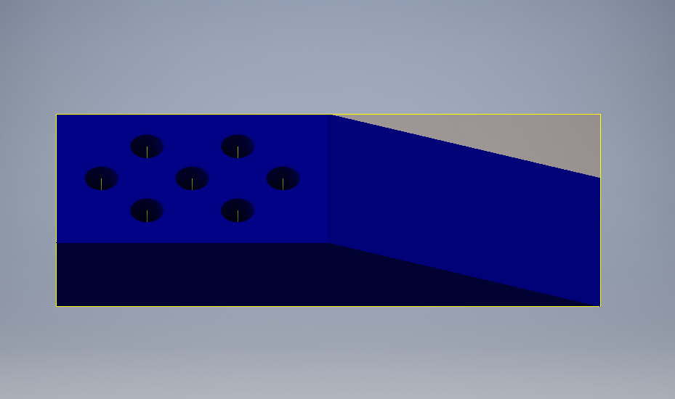

Trident Tooth: Created in Autodesk®Inventor® 2017

In this competition, we need to design a robot that fulfills all the specifications and expectations of the contest. When designing this challenge’s robot, we took into consideration the possible problems that we would face, such as weight, speed, and precision. Yet, there are other factors, such as minuscule bending and tensions between the screws and the metals. This is why the assembly is so important. It is in this phase that we realized what problems we had and began looking for their solutions. One of those solutions was the reason we designed the trident tooth. The trident tooth helped us improve the performance of the shovels, forks, and even claws created for testing.

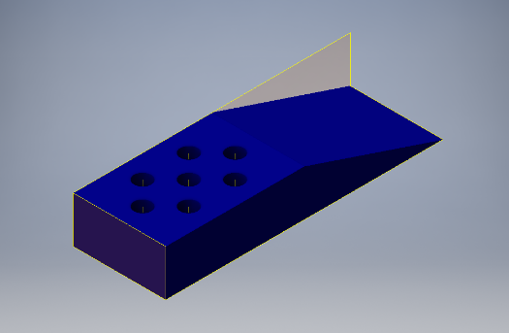When our prototype shovel was created, it had to be raised so that it would not scratch the floor but this affected the grip for the objects to the point where it was more challenging to take objects when meshed together than when we had to manage scraping the floor while driving. Therefore, the trident tooth was placed at the end of the c-channels so that the cubes could smoothly slide onto the shovels and forks, making our robot more time efficient and removing previously required friction forces.

The designing process began on a different platform, since our university has made it available for all our students. Almost all of the team members have had experience with using this program and have been constantly designing different parts for our base and arm mechanisms. However, the program wasn’t available halfway through the process due to licensing, and so we thought to start over on inventor, until we found out that inventor is extra handy and can actually open almost every design platform’s files, and continues editing it. We continued on inventor creating different pieces, and found extrusions and revolves accessible on one click, as well as making assemblies with parallel and coinciding options on right clicks next to other options easy to access such as editing, deleting, copying, and rotating views in preset or custom ways. After some time, all basic commands were instinctive and the whole design process sped up.

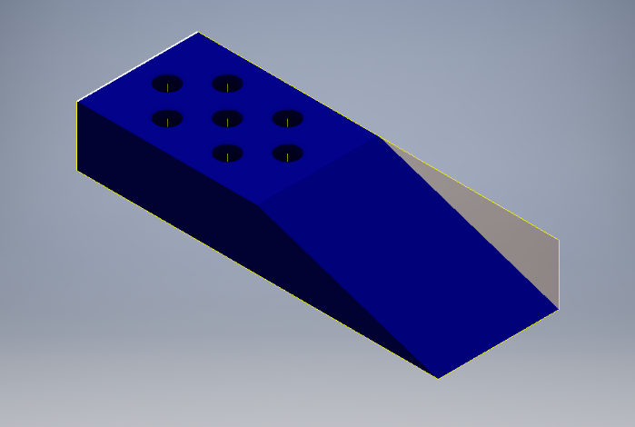

With this project we learned that not every problem has an immediate solution so you have to have a creative mind willing to explore. For our help, we have programs like Inventor or Infusion that give us the opportunity of bring our ideas to a three-dimensional plane and print them in a future. We would use Inventor in the future for other competition or even projects in our University. This program is a helpful and easy to handle tool. Learn how to use the program will help us in our career as we will work a lot with the design and creation of objects. This is a changing world to which we must adapt to innovations and this program helps us to do so.